Map Quiz!
Minehead map
Look at the map (page 3) and the map key (pages 4 and 5) to answer the questions:
- How many camp sites can you find?
- Can you find a train station?
- Find 3 places where people work.
- Find 3 places where people go for fun.

- What is the biggest building on the map?

- Can you find a nature reserve?

- Roughly, how far is it from Minehead to Dunster train station? Look at the scale bar!
- What structures are there in the sea?

- What is the highest point on the map and how many metres is it?

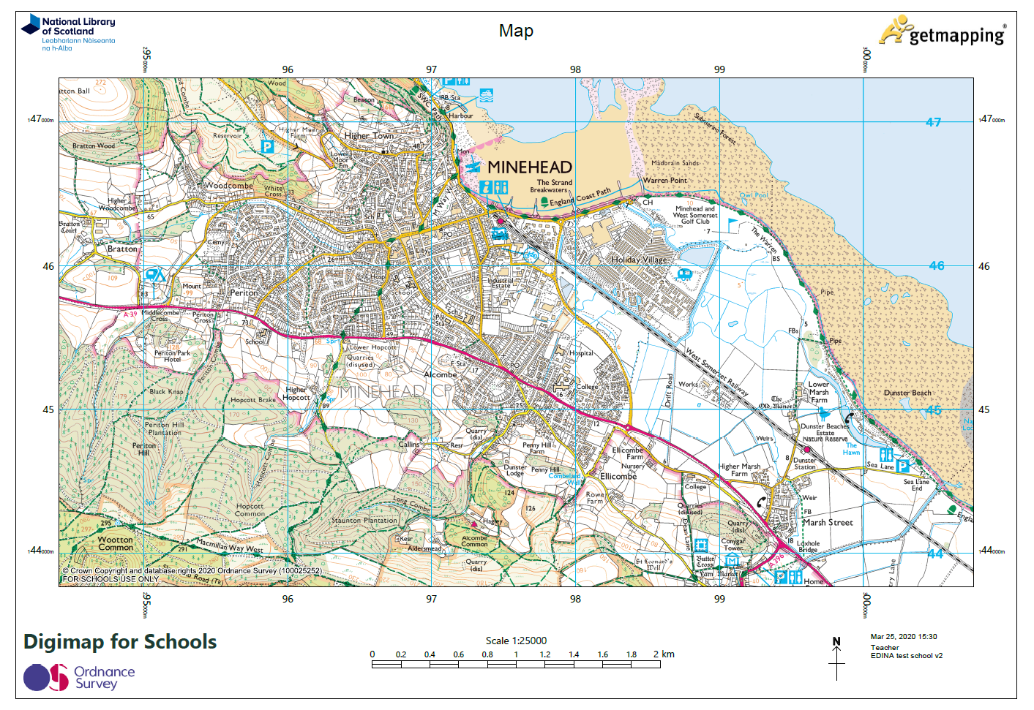

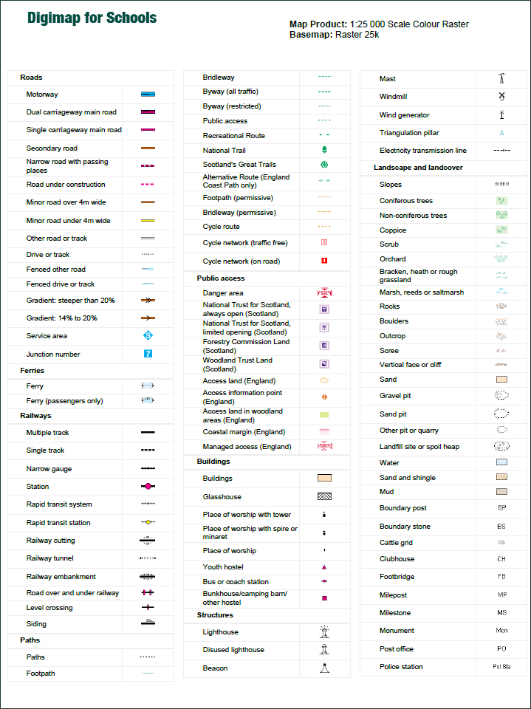

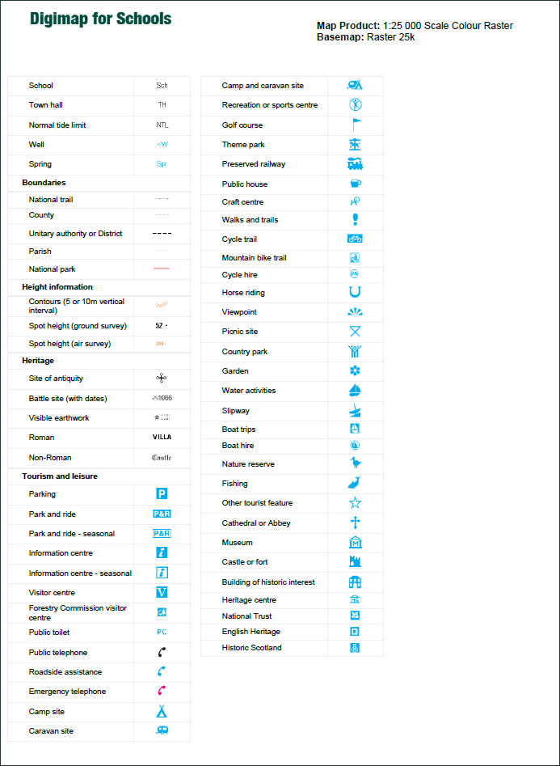

Copyright
©EDINA at the University of Edinburgh 2020
This work is licensed under a Creative Commons Attribution Non-Commercial Licence

Acknowledgements
© CollinsBartholomew Ltd (2019) FOR SCHOOLS USE ONLY
© Crown copyright and database rights 2020 Ordnance Survey (100025252). FOR SCHOOLS USE ONLY.
Aerial photography © Getmapping plc. Contains OS data. FOR SCHOOLS USE ONLY.
Historic mapping courtesy of the National Library of Scotland. FOR SCHOOLS USE ONLY.

