Map your walk!
Login

- Go to: https://digimapforschools.edina.ac.uk/
- Select the Login button
- Put in your username*
- Put in your password*
- Select Log In
- *Ask a teacher if you don’t know this

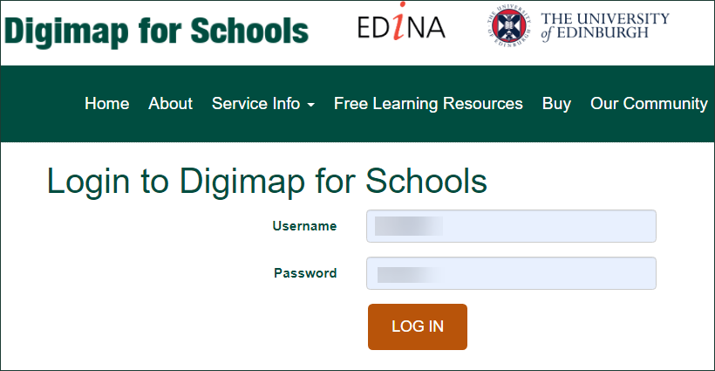

Find your school
- Type your school’s postcode in the Search box - it’s above the map, on the left.

- Now select the magnifying glass next to the search box.
- The map should show your school. To remove the red marker, select the X next to the search results.
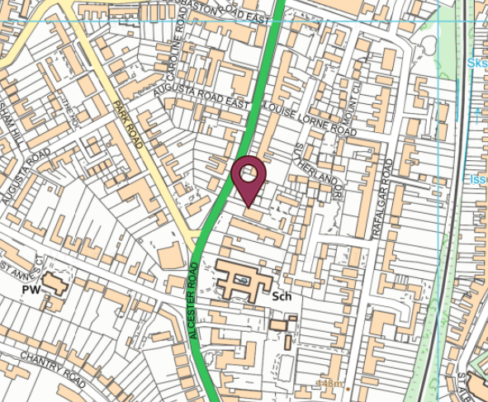
Zoom in
- Let’s zoom in on your school. You can:
  - Select the plus button on the scale bar
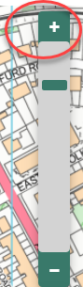
  - Or double click or double tap where you want to zoom in.
- Can you see your school?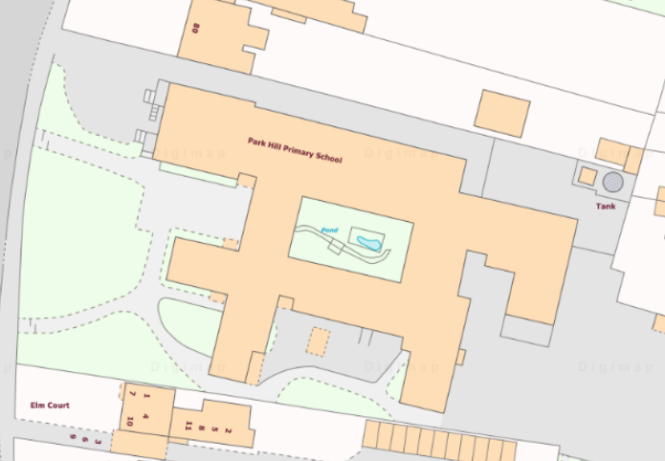
Measure
Let’s measure how long it is to walk all the way around your school.
- Open the Measurement Tools – you’ll find them on the left of the map.
- Select Distance:
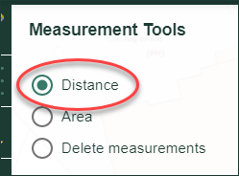
- Now let’s draw a line around the school grounds.
  - Tap or click on a point on the screen to start.
  - Keep tapping or clicking to add new points. Work your way around the school grounds.
  - Double click at the end.
  - You should see a measurement on the screen AND in the measurement tools box.
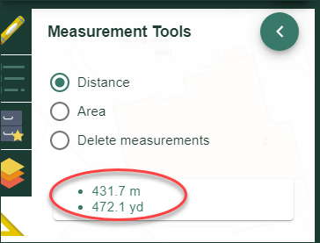
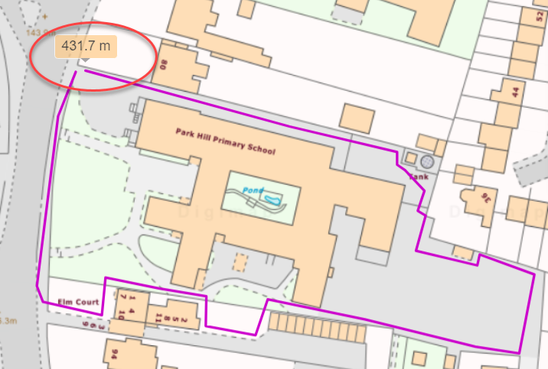

- Make a note of the measurement. Round it up to the nearest whole number. So for the map above, which shows 431.7 metres, we will note down 432 metres.

Your walk to school

- Is the walk around the grounds more or less than your walk to schools?
- Zoom out until you find your house. Or you can search with your postcode.
- Measure a line from your house to school. The walk below is 596 m.
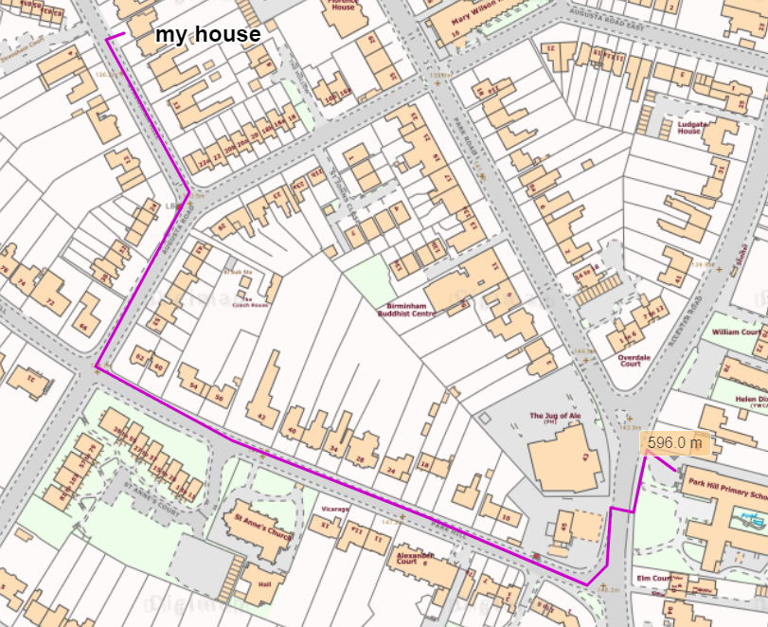
Who lives nearest?

- Can you add a marker to show a school friend’s house?
- Open the Drawing Tools.
- Select a marker then select a place on the map to add it.
- Add a label with their name.
  - Select the label tool (the orange one in the picture below).
  - Choose a place on the map.
  - Type the name.
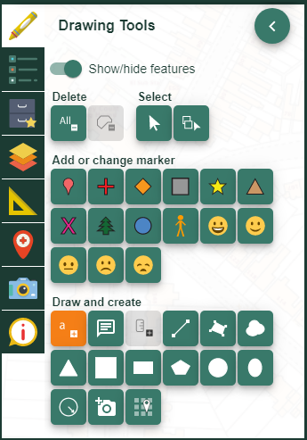

- Now go back to Measurement Tools.
- Measure the distance from your friend’s house to school.
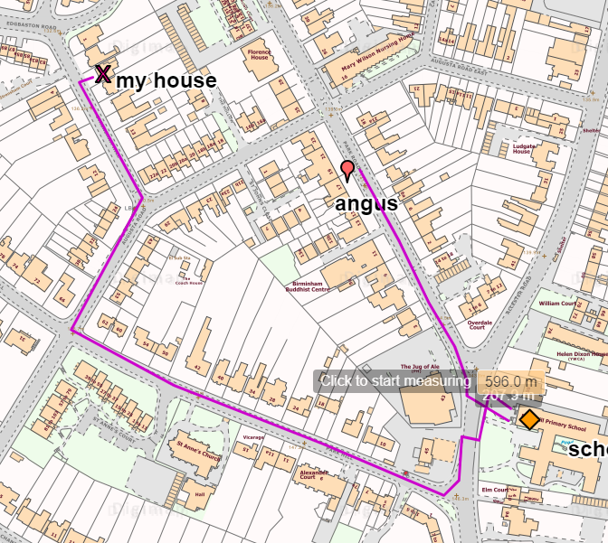
- Who walks furthest??
- Print your map.

Let’s compare!
432 metres is the distance round the school grounds.
How many times would you have to walk around your school to walk as high as Mount Everest??
Divide the height of Mount Everest by the distance round the grounds. Round up the answer.
Try some more!
Landmark | How high? | My school | Sum
Mount Everest | 8848m | 432m | 8848 / 432 = 21 times!
Burj Khalifa, Dubai | 828m | 432m | 828 / 432 =
Petronas Towers, Malaysia | 452m | 432m | 452 / 432 =

Copyright
©EDINA at the University of Edinburgh 2020
This work is licensed under a Creative Commons Attribution Non-Commercial Licence

Acknowledgements
© CollinsBartholomew Ltd (2019) FOR SCHOOLS USE ONLY
© Crown copyright and database rights 2020 Ordnance Survey (100025252). FOR SCHOOLS USE ONLY.
Aerial photography © Getmapping plc. Contains OS data. FOR SCHOOLS USE ONLY.
Historic mapping courtesy of the National Library of Scotland. FOR SCHOOLS USE ONLY.

