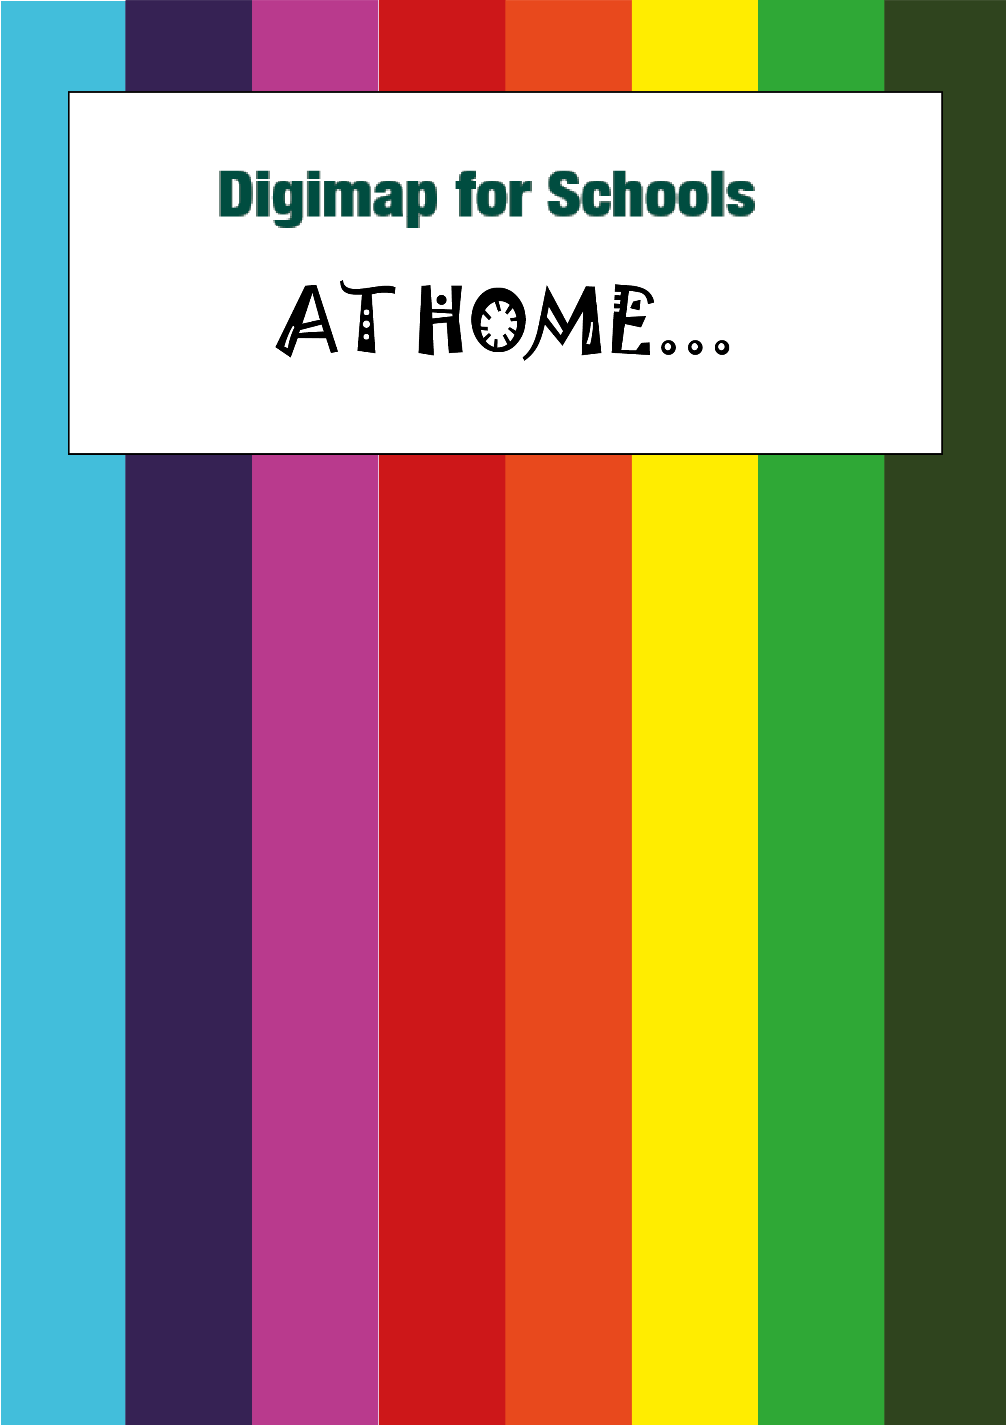
Scavenger Hunt!
- Go Hunt!

Pick a list of things to find. If you don’t have a garden, try list two!

Take photos of anything you find!

List 1 – in the garden | List 2 – from your window
- A flat stone  - A flower  - 10 blades of grass  - Something that is heavy  - Something that is light  - Something that needs sun to live  - Something smaller than your thumb  - Something that starts with “S” | - An oddly shaped cloud  - 3 red cars  - House numbers with 4 in the number  - Blue front doors  - Yellow flowers  - A dog  - A rainbow  - Something green  - Something that starts with “S”
- Login

- Go to: https://digimapforschools.edina.ac.uk/
- Select the Login button
- Put in your username*
- Put in your password*
- Select Log In
- *Ask a teacher if you don’t know this

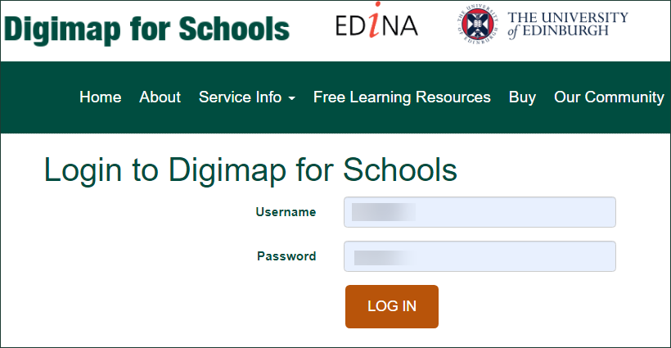

- Find your street
- Type your postcode in the Search box - it’s above the map, on the left.

- Now select the magnifying glass next to the search box.
- The map should have a red marker on your street.
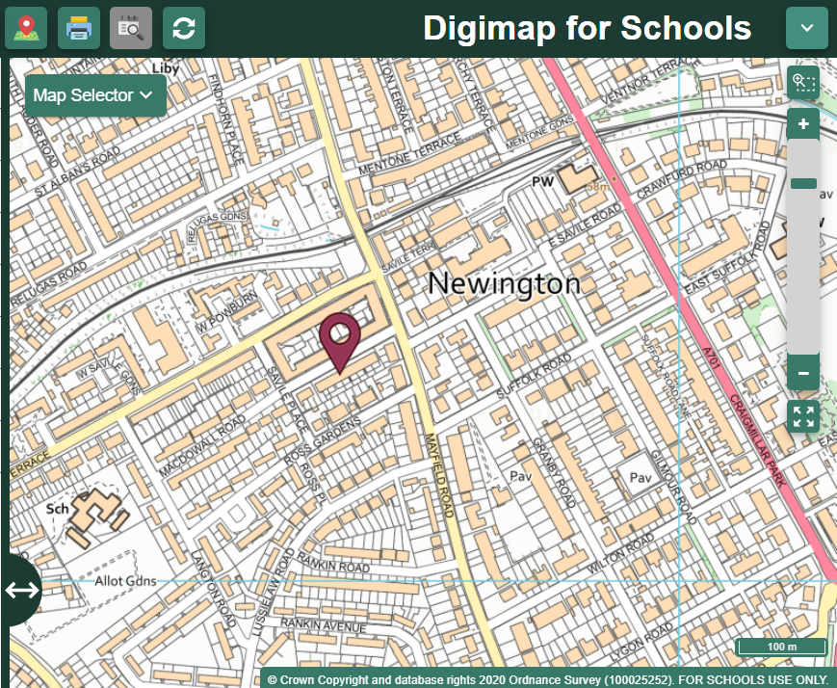
- Zoom in!
- Let’s zoom in on your house. You can:
  - Select the plus button on the scale bar, or
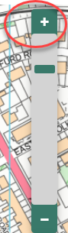
  - Double click or double tap where you want to zoom in.
- Can you see your house?
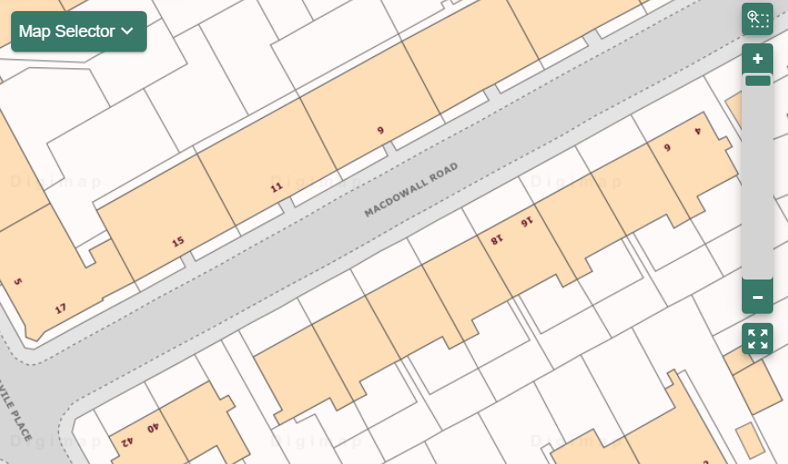
- Let’s Draw!
- Select Drawing Tools – look on the left.
- Add a marker to your house. Just choose your marker then select your house.
- Add a text label: maybe ‘my house’ or ‘my hunt’.
- Now let’s add your scavenger hunt photos!
  - Make sure you have any photos you took on your computer
  - Select the Add photo button:
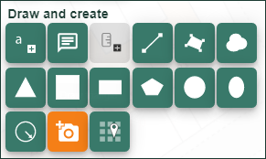
  - Select the point on the map where you want to add a photo
  - Now Select Choose File, find your photo and select Open
  - Select Upload
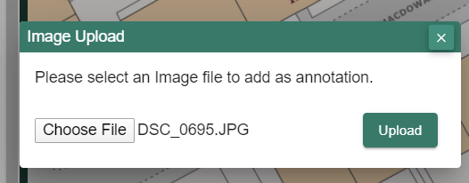

- Keep adding photos until you are happy with your map

- Share your work
- Select Print – look above the map
- Type in a title, your name.
- Select Generate Print file.
- Your computer will ask you where to save your PDF file.
- You now have a map you can share with your family, teacher, friends or US! We would love to see it. Tweet us @digimap4schools.

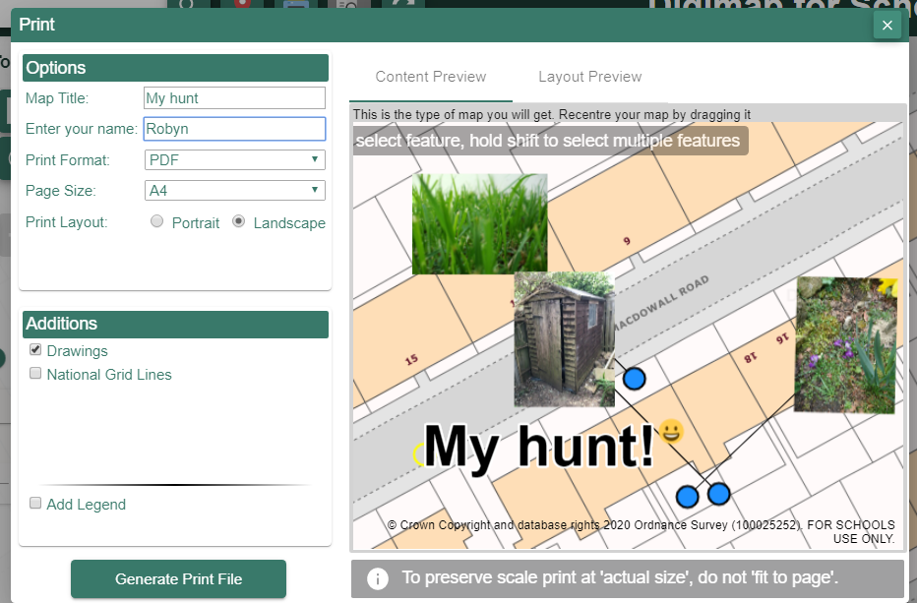

Copyright
©EDINA at the University of Edinburgh 2020
This work is licensed under a Creative Commons Attribution Non-Commercial Licence

Acknowledgements
© CollinsBartholomew Ltd (2019) FOR SCHOOLS USE ONLY
© Crown copyright and database rights 2020 Ordnance Survey (100025252). FOR SCHOOLS USE ONLY.
Aerial photography © Getmapping plc. Contains OS data. FOR SCHOOLS USE ONLY.
Historic mapping courtesy of the National Library of Scotland. FOR SCHOOLS USE ONLY.

