Signs of Spring!
Get spotting!

What signs of spring can you find in your garden?

Check page 3 for some ideas. Tick off any that you find.

Take photos too!

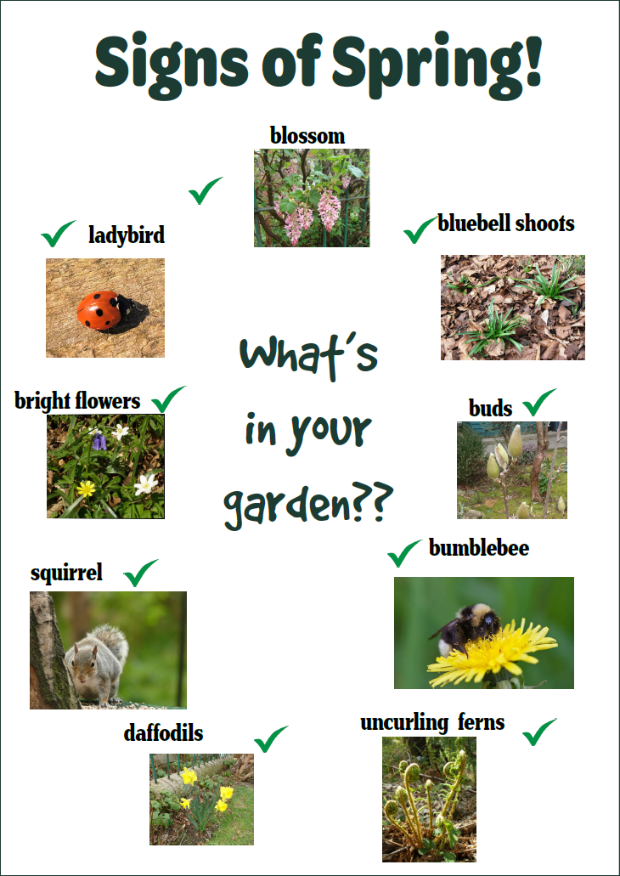
Login
- Go to: https://digimapforschools.edina.ac.uk/
- Select the Login button
- Put in your username*
- Put in your password*
- Select Log In
- *Ask a teacher if you don’t know this

Image search
- Let’s go to your area: either.
  - Type your town in the search box at the top left. If there is more than one result, select the right one from the list, or
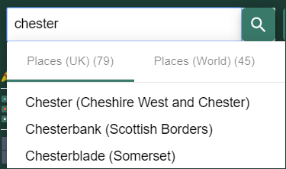
  - Type your postcode in the search box at the top left.
  - Hopefully you can now see your area on the map.
- Open Image Search – look on the left of the map.
  - Type a word in the Search box and select the magnifying glass– try:
  - Daffodils
  - Spring
  - Blossom
  - Buds
  - any other words you’d like to try.
- Any images will be shown on the left AND on the map.
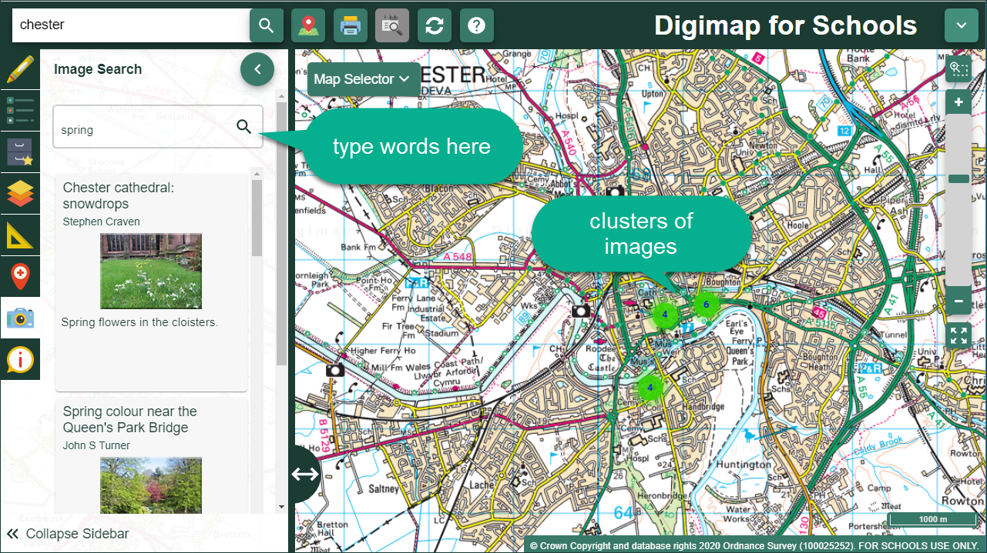
- Zoom in on the clusters to view any images.

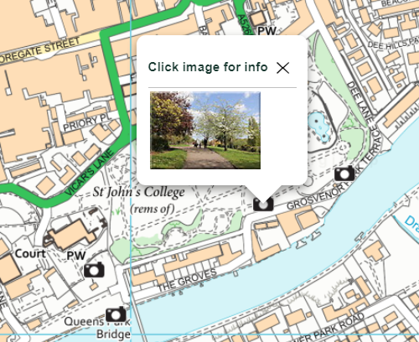
Zoom in!
- Now let’s zoom in on your house. You can:
  - Select the plus button on the scale bar, or
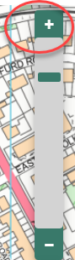
  - Double click or double tap where you want to zoom in.
- Can you see your house?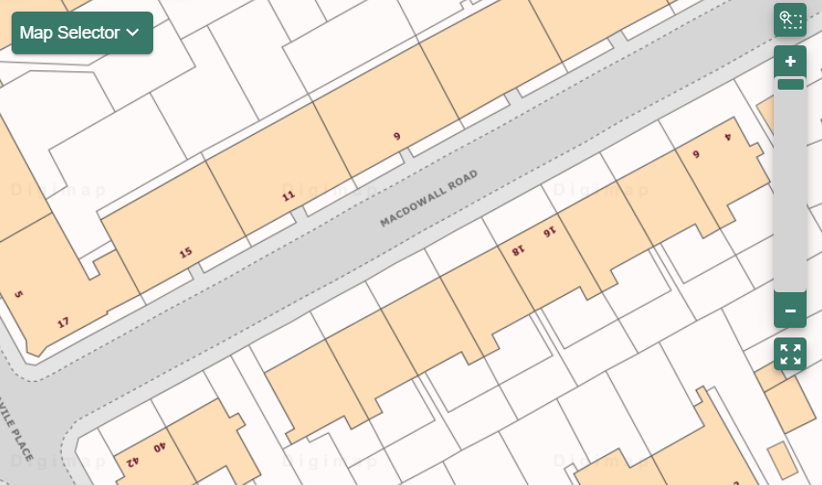

Let’s Draw!
- Select Drawing Tools – look on the left.
- Add a marker to your house. Just choose your marker then select your house.
- Add a text label: maybe ‘my house’ or ‘Spring Time’.
- Now let’s add your spring photos!
  - Make sure you have any photos you took on your computer.
  - Select the Add photo button:
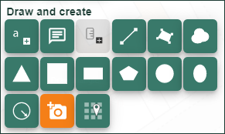
  - Select the point on the map where you want to add a photo.
  - Now Select Choose File, find your photo and select Open.
  - Select Upload.
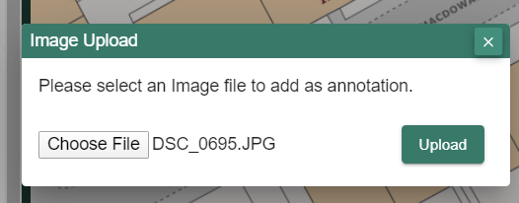

- Keep adding photos until you are happy with your map
Share your work
- Select Print – look above the map
- Type in a title, your name.
- Select Generate Print file.
- Your computer will ask you where to save your PDF file.
- You now have a map you can share with your family, teacher, friends or US! We would love to see it. Tweet us @digimap4schools.

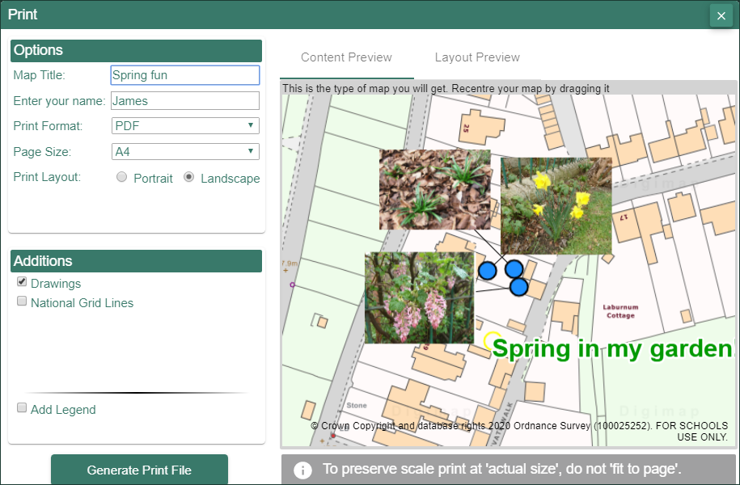

Copyright
©EDINA at the University of Edinburgh 2020
This work is licensed under a Creative Commons Attribution Non-Commercial Licence

Image Acknowledgements
Come back for the Bluebells in April, cc-by-sa/2.0 - © Chris Reynolds - geograph.org.uk/p/1192420
Grey squirrel in Center Parcs, cc-by-sa/2.0 - © Graham Hogg - geograph.org.uk/p/5547805
Native spring flowers in Coxhill woods, cc-by-sa/2.0 - © Carol Rose - geograph.org.uk/p/407133
Seven-spot ladybird, cc-by-sa/2.0 - © Bill Kasman - geograph.org.uk/p/6128086
Ferns unfurl in late spring sunlight, cc-by-sa/2.0 - © Carol Rose - geograph.org.uk/p/798469

Acknowledgements
© CollinsBartholomew Ltd (2019) FOR SCHOOLS USE ONLY
© Crown copyright and database rights 2020 Ordnance Survey (100025252). FOR SCHOOLS USE ONLY.
Aerial photography © Getmapping plc. Contains OS data. FOR SCHOOLS USE ONLY.
Historic mapping courtesy of the National Library of Scotland. FOR SCHOOLS USE ONLY.

