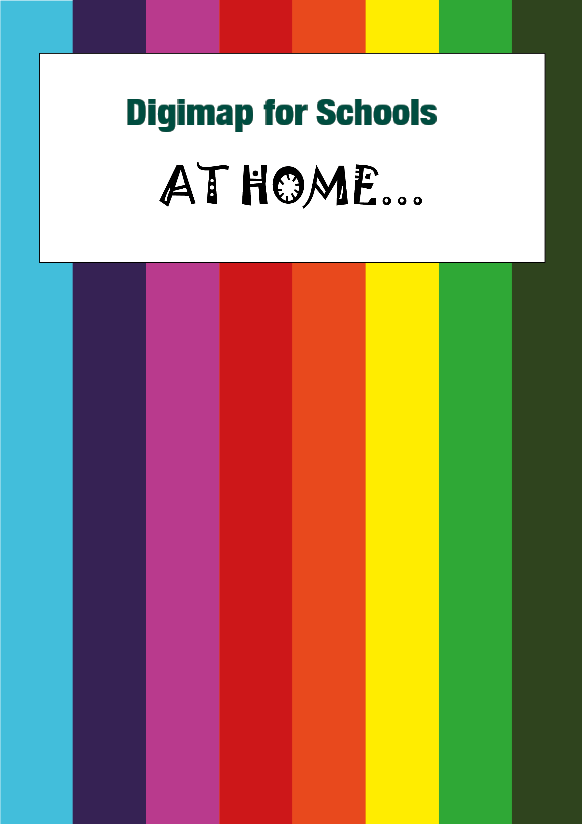

Urbanisation

What’s it about?

Let’s try and explore an area and how it has changed since the 1890s. We’ve chosen Congleton in Cheshire but you could try this for any area.

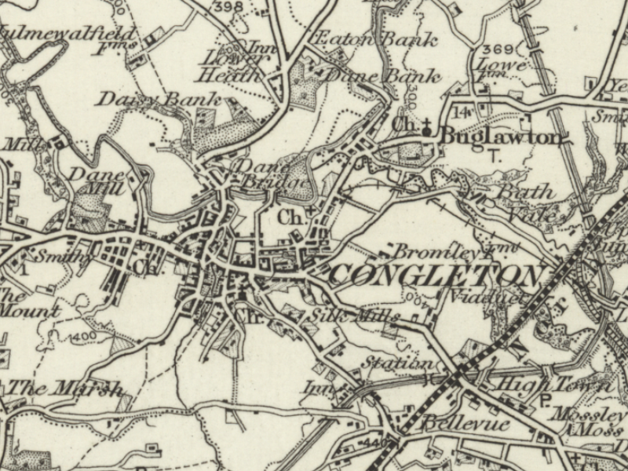

Steps!
What’s it about? 2
Find our location 3
Compare maps 4
Outline the area 5
Compare the eras 9
Find out more 10

Find our location
- Login to Digimap for Schools.
  - Go to: https://digimapforschools.edina.ac.uk/
  - Select the Login button
  - Put in your username*
  - Put in your password*
  - Select Log In
*Ask a teacher if you don’t know this
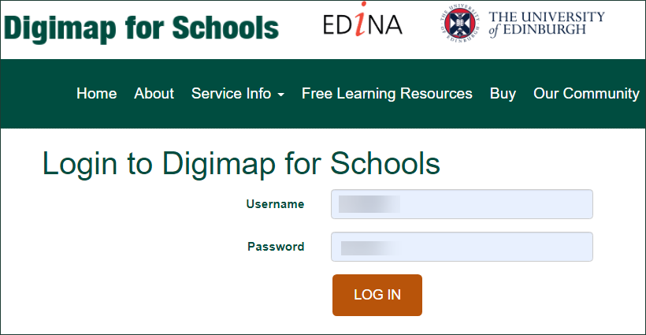

- Type Congleton in the search box.
- Select the magnifying glass.
- Select Congleton (Cheshire East) from the results.

Compare maps
- Now let’s view a historical map.
- Open the Map Selector on the map window.
- Select the button to the right of 1890s.
- You should see a historical map of Congleton, similar to the image below:

Explore the 1890s map
Zoom in and have a look around the map.
Open the Map Key on the left if you are not sure what the symbols mean.
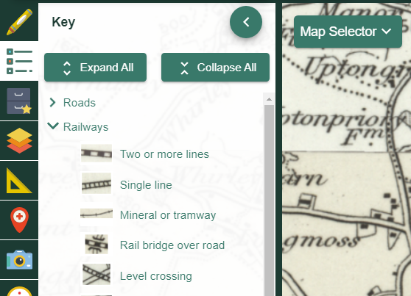

- Can you see any evidence of where people worked, or how they lived? Mills, farms, blacksmiths? Write down anything you see.
- Do you see any signs of transport, like train lines or stations or larger roads?
- Is there any sign of a river, or water, that would have been useful for industry?
Write down anything you notice.

Outline the area
We want to add a shape over the area, to get an idea of its geographic size at that time.
- Select Drawing Tools – look on the left.
- Select the Draw Freehand Polygon tool (look under the Draw and Create area).
- Select a line colour under line settings, a colour that will stand out on the map
- We want the polygon to be see through…under Fill Settings, move the transparency slider bar all the way to the left (see image below).
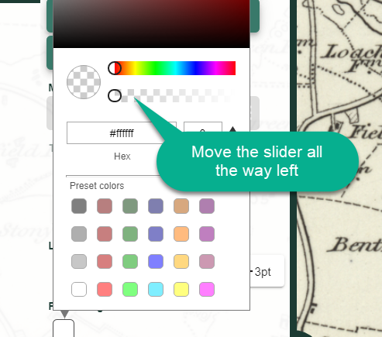

- Now let’s draw a polygon over the area.
  - Click and hold, or tap and hold on the map to start, then move the mouse or your finger to draw the shape.
  - Let go to finish your polygon.
  - TIP: If the draw freehand polygon tool is tricky, try the draw polygon tool instead.
- Now select Place Standalone label.
- Add a text label near your shape, that says 1890s.

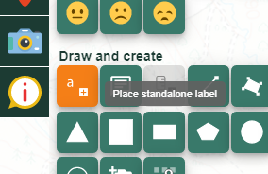
Your map should look similar to the image below.
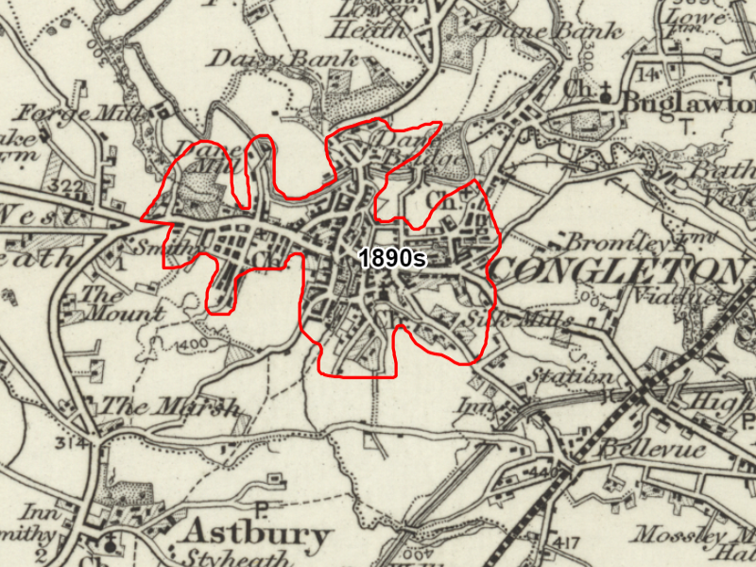

Explore the 1950s
- Select the 1950s map from the Map Selector.
- What changes do you see? Remember you can check the map key for any symbols you are not sure about.
  - Has industry changed? Are the mills still there?
  - Has the area got bigger?
  - Any signs that society has changed? Do you see more schools? A hospital? A golf course?

- Write down anything you notice.

- Now outline the area. Repeat the steps above. Add a polygon with a different line colour and with no fill colour.
- Add a ‘1950s’ label.

Present day
- Select the Ordnance Survey map from the Map Selector.
- What changes do you see? Remember you can zoom in to see more detail and check the map key for any symbols you’re not sure about.
  - How has industry changed? Do you see industrial or trading on the outside of the town? Are the mills still there?
  - Has the area got bigger? Can you zoom in on the new areas and see if they are housing or industry?
  - Any signs that society has more time for leisure? Any parks, museums, leisure centres, golf courses?

- Write down anything you notice.

- Now outline the area. Repeat the steps above for the present day. Add a polygon with a different line colour and with no fill colour.
- Add a ‘Present day’ label.

Compare the eras
- Finally, select an Aerial map from the Map Selector.
- This will give you a clear view of how the size of Congelton has changed.
- Save or print your map.
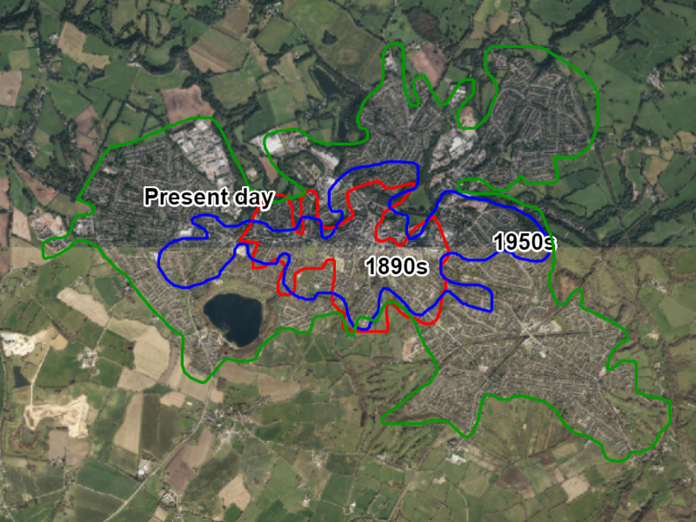

Find out more
BBC Bitesize has fantastic information about urbanisation and why towns and cities develop.

https://www.bbc.co.uk/bitesize/topics/z4mfb9q

Copyright
©EDINA at the University of Edinburgh 2020
This work is licensed under a Creative Commons Attribution Non-Commercial Licence

Acknowledgements
© CollinsBartholomew Ltd (2019) FOR SCHOOLS USE ONLY
© Crown copyright and database rights 2020 Ordnance Survey (100025252). FOR SCHOOLS USE ONLY.
Aerial photography © Getmapping plc. Contains OS data. FOR SCHOOLS USE ONLY.
Historical mapping courtesy of the National Library of Scotland. FOR SCHOOLS USE ONLY.

