**Controlled Assessment**

Alan Parkinson

**Geography Teaching Resource**

Age 14-18

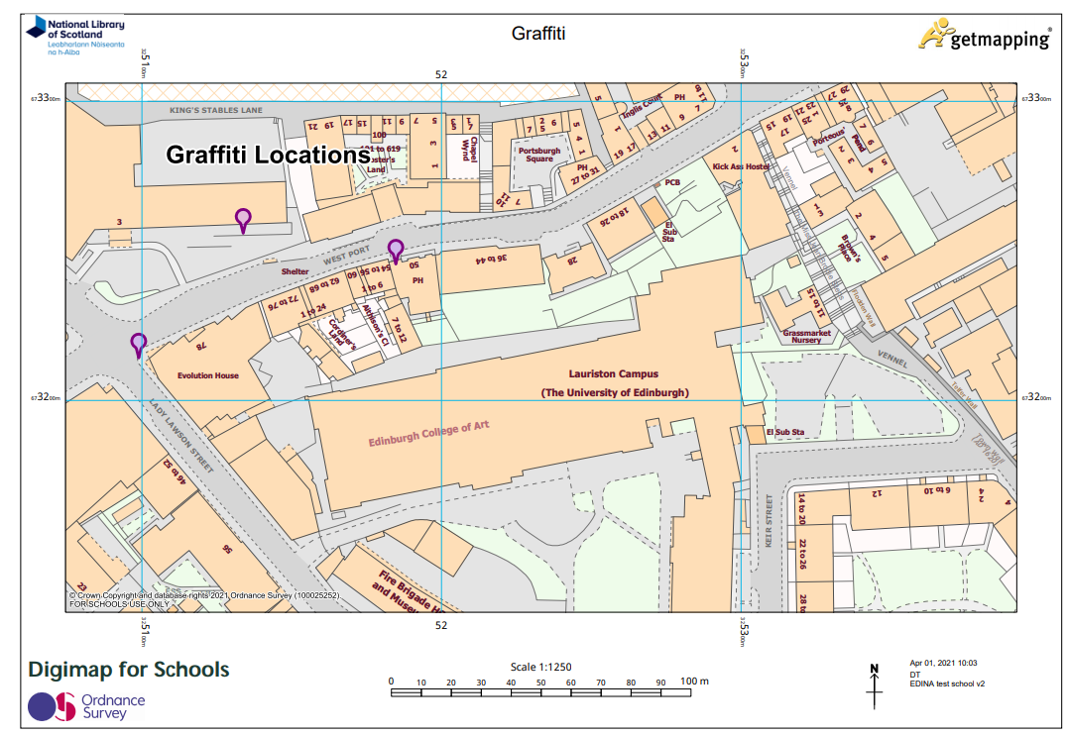

# Controlled Assessment – Finding a map

Success in a controlled assessment in geography depends on the effective use of geography skills.

# Introduction

All Controlled Assessment tasks need a map to locate the key areas that will be explored during the assessment. These are likely to be the same locations that were visited during fieldwork.

# Produce a map using Digimap for Schools*.*

1. Login to Digimap for Schools.
2. Use the **Search** function to find the place that is relevant to your coursework.
3. Zoom to an appropriate level using the Zoom bar so that you can show the information that is relevant to your Controlled Assessment title.
4. Consider if you want to add a British National Grid, Postcodes or other overlay. Available in **Overlays** menu to the left of the map.

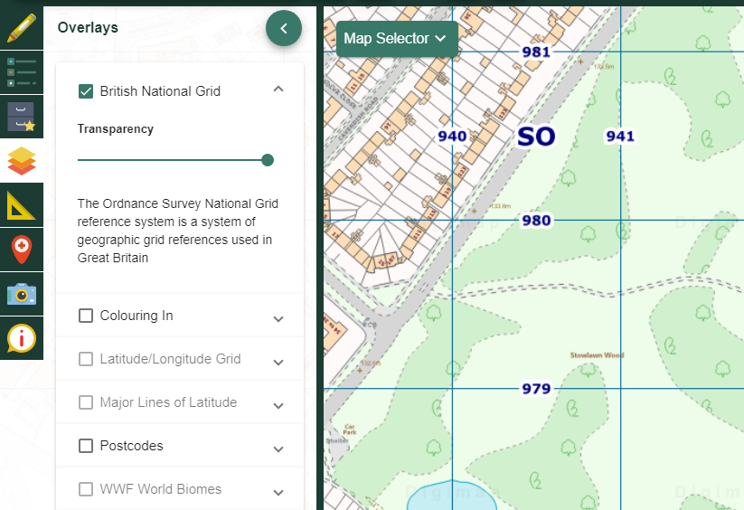

1. Annotate as necessary using the **Drawing Tools.** This may include:
   1. Adding and labelling points, areas, buffer zones or photographs.
   2. Measuring areas and distances.
   3. Adding symbols or routes.

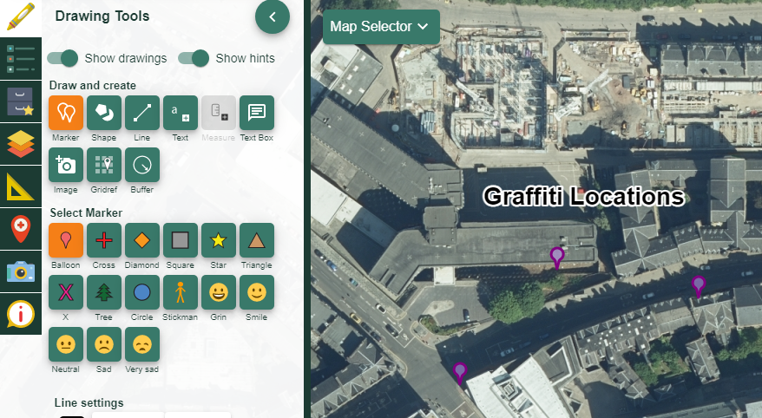

1. Use the **Print** options:
   1. Choose landscape or portrait,
   2. A4 or A3,
   3. PDF, PNG or JPEG.
   4. Check the layout tab to make sure the print will cover the right area.
   5. Ensure you add your name and an appropriate title before printing the map.

# print menu

# Methodology section

Can include maps to identify why particular locations were chosen for data collection.

# Information/data processing

Evidence can be organised using mapping.

# Data presentation

Proportional shapes can be used, or maps can be printed to act as a background to data.

# Copyright

©EDINA at the University of Edinburgh 2016

This work is licensed under a Creative Commons Attribution-Non Commercial LicenceCreative commons licence, CC BY NC

# Acknowledgements

© CollinsBartholomew Ltd (2019) FOR SCHOOLS USE ONLY

© Crown copyright and database rights 2020 Ordnance Survey (100025252). FOR SCHOOLS USE ONLY.

Aerial photography © Getmapping plc. Contains OS data. FOR SCHOOLS USE ONLY.

Historic mapping courtesy of the National Library of Scotland. FOR SCHOOLS USE ONLY.