Earthquakes in GB

Prevalence of tectonic hazards in Great Britain

Alan Parkinson

Geography Teaching Resource

Secondary

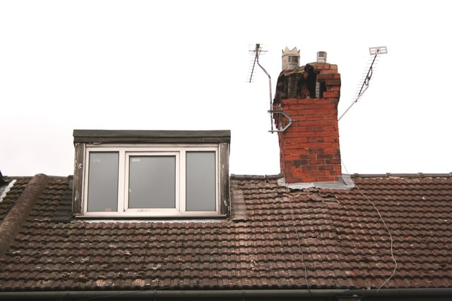
Earthquake damage
cc-by-sa/2.0 - © Richard Croft - geograph.org.uk/p/708676
Contents
Digimap for Schools Geography Resources 3
Content and Curriculum Links 3
Summary 3
Introduction 4
Earthquakes in GB – Activity 4
Eyewitness earthquake reports 5
European Macroseismic Scale 7
Taking it further 8
Web links 8
Copyright 9
Acknowledgements 9

Digimap for Schools Geography Resources
These resources are a guide for teachers to demonstrate to the whole class or direct individual students as appropriate. Each activity has several ideas within it that you can tailor to suit your class and pupils. Some resources contain worksheets for direct distribution to pupils.

Content and Curriculum Links

Level | Context | Location
Secondary | Prevalence of tectonic hazards in Great Britain | The example refers to the earthquake that took place in Market Rasen in Lincolnshire in 2008. Small earthquakes occur in the UK from time to time, and are monitored by the British Geological Survey: http://www.bgs.ac.uk/

Knowledge | Mapping/Grid Reference Tool/Symbology and Labelling
Curriculum links (England) | Plate Tectonics/Tectonic Hazards/Earthquakes/Mapping
Curriculum links (Wales) | WJEC Geography Specification:  A: Living in an Active Zone: Reducing the Risk
Scottish Curriculum for Excellence | National 4 & 5 Qualifications: Plate Tectonics

Summary
This activity refers to the way that earthquakes are recorded and mapped. When an earthquake occurs, recordings are made in various locations using equipment called seismometers, which produce a trace showing the shaking that has been recorded on a seismogram.

Most people have heard of the Richter Scale (see web links). But this exercise is using the Mercalli scale or a variation on this called the European Macroseismic Scale (EMS). This enables users to identify the probable strength of the earthquake by observing the effect it has on physical features.

Introduction

At around 1 am on the 27 of February 2008, I was woken by a sound which I realised was an earthquake. It lasted for around 15 seconds and sounded like the neighbour was moving furniture around and scraping it on the floor.
There was a slight sensation of rumbling which was unnerving, and I was concerned that it would perhaps cause some damage to the house. Items on a chest of drawers were rattling against each other.
I went out into the street expecting lots of people to be out there, and I was the only one there! Perhaps the rest of the street were heavier sleepers? I then turned on my mobile phone, and within minutes there was a stream of messages on social networking sites, followed by the main news media. There had been a fairly large earthquake in the UK. Where was it centered? How far away was it from me? How can earthquakes in GB be recorded and measured?

Those questions form the basis of this activity. Maps produced by students should look similar to the image below.

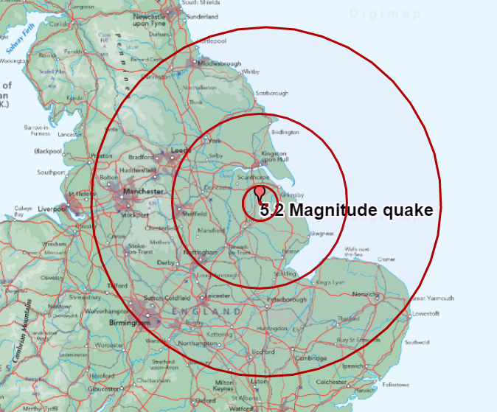

KEY
Intensity EMS
5: Moderate
4: Light
3: Weak
2: Scarcely perceptible
1: Not felt

Earthquakes in GB – Activity

- Read the eyewitness earthquake reports and compare the description with those used in the European Macroseismic scale document.

- Using Digmap for Schools locate each location and add markers to each (use the Drawing Tools).

- Label with a number corresponding to the scale of the earthquake as it was felt in that location, according to the EMS (European Macroseismic Scale).

- At the time of the earthquake, I was living in Snettisham in North Norfolk. Based on the description of what I felt, I would say that I experienced a scale 4 earthquake using this scale. Do you agree?

- Zoom out to the smallest scale. Using the Drawing tools (or on a printed map) you should be able to join up the locations with the same strength with lines to roughly identify areas that are closer or further away from the epicentre of the earthquake.

Where do you think the epicentre is?

The epicentre is the point on the surface immediately above the point where the earthquake actually happened. This is usually the point at which the rock ruptured or slipped, and the energy was released as shockwaves. This point, beneath the ground, is called the focus or hypocentre.

Eyewitness earthquake reports

Adam Wilson – Cotgrave, Nottingham – I was lying in bed playing an online game. I felt the window start to vibrate for a few seconds and then it carried on and I was thinking ‘come on, stop now’. I was a bit nervous, my blinds were making a racket. It probably lasted 10 seconds but felt much longer. I walked around to check damage and noticed a crack in the kitchen. We do a lot of decorating so I know it was as a result of the tremor.
Mr Bristow – Market Rasen, Lincolnshire – The whole house just started shaking. It woke me up, it was terrifying. The windows were shaking and at first we thought it must just be a train at the nearby station. The noise was unbelievable.
Guy Robinson – Sheepy Magna, Leicestershire – Our house shook gently for five to 10 seconds with a short spell of significant vibration. The wardrobe doors banged during this period, which subsided to another five to 10 seconds and then peace again. It was very scary – we have a small baby that my wife and I were worried for.
Peter Thorp – Poynton, Cheshire – I was just about to shut down my computer when the quake occurred at just after 0055, the weird thing was that there was no noise when it started, the room just started shaking and the chair I was sat on started moving on its casters. There was then the noise of the house shaking and the illusion of the room moving, I would have said it lasted for five to 10 seconds, but for at least the same time again the lamp in my room continued to shake.

Lynette – Malvern, Worcestershire – Just been woken by our computer monitor, desk and whole bedroom shaking. Just before 1 am, very similar to the earthquake in 2002. Neighbours’ children were woken up by it too and started crying with fear. My daughter slept right through it.

Simon Whiteley – Lytham St Annes, Blackpool – I've just felt an earthquake. Shook the whole apartment building for about 10 seconds, appears to be no damage. Very concerning as I live next to the airport 1,000 yards from the sea. Strange experience – was like someone was shaking my bed quite violently.
Margaret Mason – Harrow, North West London – I was asleep in bed. I was awoken by the sensation of my room shaking and it lasted for five to 10 seconds. My first thought was that there was an intruder thumping about in my room; my second thought was that it was a poltergeist. Then I realised that there was no noise, only vibration. I only realised some hours later that there had been an earthquake.
Leigh Cocker – Exeter, Devon – My whole house just shook... I didn’t know what on earth was happening and ignored it as we often get trucks that drive past our house. But this seemed bigger though.
Helen Brown – King's Lynn, Norfolk – We were woken just before 1 am, our old house was really shaking. We were not sure what was going on. At first we thought it could be a lorry on the road but it lasted too long for it to be that.
Phil – Milton Keynes, Buckinghamshire – It felt as though someone was shaking the sofa, when I realised the whole room was moving I jumped up and looked out of the window. I noticed lights coming on all down the street and then it stopped as suddenly as it started, a very strange experience.
Tina Griffiths – Wrexham, North Wales – I was just getting into bed when I heard a relatively loud noise, the whole room started shaking, my bed (which is solid to the floor) started shaking, and car alarms went off. Even my wardrobe shook. My neighbour’s child fell off his bunk bed, but was unhurt. I remember a similar experience as a teenager.
Graham – Sheffield, South Yorkshire – I’ve just sat through an earthquake. Pretty weird for the UK I think. Scared the hell out of me, must have been around 12:55 am. I am on the fifth floor – everything started shaking and there was a rumbling.

European Macroseismic Scale
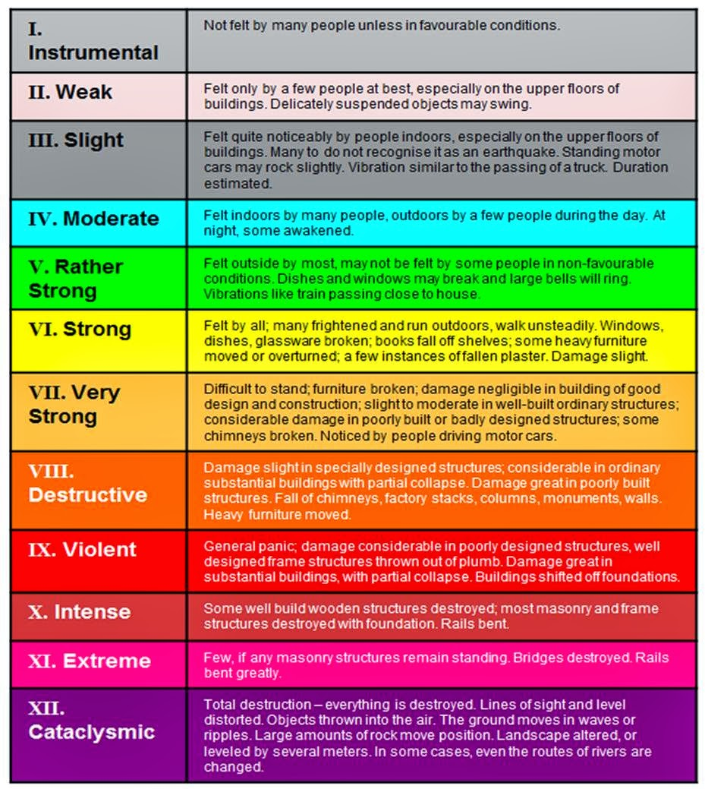

Taking it further

- Does fracking cause earthquakes and should we be worried? Explore news coverage about earthquakes and fracking. The government is apparently keen to develop this technology in large parts of the country. Do you live in a potential area for fracking in the future?
- Have there been earthquakes in your area? Try to find out.
- Explore the latest news from USGS about earthquakes. Make a visual classroom display to post up the latest earthquake information from Quakefeed so that students without smartphones/iPads can understand how frequent they are. Keep an eye on the BGS Twitter feed too for more local quakes.
- Hold an earthquake drill in your class, similar to the Great California Shake-Out. This is an annual drill which involves millions of people. Sound files and other useful information can be downloaded from: http://www.shakeout.org/ Also look for the New Zealand version.

This activity would be a good opportunity to revise and revisit terminology relating to seismology.

Web links

The British Geological Survey is the best source of information on earthquakes in the UK:
http://www.bgs.ac.uk/discoveringGeology/hazards/earthquakes/home.html

They have a range of downloadable resources and support materials for UK earthquakes at:
http://earthquakes.bgs.ac.uk/

GB Earthquakes map 1970–2012 animated sequence:
http://mapapps.bgs.ac.uk/geologyofbritain/home.html?mode=earthquakes

BGS article about the Blackpool fracking earthquake:
http://earthquakes.bgs.ac.uk/research/earthquake_hazard_shale_gas.html

United States Geological Society have rich resources about earthquakes the world over:
http://education.usgs.gov/secondary.html#earthquakes

Many resources here are suitable for teaching and students own exploration:
http://earthquake.usgs.gov/learn/kids/

Copyright
©EDINA at the University of Edinburgh 2016.
This work is licensed under a Creative Commons Attribution-Non Commercial Licence

Acknowledgements
© CollinsBartholomew Ltd (2019) FOR SCHOOLS USE ONLY
© Crown copyright and database rights 2020 Ordnance Survey (100025252). FOR SCHOOLS USE ONLY.
Aerial photography © Getmapping plc. Contains OS data. FOR SCHOOLS USE ONLY.
Historic mapping courtesy of the National Library of Scotland. FOR SCHOOLS USE ONLY.

