Location, Location, Location Explore different locations within cities

Alan Parkinson

Geography Teaching Resource

Secondary

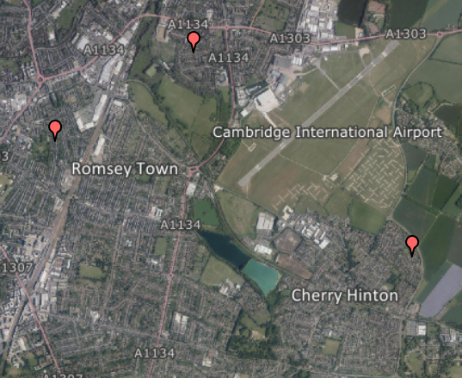

Contents
Contents 2
Digimap for Schools Geography Resources 3
Content and Curriculum Links 3
Summary 4
Introduction 4
Location, Location, Location – Activity 5
Taking it further 8
Web links 8
Copyright 9
Acknowledgements 9

Digimap for Schools Geography Resources
These resources are a guide for teachers to demonstrate to the whole class or direct individual students as appropriate. Each activity has several ideas within it that you can tailor to suit your class and pupils. Some resources contain worksheets for direct distribution to pupils.

Content and Curriculum Links
Level | Context | Location
Secondary | Explore different zones within cities | This activity is located in Cambridge, but can be adapted for other locations across GB

Knowledge/skills | Zoom levels/map interpretation/measurement and routes.
Curriculum Links (England) | Urban land use/map interpretation.
Curriculum Links (Wales) | Use maps, imagery and ICT to find and present locational information.
Scottish Curriculum for Excellence | Social Studies Outcomes: People, Place and Environment: 1.11a, 3.14a, 4.10b-c, 4.14a

Summary
Moving house is an experience many students will be familiar with, or will have seen television programmes about. This activity places them in the role of trying to satisfy the different needs of one family. The student sheet can be used in class or given as homework.

Introduction
There are many different zones of cities, which can be identified in the common land use models. GCSE students will perhaps be familiar with the models of Ernest Burgess or Homer Hoyt.

CC image from Wikimedia Commons: http://en.wikipedia.org/wiki/File:Burgess_model1.svg

Location, Location, Location – Activity
The Griffin family is looking for a house in Cambridge. They have particular requirements that are described on the next sheet. They have narrowed down their search to 3 places that are within their budget. These are in different areas of the city.

- Gwydir Street, Cambridge, CB1 2LL
- Stansfield Road, CB5 8NH
- Lemur Drive, CB1 9XZ

- Locate and mark these three houses using Digimap for Schools. Remember you can view Aerial images with the Map Selector tool.

- Read the description of the Griffin family, and the requirements and preferences of each family member. Using only the information on the map in the first place, decide which house you think would be best for the family.

Things to look for include:
- Proximity to places of interest to members of the family, such as Cambridge railway station and Hills Road Sixth Form College.
- Size of house plot/garden (you can measure this).
- Type of housing; for example, terraced or spread out.
- Places to walk to nearby.
- Anything that might make a house less or more desirable, such as busy roads, or noise from nearby premises.

- They will be living in the house for some time. How suitable will this house be for the Griffins five years from now?

- Use the Drawing Tools to highlight the location of your chosen house to say why you think this would be the best location for the Griffins. Add photographs to support your comments.

Websites
There are many websites and apps that are designed to help people locate the house of their dreams.
Discuss with your teacher which ones you should use for this activity.

The Griffin family
Cambridge is a very expensive place to live and their new house must cost under £450,000 (they would like to spend much less). They aspire to have four bedrooms so that one of them can be an office/spare room, but would settle for a three-bedroomed house if it had good-sized rooms.

Mr Griffin works in London and has to catch the train from Cambridge railway station. He is trying to get fit, and also prefers not to drive to the station as that would cost money for parking and he already pays thousands of pounds for his season ticket. Occasionally he can work from home.
He likes to play golf, and also enjoys taking the family dog for longer walks at weekends along footpaths, and letting it have a run in a public park. He would like to be near some sort of nature reserve, or within reach of open spaces. He is a light sleeper, so would prefer to be on a quiet cul-de- sac or other road that wasn’t too busy.

Mrs Griffin works for an information technology company in one of the out-of-town science parks and always drives to work. This means she can potentially drop off one or both children in the morning, but they need to make their own way home.
She likes watching movies, and often visits the cinema with friends and family. Her mother lives in an area of the city called Romsey Town. It would be very useful to be close to there because her mother does not drive and her help is sometimes needed if John is off school, or if no one else is available to take the dog out.
She likes growing food and would like to have a garden or allotment. She would also like to have a relatively new house because they don’t have much spare time for maintenance and house redecoration.

Sally Griffin is about to leave secondary school and has a place at Hills Road Sixth Form College, which is a successful college near the centre of the city. She would like to be able to cycle there without having to travel along too many busy roads. Her friends mostly live in an area called Newtown.
She has a part-time job in a small café near to Parker’s Piece, a large area of open space to the south east of the city centre, but they only ask her to come in when they are busy. There are more and better part-time jobs in the city centre, but if it takes too long and is too expensive to get there then they won’t be worthwhile.

John Griffin is 10 and he and Mr Griffin support Cambridge United. They go to every home match so he would like to live somewhere close to the ground. He does not mind moving primary school as he would rather live close to school and have friends nearby. His best friend lives in an area of the city called Newnham Croft. He likes skateboarding and would like to be near a park so he can walk the dog there after school. His other hobby is fishing.

Taking it further
- Create a local version of this resource, and/or create a different fictional family who might be on the hunt for their perfect property.
- You might also suggest that it is Mr Griffin who has the ‘final say’ or perhaps it is Mrs Griffin, or the children?
- You could add extra details to the description, so that students consider where the family looks to for shopping, entertainment and so on, which will enable them to study the way that the edge of cities like Cambridge changes as the land use moves slowly from urban to rural. This rural-urban fringe is another interesting area to study: the ‘edgelands’ of cities are changing fast.
- Further information, such as bus routes in Cambridge, details on house price change over time, location of schools and retail premises can all be obtained using appropriate web searches.
- Ask students to fast forward and imagine that they are at a need to find a rented property themselves close to a new job. What geographical criteria are now most important to them and how is this different to the needs of a typical family?

Web links
It is suggested that you provide a list of preferred websites for the students to use when researching potential properties.

- Property websites such as https://www.rightmove.co.uk/ are a rich information source and permit click-through to Google Street View.
- Over 5 million photographs are available at http://schools.geograph.org.uk/
- You can also use the Image Search tool in Digimap for Schools to find Geograph images. Enter your search terms to find matching images. NOTE: you can enter an asterisk to see all available images at a location (only in the 5 most zoomed in maps).
- Find out more about the suggested locations using Zoopla https://www.zoopla.co.uk/

Copyright
©EDINA at the University of Edinburgh 2016.
This work is licensed under a Creative Commons Attribution-Non Commercial Licence.

Acknowledgements
© CollinsBartholomew Ltd (2019) FOR SCHOOLS USE ONLY.
© Crown copyright and database rights 2020 Ordnance Survey (100025252). FOR SCHOOLS USE ONLY.
Aerial photography © Getmapping plc. Contains OS data. FOR SCHOOLS USE ONLY.
Historic mapping courtesy of the National Library of Scotland. FOR SCHOOLS USE ONLY.

