Mr Postman

Alan Parkinson

Geography Teaching Resource

Secondary
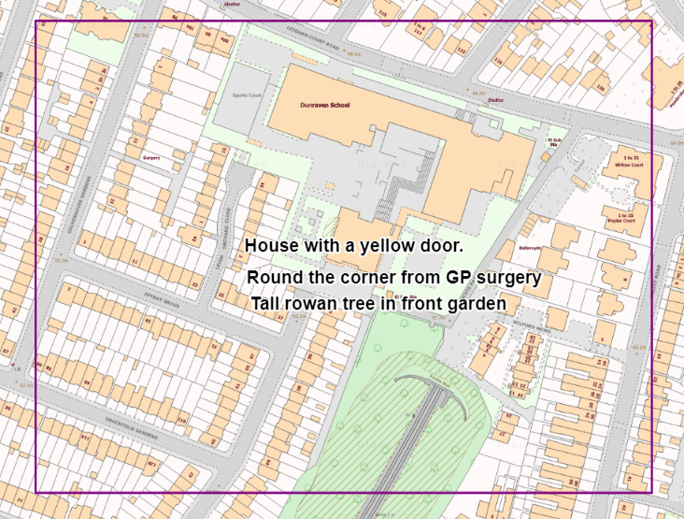

Contents
Contents 2
Digimap for Schools Geography Resources 3
Content and curriculum links 3
Activity 4
Introduction 4
Main activity 5
1. Start by finding your school and home 5
2. Add the address box 5
Changing drawings 5
3. Add Text 6
4. Mark school and route 6
5. Create an envelope 7
Taking it further 8
Copyright 9
Acknowledgements 9

Digimap for Schools Geography Resources
These resources are a guide for teachers to demonstrate to the whole class or direct individual students as appropriate. Each activity has several ideas within it that you can tailor to suit your class and pupils. Some resources contain worksheets for direct distribution to pupils.
https://digimapforschools.edina.ac.uk/

Content and curriculum links
Level | Context | Location
Secondary | This activity involves creating ‘map envelopes’ | Any location

Knowledge/Skills | Zoom levels/drawing tools
Curriculum links (England) | Map skills
Curriculum links (Wales) | Locate places and environments using globes, atlases, maps and plans. Use maps, plans and imagery of different types and scales and ICT to interpret and present locational information.
Scottish Curriculum for Excellence | Social Studies Outcomes: People, Place and Environment:

Activity
Students will explore zoom levels on a map, and create a label for an envelope. While doing this they will be exploring their home area and finding their house. Look in Google images for ‘Klauss Flugge envelope’ to find examples.

Introduction
Pupils will be creating an envelope which has the route to the recipient added on, but described instead of providing the address.

This activity uses the Drawing tools to identify the location of an address that a letter is to be delivered to, and produce a box which includes the description. This will then be printed out and turned into an envelope using the template that has been provided.

The intention should be to produce a map which shows both the origin of the letter (the school) and its destination.

Main activity

1. Start by finding your school and home
- Enter a postcode (or place name) to find your locations.
- Zoom the map so that both your school and home are on the map.
- Make the map fill the screen if that will help.

2. Add the address box

- You need to add a rectangle to the map.
- Open the Drawing Tools.
- Select Shapes.
- Select a rectangle.
- Under Fill settings, move the slider all the way to the left so your rectangle is transparent.
- Place the rectangle so that your house can still be seen on the map.

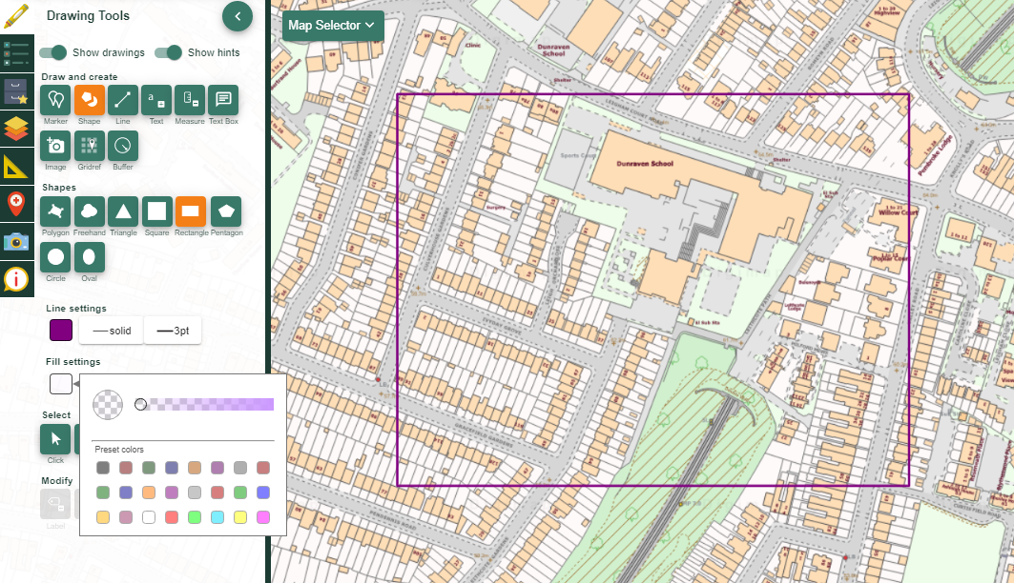

Changing drawings
If you want to change anything you can click on it to select it – once it is highlighted in yellow you can change.
To move a drawing, just click and drag to the new location. Make sure the Select arrow is highlighted before you move.
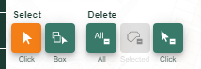

Add Text
- Select the Text tool.
- Write a description of your house which doesn’t include the actual name/ street but provides enough of a description for it to be found by someone.
- Set your text settings, choosing colour, font and size of text.
- Click in the rectangle to place the text.
- Enter your text in the pop-up box and click save.
- You will need to add the address one line at a time as there is a length limit on the label of 30 characters maximum.

The description of your house could include:
- Distance and direction from a landmark.
- Description of the house – what makes it stand out from others on the street?
- Particular features in the street or garden.
- Could count along from a particular point for example, the third streetlight, the tallest tree, the second blue gate.

4. Mark school and route
- Add a marker to the school location and give it a label. Choose a suitable colour and style from the outline options and then select ‘Draw a Line’. Mark the route back to your house, clicking to change direction. When you double-click at the end the line will change to your selected colour and style.

An example postcard that was produced is here:

5. Create an envelope

- Print out your map at A4. Make sure the ‘address’ is large enough to be readable. Cut out the map so that it covers most of one of the envelope sizes below. If you have an old envelope, stick it on the front to make a new one.
- See the ENVELOPE SIZES image below for the various envelopes that people use:

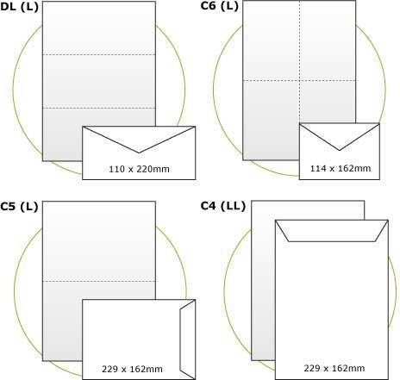

Taking it further

1. If you want to make the map print itself into an envelope you may have to modify your map to get the address in the right place.

2. Put some of these envelopes in the post and see if they arrive!

Copyright
©EDINA at the University of Edinburgh 2016
This work is licensed under a Creative Commons Attribution-Non Commercial Licence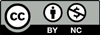

Acknowledgements
© CollinsBartholomew Ltd (2019) FOR SCHOOLS USE ONLY
© Crown copyright and database rights 2020 Ordnance Survey (100025252). FOR SCHOOLS USE ONLY.
Aerial photography © Getmapping plc. Contains OS data. FOR SCHOOLS USE ONLY.
Historic mapping courtesy of the National Library of Scotland. FOR SCHOOLS USE ONLY.

