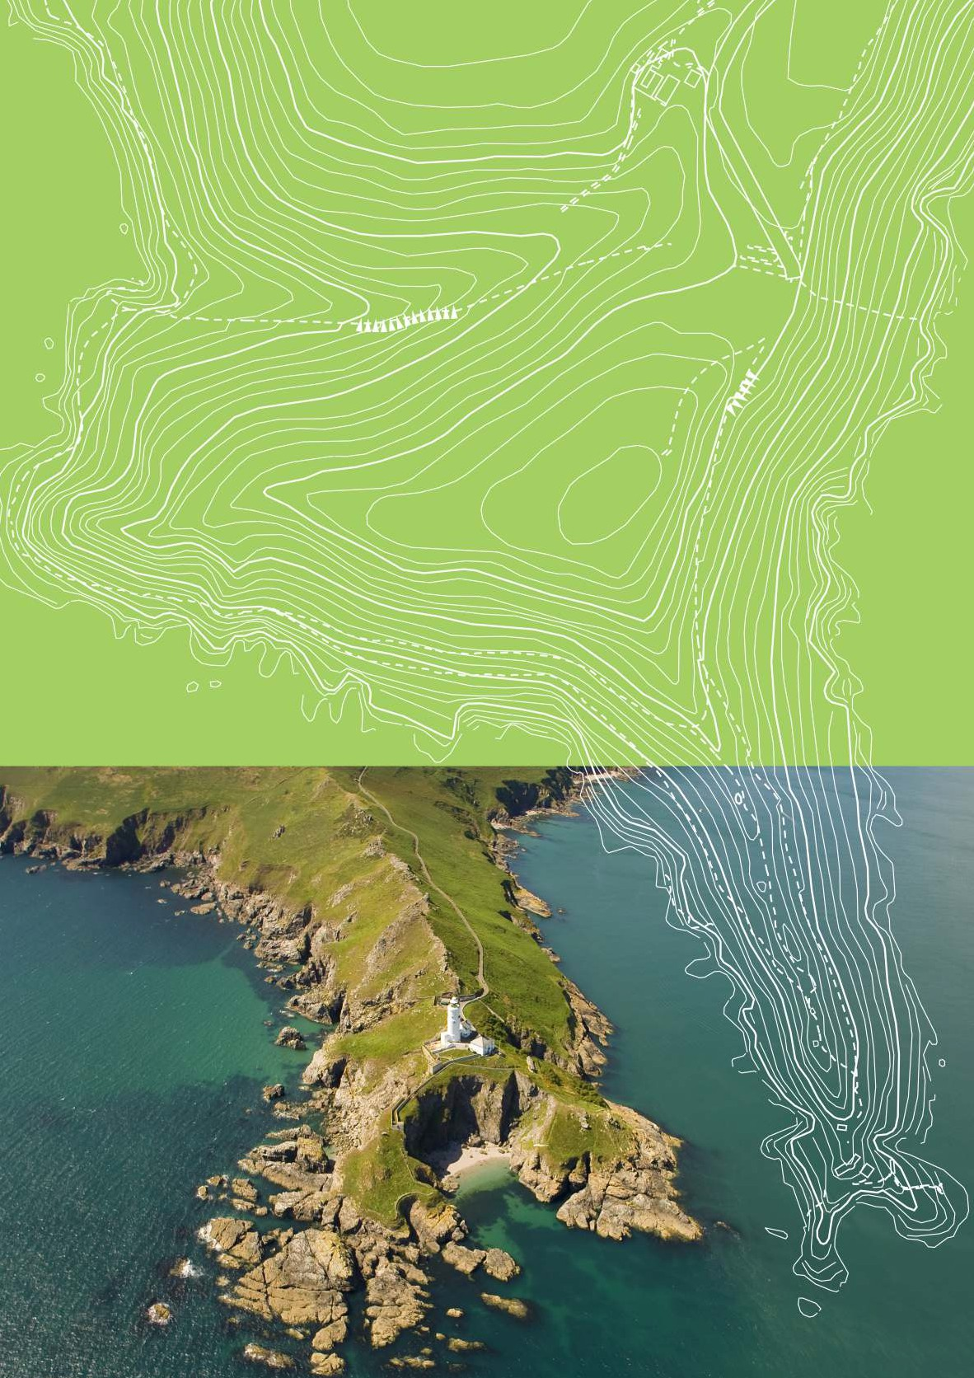

KEY STAGE 3 GEOGRAPHY

PLANNING FOR PUPIL PROGRESS.
by David Gardner

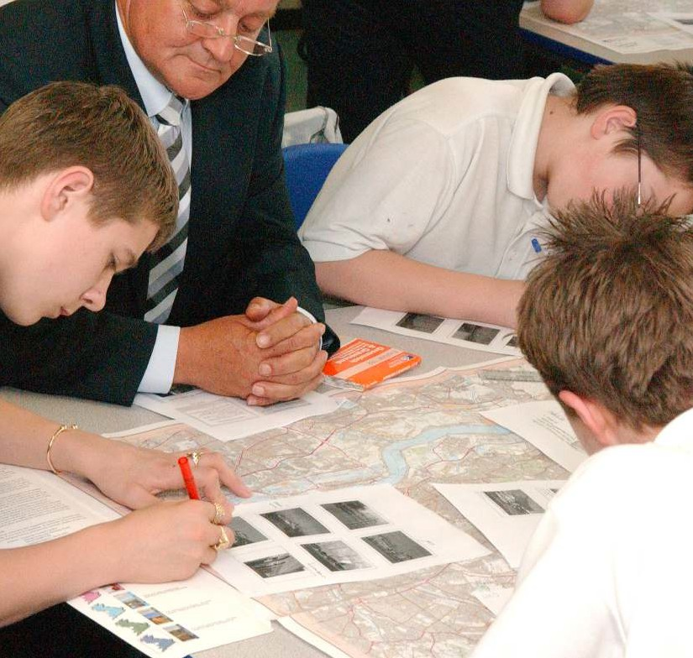
PLANNING FOR PUPIL PROGRESS IN THE USE OF ORDNANCE SURVEY MAPS
Key Stage 3 Geography

All weblinks in this document can be found at www.os.uk/teachinginformation

The new National Curriculum for Geography for September 2014 provides the ideal opportunity for schools to reflect on current practice and plan for the future.

National Curriculum Geography Programme of Study (England)
The National Curriculum for Geography aims to ensure that all pupils:
Using OS maps progressively from Key Stages 1 to 3 is really important if pupils are to achieve all aspects of these aims.
The Key Stage 3 Geography programme of study includes the following reference to maps:
- develop an understanding of social and physical characteristics and processes within the context of significant areas of the world.

Geographical skills and fieldwork
- build on their knowledge of globes, maps and atlases, and apply and use this knowledge routinely in the classroom and in the field
- understand the processes behind key physical and human geographical features, how these are interdependent and how – and why – things differ from place to place on the surface of the earth.
- interpret Ordnance Survey maps, including using grid references and scale, topographical and other thematic mapping, and aerial and satellite photographs
- are competent in the geographical skills needed to:
  - collect, analyse and communicate
information gathered through fieldwork
  - interpret the likes of maps, diagrams, globes, aerial photographs and Geographical Information Systems (GIS)
  - communicate geographical information in a variety of ways, including through maps, numerical and quantitative
skills and writing at length.
- use Geographical Information Systems (GIS) to view, analyse and interpret places and data
- use fieldwork in contrasting locations to collect, analyse and draw conclusions from geographical data.1

1 http://www.ordnancesurvey.co.uk/docs/education/national-curriculum-geography-ks3.pdf
3

Evidence of poorly developed map skills at KS3

As in previous versions of the national curriculum, use of Ordnance Survey maps is clear and prominent, and yet successive OfSTED reports for geography state that in many schools, pupils’ map skills are poorly developed.

OfSTED inspections of geography in a wide range of schools has identified a significant issue in the use of maps:
“Mapwork skills continue to be poorly developed. It is not uncommon for students to be unfamiliar with Ordnance Survey maps. Maps are a basic tool of geography but students admit to being uncomfortable reading maps and have little
opportunity to use maps in lessons. In far too many schools, map use is limited to specific examination requirements, rather than the progressive development of these specific geographical skills.”
Geography: a fragile environment? Leszek Iwaskow Teaching Geography Summer 20132
Poorly developed mapwork skills and specific examination requirements were also highlighted in the 2011 OfSTED geography report:
“Students weren’t given opportunity to develop real competence in map skills. They were expected to understand places and issues but they did not know where the places were, what they were like or the characteristics of their landscapes.”
Geography : learning to make a world of difference Feb 2011, 37 3
Teaching pupils how to read and interpret different types of OS maps is a fundamental aspect of geography teaching.
It would appear, however, that a significant number of schools do not plan for pupil progress in the use of OS maps. In many schools pupils are introduced to OS maps in an initial unit of work in Key Stage 3
geography lessons. The basic skills of direction, compass points, scale, measuring distance, map symbols, four and six figure grid references, representation of height on maps – spot heights, contours, describing routes are introduced and tested.
While pupils can locate places using six-figure grid references there is little learning opportunity in the rest of Key Stage 3 for pupils to put these skills to good use in studying different places.
Often the next time pupils use OS maps is as part of a GCSE course. As OfSTED identifies this is a wasted opportunity and undermines pupils’ understanding of places.
It is clear that a more progressive use of maps would
be hugely beneficial for pupils. This guide offers a progression framework of mapping skills and knowledge for learners aged 11–14. Use it to help pitch planning appropriately and to help assess learning.

2 http://www.ordnancesurvey.co.uk/docs/education/geography-fragile-environment.pdf
3 http://www.ordnancesurvey.co.uk/docs/education/geography-learning-to-make-a-world-of-difference.pdf

4

What are you trying to achieve?
1

The aims in the new national curriculum
are a good starting point.
The Geographical Association manifesto for geography, A Different View also makes a compelling case for the subject’s place in the curriculum. It encourages the development of pupils who can think geographically.
“‘Living Geography’ brings school geography alive – children and young people ask questions about and investigate their own world.”
http://www.geography.org.uk/resources/adifferentview/
The GA explains that curriculum making is the creative act of interpreting a curriculum specification or scheme of work and turning it into something coherent, challenging, engaging and enjoyable.
Curriculum making is a job that really never ends and lies at the heart of good teaching.
This process is explained at: http://www.geography.org.uk/cpdevents/curriculum/ curriculummaking/curriculummakingexplained
At Key Stage 3, pupils need to develop basic
skills to support their investigation of places and themes. Designing a curriculum designed to create sophisticated geographers needs to start with supporting pupils to gain and develop map skills.
In 1997 Dr. Susan Hanson assembled a distinguished group of North American geographers to write about 10 important geographic ideas that changed the world.
The introduction to the book provided useful insights into what geographers do and how they think.
She believes geographers don’t just want to know ‘where’ and what the spatial pattern looks like, but why they happen where they do.
The answer often lies in a map. She explains that the geographic mind wants to see the big picture, is not content with unrelated fragments, and wants to grasp how pieces fit together in place. The map, she believes “can provide this synthesizing framework – a touchstone of geography.”
“Show any geographer a map, and she is immediately immersed in relationships and connections.”
The ten ideas outlined in the book are:
- The map
- The weather map
- GIS
- Human adjustment of physical systems e.g. flood management
- Water balance
- Human transformation of the earth
- Interdependence
- Central Place Theory
- Megalopolis
- A sense of place
10 Ideas That Changed the World, edited Hanson, S 1997 Rutgers
University Press

5

People’s fascination with maps should not be underestimated. Many people collect antique, vintage and quirky maps. Old school hanging maps are sold in trendy designer furniture stores, and maps on gifts and homewares are proving increasingly popular.
“When I looked at maps before I was really confused but now I’ve learned about it I understand it ...it has taught me about symbols and stuff”. Girl, Rugby.
Maps help quench people’s thirst for knowledge about places. Mike Parker in his book Map Addict sums it up well in his introduction: “Maps not only show the world, they lubricate its easy movement. On an average day, we consult them dozens of times, often almost unconsciously; checking the AA road atlas or the satnav, scanning the tube and bus map, doing a quick search online…..watching the weather forecast; visiting a theme park or stately home, conference centre or industrial estate, catching up on the news, booking a holiday or a hotel.”
“Being able to read maps gives you freedom... helps you find out about places, where you are, stops you getting lost ...opens up the world”.
Girl, Crown Hills
“It’s helped me like looking at other maps... helped me to learn how to use them ...about map reading”. Girl, Lenzie Academy.
Ramblers, walkers, cyclists and tourists are all avid users of OS maps, many of the resources provided on the OS website caters for their needs. This fascination can be stimulated in the geography classroom
“Map reading is really important ...cos when you leave home you’ll know how to do it and everything cos you won’t have your mum and dad to help you. Yeah, it’s really important ... it helps you get around ...it’s a real skill”.
Girl, North Leamington.
and built upon to explain how and why maps and spatial data are used by so many organisations and businesses today.
In May 2006 the University of Northampton published research findings for the Ordnance Survey of the Free Maps for 11-year-olds scheme.
This provided extensive evidence of how using the maps stimulated an interest in places and wider use of maps.
“It’s been good in developing our skills for now and for when we are older”.
Girl, William Parker.
“It kind of makes you more eager to look at
other maps”. Boy, North Leamington
“Say you never learned map reading, that would be something that limits you in your future life? Before I used to look at maps and sort of left it away, and now that I understand them look at more different places and
what surroundings are so it makes me more
interested to visit different places”.
Boy, Lenzie Academy.
“Yeah...before I didn’t really look at maps, but now I look at them ...before I used to think it was too big and I wouldn’t understand it...when I got this I could actually look at it and [I now realise] it only takes you a few minutes to find
...what you’re looking for ...it’s much easier than I thought”. Girl, North Leamington.

“When we got the maps I never knew ...how to find something...but it has certainly got easier... Before I used to look at maps and it sort of left me cold ...now I understand them ...it makes me more interested to visit different places”.
Girl, Crown Hills.
“I discovered new places...I know that sounds really stupid but...you are looking at it and you think to yourself, oh I have never been there before and I will go and check it out like”. Girls,
William Parker School.

Interestingly the main critical message to emerge from focus groups with teachers at pilot schools was that the momentum and impact of the Free Maps scheme was lost by the end of Key Stage 3, because of a shortage of opportunities to embed maps in the geography curriculum (coupled with a dwindling uptake of Geography GCSE).
“The consequence of the National Curriculum though is that things happen there in Year 7 and then they don’t happen again. It means they forget all about it!” Teacher.
“It’s great...a Government department giving out these free resources but does the curriculum allow them to be used to their maximum potential?” Teacher.
These two quotes would seem to be symptomatic of a larger problem. It is not a consequence of the National Curriculum that maps are only used in Y7.
The national curriculum programme of study is just a statement of what should be taught and learnt. It is
for teachers to bring this statement to life with a clear vision of what they are trying to achieve for young people.
Margaret Roberts in her book Geography Through Enquiry makes the following observation regarding the failure to embed use of maps through KS3 units of work:
“Many geography courses devote a lot of time when students start secondary school teaching map skills….What I find astonishing is that they emphasize the importance of these skills but then fail to make much use of them when investigating themes and places. In my experience as external examiner for PGCE courses I have rarely seen information on maps used as evidence, in spite of their relevance to what was being studied ...If the skills are not used for several years, such as six-
figure grid references, then students will forget how to use them. If skills are not applied in meaningful contexts students are less likely to perceive their value”
In December 2013 Ofsted updated their Generic grade descriptors and supplementary subject-specific guidance for Geography for inspectors on making judgments during visits to schools. This document is an invaluable tool to support the curriculum-making process.
http://www.ordnancesurvey.co.uk/docs/education/ofsted-geography- survey-visits.pdf
The document outlines how greater attention should be paid to the use of maps and in particular locational knowledge. As part of the outstanding description for quality of teaching OFSTED state the following :
“Maps, at a variety of scales, are used frequently as a matter of routine and are an intrinsic part of
learning in geography. This ensures that pupils have good spatial awareness and are very secure in their ability to locate the places they are studying.”
The progression framework outlined here has been developed to support the use of maps “as a matter of routine” in Key Stage 3 Geography lessons, as “an intrinsic part of learning in geography”.
There are many opportunities to develop map-work skills. It can be done in isolation, or can be integrated into other work to enhance skills. Units of work on farming or settlement, for example, lend themselves to using Ordnance Survey maps in this way.

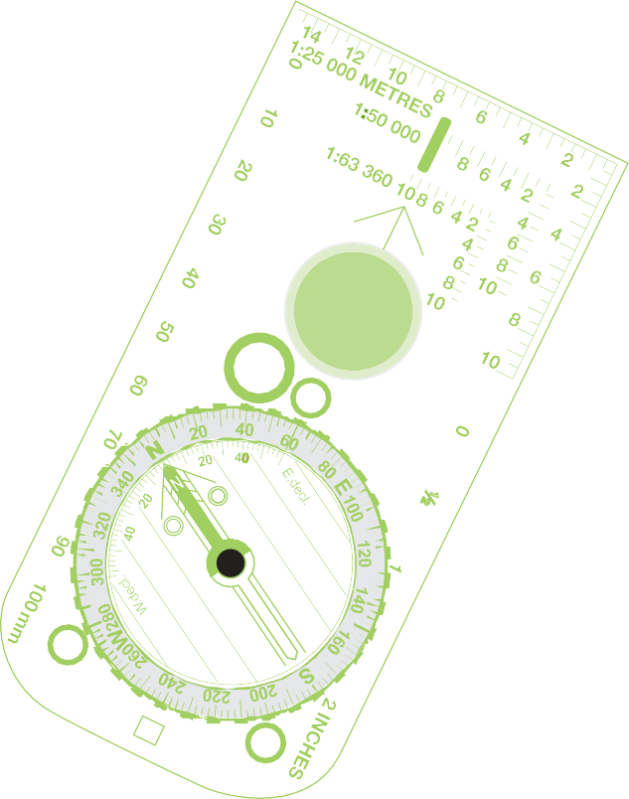

How will you organise learning?
2

Planning for progression in Key Stage 3 Geography

You know what you want pupils to have achieved at the end of Key Stage 3 and are now ready to consider how to organize appropriate learning.
Many schools create a key stage 3 plan which basically provides a list of topics to be covered over three years. As the extract below illustrates, more thought needs to be given to planning a coherent and challenging experience for pupils enhanced with a richness in resources:
“When the teaching was no better than satisfactory, an emphasis on covering content did not encourage active learning and, as a result, students’ geographical skills were often underdeveloped.
Teachers did not make enough use of maps and fieldwork to progressively build up students’ skills in gathering data, analysis and interpretation. In far too many classes there was an over-reliance on text books, especially by non-specialist teachers. The result was frequently work that occupied rather than
engaged students. In just over half of the schools visited, a narrow range of textbooks and a focus on factual recall rather than on exploring ideas failed to capture students’ interest. Higher-attaining students, in particular, were rarely challenged.”
Geography: learning to make a world of difference Feb 2011, p26
http://www.ordnancesurvey.co.uk/docs/education/geography-learning-
to-make-a-world-of-difference.pdf
The Qualifications and Curriculum Authority, the former government QUANGO responsible for the curriculum produced a definition of a Key Stage plan that is still valid today “It draws parts of
the programme of study together into coherent,
manageable teaching units. It shows how these teaching units are distributed across the three years of the Key Stage in a sequence that promotes curriculum continuity and progression in pupils’ learning.”
http://webarchive.nationalarchives.gov.uk/20090608182316/ http:/standards.dfes.gov.uk/schemes2/secondary_geography/ teaching?view=get

Appendix 1 of the QCA Geography scheme of work Teachers’ guide provided two useful tables still of great relevance in planning for progression:

 | From |  | To
Vocabulary | using a limited geographical  vocabulary |  | precise use of a wider range of  vocabulary
knowledge of places | geographical knowledge of some  place |  | understanding of a wider range of  areas and links between them
Patterns and processes | describing geographical patterns and  processes |  | explaining geographical patterns  and processes
Geographical thinking | participating in practical geographical  activities |  | building increasingly abstract  models of real situations
Geographical explanation | explaining events and phenomena in  terms of their own ideas |  | explaining these in terms of  accepted ideas or models
Investigation | unstructured exploration |  | more systematic investigation
Map skills | using simple drawings, maps and  diagrams to represent geographical  information |  | choosing and using a wide range of  conventional maps, diagrams and  graphs
Fieldwork | guided practical activities in the field |  | working independently outside the  classroom

Some questions to ask when planning for progression | What is known about what pupils have already achieved at Key Stage 2 and how does this affect the pitch of early units? | How are pupils who have some competence or expertise beyond the levels expected in particular years challenged?
 | What ideas in Geography depend on secure understanding of other ideas? | Is there sufficient challenge in Year 7,  Year 8 and Year 9?
 | How can units be sequenced so that earlier work lays the foundation for later work? | Are appropriate expectations made of pupils in their use of language, number and ICT?
 | Are there opportunities to revisit and reinforce the ideas pupils need to understand and which some will find difficult? | Does the programme present a coherent experience of Geography for those who leave the subject at the end of Year 9?
 | When ideas are revisited or reinforced, is it in a different context or using different activities? | Does the programme adequately prepare pupils who continue to study Geography at Key Stage 4?

The Geographical Association makes the following statement to support planning for pupil progress, on the National Curriculum pages of its website:
“Geography benefits from a spiral approach to curriculum - revisiting places and topics in ways that build depth of knowledge and understanding. The following broad ‘dimensions’ of progress can be helpful when thinking about planning and assessment:
- Getting used to less familiar topics
- Having greater fluency in ‘world knowledge’
- Working with increasingly complex and/or abstract ideas and generalisations
- Using data that could have variable outcomes
- Investigating the link between people and environment
- Applying geographical thinking to new contexts and situations
- Becoming more precise (in language, ideas, skills), and making distinctions
- Becoming more comfortable with ‘grey areas’ where answers are not so clear cut
- Connecting information and ideas, and building (not just receiving) new knowledge
- Drawing on increasing breadth of content and contexts
- Understanding the importance of perspective, recognising a range of values and views”
http://www.geography.org.uk/news/2014nationalcurriculum/ ks3planningforprogress/

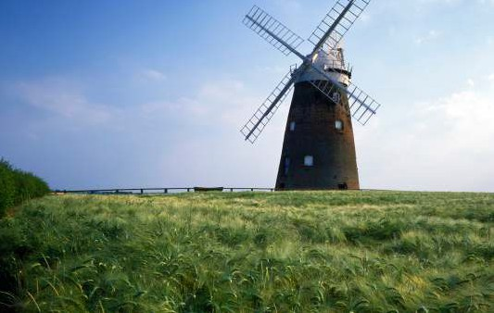

The following diagram, developed by the Geographical Association to support the implementation of the 2007 National Curriculum, also provides points to consider in planning for pupil progress across your Key Stage 3 Geography curriculum.
How do you plan for progression?
Year 7 ▶
Topic 1
Topic 2
Topic 3
Topic 4
Topic 5
Topic 6
Which concepts are being showcased?
Which skills are being taught & reinforced?
Is progression built in? If so, how?
Year 9 ▶
Topic 1
Topic 2
Topic 3
Topic 4
Topic 5
Topic 6
Which concepts are being showcased?
Which skills are being taught & reinforced?
Is progression built in? If so, how?
▶
▶
▶
▶
▶

Year 8 ▶
Topic 1 | Topic 2 | Topic 3 | Topic 4 | Topic 5 | Topic 6
Which concepts are being showcased?
Which skills are being taught & reinforced?
Is progression built in? If so, how?

The new National Curriculum has prompted many teachers to review their Key Stage 3 curriculum.
Simon Renshaw and Rebecca Aston, Heads of Geography at Soar Valley College in Leicestershire, made the following points about developing progression in the use of OS maps.
“Prior to the 2007 curriculum, our first year 7 unit was an introduction to Geography and map skills, which aimed to develop students’ capacity to read and use Ordnance Survey (OS) maps. When planning our 2007 curriculum, we decided a more engaging introduction to Geography would be desirable, so we replaced it with a student-led enquiry into the local area. This featured some map use, but focused on supporting students in developing their own enquiry.
Our intention was that OS map skills would be built into the various learning sequences across Key Stage 3, but we felt on reflection that this approach had not
secured the foundation for a transferable base of OS map skills. With this in mind, our 2014 programme of study will include an enquiry into land use in Leicester explicitly developing OS map skills during year 7.
We hope this will lay a solid foundation of OS map skills, but the intention will still be for map skills to be featured at every available opportunity in Geography lessons. A subscription to Digimap for Schools, the subscription OS map service, is going to greatly assist in this regard!”
Rebecca Aston, Simon Renshaw, Planning a new Key Stage 3 Teaching Geography Summer 2014 p64-65 (this article provides an outline of their KS3 plan)

Curriculum opportunities created?
Range and content covered?
Skills taught and reinforced?
Concepts showcased?
Progression built in?

http://www.ordnancesurvey.co.uk/docs/education/planning-new-ks3-aston-renshaw.pdf

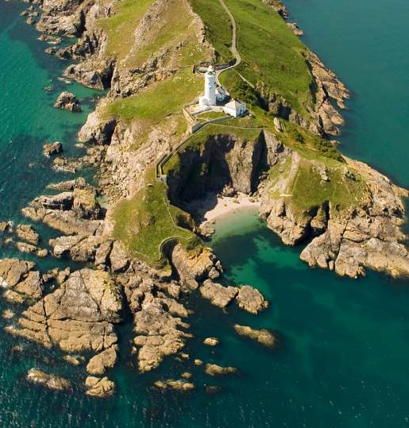
When planning the use of maps in her new Key Stage 3 plan, Kirsty Cook from The King’s School, Pontefract, also looked at progression and attainment by the end of the key stage, asking: What does good progression look like? and: How will we measure it?
Attainment targets are linked to a student’s ability to interpret and use a variety of maps. To clarify how they could develop students’ knowledge and confidence they produced the table below.

Above: Use of maps at Key Stage 3 Geography,
King’s School.
“This was helpful in getting us to think about progression and developing our students’ abilities to interpret different maps at a variety of scales and in different contexts.””
Kirsty Cook, Planning a new Key Stage 3
Type of map | Year group | Topic/purpose
Climate maps | Year 8 | Students analyse and create a global map showing world climate zones, and link to ocean currents.
Economic or resource maps | Year 7 | Students analyse a resource map of Africa (atlas) to identify/think about  which countries might be ‘resource-rich’.
Physical maps | Year 7  Year 8 | Students analyse and use physical maps of the UK and Africa. Students analyse physical maps of Brazil and Iraq.
Political maps | Year 7  Year 8 | All topics as intro to, and locations of, from national to international scale.
OS maps | Year 7  Year 8 | Use 1:25 000 OS map of Pontefract area to complete a murder mystery task. Y8 use a 1:10 000 street view of Pontefract to create Ponte- opoly game.
Topographical maps | Year 7 | OS map Pontefract and designing a car rally.
Topological maps | Year 8 | Use of Worldmapper maps of world military  expenditure for example in  ‘The geography of conflict’.
Google maps, Google Earth and atlases | Year 7  Year 8 | Use google maps and Google Earthn on our IWB. Atlases are also used regularly.

Teaching Geography, Spring 2014, p16-17

http://www.ordnancesurvey.co.uk/docs/education/planning-new-ks3
-cook.pdf

Planning for progression in mapskills

Record your starting point

If your primary feeder schools have developed map skills as part of Key Stages 1 and 2 your new Year 7 students should already be able to do the basics, but you will need to find out. This is why many secondary schools have a skills unit of work at
the beginning of Year 7. Paula Owens has produced a progression framework for map skills for primary schools. It will be useful to look at this and ensure early in Year 7 that your pupils have a good grasp of the skills outlined here.

 | Using and interpreting | Position and orientation | Drawing | Symbols | Perspective and Scale | Digital map making
Year 5 & Year 6 | I can relate maps to each other and to vertical aerial photographs.  I can follow routes on maps  saying what is seen. | I can use four and six-figure coordinates to locate features. I can give directions and instructions to 8 cardinal points.  I can align a map with a route.  I can use latitude and longitude in an atlas or globe. | I can make sketch maps of an area using symbols and key.  I can make a plan for example, garden, play  park; with scale.  I can design maps from descriptions.  I can draw thematic maps for example, local open spaces.  I can draw scale plans. | I can use agreed and Ordnance Survey symbols. I appreciate maps  cannot show everything.  I can use standard symbols.  I know 1:50.000 symbols and atlas symbols. | I can use a range of viewpoints up to satellite.  I can use models and maps to talk about contours and  slope. | I can find  6-figure grid references and check using the Grid Reference Tool.  I can combine area and point markers to illustrate a theme.  I can use maps at different scales to illustrate a story or issue.  I can use maps to research factual information about locations and features.  I can use linear and area measuring tools accurately.
 | I can use index and contents  page of atlas. |  |  |  | I can use a scale bar on all  maps.
 | I can use thematic maps for  specific purposes. |  |  |  | I can use a linear scale to  measure rivers.
 | I know that purpose, scale, symbols and style are related. I can appreciate different map projections.  I can interpret distribution maps and use thematic maps for information.  I can follow a route on 1:50 000 Ordnance Survey map; I can describe and interpret  relief features. |  |  |  | I can describe height and slope using maps, fieldwork and photographs.  I can read and compare map scales.  I can draw measured plans for example, from field data viewpoints up to satellite.  I can use models and maps to talk about contours and  slope.
I can use a scale bar on all
maps.
I can use a linear scale to
measure rivers.
I can describe height and
slope using maps, fieldwork
and photographs.
I can read and compare map
scales.
I can draw measured plans for
example, from field data.
More Able Year 6 | Work confidently with: Large scale street maps and large scale Ordnance Survey maps (1:1250. 1:2500); aerial photographs, oblique and bird’s eye views, games with maps and globes, Ordnance Survey maps 1:1250, 1:2500,1:10 000, 1:25 000. 1:50 000 four and six-figure coordinates.  Have experience: of a range of different maps for example, tourist brochure, paper and digital maps, storybook maps, atlases, Ordnance Survey paper and digital maps at different scales, six- figure coordinates.  Introduce: what six figure Grid References mean and how to  calculate them. |  |  | Suggested Digimap For Schools Activities Fantasy Maps  Weather Warning! Coastal Mysteries Landscape Poetry Lighthouse for Sale My Top Tourism Trail  It’s a Rubbish Footprint!  Extreme GB  Map Detectives
 | Context: a range of places at different scales and with different themes, fieldwork in the wider and distant locality. |  |  | Emergency Rescue!
See also Mapping our Globe http://www.geography.org.uk/resources/mappingourglobe/#top
Think pieces and Resources Making Maps http://www.geography.org.uk/gtip/thinkpieces/makingmaps/#786
http://digimapforschools.edina.ac.uk/schools/Resources/Primary/progression_in_mapping.pdf

Curriculum making
The Key Stage 3 planner outlined below is a useful device to support your curriculum making process. It can be used by a geography department to consider how to plan for pupil progress. It can be used as a starting point before evolving schemes of work to develop students that can think geographically and work independently. An evolving version provided
here has focused on planning for progression in OS maps and interpretation. You can download a blank version of this planner from the teaching resources page of the OS website to use in your department to develop a KS3 curriculum to suit the needs of your learners in your local context.
http://www.ordnancesurvey.co.uk/docs/education/ks3-geography-planner.pdf
13
Key Stage 3 Geography Planner |  |  | The three aspects of pupil achievement in the National Curriculum | Contextual world knowledge of locations, places and geographical features |  |  |  |  | Understanding of the conditions, processes and interactions that explain geographical features, distribution patterns, and changes over time and space |  |  | Competence in geographical enquiry, and the application of skills in observing,collecting, analyzing,evaluating and communicating geographical information |  | Judgements could be expressed and recorded as, ‘working towards’ ‘meeting’ and ‘exceeding’ the expectations for their age or whatever system is in place in your school.
 |  |  | By the age of 14 pupils should : | Have extensive knowledge relating to a wide range of places, environments and features at a variety of scales, extending from local to global |  |  |  |  | Understand the physical and human conditions and processes which lead to the development of, and change in, a variety of geographical features, systems and places. They can explain various ways in which places are linked and the impact such links have on people and environments. They can make connections between different geographical phenomena they have studied |  |  | Be able with increasing independence to choose and use a wide range of data to help investigate, interpret, make judgements and  draw conclusions about geographical questions, issues and problems, and express and engage with different points of view about these.
Year | Term | Time | Theme/enquiry question | Local | Region | UK | NC area | Global | Physical geography process – landform | Human geography process | Physical human interaction | Geographical skills – mapwork | Fieldwork | Key Assessment opportunity

9

8

7

 | By the age of 11 pupils should : | Have a more detailed and extensive framework of knowledge of the world, including globally  significant physical and human features and places  in the news | Understand in some detail what a number of places are like, how and why they are similar and different and how and why they are changing. They know about some spatial patterns in physical and  human geography, the conditions which influence those patterns, and  the processes which lead to change. They show some understanding of the links between places, people and environments. | Be able to carry out investigations using a range of geographical questions, skills and sources of information including a variety of maps, graphs and images. They can express and explain their opinions, and recognize why others may have a different point of view.
‘Ordnance Survey’ and ‘OS’ refer to Ordnance Survey, Britain’s mapping agency. Ordnance Survey Limited is a company registered in England and Wales, Registration Number 09121572; Registered Address: Explorer House, Adanac Drive, SOUTHAMPTON, SO16 0AS. D12557_KS3 Planner

KS3 Planner focusing on progression in map skills

Year | Topic | Map skills – developing spatial awareness & locational framework
7 | Making connections/ local area/ map skills audit | Fieldwork in the school grounds – pupils survey site using 1:2500 OS and aerial photograph of  the school – plot key buildings and areas around the school.  From a vantage point draw a fieldsketch of the school in its surrounding area.  Benchmark basic mapskills – direction,scale, symbols, measuring distance, relief, four & six figure grid references, describing a route.
 |  | 1:50 000 and 1:25 000.
 |  | Atlas – continents & oceans, latitude & longitude.
 | Rocks, weathering & soils | Understanding of landforms related to geology map of UK.  OS map 1: 50 000– developing understanding of contours investigating chalk escarpment features – annotate features on a print out of a map, and quote evidence in a write up using grid references.
 | Population & settlement | Atlas UK population distribution related to relief map, and rivers.  OS road atlas activity to develop UK locational framework.
World distribution of population related to physical maps – relief, rivers, climate and
ecosystems.
 |  | OS map 1:50 000 – site, shape of settlements impact of relief – pupils either annotate features on a map print out or draw sketch maps to show factors influencing settlements – write up findings quoting locations on maps using grid references.
 |  | OS map 1:50 000 – site, shape of settlements impact of relief – pupils either annotate features on a map print out or draw sketch maps to show factors influencing settlements – write up findings quoting locations on maps using grid references.
 |  | Decision making activity for the local area – data sheets provided for pupils with 3 locations for a new housing estate or supermarket – OS maps at a variety of scales for each location, photos, aerial and ground, views of different people. Pupils use the data to determine best location.
 | Hydrology | Atlas and Road Atlas activity to develop locational knowledge of UK rivers.
 |  | OS map activities for river features eg v shaped valley, meanders, flood plain, ox-bow lakes, river mouth – linking maps to ground and aerial photos – annotate maps and photos used together showing river features. Pupils describe river features quoting evidence from the maps using grid references.
 |  | draw cross sections 1:50 000 or 1 : 25 000 across stages of river valley – pupils compare these with annotated maps and photos.
 |  | Atlas activity on world rivers.
 |  | Flooding eg Somerset levels or more recent flood investigate maps at a variety of scales to identify why area likely to flood.
Introduction to GIS – use of Environment Agency flood website – identify potential for flood in
local area.
 | Russia | Compare the area size of Russia to UK.
 |  | Use of Google Earth to investigate Russia.
Atlas and globe activity – time zones comparing physical and human maps of Russia to
describe and explain geographical patterns.

Year | Topic | Map skills – developing spatial awareness & locational framework
8 | Economic activity | Farm study – fieldwork – use of OS map to draw fieldsketch to show site and situation of the  farm.  Large scale plan of fields and farm buildings for pupils to plot land use.  Maps also used to investigate soil types and impact on land use across the farm.  Pupils present land use patterns on maps as part of enquiry follow up to fieldwork.
 | Glaciation | OS map interpretation of glacial erosion features in area of UK eg Lake District or Snowdonia comparing maps with aerial, ground, satellite photographs. Draw sketch maps to identify features and how they are formed eg corries, arêtes, U shaped valleys, also identify patterns of features to consider the movement of valley glacier.
 | Weather & climate | Micro climate fieldwork in the school grounds plotting data on OS map – potential to develop use of GIS to identify and explain spatial patterns of micro climate, applying understanding of principals of weather.  Use of weather satellite images and data logging.  Atlas maps to describe and explain UK climate patterns, and world patterns.  Use of weather maps –synoptic code – identify passage of depression and anticyclone.  Draw and interpret climate graphs for place around the world.
 | Natural resources | Atlas maps – location of natural resources at a variety of scales UK to global.  Case studies of exploitation of natural resources on places using OS maps, aerial photographs  and satellite images.
 | Coasts | OS map interpretation of coastal landscapes, features, erosion and depositional features – describe and explain using maps, ground and aerial photographs.  Decision making activity – locating coastal defences using range of data for a location  including OS maps, photos.
 | Africa | Use of Google Earth to investigate Africa.  Atlas and globe activities, GIS – physical and human maps of Africa to describe and explain  geographical patterns.

Year | Topic | Map skills – developing spatial awareness & locational framework
9 | Development | Use GIS to investigate world data including use of Gapminder and Worldmapper. Topologically transformed maps.
 | Asia | Use of Google Earth to investigate Asia.  Atlas and globe activities– physical and human maps of Asia to describe and explain geographical patterns.  GIS to investigate geographical patterns.
 | Fieldwork  enquiry | OS maps of variety of scales, and range of data collection techniques to investigate a contrasting locality to the school. Elements of independent enquiry for more able. Use of Maps to present data and analyse patterns.  GIS investigation of a local issue.
 | Plate tectonics | Atlas and globe activity on world distribution of volcanoes, earthquakes and fold mountains  to develop understanding of plate boundaries.  Use of satellite images and aerial photography to investigate impact of volcanic eruption or  earthquake on area before and after event.  How do people adapt to volcano – case study of people living near a volcano – draw a cross-  section across a volcano – annotate how people use the slopes eg Mount Etna.
 | Climate  change | Use of maps at a variety of scales to investigate impact of climate change.

Pedagogical approaches to Geography teaching at KS3, with OS maps
What are you trying to achieve?

“Our pupils have good spatial awareness and are very secure in their ability to locate the places they are studying.
How do we organize learning to achieve this?”
Maps, at a variety of scales, are used frequently as a matter of routine and are an intrinsic part of learning in geography.

What are the implications for pedagogy in geography ?

The Geographical Association points out that the enquiry approach to learning is at the heart of curriculum making in geography. It evokes the subject’s rich heritage of exploration and discovery.
Margaret Roberts (2003) has shown how this approach contains four central aspects including the creation of a ‘need to know’ through the use of
an engaging stimulus. It then develops through the collection and use of data, processing and making sense of that data and finally reflecting on learning in order to apply it to future enquiries.
This process has been captured in a single diagram
(adapted from Roberts, 2003).

1
Create a need to know
Curiousity Imagination Questions Identify an issue
2
Use data
Pictures Numbers Text Evidence
maps
OS

Apply to next enquiry
4
Reflect on learning
Skills used Changing opinions
How to make judgements
What other evidence would be useful
3
Make sense of the data
Describe Analyse
Explain Intepret
Compare Clarify
Contrast Speculate

http://www.geography.org.uk/cpdevents/curriculum/curriculummaking/curriculummakingexplained
(This is the source of the diagram, athough you will see that here the GA do not include maps in box 2 use data).

Creating a need to know
The class teacher could introduce OS maps at different scales on a regular basis to demonstrate how places are different. For example, in one lesson a mountainous area of the Lake District could be projected on a screen from Digimap for Schools.
Pupils use the interactive whiteboard to label clues from the map about the area, for example contour lines close together showing steep slopes or roads following the valley floor.
At the beginning of the next lesson a flat area in the Fens could be projected. This is clearly a very different landscape to be interpreted by pupils,
helping them to realise how places are different and
how OS maps show this.

The mystery map activity available on Digimap for Schools could also be used as a starter for lessons
Such activities spark pupils’ natural curiosity about places and maps, and if used frequently map interpretation skills will be developed.
Teachers should also consider the classroom environment. Maps are a pivotal aspect of the subject, therefore the geography classroom should reflect this with maps of a variety of scales on display. These maps should not take on the role of wallpaper, however, pupils should engage in activities which make them use these maps on a regular basis

OS mapwork displays
Classroom displays incorporating OS maps used regularly by pupils as part of planned learning activities is a key way to make maps an “intrinsic part of learning in Geography.”
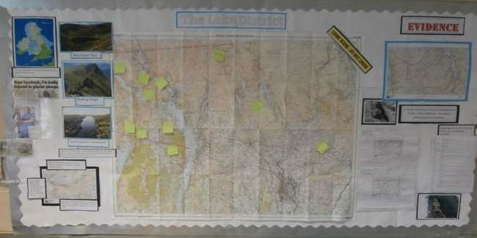

Example 1. PGCE Geography Goldsmiths University Trainee Emma Fearnley

PGCE Geography Goldsmiths University Trainee Emma Fearnley attempted to do this as part of her second school experience at Adey and Stanhope school in London, as she explains:
“The OS map display was a method of enriching students’ understanding of the landscape in the Lake District and how it was created through glaciation. The OS maps of the area were integrated
into students’ class work as a method of ensuring progress in the use of maps and map interpretation. The display was a constantly developing format that meant students could display their work, interact with a large OS map and see a visible path of understanding through the module.

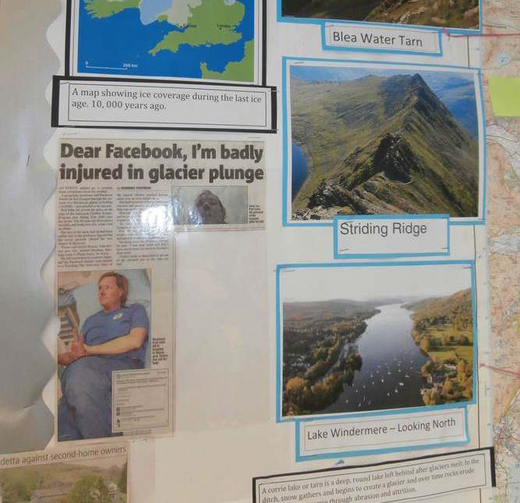
The display began as a map and a title and in each lesson more information was added - including students’ work. Each lesson students were told a clue about a murder that had happened in the Lake District. The lesson would involve them solving the clue and interpreting sections of OS maps, with the outcome being another section of glaciation understood.
On several occasions students would be searching for landforms, which correlated with those given to them individually, and marking them on the large OS map on the map on the wall. Using an OS map of the Lake District meant that students could forge a link between the ice age and the landscape in 2014, developing a deeper understanding of the physical processes that shaped the landscape and linking that to current uses and pressures on the environment.”

Example 2. Ladea Michelsen, Goldsmiths University trainee
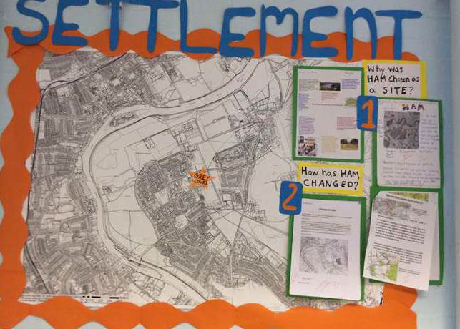
“During my PGCE placement at Greycourt School I planned, prepared and taught a scheme of work on Settlements. The scheme of work aimed to build up the students’ learning in using OS maps, annotating photographs and carrying out local fieldwork -all of which culminated in an extended piece of writing on the environmental quality of the local area around the school. During this scheme of work the use of OS maps at different scales was integral throughout class work and homework. OS maps were also integrated through the use of a display which developed as the scheme of work progressed.
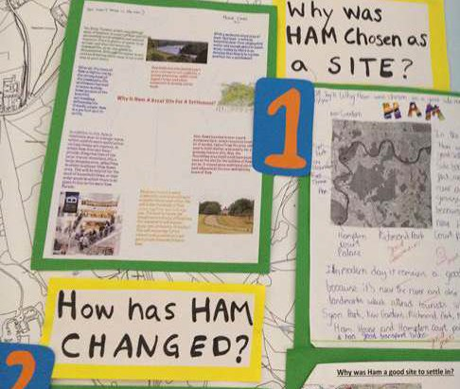
The students’ best classwork and homework was displayed and mapped out across the large OS map as the background of the display. However, the OS map was far from wallpaper, outlining the learning journey the students were making and allowing them to see the ‘bigger picture’ mapped out as the students came to write up their fieldwork.
The OS map display allowed the successful integration of OS maps into classroom practice, motivated the students and also allowed for the learning journey to be illustrated. It charted what the students had completed throughout the scheme of work and therefore what was expected from them to draw upon in their fieldwork writing, which was used as the end of unit assessment.”

Use data
Margaret Roberts has written a challenging article for trainee teachers: ‘What makes a geography lesson good?’, which explores the key elements of a good geography lesson and how to judge them.
She believes that every geography lesson should contain some geographical data. “I see secondary geographical data as the ‘real stuff’ of the subject,
the evidence we use to make generalisations and judgements.”
“I have observed many lessons in which there have been no representations of the world for students to study, no geographical data, indeed no evidence.”
Locational contexts
“I think that what is studied in geography lessons should be located and placed within a wider context. Places, regions, countries and continents do not exist in isolation but are interconnected. The location of what is

studied in relation to other places is significant.
“I rarely see atlases, globes or wall maps used. Locational knowledge of continents, oceans, countries, cities, deserts, etc, enables us to place new information into a wider context. I would not argue for the rote learning of this information but students can be expected to know the locations of places they are studying and their significance. If this done for every unit of work, they will gradually build up meaningful contextual knowledge.”
What makes a Geography lesson good?
Margaret Roberts
Based on a lecture given at the 2011 GA Annual Conference
This view clearly chimes with OfSTED’s believe that maps are an intrinsic part of learning in geography.

Make sense of the data
This is at the heart of learning in geography. It is really important that teachers provide significant opportunities for pupils to interpret geographical data, for themselves through discussion, written work or annotating maps and images to describe and explain geographical patterns.
Use of Ordnance Survey maps is a vital aspect of this enquiry approach. They provide real geographical

data for pupils to make sense of in geography lessons. Maps should be used in conjunction with other resources that illustrate place such as photographs and satellite images. It is also important that pupils get the opportunity to zoom through the scales of map to see this locational context, which can be done with ease using Digimap for Schools

How are OS maps used in everyday life – Living Geography

Maps are used by people for work and leisure. They are an important tool to support everyday life.
They help:
- Planners to decide where a new road or a new housing estate should be built.
- A home-delivery pizza company trying to make sure that our pizza gets to us whilst it is still hot.
- The police to plan a raid on houses used by a group of drug dealers.
- Tourists trying to get across London by tube train or across a large city by bus.
- Cyclists out on their mountain bikes trying to find a
way over a large hill.
- Motorists planning and following a route for a car journey.
- The Army to plan an attack on an enemy town.
- Young people at a theme park trying to find the
new ride that they have seen advertised.
- A supermarket using data and GIS to track the catchment area and requirements of its customers.
It is important that in geography lessons these real life applications of maps and GIS are embedded in teaching and learning to bring learning to life and demonstrate the importance of maps to pupil’s lives now and in their futures.

http://www.ordnancesurvey.co.uk/docs/education/what-makes-a-geography-lesson-good.pdf

How well are you achieving your aims?
3

You should plan ‘reflection points’ when you assess your pupils’ progress towards developing map skills and, as a result, what you should do next. You will need to determine how frequently you do this, and identify assessment opportunities in your Key Stage 3 planner. Short-term steps forward in developing map skills will require termly tracking.

Use the evidence you collect to answer two questions:
- What progress have your learners made towards achieving their goals?
- What action needs to be taken to improve their progress?
When constructing the department’s plan for KS3 and developing schemes of work it is important that you plan for assessment using maps providing opportunities for pupils to demonstrate what they know, understand and can do. It will be useful to construct a framework for using maps to support pupil progress towards your department’s shared vision of KS3 achievement.
The Geographical Association have developed subject specific guidance for teachers of geography for setting up a system for assessing without levels.
It outlines what it means to make progress in geography, providing age-specific expectations for 7, 9, 11 and 14 years. These can be used to inform planning and support the development of mark schemes and other good assessment practice.
You can download this guidance – http://www.geography.org.uk/news/2014nationalcurriculum/ assessment/
The Geographical Association have also published a new edition of their book Assessing progress in your Key Stage 3 geography curriculum, which provides an excellent introduction to approaches to assessment without levels.
This guidance on planning for pupil progress with Ordnance Survey maps links directly to the GA’s age specific expectations.

Bibliography
Aston.R, Renshaw.S, Planning a new Key Stage 3 Teaching Geography Summer 2014 p64-65
Cook.K Planning a new Key Stage 3 Teaching Geography, Spring 2014, p16-17
Geographical Association. A different view – a manifesto for Geography
Hanson.S edited (1997) 10 ideas that changed the world, Rutgers University Press
Iwaskow.L (2013) Geography: a fragile environment? Teaching Geography Summer 2013
http://www.Geography.org.uk/Journals/Journals.asp?issueID=83
Northampton University (2006) Mapped Out Free maps for 11 year olds,
overview of findings 2000-2006
OfSTED (2011) Geography : learning to make a world of difference
http://www.ofsted.gov.uk/inspection-reports/our-expert-knowledge/ Geography
Parker.M Map Addict 2009, Collins
Roberts.M (2013) Geography through Enquiry, GA
Roberts.M (2011) What makes a Geography lesson good ? GA website

Weblinks
Ordnance Survey resources
Digimap for schools http://digimapforschools.edina.ac.uk
A series of utube videos you can embed in your lessons on map skills http://www.youtube.com/user/OSMapping
The teacher resource section of Mapzone includes a useful guide of activities on basic map skills
http://www.ordnancesurvey.co.uk/docs/leaflets/map-reading-made-easy-
peasy.pdf

Using the National Grid
http://www.ordnancesurvey.co.uk/resources/maps-and-geographic- resources/the-national-grid.html
Free resources and videos about map skills includes a range of excellent outline maps of Great Britain
http://www.ordnancesurvey.co.uk/resources/maps-and-geographic- resources/outline-maps.html
Map symbol flashcards – great to develop understanding of symbols
http://www.ordnancesurvey.co.uk/education-research/teaching-
resources/map-symbol-flashcards.html

Twig
Film and resources about the Ordnance Survey and mapping http://www.twig-world.co.uk/films/ordnance-survey-maps-1585/ Geograph http://schools.geograph.org.uk
An online collection of photographs for every OS grid square
Alan Parkinson has produced a fact sheet http://digimapforschools. edina.ac.uk/Resources/allstages/using_geograph.pdf on the Digimap for Schools website on how to use Geograph http://schools.geograph.org.uk
An online collection of photographs for every OS grid square.

Key Stage 3 Geography Planner |  |  | The three aspects of pupil achievement in the National Curriculum | Contextual world knowledge of locations, places  and geographical features |  |  |  |  | Understanding explain geogra over time and s
 |  |  | By the age of 14 pupils should : | Have extensive knowledge relating to a wide range of places, environments and features at a variety of scales, extending from local to global |  |  |  |  | Understand the which lead to t geographical fe various ways in have on people between differ
Year | Term | Time | Theme/enquiry question | Local | Region | UK | NC area | Global | Physical geogr process – land

9

8

7

‘Ordnance Survey’ and ‘OS’ refer to Ordnance Survey, Britain’s mapping agency. Ordnance Survey Limited is a company registered in England and
By the age of 11 pupils should :
Have a more detailed and extensive framework of knowledge of the world, including globally
significant physical and human features and places in the news
Understand in s
and why they ar changing. They human geograp the processes w of the links betw

p
of the conditions, processes and interactions that hical features, distribution patterns, and changes pace |  |  | Competence in geographical enquiry, and the application of skills in observing,collecting, analyzing,evaluating and communicating geographical information |  | Judgements could be expressed and recorded as, ‘working towards’ ‘meeting’ and ‘exceeding’ the expectations for their age or whatever system is in place in your school.
physical and human conditions and processes e development of, and change in, a variety of atures, systems and places. They can explain  which places are linked and the impact such links and environments. They can make connections nt geographical phenomena they have studied |  |  | Be able with increasing independence to choose and use a wide range of data to help investigate, interpret, make judgements and  draw conclusions about geographical questions, issues and problems, and express and engage with different points of view about these.
aphy form | Human geography process | Physical human interaction | Geographical skills –  mapwork | Fieldwork | Key Assessment opportunity

h

e

ome detail what a number of places are like, how e similar and different and how and why they are know about some spatial patterns in physical and  hy, the conditions which influence those patterns, and hich lead to change. They show some understanding  een places, people and environments. | Be able to carry out investigations using a range of geographical questions, skills and sources of information including a variety of maps, graphs and images. They can express and explain their opinions, and recognize why others may have a different point of view.
Wales, Registration Number 09121572; Registered Address: Explorer House, Adanac Drive, SOUTHAMPTON, SO16 0AS. D12557_KS3 Planner

Ordnance Survey
Adanac Drive, Southampton,
United Kingdom, SO16 0AS.
+44 (0)3456 050505 (General enquiries)
+44 (0)2380 056146 (Textphone)
customerservices@os.uk
www.os.uk

‘Ordnance Survey’ and ‘OS’ refer to Ordnance Survey, Britain’s mapping agency. Ordnance Survey Limited is a company registered in England and Wales, Registration Number 09121572; Registered Address: Explorer House, Adanac Drive, SOUTHAMPTON, SO16 0AS. D12557

