**Ruin the landscape, spoil the view**

Alan Parkinson

**Geography Teaching Resource**

GCSE

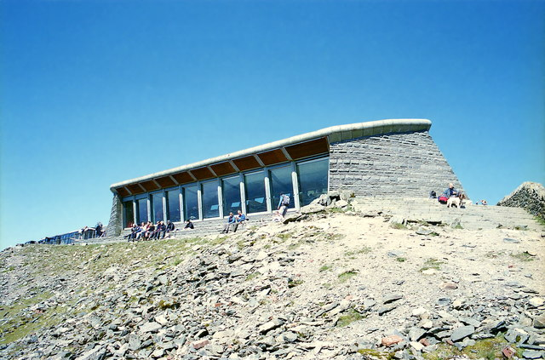

[Hafod Eryri - Snowdon Summit Visitor Centre](https://www.geograph.org.uk/photo/5415588)

**© Copyright**[**Jeff Buck**](https://www.geograph.org.uk/profile/12987)**and licensed for reuse under this**[**Creative Commons Licence**](http://creativecommons.org/licenses/by-sa/2.0/)

# Contents

Contents 2

Digimap for Schools Geography Resources 3

Content and Curriculum Links 3

Summary 4

Introduction 4

Activity: ‘Ruin the landscape and spoil the view’ Snowden café and visitor centre 5

Talking Heads (Snowdon) 6

Cheddar Gorge 8

Talking Heads – Cheddar Gorge 10

Taking it further 12

Copyright 14

Acknowledgements 14

# Digimap for Schools Geography Resources

These resources are a guide for teachers to demonstrate to the whole class or direct individual students as appropriate. Each resource has several ideas within it that you can tailor to suit your class and pupils. Some resources contain worksheets for direct distribution to pupils.

# Content and Curriculum Links

|  |  |  |
| --- | --- | --- |
| **Level** | **Context** | **Location** |
| GCSE | Protecting the scenery to satisfy all interests. | Snowdon, Cheddar Gorge and other scenic places |

|  |  |
| --- | --- |
| Knowledge/skills | Finding places and using drawing tools. |
| Curriculum Links (England) | National Parks, Managing Rural Areas, Tourism, Landscape change issues, appropriate for SDME preparation, Rural rebranding. |
| Curriculum Links (Wales) | Use maps to interpret and present locational information, communicate ideas and information using maps and visual images. Explain how and why places and environments change. How do environments and people interact? |
| Scottish Curriculum for Excellence | Social Science Outcomes: People, Place and Environment. |

# Summary

Snowdon, or Yr Wyddfa as it also known, is the highest peak in Wales. It is in the Snowdonia National Park and a very popular destination for tourists. This activity looks at the facilities available on the peak for visitors and asks students to consider the plus and minus points of the updated summit café; named Hafod Eryri.

At Cheddar Gorge, a second location in Somerset, plans to install a cable car where none currently exists, are having a far harder time gaining acceptance.

Discuss the results in class and explain that this kind of debate is being played out in a number of our most beautiful places, such as Areas of Outstanding Natural Beauty (AONBs) and National Parks.

Many people believe that no new activities (especially those that might draw in large numbers of people, or which require ‘structures’) should be permitted as they will risk permanent damage to the landscape.

Preservation is seen as key. But the landscape is just a snapshot of what it has looked like over the centuries and has come into existence through past human interaction. Refusing further change is the safe option, but what are the risks in keeping things just the same?

# Introduction

* Students will start by gathering information from Digimap for Schools and Geograph to give them a good understanding of the location.
* Students should decide how much they think the Snowdon visitor centre and café does ‘*ruin the landscape, (and) spoil the view*’.
* This remark is now the slogan of the Keep Cheddar Gorgeous protest group who are against the building of a cable car in the gorge. The second part of the exercise is for students to consider if they feel the same way about an attraction that has not yet been built.

# Activity: ‘Ruin the landscape and spoil the view’ Snowden café and visitor centre

1. Identify the location of Snowdon. Explore the different detail of the mountain peak and the area around it at different map scales. Identify the location of the café on the summit.

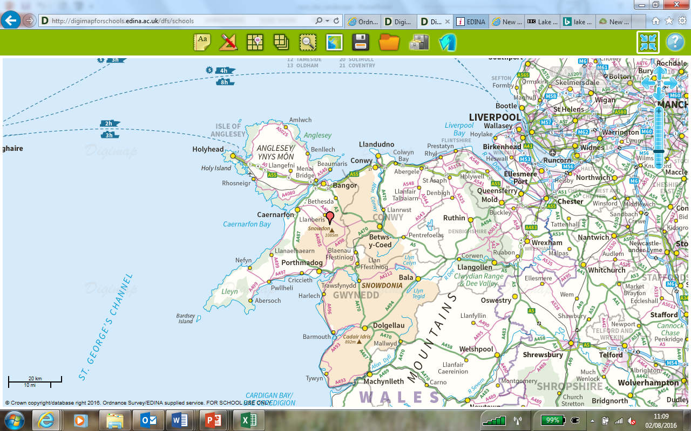

1. Look at some photographs and read about the park using the following links.
   * Visitor centre inside: <https://snowdonrailway.co.uk/summit-visitor-centre/>
   * Unofficial photographs <http://www.geograph.org.uk/article/Snowdon-Snowdonia-National-Park>

The construction of the café was controversial. There had been a structure on the summit for many years, but not everyone was convinced that it should have been there.

1. Use the map, and the Talking Heads to explore the plus and minus points that are identified by the visitors to Snowdon about the presence of the café near the summit.
2. Use the acronym **SPEED** to help you write about it.

* S Social Factors
* P Political Factors
* E Economics Factors
* E Environmental Factors
* D Demographic Factors

image of the acronym SPEED: Social, Political, Economic, Environmental, Demosgraphic

# Talking Heads (Snowdon)

## Tony

I’ve visited Snowdon many times over the last couple years. I enjoy the beautiful scenery and breathtaking views, as well as the challenge of walking to the highest point in Wales, but I’m always left with a distinct sense of disappointment when I reach the summit. I refer of course to the Summit Café: the concrete bunker that blights the mountain.

## Gwyn

As a local, I’m very much in favour of redeveloping the Summit café. I agree that the previous building was looking a little tatty. A public enquiry, involving locals, walkers and tourists were in favour of redevelopment: only a few wanted the building to be removed. Hopefully the contemporary design will continue to act as a further magnet for tourists, providing a much needed boost to the economy in the area.

## Rob

With the redevelopment I feel a sad loss, the original building was designed by Sir Clough Williams Ellis, the creator of the beautiful village of Portmeirion, so a little bit of cultural heritage has been lost, as well as my fond memories of drinking a strong cup of tea at the summit! I’m happy though that the building is to be replaced, future generations need a suitable place to rest their feet, take a drink, and admire the views.

## June

We need to remember that the summit of Snowdon is a major tourist attraction for Wales, so we have to cater for both experienced walkers and those tourists who travel by the train. The ten million pound redevelopment is much more attractive and less dominating of the summit. The building has been designed to be energy efficient and use stone that compliments the natural landscape. Removing the café would cost fifty eight jobs, but the new development will create another twenty. Local workers and contractors are also been used during the construction process.

## Ffion

I’m not worried about the crowds of people in the summer, most of whom arrive via the train, but when I reach the summit, I want to close my mind to the others around me and feel a sense of being the only one there, of being alone in this rugged landscape. Sadly, I can’t manage that with so many people.

## Dennis

As a tourist I’ve always been fond of the Summit Café, though many disliked it, including Prince Charles, who called it the highest slum in the Britain, it brings back found memories of travelling to the summit by train and viewing the beautiful Welsh landscape.

# Cheddar Gorge

Cheddar Gorge has been a tourist destination since the 19th century and the town is faced with the choice of allowing the steady decline of the gorge tourism to continue or agreeing to some development of the gorge. Without tourism Cheddar will primarily become a commuter town for Bristol, albeit with some nice scenery nearby attracting walkers and climbers.

The Longleat Estate controls the south side of the gorge, which includes the world-famous caves and most of the commercial element of the ‘honey pot’ natural attraction. The National Trust owns the north side and has denied permission for the cable car to run over its portion.

The Longleat Estate point out that, unlike the National Trust, a charity eligible for grants, it is a private company that has to generate income to conserve its portion of the gorge. Everybody agrees that the site is run down, but some people suggest this is deliberate to make the plans look more attractive.

## <https://www.bbc.co.uk/news/uk-england-somerset-24472075>

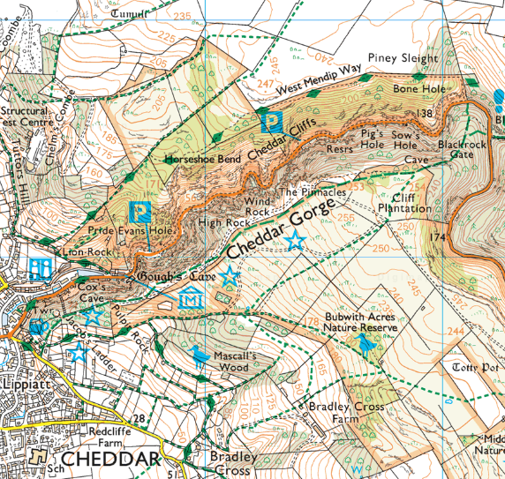

## Summary of the main concerns

1. **Visual impact of top station.** Concern particularly if proposed development includes a sizeable visitor centre/cafe building at the top, especially if visible from the bottom of the gorge.

1. **Visitor parking/traffic.** There are already problems locally on busy days/peak holiday times and concern about existing parking in gorge.

1. **Future of Cox’s Mill.** Considered a real eyesore and that Longleat should not have allowed the building to deteriorate. Urgent short term need to improve its appearance. The building should be included in the future proposals, perhaps as an education centre.

1. **Impact of man-made features spoiling this natural wonder and views.** Some objectors are strongly opposed to any form of man-made intrusion into the landscape; others are more concerned to mitigate any visual and physical impact on the environment.

1. **Access road up to the top.** Further concern that a road would be required during construction and then once the cable car/top station built for servicing and by emergency vehicles.

1. **Creeping development.** View by some that once top station is approved, Longleat will apply for permission for further developments.

1. **Effect on protected wildlife and ecology.** Will the cable car mechanism affect bat flight paths and wildlife generally in relation to additional noise and disturbance?

1. **Effect on footpaths and climbers.** Would the new structures affect cliff access/users such as climbers?

1. **Wider economic benefits.** Uncertainty whether more spend by visitors will just benefit Longleat or will actually benefit all traders/businesses in the village.

# Talking Heads – Cheddar Gorge

## Elizabeth

It is disingenuous to suggest that this cable car is being put forward for the benefit of less physically able visitors. Under the guise of philanthropy, what Longleat Estate plan for Cheddar Gorge is sheer vandalism.

## Simon

Cheddar Gorge is steep in places and ridiculously steep everywhere else. It’s 274 steps to get to the base of the viewing tower. Visitors nowadays expect to be able to get access. If they can’t see the view they won’t (and don’t) come. Visitor numbers have dropped by 90% since the 1970’s.

## Gordon

Looking at this proposal my heart plummets. The circular walk around Cheddar Gorge is so beautiful, so dramatic and yes, so energetic that it is one of my all-time favourite ways to pass an afternoon – at any time of year. The cable car will blight one of our last really natural and awe-inspiring local landscapes. No more will we be able to enjoy the peace and quiet, the echo of the blackbirds in the rain, the feeling of space.

## Trade Association

We would like to see everyone unite together and see Cheddar put fairly and squarely back on the prime tourist attraction map, attracting visitors from all over the world.

## Sam

A quick-fix yet again to earn some quick money, and to direct visitors to a pricey new restaurant to be sited on top of the gorge sometime in the future.

## Helen Bonser-Wilton, assistant director of operations at the National Trust

This is the equivalent of trying to build a cable car in front of Buckingham Palace. Cheddar Gorge is of international importance… It is far better to retain the uniqueness of the place. More could be made done to present the cave better and we could make the whole thing more of a natural experience, more of a wildlife experience.

## Chloe

In almost every family group there will someone who cannot climb the steps. Why should granny have to sit at the bottom, or someone else miss out because they have to mind the baby buggy. No one is suggesting taking the steps away. Those who want the challenge, or to get up there free of charge will still be able to do it. A cable car means everyone can see the views.

# 

# Taking it further

## 1. What if?

Ask your students to imagine that either the Cheddar Gorge cable car or the Snowdon café has been open for 20 years and is now in need of refurbishment that the owners can’t afford. Do they think that local people would campaign to raise funds to save or replace these attractions or would they be happy to see them dismantled? What if these attractions were 100 years old?

## 2. Moors Valley and the New Forest

Moors Valley Country Park is a hugely popular forest and country park. It is situated just outside the New Forest National Park, but people with children often prefer it. As one parent explains:

*“It’s a pity because to get to Moors Valley we actually drive through the New Forest. At Moors Valley there are things round every other corner, sometimes it’s just something simple like some logs for children to climb on, and it keeps them interested and draws them on.*

*In the New Forest there are long stretches with nothing to engage children and they quickly ask ‘how much further’. I don’t understand why the New Forest can’t be just a little bit more like Moors Valley, it’s so much bigger it could absorb lots more people. Surely a few walks could be set out to be a bit more child friendly. There are exciting activities, like rope walks, in both places, but these are too expensive for us.”*

<https://www.moors-valley.co.uk/planning-your-visit/>

<https://www.newforestnpa.gov.uk/todo/>

## 3. No to zip wire in the Lake District

Plans to erect a mile-long zip wire for a temporary period on a Lake District mountain have been rejected. The Lake District National Park Authority (LDNPA) planning committee rejected the proposal for the zip wire at Honister Slate Mine.

Seven members voted against the proposal and four were in favour. The plan would have seen two zip wires built from near the top of Fleetwith Pike following the route of the old Lancaster aerial ropeway. Supporters of the proposal said it would have allowed visitors to return to the base of the mine visitor attraction without damaging the fragile alpine environment on foot.

The LDNPA had previously rejected plans that were presented in 2010, as they felt it would be detrimental to the environment. The proposed zip wire at the mine would have replicated a similar construction that existed there more than 80 years ago. Its reintroduction was the brainchild of Mark Weir, who ran the slate mine at the top of the Honister Pass. Mr Weir died in a helicopter crash close to the mine in March 2011.

Speakers at the LDNPA headquarters in Kendal presented arguments both for and against the new proposal.

Parish councils and Friends of the Lake District were represented and Cumbrian mountaineer, Sir Chris Bonington spoke in favour of its installation. He said that the new scaled down plan was appropriate and would cause very little in the way of noise pollution.

However, National Park planners said there was a ‘fundamental principle’ at stake that the mountain tops were not the right place for such an activity.

<https://www.bbc.co.uk/news/uk-england-cumbria-20890063>

# Copyright

©EDINA at the University of Edinburgh 2016.

This work is licensed under a Creative Commons Attribution-Non Commercial Licence.Creative commons licence, CC BY NC

# Acknowledgements

© CollinsBartholomew Ltd (2019) FOR SCHOOLS USE ONLY.

© Crown copyright and database rights 2020 Ordnance Survey (100025252). FOR SCHOOLS USE ONLY.

Aerial photography © Getmapping plc. Contains OS data. FOR SCHOOLS USE ONLY.

Historic mapping courtesy of the National Library of Scotland. FOR SCHOOLS USE ONLY.