Up North

Identifying and understanding compass directions

Alan Parkinson

Geography Teaching Resource

Secondary
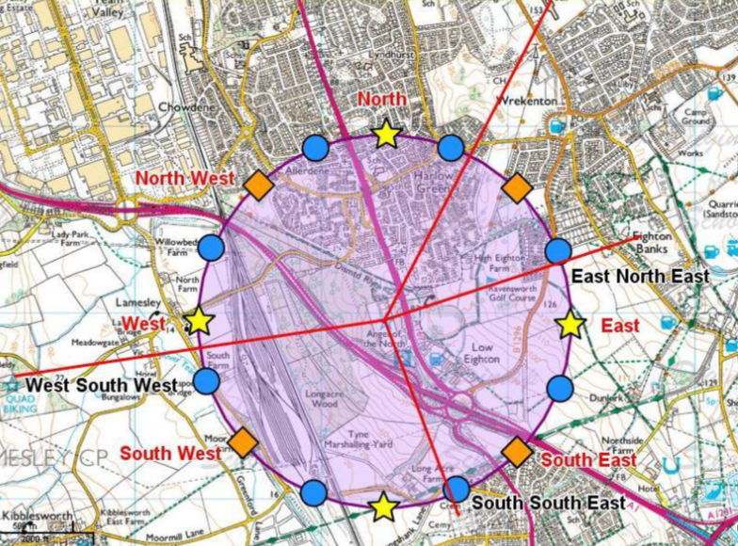
Contents
Digimap for Schools Geography Resources 3
Content and Curriculum Links 3
Introduction 3
Up North – activity 6
Draw your ‘compass’ 6
Find locations 8
The 16 point compass 9
Taking it further 10
Weblinks 10
Copyright 11
Acknowledgements 11

Digimap for Schools Geography Resources
These resources are a guide for teachers to demonstrate to the whole class or direct individual students as appropriate. Each activity has several ideas within it that you can tailor to suit your class and pupils. Some resources contain worksheets for direct distribution to pupils.
https://digimapforschools.edina.ac.uk/

Content and Curriculum Links
Level | Context | Location
Secondary | Identifying and understanding compass directions | Gateshead, but customizable to other locations

Knowledge | Use of measuring tool/use of symbols from Annotation Tool/recap on compass directions on 16 point compass.
Curriculum links (England) | Map skills/local geography – communicating geographical information in a variety of ways.
Curriculum links (Wales) | Locate places and environments and use maps plans and imagery to interpret and present locational information.
Scottish Curriculum for Excellence | Social studies outcomes: people, place and environment: SOC3-14a.

Introduction
Ask pupils to source a map and identify features at a given compass direction from a central point.
This activity uses the Angel of the North but can be adapted to use a school building or a famous local landmark instead.

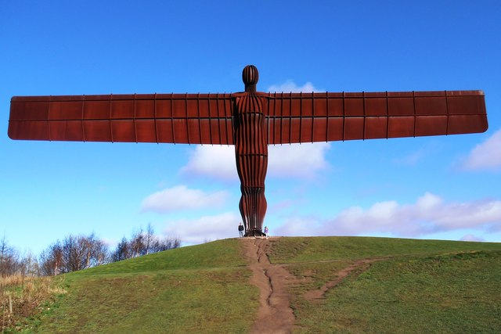
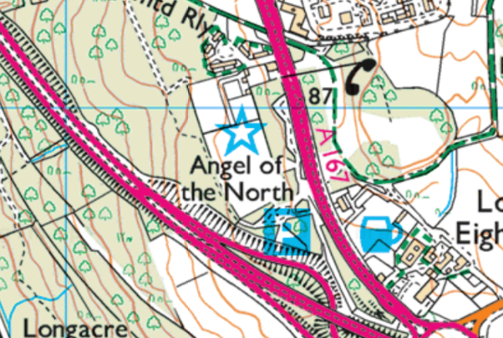
©Copyright Bill Henderson
www.geograph.org.uk

By following the instructions, students illustrate the directions of the classic 8-point compass on a map. They measure distance and direction and then add the intermediate compass points. Students’ maps can be saved in a shared area for checking and/or display to the group. In theory, the maps should all look similar to this example:

Up North – activity
Name:
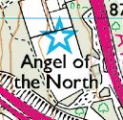
Find the Angel of the North (postcode NE9 7TY). The Angel of the North is an important landmark. It is a sculpture designed by Antony Gormley http://www.antonygormley.com/ , based on his own body, and stands next to the A1 dual carriageway. It can be seen from the road.

Draw your ‘compass’
Open Drawing Tools and select the Point Buffer tool and use it to draw a circle on the map with a radius of 1 km.
There are 15 available marker symbols (the remaining symbols are not applicable to this task). Place the symbols around the circle’s edge in the correct places as indicated in the table.
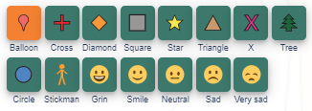

Label each of these markers with the compass point name in a suitable font size.

Symbol | Direction from Angel of the North
 | South
 | North East
 | South East
 | North
 | North West
 | West
 | East
 | South West

Find locations
Use the measurement label tool (in the Drawing tools) to find out the distance from the Angel of the North to each of the locations below.
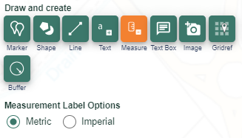

Feature | Distance from Angel of the North | Direction
Moor Mill Farm
Lamesley Bridge
The phone box near the Angel of the North
The start of the word Valley, in ‘Team Valley’
The middle of the footbridge over the A167

The 16 point compass

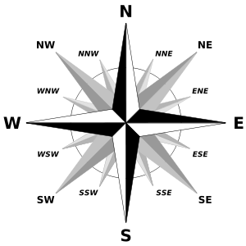

- Look at the top of the flag marking the golf course. What direction is this from the Angel of the North? Does it fit one of the 8 main directions? You can now see why a 16 point compass is often useful. Add in the extra compass points using blue circles.

- Draw lines on your map to the features below and label them with their direction from the Angel of the North. Then identify two other locations on the map and add them to the table.

Feature
The Crematorium in grid square 2,656
Quad Biking
The school north of Wrekenton
Eighton Banks

Taking it further
North is the most ‘important’ direction because compass needles will point north. You may wish to discuss with students the difference between the meaning of ‘compass north’ and ‘grid north’ or show them the Simon King video on this topic (see weblinks).
Discuss why all maps have north at the top. What happens if you change that (see weblinks).
Public art has often had an important navigational role. For example, road distances to London from all over the country were traditionally measured to the statue of King Charles I at the junction of the Strand, Whitehall and Cockspur Street, just south of Trafalgar Square.
Locate public art that is close to your school that provides a navigational landmark (or decide where a good location for a piece of public art might be).

Weblinks
This two minute video tells the inspirational story of a 12-year old Australian school boy, Stuart McArthur who decided that south should be north. www.youtube.com/watch?v=QYuV4eOVz38
Ordnance Survey has a You Tube channel. This link takes you to the four minute Simon King video Know Your Compass:
https://www.youtube.com/watch?v=_ByQuL3HT1E
Information about magnetic north starts just after two minutes into the video.

Copyright
©EDINA at the University of Edinburgh 2016
This work is licensed under a Creative Commons Attribution-Non Commercial Licence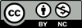

Acknowledgements
© CollinsBartholomew Ltd (2019) FOR SCHOOLS USE ONLY
© Crown copyright and database rights 2020 Ordnance Survey (100025252). FOR SCHOOLS USE ONLY.
Aerial photography © Getmapping plc. Contains OS data. FOR SCHOOLS USE ONLY.
Historic mapping courtesy of the National Library of Scotland. FOR SCHOOLS USE ONLY.

