Crime Mapping

Prevalence of littering on school grounds

Alan Parkinson

Geography Teaching Resource

Secondary

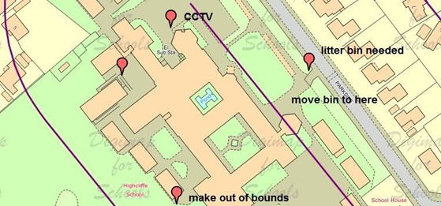

Contents
Digimap for Schools Geography Resources 3
Content and Curriculum Links 3
Activity 4
Introduction 4
Main activity 4
School Crime Mapping 4
Taking it Further 7
Web links 7
Copyright 8
Acknowledgements 8

Digimap for Schools Geography Resources
These resources are a guide for teachers to demonstrate to the whole class or direct individual students as appropriate. Each activity has several ideas within it that you can tailor to suit your class and pupils. Some resources contain worksheets for direct distribution to pupils.

Content and Curriculum Links

Level | Context | Location
Secondary | Crime is a topic which has been added to many secondary-level schemes of work and offers good potential for mapping. | Anywhere in GB

Knowledge and skills
Curriculum links (England) | Interpreting a range of sources of geographical information, including GIS.
Curriculum links (Wales) | Locate places and environments and explain the spatial pattern of features. Responsibilities of being a global citizen.
Scottish Curriculum for Excellence | Social Studies Outcomes: People, Place and Environment: 0.07a, 2.10a, 11.1a, 1.14a.

Activity
This activity introduces the police crime maps and then asks pupils to map the ‘crime’ of littering at their school. Considering the spatial element of crimes can help to provide a solution. Other ‘offences’ could be added or used instead of litter.

Introduction
- Start by setting the scene by discovering the overall crime rate of your area using the website https://www.police.uk/

- Enter the postcode of your school in the ‘What’s happening in your area?’ area.

- Select the Crime Map tab.

- In the dropdown list of ‘All Crime’ it will tell you the number of recorded incidents of crime of various types. If there is a lot of crime, you may want to choose one type, such as ASB (antisocial behaviour).

- Repeat this searching for two other areas within your local area; one in an area where you would expect the crime rate would be low and one in an area where you would expect the crime rate would be high.

- Discuss the possible reasons for the difference, using your own knowledge of the areas. If students are working individually ask them to produce a written summary using no more than 100 words. Choose the ‘Reported in…’ tab to change the month and assess the trend in local crime. Is it going up or down over time? Are these trends apparent from the reporting of crime in the local newspaper?

Main activity
Students should now open Digimap for Schools and follow the instructions below to create a crime map of the school.

School Crime Mapping
You are going to create a map to show where crime is taking place at your school. You may be concentrating on litter, but other ‘offences’ can be mapped as well.
- Open Digimap for Schools and find your school. Zoom in until you can see the most detailed maps.
- Open the Drawing Tools.
- Select the buffer tool.
- Select a point buffer.
- Select a distance of 0.1 km or 0.15 km.
- Click the centre of your school to place your buffer.

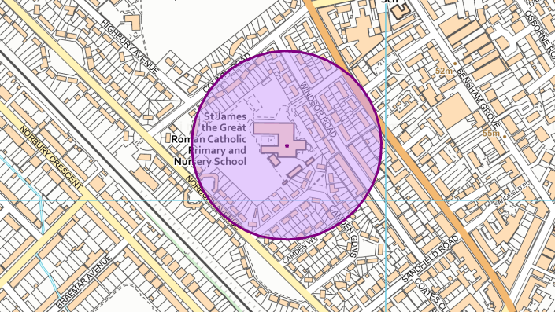

- Using your own knowledge of the school and surrounding streets add symbols to your map to show where you know that students tend to drop litter.
- When dealing with real crimes the police give advice to residents about how they can reduce the chances of crime taking place. The general term that is used when people try to reduce the chance of their property being affected by crime is ‘target hardening’. Examples of ‘target hardening’ include:
  - Fitting an alarm (or a ‘fake’ alarm)
  - CCTV
  - Neighbourhood Watch schemes
  - Good lighting

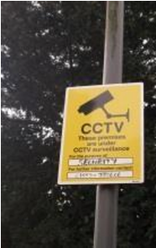

- Decide what could be done to reduce the chances of litter being dropped, or other problems taking place in the places shown on your map. Add comments to show what you think could be done.

Taking it Further
- Tell students that you only have the funding to make three improvements to the school site.
- Which ones do they think you should choose and where should you site them?
- Ask them to create an annotated map to justify this decision.
- Share the above results with the head teacher/person responsible for solving the issue.
- Ask them to give feedback to the class about these ideas.

- Why not imagine the opening of a crime thriller that is set in the area shown on your map; write the first page of the book.

- Produce a report for local community support police officers, or invite one in to school to talk about crime prevention as part of your investigation.

Web links
- Crime data related to locations can be viewed at: https://www.police.uk/
- If you live in London, there is an additional source of information from the Metropolitan Police: https://www.met.police.uk/a/your-area/
- There have been some suggestions that the way that estates are designed to make crime worse. These reports could be used for a unit exploring housing estates on Digimap for Schools and seeing whether any of the design faults are built into them: https://www.designcouncil.org.uk/resources/report/creating-safe-places-live-through-design

Copyright
©EDINA at the University of Edinburgh 2016
This work is licensed under a Creative Commons Attribution-Non Commercial Licence

Acknowledgements
© CollinsBartholomew Ltd (2019) FOR SCHOOLS USE ONLY
© Crown copyright and database rights 2020 Ordnance Survey (100025252). FOR SCHOOLS USE ONLY.
Aerial photography © Getmapping plc. Contains OS data. FOR SCHOOLS USE ONLY.
Historic mapping courtesy of the National Library of Scotland. FOR SCHOOLS USE ONLY.

