Digimap for Schools to support GCSE

Alan Parkinson

Geography Teaching Resource

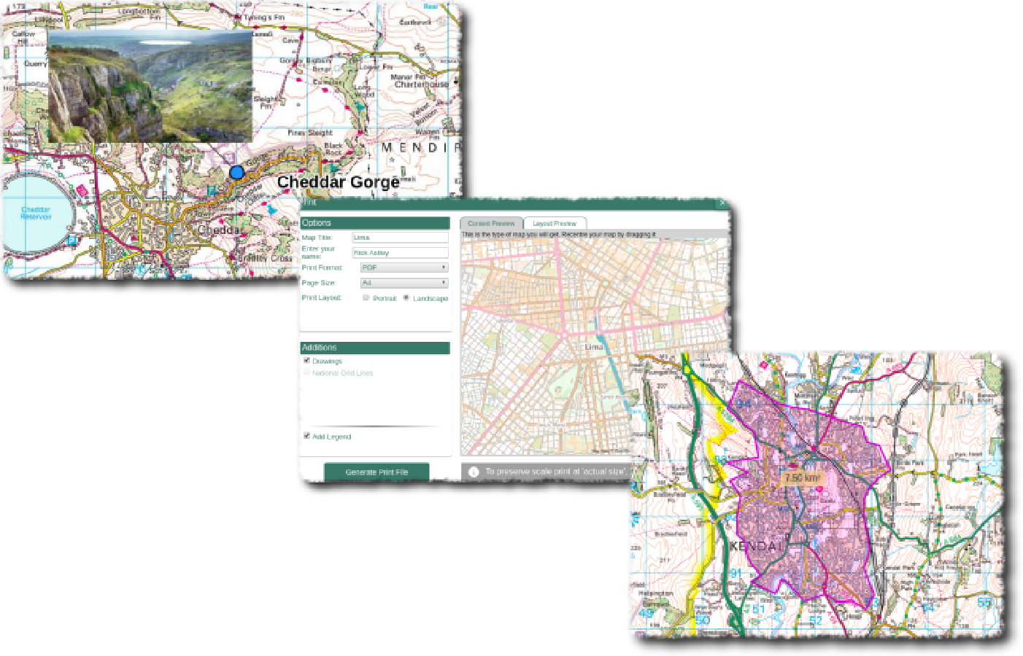
GCSE

Contents
Contents 2
Digimap for Schools Geography Resources 2
Introduction 2
Map skills in the new exam specifications 3
Map Interpretation Skills 3
Place knowledge 4
Physical geography 4
Maps 4
Fieldwork 4
Use of data 4
Controlled Assessments 4
Copyright 5
Acknowledgements 5

Digimap for Schools Geography Resources
These resources are a guide for teachers to demonstrate to the whole class or direct individual students as appropriate. Each activity has several ideas within it that you can tailor to suit your class and pupils. Some resources contain worksheets for direct distribution to pupils.

Introduction
All GCSE specifications were updated ready for first teaching from September 2016. Although there has been significant additional content, and a strengthening of the numeracy requirements, the connection with map skills remains strong. There is broad agreement between specifications on the major reasons why candidates need to access and use OS maps.

Map skills in the new exam specifications

Map Interpretation Skills
Students will need to be able to interpret 1:25 000 and 1:50 000 maps and understand the significance of changing the scale of a map. Skills of analysis, interpretation and evaluation are required.
Common skills that are mentioned in awarding body exam specifications are listed below. (Those highlighted in red could be developed with the aid of Digimap for Schools and its tools).
Students will be assessed on their ability to:
- Recognise symbols (using a key), four- and six-figure grid references, and straight line and winding distances.
- Demonstrate an understanding of direction, using an eight-point compass.
- Demonstrate understanding of the construction of cross-sections.
Contours are marked on the map. Although Digimap for Schools does not offer a cross-section tool, it would allow for the exploration of the heights of land along a straight line placed on the map. Maps can also be printed out at an appropriate scale to enable the manual plotting of cross-section data.
- complete and annotate cross-sections, indicating height and degree of slope and simple contour patterns.
- Recognise and describe patterns of vegetation, land use and communications.
These skills can be developed using the appropriate zoom level. Map keys are provided for each type of map in the service.
- Describe and identify the site, situation and shape of settlements.
- Recognise and describe distributions and patterns of both human and physical features.
- Infer human activity from map evidence, including tourism – tourism is a major feature of Ordnance Survey maps, particularly at the 1: 25 000 scale level.
- Use maps in association with photographs, sketches and written directions. Images up to 10 Mb in size can be added to maps – these can also include images that are made from Excel charts.
GCSE specifications should require students to develop and demonstrate:

Place knowledge
Geography of the UK – in-depth knowledge and understanding of the UK’s geography to include its physical and human landscapes, environmental challenges, changing economy and society, the importance of cultural and political factors, and its relationships with the wider world.

Physical geography
Geomorphic processes and landscape – how geomorphic processes (such as weathering, slope movement and erosion by water, wind and ice) have influenced and continue to influence the landscape of the UK and the interaction of those processes with human activity. This should include detailed reference to some distinctive physical landscapes in the UK (for example, chalk, limestone, glacial, coastal deposition or river valley). The new aerial photography layer will allow students to explore these landscapes in more detail and identify further features which are not marked directly onto the map.

Maps
The use of a range of maps, atlases, Ordnance Survey maps (including historical maps) and other graphic and digital material, including the use of aerial photography, to obtain, illustrate, analyse and evaluate geographic information. To include making maps and sketches to present and interpret geographic information.

Fieldwork
Different approaches to fieldwork undertaken in at least two contrasting environments in order to explore physical and human processes and the interactions between them (for example, city street, beach, woodland, suburban estate, moorland edge). This should involve the collection of primary physical and human data. The ability of Digimap for Schools to be accessed and displayed on a smartphone or tablet means that the tool is of increased benefit for fieldwork, both local and further afield.

Use of data
The collection, interpretation, analysis, presentation, application and evaluation of primary and secondary data. This should include: fieldwork data, GIS material, library and digital sources, visual and graphical data, and numerical and statistical information.

Controlled Assessments
Although there is no longer a requirement for this, many departments will still find the OS mapping and aerial photography useful for other fieldwork related work.

Copyright
©EDINA at the University of Edinburgh 2016
This work is licensed under a Creative Commons Attribution-Non Commercial Licence

Acknowledgements
© CollinsBartholomew Ltd (2019) FOR SCHOOLS USE ONLY
© Crown copyright and database rights 2020 Ordnance Survey (100025252). FOR SCHOOLS USE ONLY.
Aerial photography © Getmapping plc. Contains OS data. FOR SCHOOLS USE ONLY.
Historic mapping courtesy of the National Library of Scotland. FOR SCHOOLS USE ONLY.

