Share your experiences

Digimap for Schools and the John Muir Award.

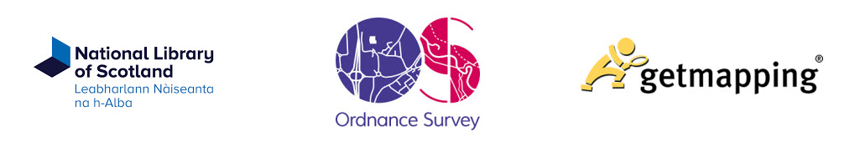

Introduction
Digimap for Schools is an engaging cross-curricular learning resource, widely used in primary and secondary schools in Great Britain.
Our high-quality maps and engaging features help to build pupils’ digital skills while developing their geographic knowledge.
This guide is designed to introduce you to our features and how they can be used to meet a John Muir Award.

Share your experiences
This challenge is a great chance to shout about your learning and achievements. Digimap for Schools can help with map prints and the ability to personalise your maps with symbols, images and shapes. You could add images of your maps on social media.

Contents
Introduction 2
Share your experiences 2
Contents 2
Personalise your maps 3
Sample Drawings 2 5
3D Table map 6
Print 7
Sharing maps 8

Personalise your maps

Add photos
Images of your explorations, conservation work and of everyone involved will really bring your place to life for family and friends. Remember to collect lots of photos of your wild place and the work you do there. Add these to your maps in Digimap for Schools.
- Open the Drawing Tools and select the Add Photo option.
- Select the point on your map where you want to put the image.
- Select Choose File.
- Find the image on your computer or tablet.
- Select Open.
- Select Upload.

Add text, symbols and shapes
Remember the Drawing Tools offer great potential to personalise your maps. Add:
- Symbols
- Labels
- Text boxes
- Buffer zones
- Shapes
- Polygons

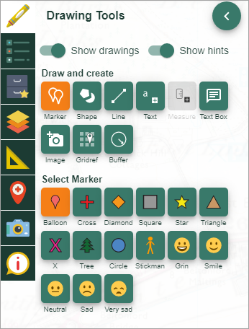

Sample Drawings 1
In the example below, pupils have added a buffer 50m around the John Muir Way path that is marked on the map. Then they have added images of what they saw and found within that area on their visit.
You can print this on paper or insert the image into reports and blog posts.
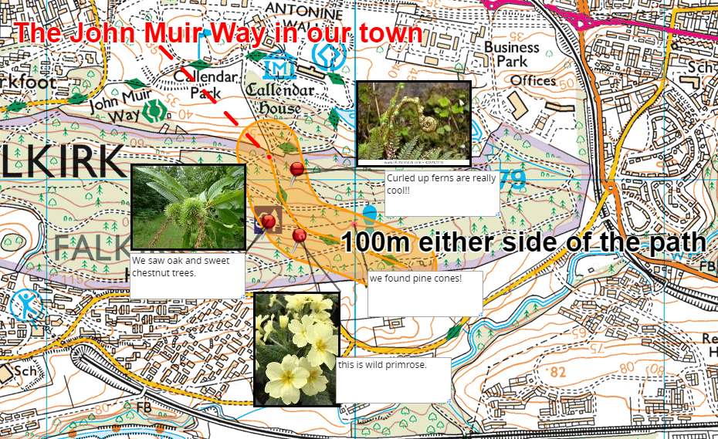

Sample Drawings 2
In this example, pupils have recorded a school trip by annotating a map with labels, images, a walking route and ‘stick-man’ symbols.
Remember that when you use a map image from Digimap for Schools you need to put a copyright acknowledgement on it.
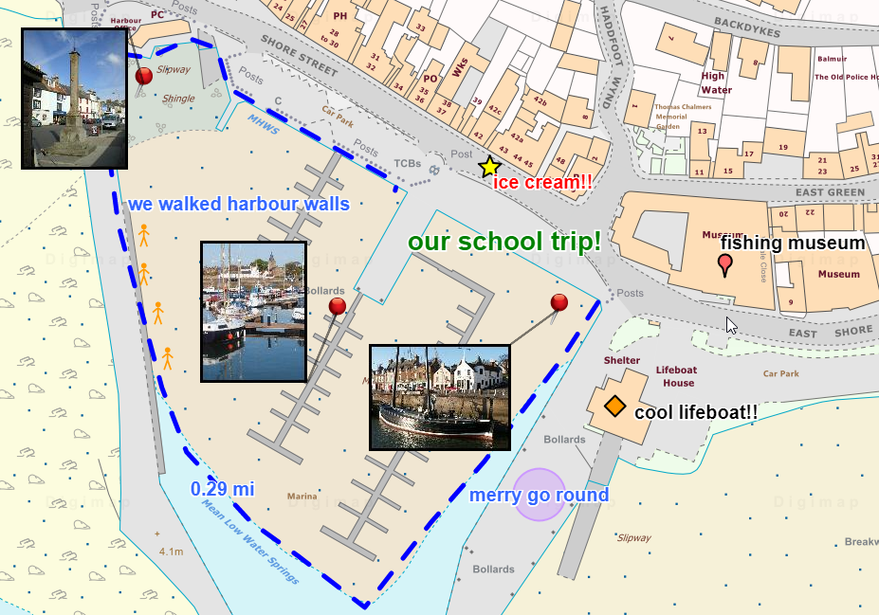

3D Table map
Print off an A3 map of your place. An aerial map might work well. Paste it on a tray or inside a cardboard box with the sides cut down.
Pupils can use this as a working project map and add objects to it. You could add leaves, twigs, pine cones. Make models and drawings of birds, trees or insects. Print the best photos you take and display them around the side, using a string with clothes pegs.
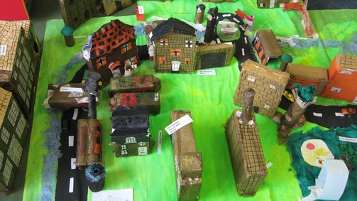

Photo source: The Geographical Association http://www.geography.org.uk/

Print
All print options are available to the left of your map, as shown in the image below.
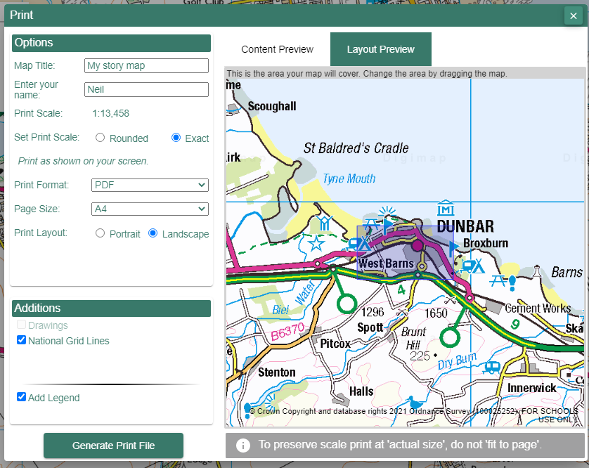

Print selections
- Format – make a choice between PDF or JPG.
  - PDF: choose this if you plan to print your map.
  - JPG: choose this if you plan to insert your map in a document or a blog or share on social media.
- Size – A3 or A4.
- Layout – landscape or portrait.

Optional extras
- Add grid lines – this will add British National Grid lines to your map print.
- Show print extent – select this and a box will appear in the map window showing the area your map print will cover.
  - If you uncheck lock/unlock you can move the box to change the area covered by the map print.
- Title – just type a title of your choice.
- Name – this could be the name of your class, an individual or your challenge name.

Sharing maps
Maps are a fantastic way to communicate your work on the John Muir Trust Award. Print your maps and share them with other classes or with parents. Use the map images on blogs, reports, on twitter…get the word out!
Tweet them to us – we love seeing what you create with Digimap for Schools!
https://twitter.com/Digimap4Schools

What are we allowed to do?
The educational licences with our map providers allow you to share the map images on social media, your school website, in presentations and in reports. If you’re unsure if the licence covers what you want to do, please get in touch and we can find out.

Terms of use
You can see the full terms of use here:
https://digimapforschools.edina.ac.uk/termsofuse

Copyright statements
When you create a map print, the copyright statement is there in the bottom left corner, as circled this image:
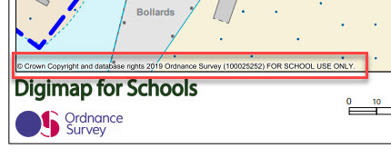

My map image doesn’t show the statement
You might only be sharing a small portion of your map print, which doesn’t include the copyright statement. In that case, please remember to include the statement somewhere near the image.
Remember that the statement will vary – if you have printed a historic map, it will be the historic map copyright statement. All three statements are given below:

Ordnance Survey maps
© Crown Copyright and database rights 2019 Ordnance Survey (100025252) FOR SCHOOL USE ONLY.

Historic maps
Historic mapping courtesy of the National Library of Scotland. FOR SCHOOL USE ONLY.

Aerial maps
Aerial photography © Getmapping Plc. FOR SCHOOL USE ONLY.

This resource is licensed under a Creative Commons Attribution-NonCommercial-ShareAlike 4.0 International License.

