From Field to Fork

Food Miles

Alan Parkinson

Geography Teaching Resource

Secondary
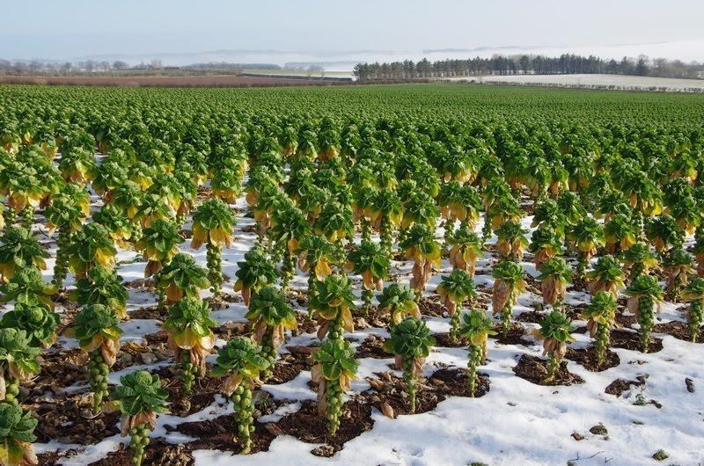

Contents
Digimap for Schools Geography Resources 3
Content and Curriculum Links 3
Activity 4
Introduction 4
Web links 4
Main activity 5
Produce an illustrated story of the ‘diary of a sprout’ 6
Location 1 6
Field: grid reference TF2438 6
Location 2 6
Processing plant: grid reference TF2525 6
Location 3 7
Warehouse: grid reference SK8255 7
Location 4 7
Supermarket: grid reference TF8109 7
Location 5 7
Fork: your choice of location 7
Resources: 8
Taking it further 9
Local food 9
Protected names 9
Protected name applications 10
Copyright 11
Acknowledgements 11

Digimap for Schools Geography Resources
These resources are a guide for teachers to demonstrate to the whole class or direct individual students as appropriate. Each activity has several ideas within it that you can tailor to suit your class and pupils. Some resources contain worksheets for direct distribution to pupils.

Content and Curriculum Links
Level | Context | Location
Secondary | Food miles | Lincolnshire, GB

Knowledge/skills | Using zoom levels, annotating maps, labelling maps.
Curriculum Links (England) | Agriculture/Food Miles/Diversification.
Curriculum Links (Wales) | Use maps to interpret and present locational information, communicate ideas and information using maps and visual images.
Scottish Curriculum for Excellence | Social Science Outcomes: People, Place and Environment 1.13b, 2.09a, 4.09a-b, 4.14a.

Activity
This activity looks in detail at the journey made by Brussel sprouts from field to dinner plate and introduces the concept of foods with protected names.

Introduction
One focus for geographical study is the journeys made by food from the place where it is produced to the place where it is consumed; this distance is measured in ‘food miles’. Food that has travelled further is generally thought to be ‘worse’ for the environment than food that is grown more locally.

Web links
In addition to the web links in the activities, the following may be of interest:
https://ahworth.co.uk/our-story/
http://geography.org.uk/cpdevents/onlinecpd/foodsecurity/

Main activity
You are going to follow the journey made by a vegetable that is not popular with everyone: the humble sprout…
Sprouts are grown in a number of locations, but one of the main areas is the Lincolnshire Fens. This is also one of the main locations for food processing and warehousing, from which food is transported to supermarkets.
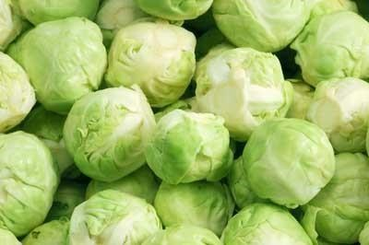

Produce an illustrated story of the ‘diary of a sprout’
Show how the sprouts get from field to fork. Include maps of the locations that are given below.
- You will need to produce a series of screenshots of the maps shown at different levels using the grid references provided for each location.
- You can include photographs and describe the landscape that you see.
- Consider whether there are savings to be made in the carbon footprint of food production by changing the way that food is distributed. Why do you think food is currently distributed in the way that it is?
- Find out where Brussels is and why the sprouts are called Brussel sprouts.

Location 1

Field: grid reference TF2438
Sprouts are grown in the Lincolnshire Fens because the soil is ideal for them to grow, as it is a fine texture, fertile and well drained.
Sprouts are stripped from the stalk and sold loose or in nets, although some shops also sell sprouts still attached to the stalk.
Some forms of harvesting also involve the stripping of an entire field. In this case, there may be the use of livestock such as sheep, who are kept in the field for a while to eat the remaining stalks and waste.

Location 2

Processing plant: grid reference TF2525
Some supermarkets also want the sprouts to be prepared, which involves removing the outer leaves and bagging in vacuum sealed bags at a particular weight. This adds value but takes additional time in the food processing. Sprouts have to be moved quickly as they are perishable products.
Processing is done at a plant near to Spalding in Lincolnshire.

Location 3

Warehouse: grid reference SK8255
The sprouts are then taken to a warehouse on the edge of Newark, before finally arriving at the supermarket.

Location 4

Supermarket: grid reference TF8109
The grid reference refers to a supermarket in Swaffham. One of the quirks of centralised warehouses is that food may be transported a long way from an area before being returned to the same area for sale. This increases the food miles in what may seem to be an unnecessary way.

Location 5

Fork: your choice of location
Finish the journey by going to the home of an imaginary purchaser of the sprouts, or at your own house, where they are served up for dinner.

Resources:
In addition to the Ordnance Survey maps, you may want to illustrate your diary with some images.
- You can use the Image Search tool in Digimap for Schools to find images. Open Image Search and enter your search terms to find matching images. NOTE: you can also enter an asterisk to see all available images at a location (only in the 5 most zoomed in maps).

- Try typing in the following in the search box:
- Lincolnshire Fenland
- Brussel sprouts
- Lincolnshire vegetable processing plant
- Supermarket distribution centre
- Postcode of your supermarket

Taking it further

Local food
Local foods (grown or produced, processed, traded and sold within a geographic radius of 30–50 miles) are growing in popularity. Why do you think this is? Why would people be prepared to sometimes pay more for local food than food which has travelled a long distance, or been imported?

Protected names
In 1993, EU legislation came into force which gives protection to certain food names and awards one of three marks:
- Protected Designation of Origin (PDO)
These foods are produced, processed and prepared within a particular geographical area, and with features and characteristics which must be due to the geographical area.
- Protected Geographical Indication (PGI)
Must be produced, processed or prepared within the geographical area and have a reputation, features or certain qualities attributable to that area.
- Traditional Speciality Guaranteed (TSG)
Have customary names and a set of features which distinguish them from other similar products.
Under this system a named food or drink, when registered, will be given legal protection against imitation throughout the EU. It is very hard to get this status and only around 75 products in the UK have this protection. A list of all protected names and an interactive map is available at this web site. https://www.gov.uk/protected-food-names-guidance-for-producers
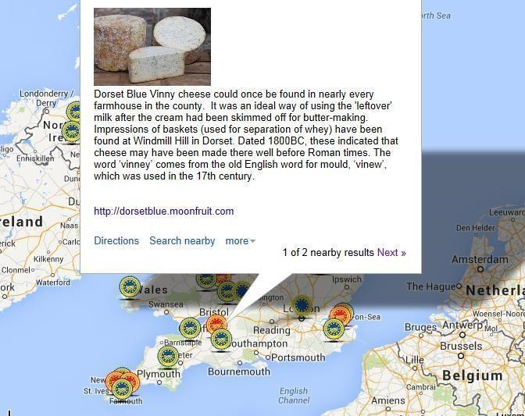

Protected name applications
Look at the list of applications under consideration at:
www.gov.uk/government/collections/protected-food-name-scheme-uk-applications-being-considered
Ask groups of pupils to ‘adopt’ one of these applications and follow its progress on social media
- What are the benefits of this protection to producers?
- Who covers the cost of making an application?
- Do you think Lincolnshire Brussel sprouts would be able to apply?
- Will ‘Brexit’ affect UK application?

Copyright
©EDINA at the University of Edinburgh 2016
This work is licensed under a Creative Commons Attribution-Non Commercial Licence

Acknowledgements
© CollinsBartholomew Ltd (2019) FOR SCHOOLS USE ONLY
© Crown copyright and database rights 2020 Ordnance Survey (100025252). FOR SCHOOLS USE ONLY.
Aerial photography © Getmapping plc. Contains OS data. FOR SCHOOLS USE ONLY.
Historic mapping courtesy of the National Library of Scotland. FOR SCHOOLS USE ONLY.

