OS EXPLORER

FLASHCARDS

Map features

1

Symbols

28

Sch

Abbreviations

83

Index

91

© Copyright 2016 Ordnance Survey Limited

For further Information contact the Education Team, Ordnance Survey, Adanac Drive, SOUTHAMPTON, United Kingdom SO16 0AS.

D14230

 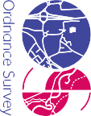

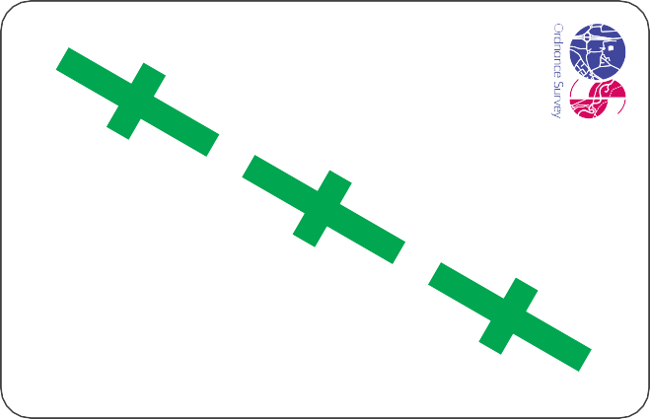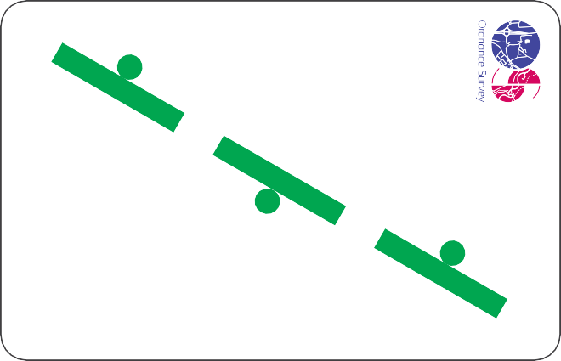



OS EXPLORER

OS EXPLORER

OS EXPLORER

OS EXPLORER

OS EXPLORER

# 1

# 2

# 3

# 4

# 5

OS EXPLORER

OS EXPLORER

OS EXPLORER

OS EXPLORER

OS EXPLORER

# 6

# 7

# 8

# 9

# 10

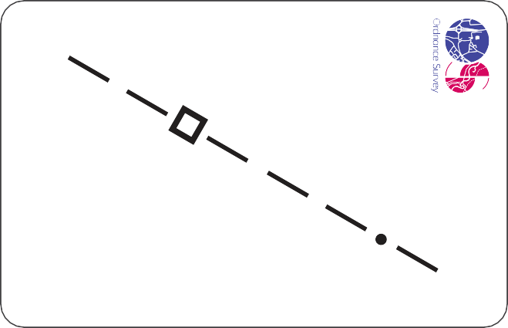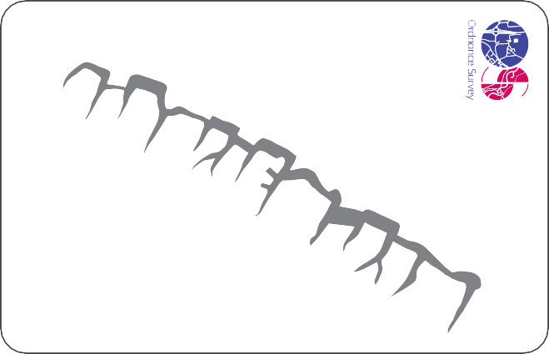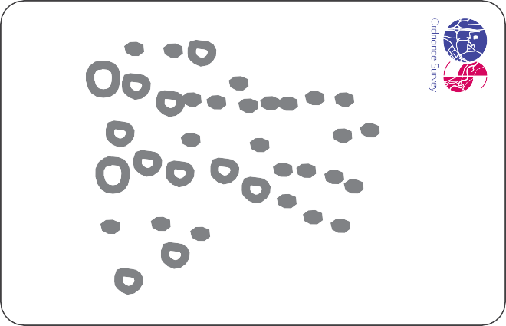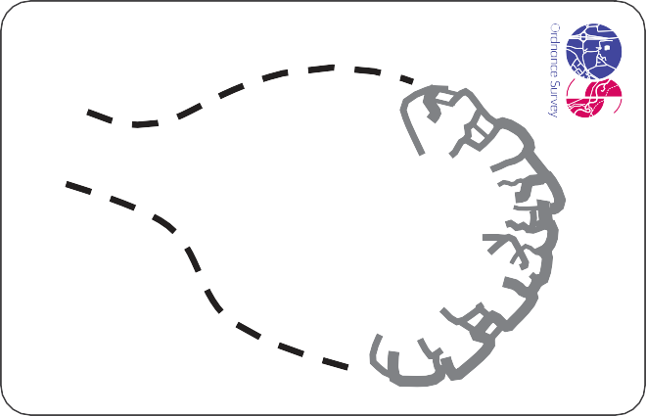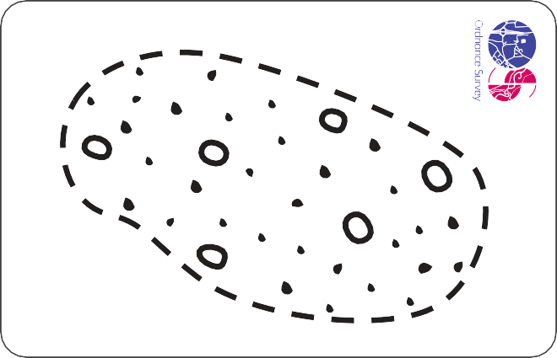



OS EXPLORER

OS EXPLORER

OS EXPLORER

OS EXPLORER

OS EXPLORER

# 11

# 12

# 13

# 14

# 15

OS EXPLORER

OS EXPLORER

OS EXPLORER

OS EXPLORER

OS EXPLORER

# 16

# 17

# 18

# 19

# 20

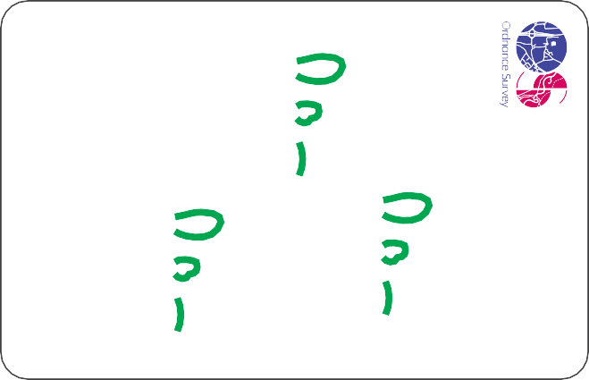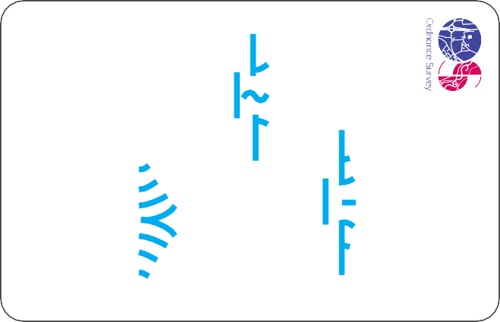

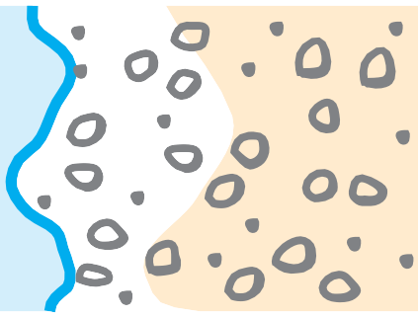

OS EXPLORER

OS EXPLORER

OS EXPLORER

OS EXPLORER

OS EXPLORER

# 21

# 22

# 23

# 24

# 25

OS EXPLORER

OS EXPLORER

OS EXPLORER

OS EXPLORER

OS EXPLORER

# 26

# 27

# 28

# 29

# 30



OS EXPLORER

OS EXPLORER

OS EXPLORER

OS EXPLORER

OS EXPLORER

# 31

# 32

# 33

# 34

# 35

OS EXPLORER

OS EXPLORER

OS EXPLORER

OS EXPLORER

OS EXPLORER

# 36

# 37

# 38

# 39

# 40



OS EXPLORER

OS EXPLORER

OS EXPLORER

OS EXPLORER

OS EXPLORER

# 41

# 42

# 43

# 44

# 45

OS EXPLORER

OS EXPLORER

OS EXPLORER

OS EXPLORER

OS EXPLORER

# 46

# 47

# 48

# 49

# 50

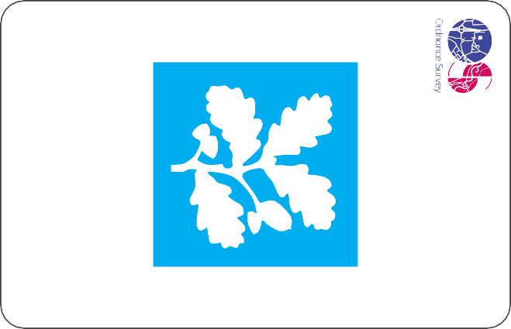

OS EXPLORER

OS EXPLORER

OS EXPLORER

OS EXPLORER

OS EXPLORER

# 51

# 52

# 53

# 54

# 55

OS EXPLORER

OS EXPLORER

OS EXPLORER

OS EXPLORER

OS EXPLORER

# 56

# 57

# 58

# 59

# 60

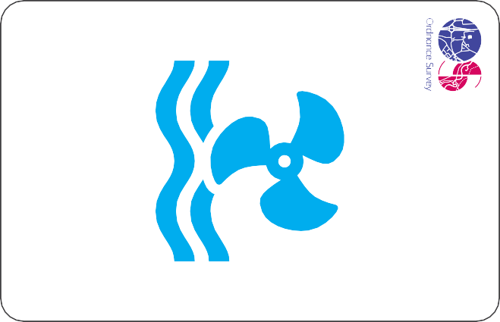

OS EXPLORER

OS EXPLORER

OS EXPLORER

OS EXPLORER

OS EXPLORER

# 61

# 62

# 63

# 64

# 65

OS EXPLORER

OS EXPLORER

OS EXPLORER

OS EXPLORER

OS EXPLORER

# 66

# 67

# 68

# 69

# 70

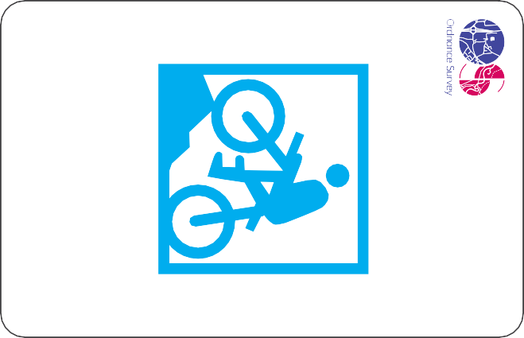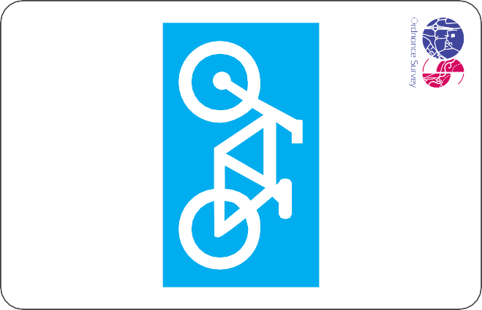

OS EXPLORER

OS EXPLORER

OS EXPLORER

OS EXPLORER

OS EXPLORER

# 71

# 72

# 73

# 74

# 75

OS EXPLORER

OS EXPLORER

OS EXPLORER

OS EXPLORER

OS EXPLORER

# 76

# 77

# 78

# 79

# 80





Pol

Sta

OS EXPLORER

Sch

Mon

OS EXPLORER

OS EXPLORER

OS EXPLORER

OS EXPLORER

# 81

# 82

# 83

# 84

# 85

W

Spr

OS EXPLORER

BS

FB

PO

NTL

OS EXPLORER

OS EXPLORER

OS EXPLORER

OS EXPLORER

# 86

# 87

# 88

# 89

# 90

Index 1 to 45

OS EXPLORER FLASHCARDS

1. Recreational path

1



2

3

4



5

1. Other route with public access
2. Footpath
3. Bridleway
4. Byway open to all traﬃc
5. Restricted byway
6. Motorway



6

7

8

9



10

1. A road
2. Level crossing
3. Railway station
4. National Park boundary
5. Contours (5m interval)
6. Electricity transmission line

11



12

13

14

15

1. County boundary
2. Cliﬀ
3. Scree
4. Quarry
5. Spoil heap
6. Access land

16



17

18

19



20

1. Coniferous wood
2. Non-coniferous wood
3. Orchard
4. Scrub
5. Bracken, heath or rough grassland
6. Marsh, reeds or saltings



21

22

23

24



25

1. Shingle
2. Mud
3. Bunkhouse, camping barn or other hostel
4. Youth hostel
5. Bus station
6. Mast



26

27

28

29

30

1. Windmill
2. Wind turbine
3. Place of worship
4. “ – with tower
5. ” – with spire or dome
6. Site of antiquity

31



32



33

34

35

1. Site of battle
2. Lighthouse
3. Solar farm
4. Camping and caravan site
5. Viewpoint (180°)
6. Parking



36



37

38

39

40

1. Information centre (seasonal)
2. Public phone

41

42

43

44

45

Index 46 to 90

OS EXPLORER FLASHCARDS

|  |  |  |  |  |  |  |
| --- | --- | --- | --- | --- | --- | --- |
|  | | | | | 46 | Emergency phone |
| 47 | Recreation, leisure or sports centre |
| 48 | Picnic site |
| 49 | World Heritage centre or area |
| 46 | 47 | 48 | 49 | 50 | 50  51 | Garden or arboretum  Nature reserve |
|  |  |  |  |  | 52 | Horse riding |
|  |  |  |  |  | 53 | Historic Scotland |
|  |  |  |  |  | 54 | National Trust |
|  |  |  |  |  | 55 | English Heritage |
| 51 | 52 | 53 | 54 | 55 | 56  57 | Welsh Heritage (CADW) Other tourist feature |
|  |  |  |  |  | 58 | Visitor centre |
|  |  |  |  |  | 59 | Toilets |
|  |  |  |  |  | 60 | Country park |
|  |  |  |  |  | 61 | Water activities (board) |
| 56 | 57 | 58 | 59 | 60 | 62  63 | Water activities (paddle)  Water activities (powered) |
|  |  |  |  |  | 64 | Water activities (sailing) |
|  |  |  |  |  | 65 | Watersports centre (multi-activity) |
|  |  |  |  |  | 66 | Boat hire |
|  |  |  |  |  | 67 | Public house |
|  |  |  |  |  | 68 | Slipway |
| 61 | 62 | 63 | 64 | 65 | 69 | Preserved railway |
|  |  |  |  |  | 70 | Theme park |
|  |  |  |  |  | 71 | Walk or trail |
|  |  |  |  |  | 72 | Mountain bike trail |
|  |  |  |  |  | 73 | Bike hire |
|  |  |  |  |  | 74 | Cycle trail |
| 66 | 67 | 68 | 69 | 70 | 75 | Heritage centre |
|  |  |  |  |  | 76 | Museum |
|  |  |  |  |  | 77 | Art gallery |
|  |  |  |  |  | 78 | Castle |
|  |  |  |  |  | 79 | Historic house |
|  |  |  |  |  | 80 | Abbey or cathedral |
| 71 | 72 | 73 | 74 | 75 | 81 | Fishing |
|  |  |  |  |  | 82 | Craft centre |
|  |  |  |  |  | 83 | School |
|  |  |  |  |  | 84 | Police station |
|  |  |  |  |  | 85 | Monument |
|  |  |  |  |  | 86 | Boundary stone |
| 76 | 77 | 78 | 79 | 80 | 87 | Footbridge |
|  |  |  |  |  | 88 | Post Oﬃce |
|  |  |  |  |  | 89 | Normal Tidal Limit |
|  |  | Sch | Pol  Sta | Mon | 90 | Well, Spring |
| 81 | 82 | 83 | 84 | 85 |  |  |

BS

86

FB

87

PO

88

NTL

89



W

Spr

90