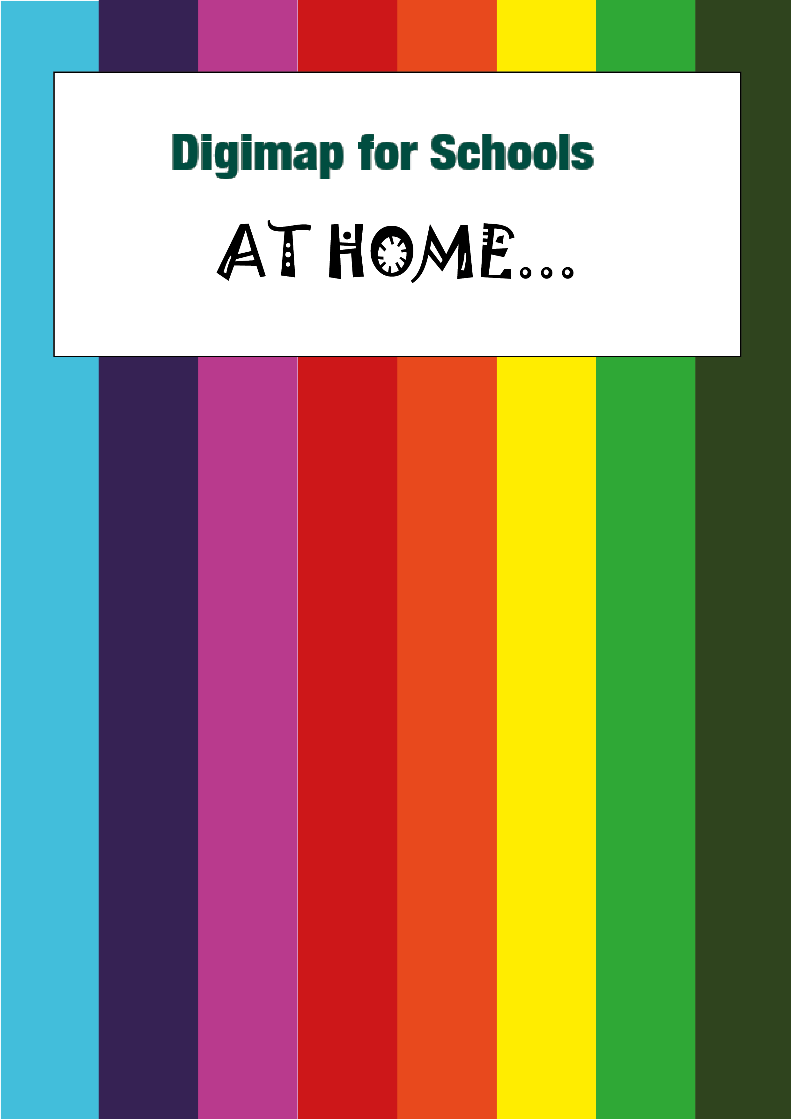

A river journey

What’s it about?

Let’s try and find out more about rivers by following a river’s journey. We’ve chosen the River Medway. We’ll choose points along its journey from source to mouth and look at images people have taken.
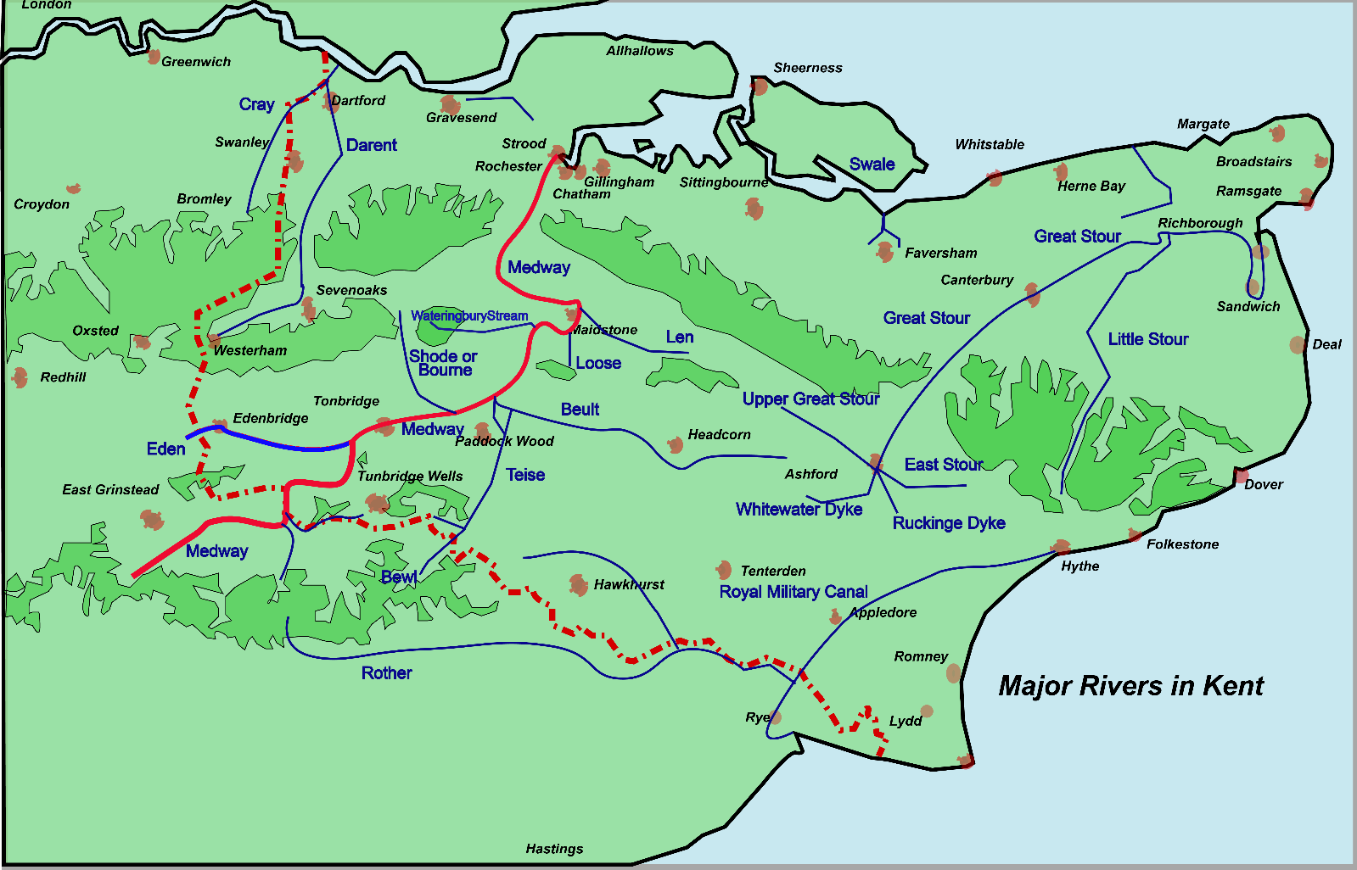

Steps!
- Reminder of river words
- Find the river’s source
- Add marker and label
- Explore the images of the river’s source and mouth
- Explore the landscape of an area that floods

River words
What are the important words we need to remember?

The Medway, a river in south East England, has its sources in the counties of East Sussex and Surrey. It starts as small streams which flow quite quickly.

Source - the start of a river is its source. This could be a spring on a hillside, a lake, a
bog or marsh. A river may have more than one source.
Stream - a small river.
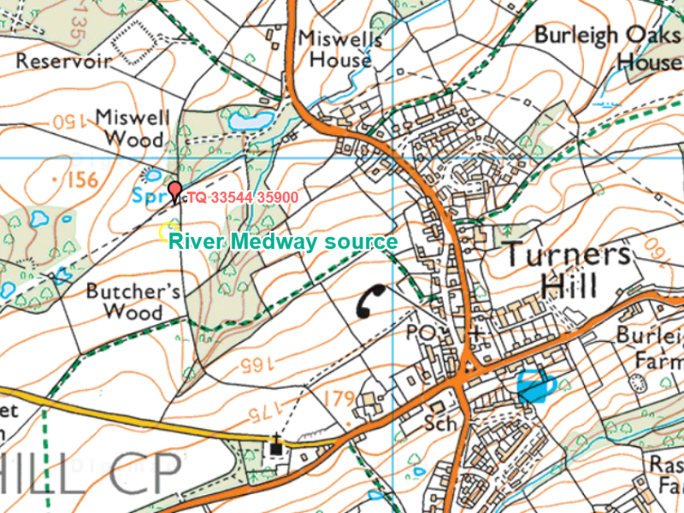
The Medway has several small tributaries such as the River Len, River Teise and the River Beult.
At the confluence with the River Beult, it turns north through the North Downs.

Tributary - a smaller river or stream that joins a big river.
Confluence - where two rivers meet.
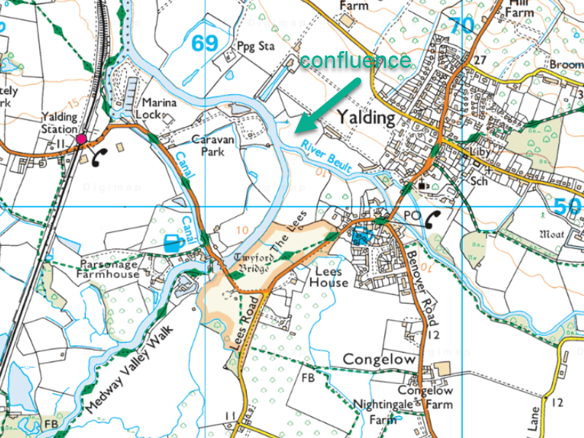

The Medway flows through Tonbridge, Maidstone and the Medway estuary area (towns include Rochester, Chatham, Gillingham and Sheerness).
The river’s mouth is between the Isle of Grain and Sheerness, where it empties into the River Thames.

Estuary - where a river reaches the ocean and the river and ocean mix. Estuaries are
normally wide and flat.
Mouth - the end of a river where it flows into the sea, another river or a lake.

Finding the source
- Login to Digimap for Schools.
  - Go to: https://digimapforschools.edina.ac.uk/
  - Select the Login button
  - Put in your username*
  - Put in your password*
  - Select Log In
*Ask a teacher if you don’t know this

- Input Turners Hill in the search box.
- Select the magnifying glass.
- Select Turner’s Hill (West Sussex) from the results.
- Zoom in 2 or 3 times on Turners Hill. Look North West until you see Miswell Wood. You should see Spr marked on the map (see the image below). This spring is the source of the Medway.
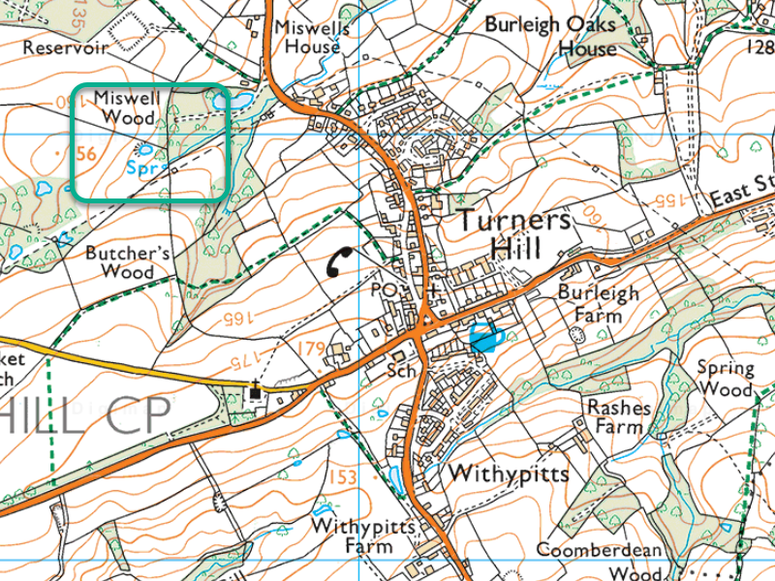

Add marker and label
- Select Drawing Tools – look on the left.
- Select a marker or emoji.
- Place it next to the spring.
- Add a text label next to the spring, that says Source.

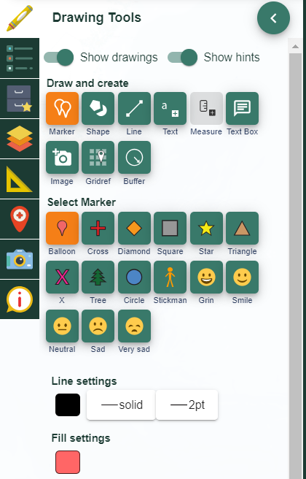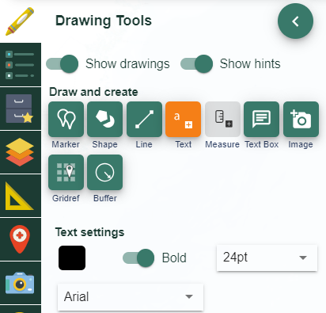

View images

River Source
- With your map still on Turners Hill, open Image Search on the left.
- Input an asterisk (*) in the search box and select the magnifying glass.
- You should see some camera icons appear on the map and a list of images in the image search menu.
- Select some of the images around the Spring…can you find any interesting ones?
- To view an image, select a camera icon then select again for a larger image. You can also select the image in the image search menu on the left.
- Pictured below are 2 we found.
  - One shows where ‘the River Medway first sees the open air’!
  - Another shows the river 150 metres after the spring and comments, ‘at this point the river looks just like a marsh’.
- Check out some other images around the spring.

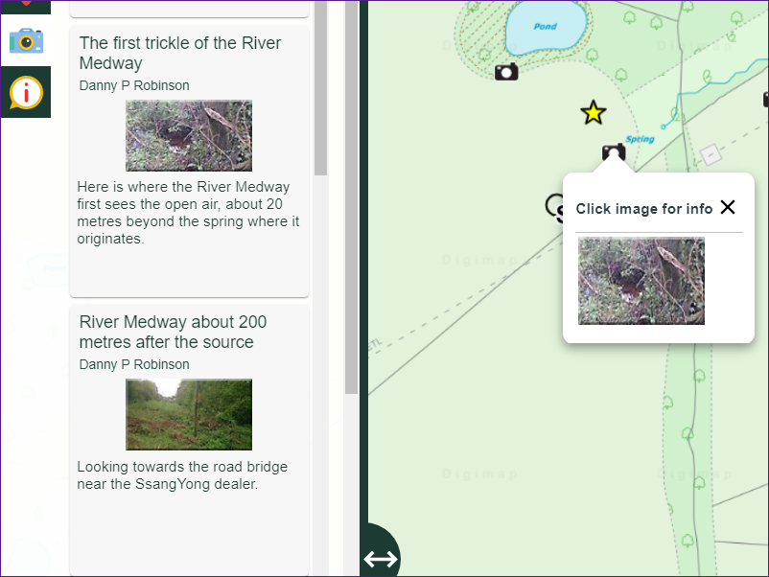

Mouth of the river
- Zoom in to Rochester, or search for Rochester.
- Now explore the images there. Search for Medway, or river, or estuary.
- To view a larger image, select the image on the map or in the menu.
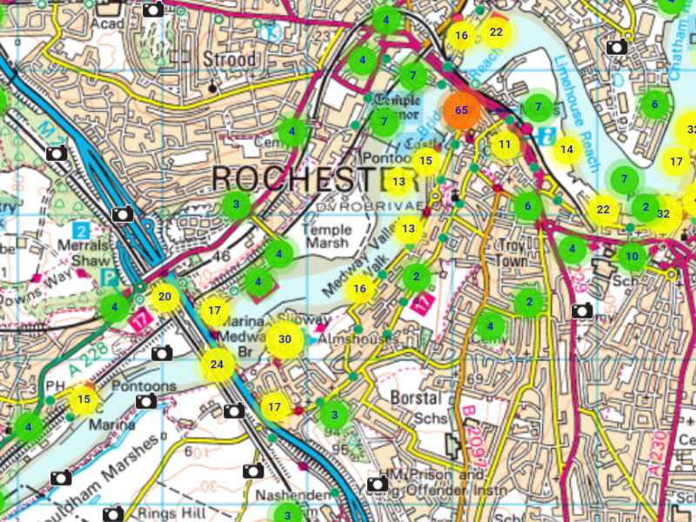
- Select a few images to look at.
- What kind of activity takes place around the river? Leisure activities? What evidence can you find of industrial activity, e.g. ports, cranes, larger ships, containers?
- Now move the map to follow the river all the way to Sheerness…select a few images along the way. Does the type of activity change as you move closer to the mouth of the river?
- Switch on the aerial map. Can you see evidence that would show this is the river mouth? Can you see the river widen as it reaches the Thames? Do the river banks look steep or gently sloped? Can you see evidence of sediment being deposited, e.g. gravel or sand on the banks?

Explore flooding images
- Search for flooding in the image Search.
- Zoom in on Tonbridge, an area prone to flooding.
- Now open the Map Selector.
- Select AerialX as your map…just select the button to the right of any map name to open it.
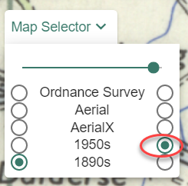

- Compare the Ordnance Survey and aerial maps.
- Look for clues as to why the area could have flooded? You can look for:
- Landscape features
- Is the place low lying? Check the spot heights and contours around the location.
- Is the river straight or meandering? A straight river speeds up the flow.
- Are there lots of rivers or streams around the area?
- Can you see evidence of lots of trees and vegetation? Tree roots will help the soil soak up water. Vegetation will help to hold back water. Water will just run off concrete or paved areas.

Measuring the river
Use the Measuring Tool on Digimap for Schools to find out the width of the river at different points.

- First let’s zoom out until you can see all of Kent.
- Open the image search box.
- Enter Medway in the search box and select the magnifying glass.
- You should see lots of clusters appear on the map, showing the approximate route of the Medway, like the image below.

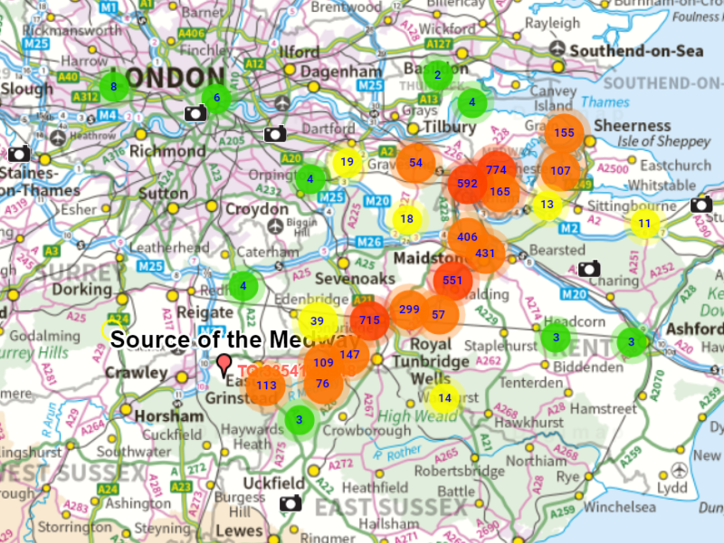

- Now choose some spots to measure.
  - Somewhere in the upper part of the river, e.g. Tonbridge.
  - Somewhere in the middle part, e.g. Maidstone.
  - Somewhere near the mouth, e.g. Rochester.
- Open the Measurement tools.
- Select distance.
- Draw a line across the river, double clicking or tapping to finish.
- What did you find? Did you find evidence that the river gets wider as it flows along its course?
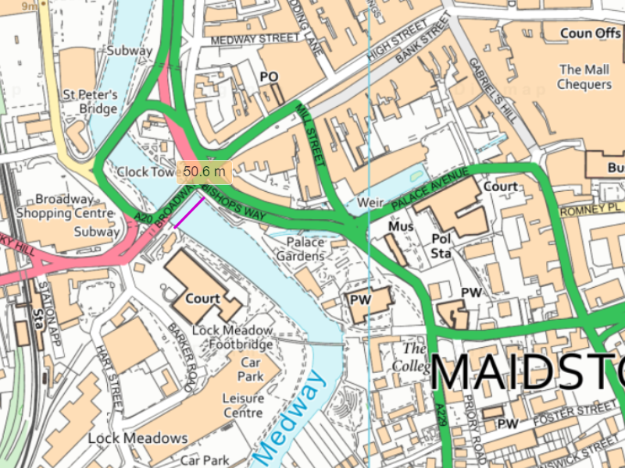

River Glossary
Sourced from Twinkl

bank The riverbank is the land at the side of the river.
basin The land water must cross to reach a river. It collects all available water from
tributaries, creeks and streams in its area.
bed The bed is the bottom of a river. A riverbed can be made of sand, rocks or mud
depending on the river.
canal A man-made waterway that is used so that boats can transport goods across
the country.
current The strength and speed of the river. Water always flows downhill; the steeper
the ground is, the stronger the current will be.
confluence The junction of two rivers, especially rivers of approximately equal width.
delta A wide muddy or sandy area where some rivers meet the sea. The river slows
down and drops all the sediment it was carrying.
downstream The direction that the water flows, downhill towards the sea.
erosion A fast flowing river can damage the riverbanks and wash bits of them
downstream, making the river wider.
estuary Where a river reaches the ocean and the river and ocean mix. Estuaries are
normally wide and flat.
floodplain The flat area around a river that often gets flooded when the level of water in
the river is high.
fresh water Rainwater that falls from the sky has no salt in it. We call this fresh water.
meander A river that follows a winding course.
mouth The end of a river where it flows into the sea, another river or a lake.
salt water The type of water in seas and oceans.
silt Small bits of dirt or sand that are carried along by a river.
source The start of a river is its source. This could be a spring on a hillside, a lake, a
bog or marsh. A river may have more than one source.
stream A small river.
tidal river At the end of a river, near the ocean, water from the sea flows up the river
when the tide comes in. This part of the river is called ‘tidal’.
tributary A smaller river or stream that joins a big river.
upstream The opposite direction to the way the water in a river flows.
watershed Water flows down the side of hills into rivers, but water that lands on opposite
sides of the same hill might flow into different rivers. The watershed is the
boundary between two river basins.

Copyright
©EDINA at the University of Edinburgh 2020
This work is licensed under a Creative Commons Attribution Non-Commercial Licence

Acknowledgements
© CollinsBartholomew Ltd (2019) FOR SCHOOLS USE ONLY
© Crown copyright and database rights 2020 Ordnance Survey (100025252). FOR SCHOOLS USE ONLY.
Aerial photography © Getmapping plc. Contains OS data. FOR SCHOOLS USE ONLY.
Historic mapping courtesy of the National Library of Scotland. FOR SCHOOLS USE ONLY.

