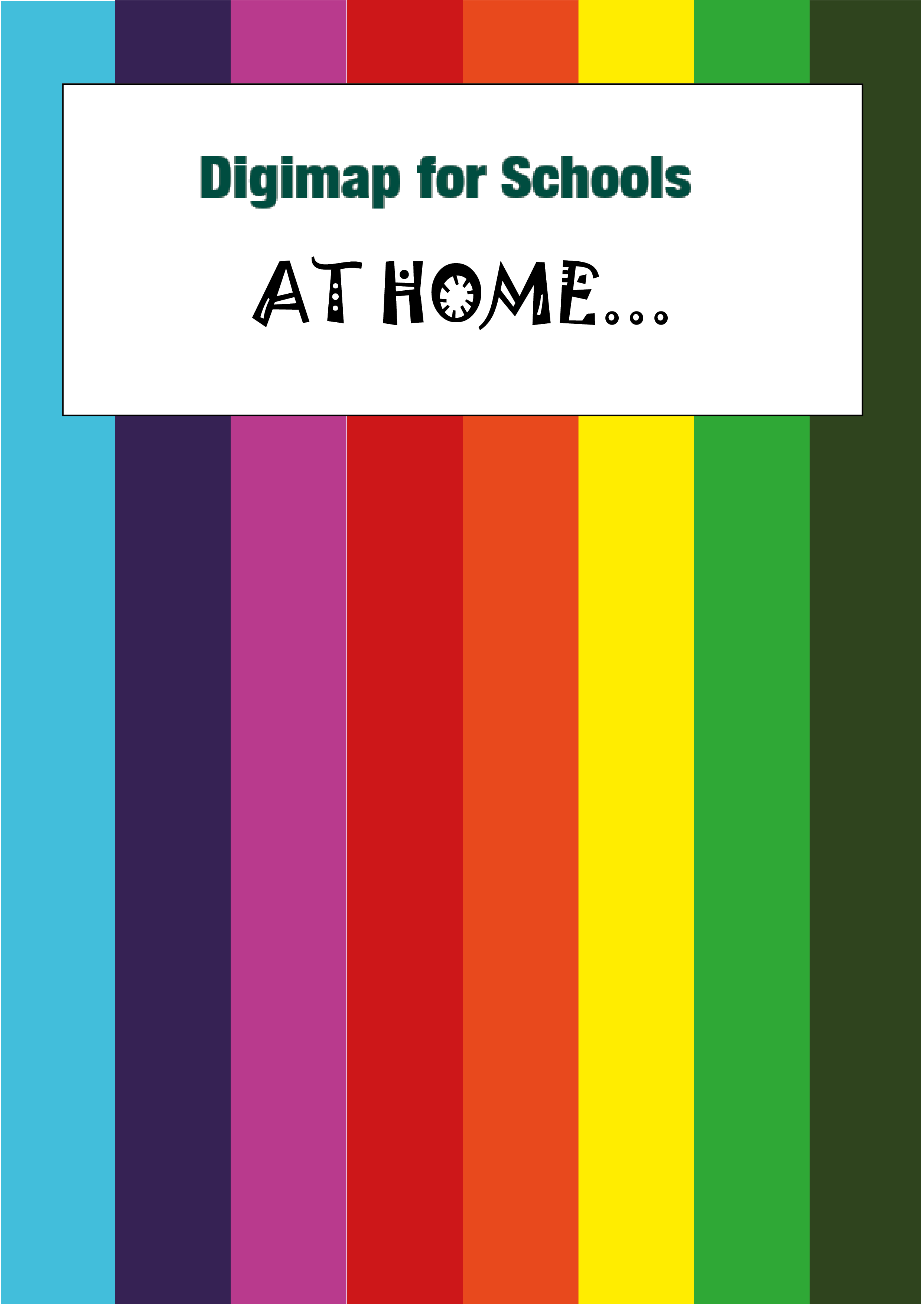

Coastal erosion

What’s it about?

Let’s explore Happisburgh in Norfolk, to find out how much the coast has eroded. We’ll use our historical maps and find images of erosion.
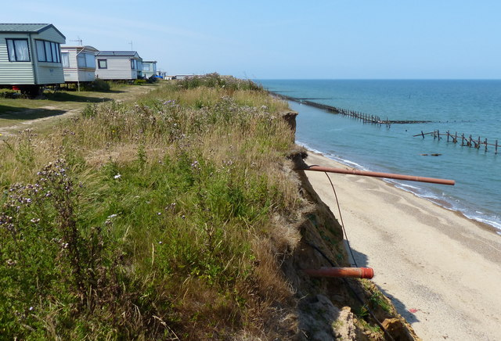
Erosion at the Happisburgh Caravan Park, ©Mat Fascione

Steps!
What’s it about? 2
Find Happisburgh 3
Draw coastline 5
Select historic map 6
Measure the differences 7
Explore images 8
Read more 9

Find Happisburgh
  - Go to: https://digimapforschools.edina.ac.uk/
  - Select the Login button
  - Put in your username*
  - Put in your password*
  - Select Log In
*Ask a teacher if you don’t know this

- Type Happisburgh in the search box.
- Select the magnifying glass.
- Select Happisburgh (Norfolk) from the results.
- Zoom in until your map is at a 200m view (at bottom right of map, circled on image below).
- Make sure you can see the beach and Happisburgh Lookout Station.
- Your screen should look similar to the image below.

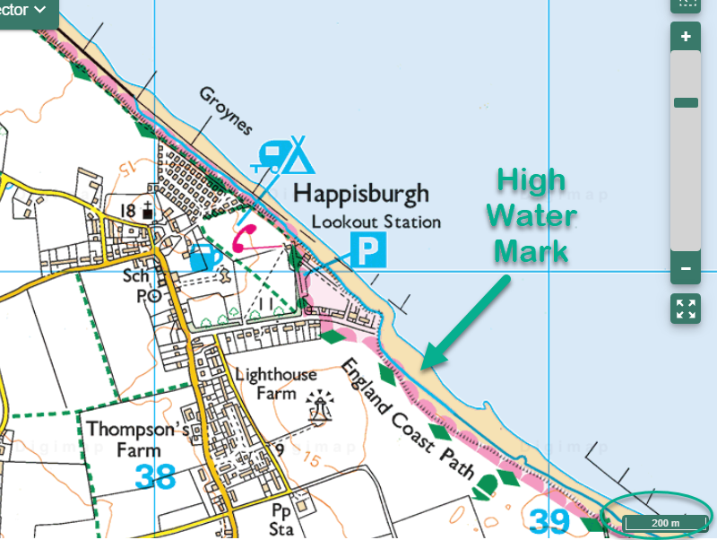

Draw coastline
- Open the Drawing Tools
- Select the line tool.
- Select a colour that will contrast with the map, I selected bright green.
- We are going to draw a line along the High Water Mark. On the present-day map, it’s a thick blue line…we’ve added an arrow to show you it in the image above.
- Select a spot on the map to start your line. I started around the Groynes and drew a line as far as I could on the screen.
- Click or tap on it, then move along the line, clicking or tapping where you want to add a point.
- Double click or tap to finish your line. TIP: this is a long line to draw so you can do it in sections, just double click at any point and then start again where you left off.
- Add a standalone label close to your line, saying Current day or Present day or Now.
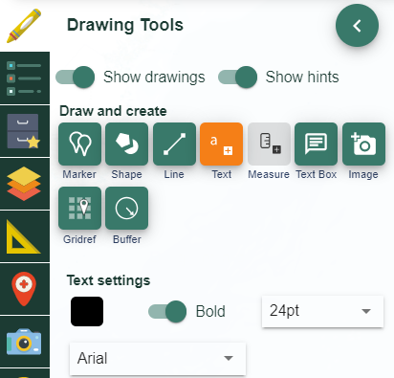

Select historical map
- Open the Map Selector on the map window.
- Select the button to the right of 1890s.
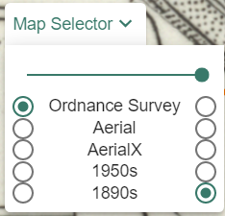
- Now we want to draw a line along the High Water Mark here. It’s the thick black line on the map.
- Choose a different colour.
- Add a label, 1890s, when you have finished.
- Now select the 1950s map from the Map Selector.
- Again, draw a line in a different colour on the high water mark.
- Add a 1950s label.

You should now have 3 lines on your screen in different colours, similar to the image below.

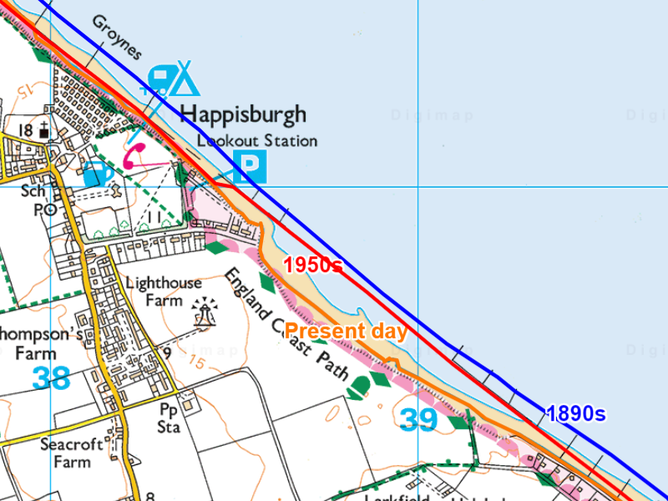

Measure the differences
- Select some points to measure. You could add markers to note the points of interest. It would be interesting to measure the biggest gaps between lines and some areas where the gap is small.
- Open the measurement tools.
- Select distance.
- Using the line measuring tool, measure the actual distance between lines.
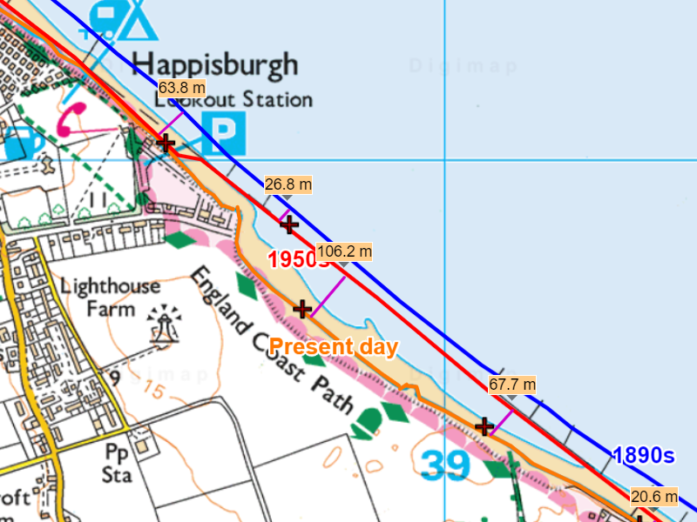

Explore images
- Open Image Search on the left.
- Type an asterisk * in the search box and select the magnifying glass. You can use any search word you want, but an asterisk will show you all the images.
- You should see some camera icons appear on the map and a list of images in the image search menu.
- Zoom in to the areas where you measured.
- To view an image, select a camera icon then select again for a larger image. You can also select images and read descriptions in the image search menu on the left.
- Do the images and descriptions offer any clues to why the coast is eroding here?
  - What’s the shape of the coastline?
  - Any mention of storms?
  - Is wave action potentially a factor?
  - What are the physical features? Are there cliffs, hard or soft rock or clay?
  - How has Happisburgh tried to prevent flooding?

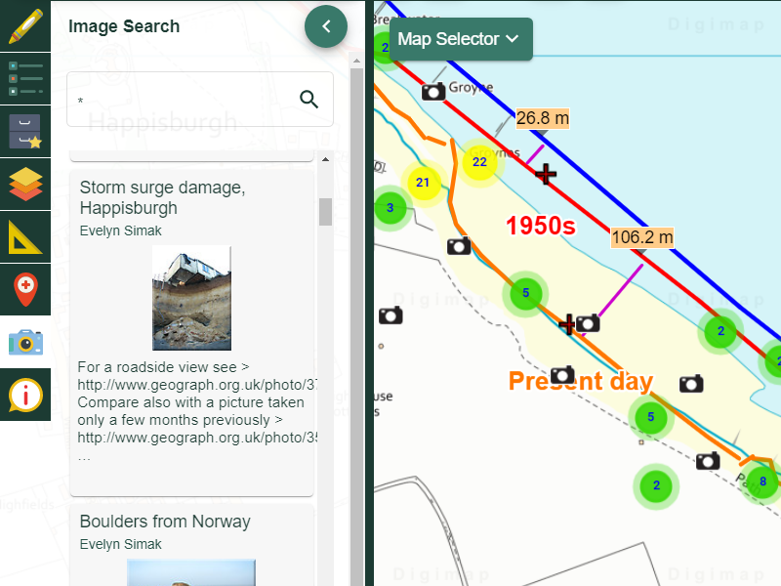

Read more
Read about the factors involved in coastal erosion on BBC Bitesize:
https://www.bbc.co.uk/bitesize/articles/zd3sy9q

Copyright
©EDINA at the University of Edinburgh 2020
This work is licensed under a Creative Commons Attribution Non-Commercial Licence

Images
Erosion at the Happisburgh Caravan Park
cc-by-sa/2.0 - © Mat Fascione - geograph.org.uk/p/5851099

Acknowledgements
© CollinsBartholomew Ltd (2019) FOR SCHOOLS USE ONLY
© Crown copyright and database rights 2020 Ordnance Survey (100025252). FOR SCHOOLS USE ONLY.
Aerial photography © Getmapping plc. Contains OS data. FOR SCHOOLS USE ONLY.
Historical mapping courtesy of the National Library of Scotland. FOR SCHOOLS USE ONLY.

