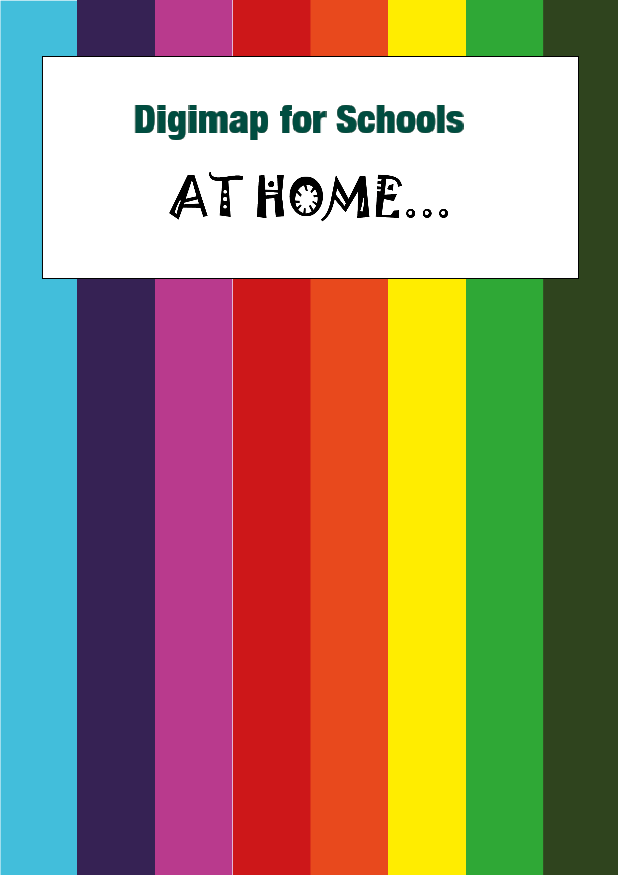
Colouring
Land Use

Choose a map
There are 3 maps to choose from below. Or print your own map.
- Login: https://digimapforschools.edina.ac.uk
- Find the area you are interested in.
- Select the Print button, above the map.
- Make sure you choose JPG as the format. We’ve circled it in the image below.
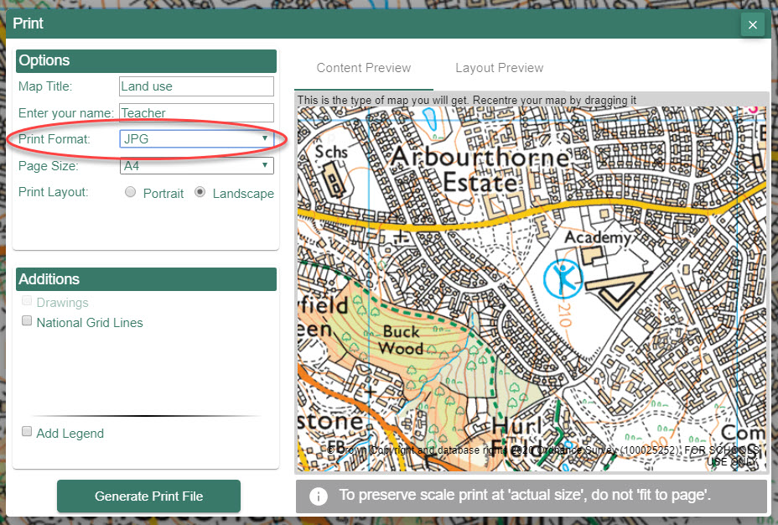
- Select Generate Print file.
- Your computer will download a JPG file.
- Print it in black and white. Check the printer options.
- Or you can add a black and white filter to the JPG image. There are lots of apps and tools to help you do this.
- If you’re struggling to convert to black and white, add your JPG to a Word document:
  - Insert > Pictures
  - Right click on the picture
  - Select Format Picture
  - Now Select the picture options
  - Change Saturation to 0%, circled in this picture.
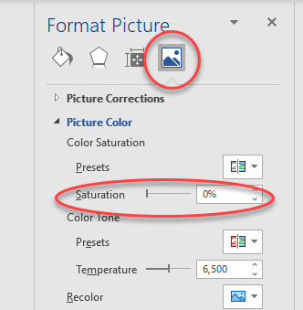
  - Finally, right click the picture again and Select Save Picture as, to save it to your computer.
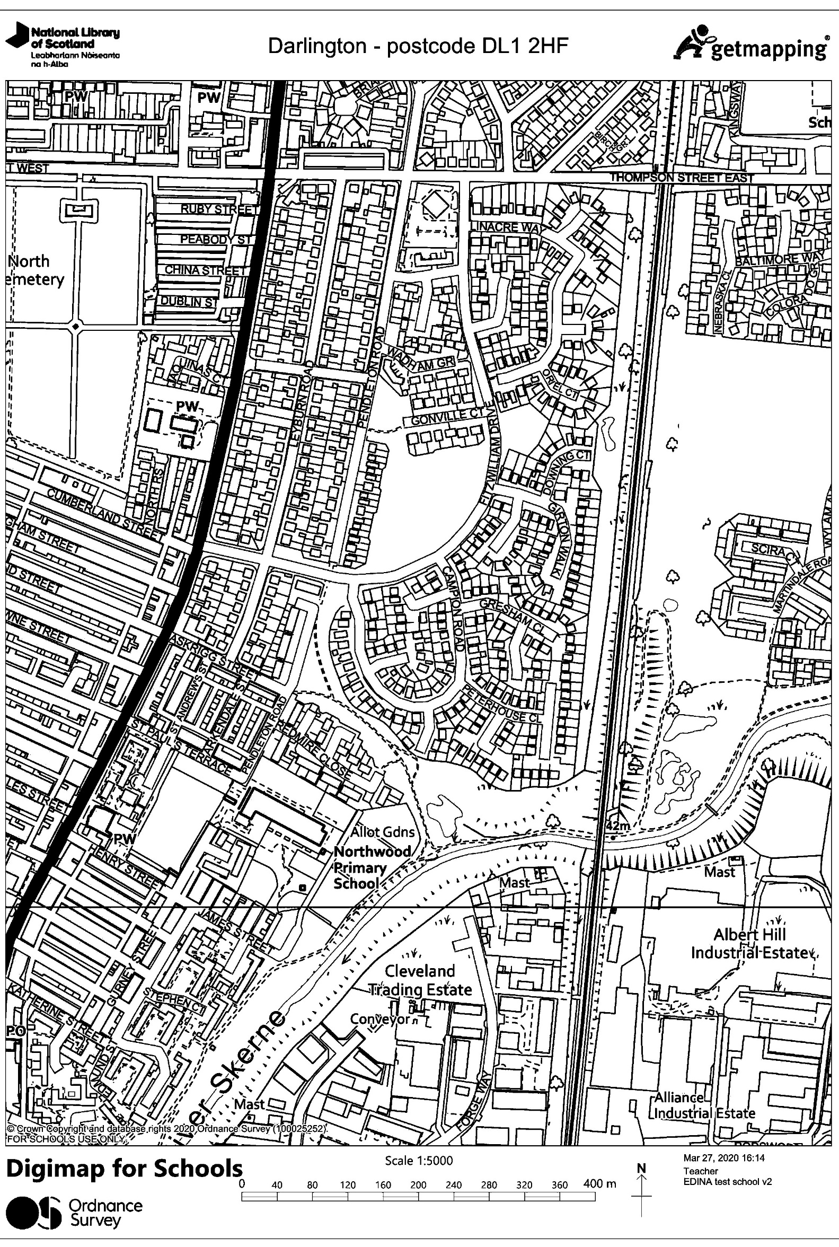
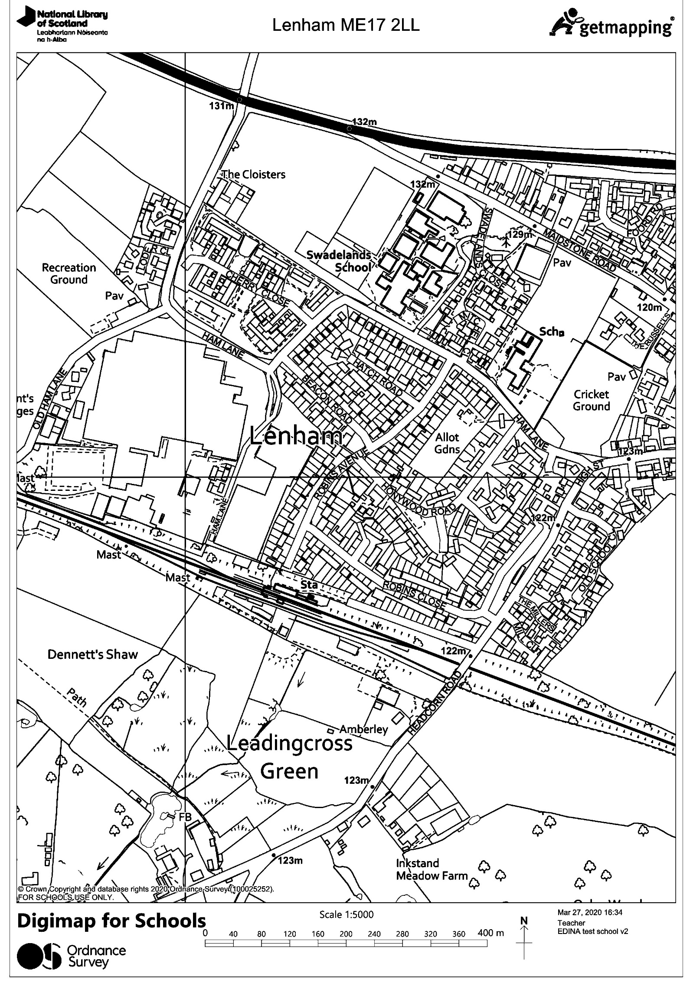
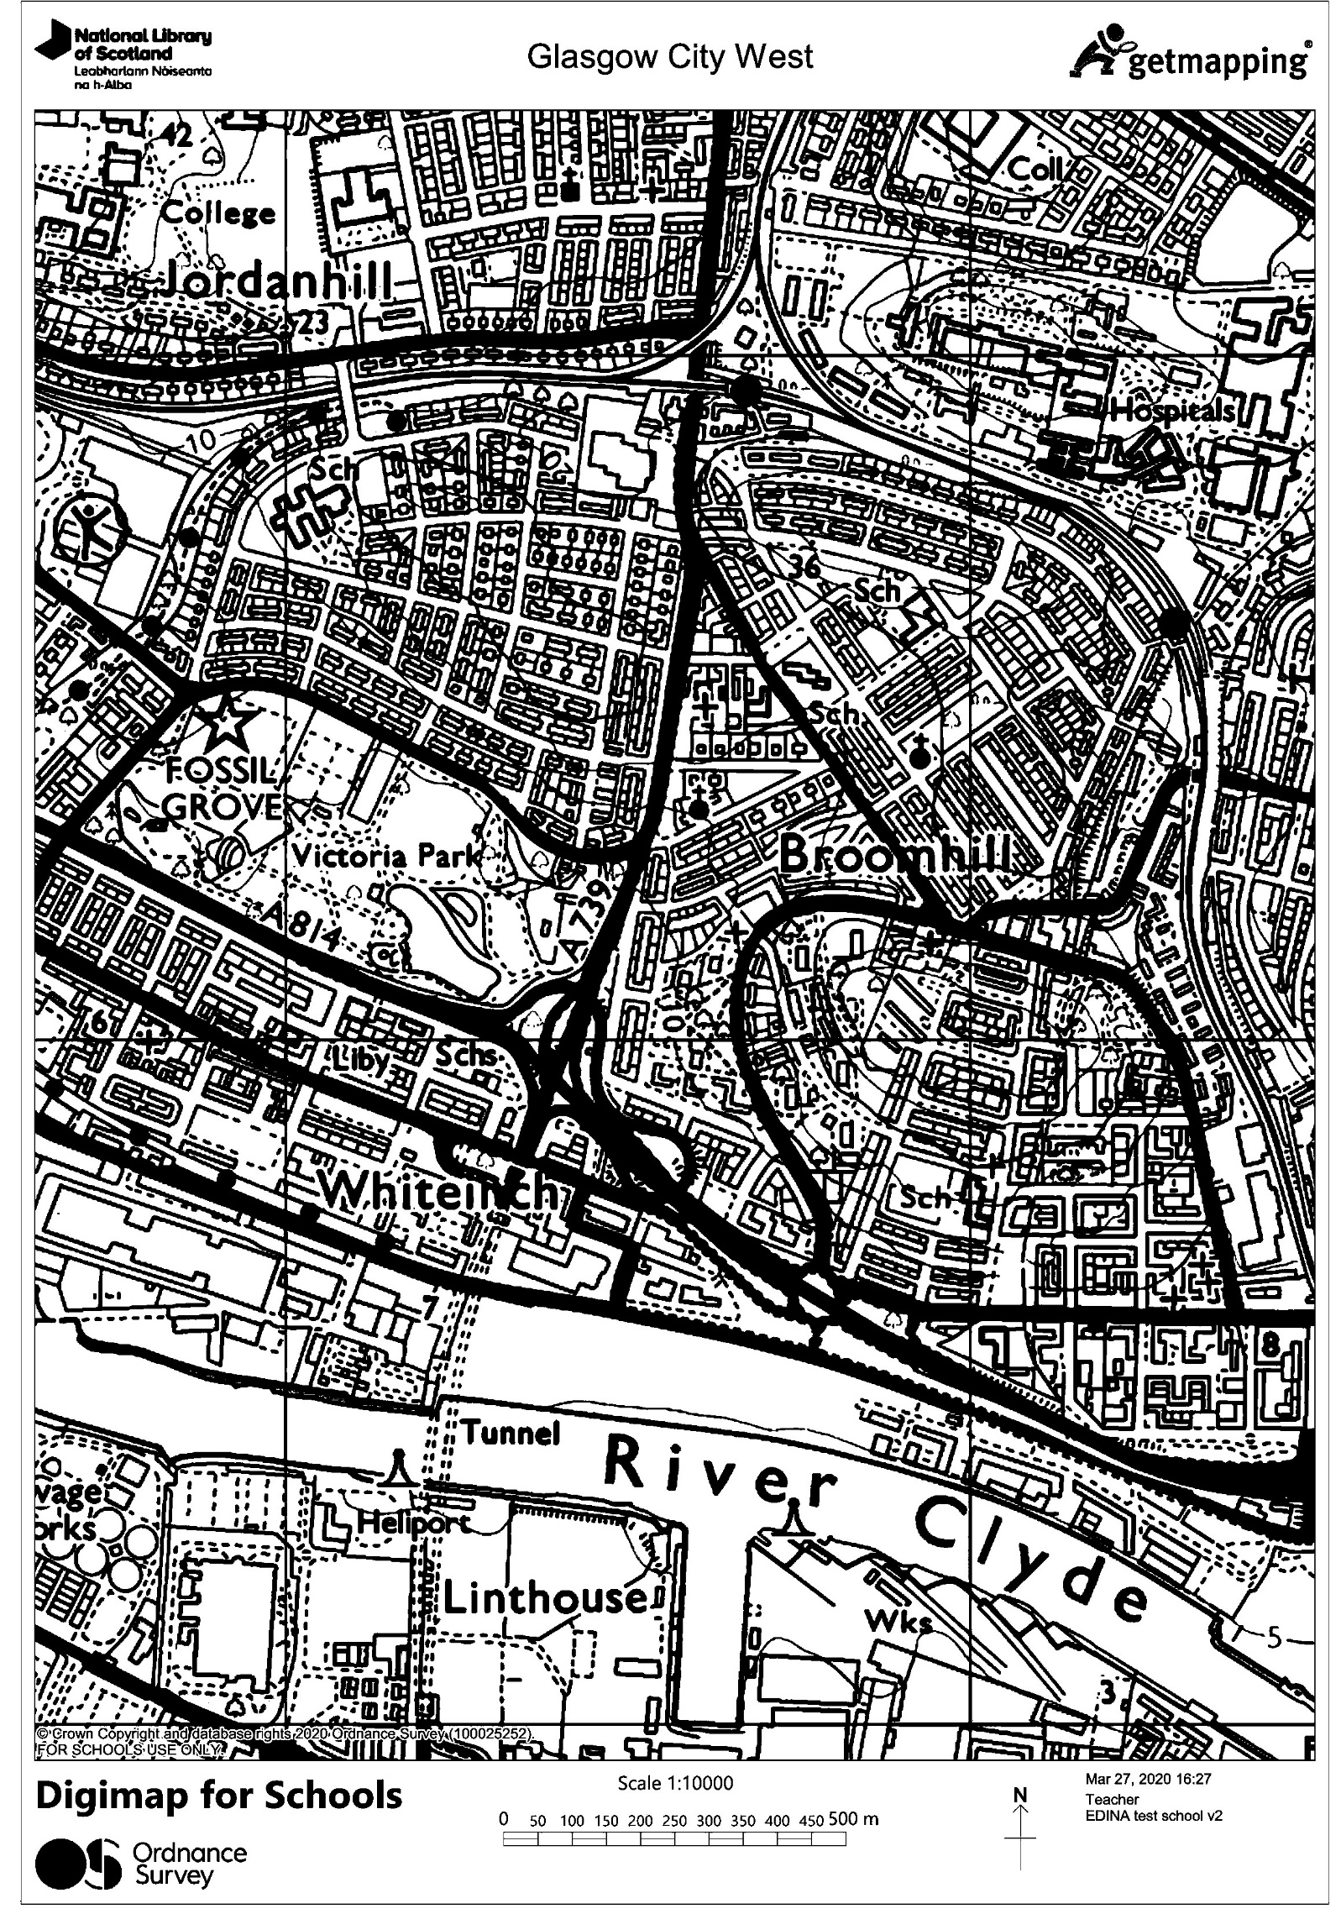

Decide how you are going to colour in the map before you start. We’ve put in the first colour to give you the idea. Add more types of land use if you need to
Create a map key
Farming
Housing
Green space
Industrial
Schools and colleges
Medical
Copyright
©EDINA at the University of Edinburgh 2020
This work is licensed under a Creative Commons Attribution Non-Commercial Licence

Acknowledgements
© CollinsBartholomew Ltd (2019) FOR SCHOOLS USE ONLY
© Crown copyright and database rights 2020 Ordnance Survey (100025252). FOR SCHOOLS USE ONLY.
Aerial photography © Getmapping plc. Contains OS data. FOR SCHOOLS USE ONLY.
Historic mapping courtesy of the National Library of Scotland. FOR SCHOOLS USE ONLY.

