How did 19th century migration affect Scotland?

Will Tuft

P7 - National 5 History Resource

Contents
Digimap for Schools Geography Resources 3
Learning intention 3
Level 3
Curriculum for Excellence Experiences and Outcomes: 3
Success Criteria 3
Equipment 3
Time allocated 3
Introduction 4
Starter 5
Activity 5
Extension 8
Plenary 8
Copyright 9
Acknowledgements 9

Digimap for Schools Geography Resources
These resources are a guide for teachers to demonstrate to the whole class or direct individual students as appropriate. Each activity has several ideas within it that you can tailor to suit your class and pupils. Some resources contain worksheets for direct distribution to pupils.

Learning intention
How did 19th Century migration affect Scotland’s urban areas?

Level
P7- S4/National level

Curriculum for Excellence Experiences and Outcomes:
SOC 3-01a
- I can use my knowledge of a historical period to interpret the evidence and present an informed view.
SOC 4-05a
- I can present supported conclusions about the social, political and economic impacts of a technological change in the past.
SOC 4-05b
- I can evaluate the changes which have taken place in an industry in Scotland’s past and can debate their impact.

Success Criteria
- All pupils will learn how to describe the pattern of 19th Century migration in Scotland.
- Most pupils will learn how to explain the reasons for this pattern.
- Some pupils will learn how to predict patterns and impacts based on resources.

Equipment
Digimap for Schools story map/Digimap for Schools to develop your own

Time allocated
1 lesson

Introduction
The content in this lesson is designed for National level History but could be utilised by several levels dependent on ability. The map element here is designed to provide location based memory tools with which pupils can refer back to when revising. The use of graphical tools also allows visual patterns to be produced to elucidate the scale of migration at the time. The lesson is designed to sit within the structure of a series of lessons based around migration or a standalone revision topic. The structure could be implemented for a range of migration case studies and used to develop pupils’ understanding of how location affects History.

Starter
Project the statement ‘ Scotland is better because of migration’ onto the board. Through directed questioning and class discussion, get pupils to state their opinion on this and 1 reason why. To complete the starter, make the counter claim that most of the people in the room, if not all, are migrants, be it Europe, Vikings, Irish etc. This could be extended by displaying a personal or famous person’s family tree. This statement acts as a lead into when one of the largest migrant movements into Scotland took place, the late 19th century.

Activity
Pupils are provided with the story map. Ideally this would take place on tablets/computers but it can be a printed copy which is attached to this document. The creation of the map by pupils is not as important here because the usage of sources is an integral skill in History assessments.

- They are to firstly identify features of Glasgow in the 1890s which would encourage people to move to the area, labelling and annotating the features. See the sample map and image of the Drawing Tool menu below.

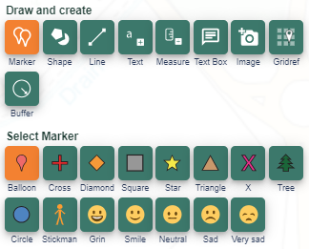
- Then, using the same map and associated resources, add stick men to show the points of Glasgow where migrants moved to e.g. Jewish migrants to the Gorbals area, and using a teacher’s own resource or a BBC website: http://www.bbc.co.uk/education/guides/zjfcwmn/revision/5

- Add a separate annotation or label attached to the stick man, identify the push factors for migration, as each migrant group had different reasons for moving.

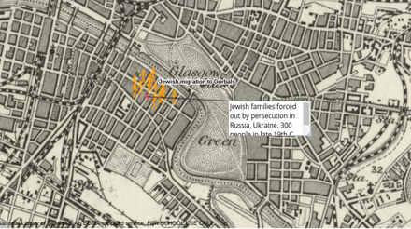

Any one of these smaller tasks can be linked to an exam question such as ‘describe patterns of migration to Glasgow’ or ‘explain reasons for migration in the 19th Century’. This type of questioning would also fit in well with Geographical concepts, allowing a cross curricular Social Sciences application. A possible structure for the creation of this map is included with this lesson plan.

From here, two options are viable, a theoretical paragraph can be written about the impacts of migration on the cities in question or another map opened and specific impacts can be located in the city (this may be more beneficial if your school has already undertaken case studies on or is located in the city).

The map below shows the growth of the city and could be used a base for the impacts of growth. The draw freehand polygon tool was used to create this map.
The independent nature of this task will allow older pupils to develop research skills, data presentation and attempt a strategy for revision purposes if this is used as an introduction to migration into Glasgow.

Extension
Identify similarities or differences between how and why Glasgow grew and the growth of another Scottish city, perhaps Edinburgh or Aberdeen. This high level comparison allows pupils to utilise theoretical knowledge and apply it to a different location. This also encourages a breadth of understanding rather than the rote learning of one particular case study exemplar. This may be particularly useful if the lesson is taking place outside of Glasgow.

Plenary
A summary of the push and pull factors. Give all pupils a post it note, ask all
pupils to write either a push or pull factor onto it. Collect up and then give out at random. Get pupils to move to one side of the room dependent on push or pull. Dependent on time, this could be further extended to ask pupils to judge which were the most important and to rank the factors they have.

Copyright
©EDINA at the University of Edinburgh 2016
This work is licensed under a Creative Commons Attribution-Non Commercial Licence

Acknowledgements
© CollinsBartholomew Ltd (2019) FOR SCHOOLS USE ONLY
© Crown copyright and database rights 2020 Ordnance Survey (100025252). FOR SCHOOLS USE ONLY.
Aerial photography © Getmapping plc. Contains OS data. FOR SCHOOLS USE ONLY.
Historic mapping courtesy of the National Library of Scotland. FOR SCHOOLS USE ONLY.

