Find the grid reference!

Login
- Login to Digimap for Schools.
- https://digimapforschools.edina.ac.uk/
- Select Login
- Type the username and password – talk to your teacher if you don’t know these.
- Select Login.
You should see a map of Great Britain like this picture:
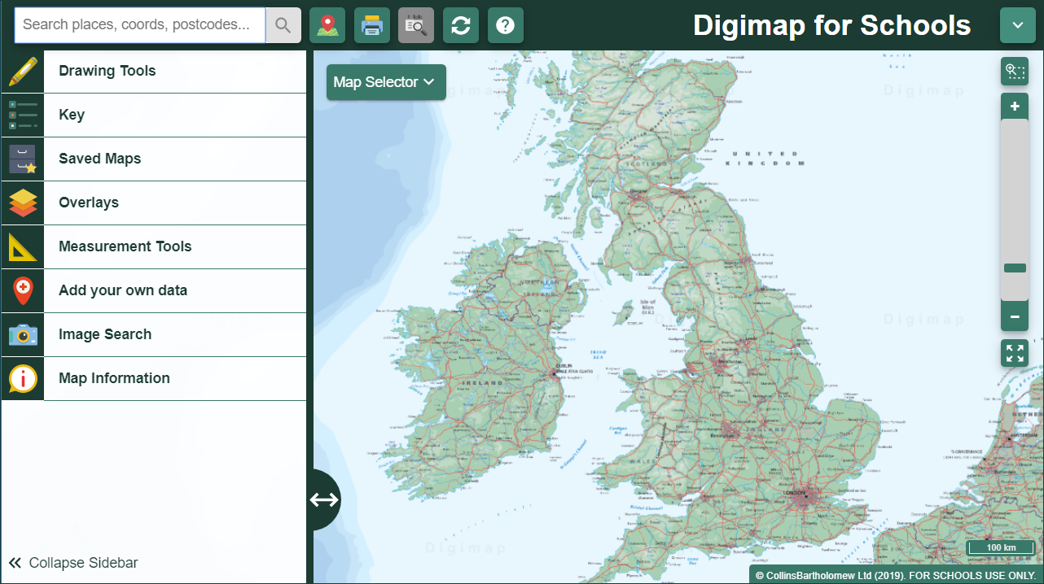

Find a grid reference

- Let’s try and get a reference for Hadrian’s Wall.
Type Hadrians Wall in the search box.
Select Hadrians Wall (Northumberland) from your results.
Your map should look like the picture below.

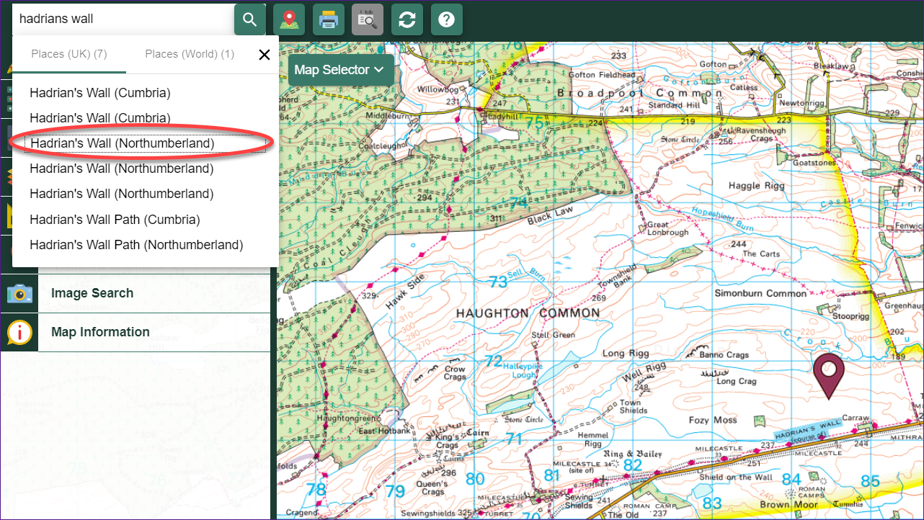
Now select Overlays on the left, then British National Grid. Now we can see the British National Grid lines on our map.
We want a grid reference for the grid square shown in red on the map below.
We always give a reference for the bottom left or south west corner, as shown by the arrow in the picture below.
First we need to find our Easting line number. Eastings are vertical lines that go from west to east. We go “along the corridor” to find the number.
It’s number 84.

Now find the Northing line number. Northings are horizontal lines that go from south to north. We go “up the stairs” to find the number.
It’s number 71.

Now we need to add in the Grid Square name…it’s shown on the map, NY.
So we put it all together:
  - Grid square NY,
  - Plus Easting line 84,
  - Plus Northing line 71 =
  - NY 84 71
This is a 4 figure grid reference. It identifies the grid square, which is 1km on each side.

Check your reference
You can check in two ways.
- Search with your grid reference.
  - Input NY8471 in the search box.
  - Select NY8471 from the results list.
  - You should be at our grid square in the map window. You may be zoomed in further and looking at a more detailed map…zoom out 2 or 3 times to check you’re at the right spot.
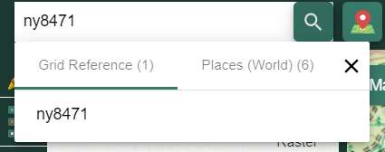
Add a grid reference marker.
  - Select Drawing Tools on the left.
  - Select the Place a Grid Reference tool. It’s under the Draw and Create area.
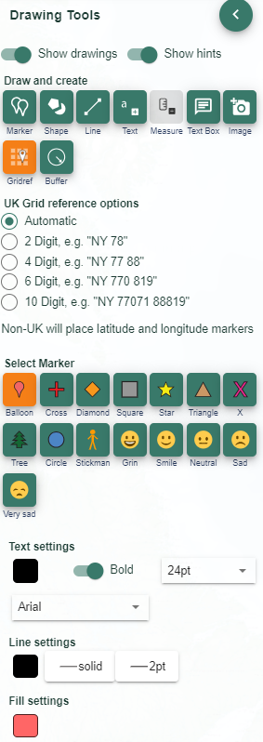
Select our grid square and a grid reference will be placed there.
My grid reference marker says NY84019 71201. This is a 10 figure grid reference and is much more detailed than our grid reference (NY 84 71). That doesn’t mean our reference is wrong! It is just less accurate.
To check our reference is right we can just look at the first two numbers in the Easting and Northing.
The Easting is 84019. The first two numbers are 84, the same as we identified.
The Easting is 71021. The first two numbers are 71, the same as we identified.

Practise!
- Try and find 4 figure grid references for each of the spots detailed below.
Then add a grid reference marker to get the 10 figure grid reference.
Place | Clue | Grid Ref 4 figure | Grid Ref 10 figure
Hadrian’s Wall |  | NY 84 71 | NY84019 71201
Stonehenge | none
Tower of London | Postcode EC3N 4AB
Roman Baths | Bath, North and East Somerset, postcode BA1 1LZ
York Minster | York YO1 7HH
Welsh Assembly | Cardiff Bay CF10 4WZ
Canterbury Cathedral | Canterbury (Kent), postcode CT1 2EE
Warwick Castle | Warwick, postcode CV34 4QX
Edinburgh Castle | Old Town, postcode  EH1 2NG
Chester Zoo | Look north to Upton, CH2 1EU
Eden Project | North East from St Austell

Answers!
Here are the answers.
*Remember your 10 figure grid reference will probably be different, as these are very detailed. You will probably not select exactly the same spot as me on the map.

Place | Grid Ref 4 figure | Grid Ref 10 figure
Stonehenge | SU 12 42 | SU 12222 42205
Tower of London | TQ 33 80 | TQ33610 80563
Roman Baths | ST 75 64 | ST 75075 64638
York Minster | SE 60 52 | SE 60330 52180
Welsh Assembly | ST 19 74 | ST 19417 74417
Canterbury Cathedral | TR 15 57 | TR15100 57927
Warwick Castle | SP 28 64 | SP 28335 64631
Edinburgh Castle | NT25 73 | NT25144 73541
Chester Zoo | SJ 41 69 | SJ41052 69865
Eden Project | SX 04 54 | SX 04845 54771

Copyright
©EDINA at the University of Edinburgh 2020
This work is licensed under a Creative Commons Attribution Non-Commercial Licence

Acknowledgements
© CollinsBartholomew Ltd (2019) FOR SCHOOLS USE ONLY
© Crown copyright and database rights 2020 Ordnance Survey (100025252). FOR SCHOOLS USE ONLY.
Aerial photography © Getmapping plc. Contains OS data. FOR SCHOOLS USE ONLY.
Historic mapping courtesy of the National Library of Scotland. FOR SCHOOLS USE ONLY.

