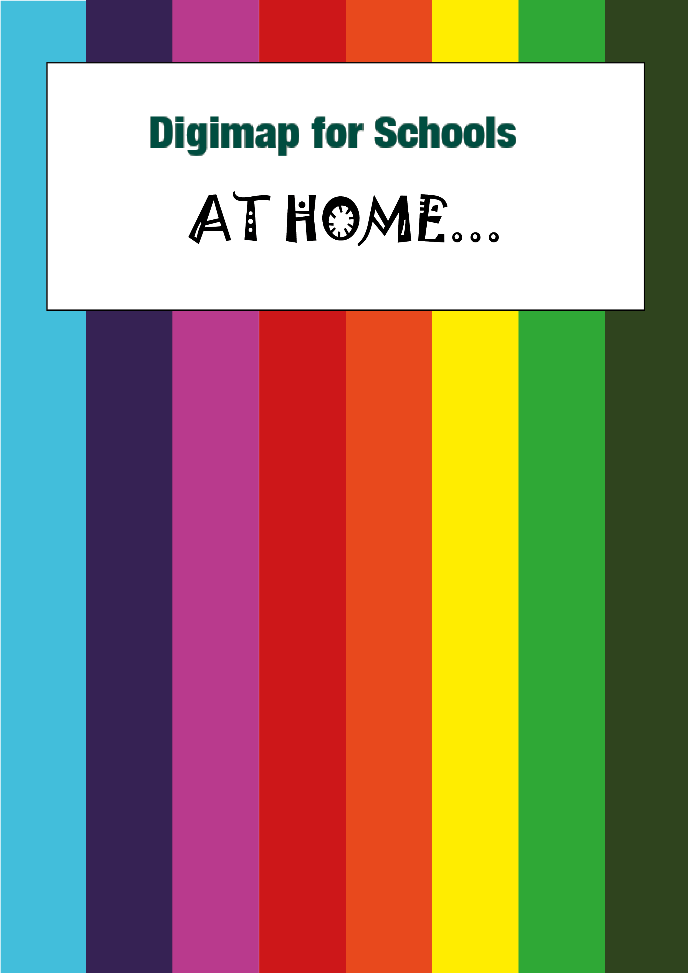
Name the City!
What to do

Login to Digimap for Schools.
- https://digimapforschools.edina.ac.uk/
- Select Login
- Type the username and password – talk to your teacher if you don’t know these.
- Select Login.

You should see a map of Great Britain like this picture:
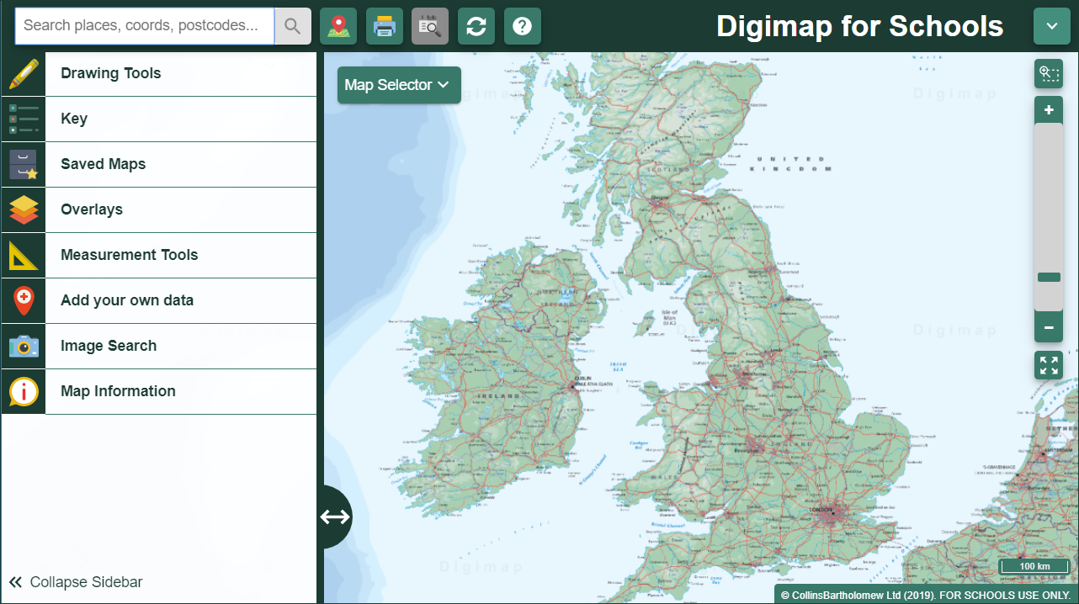

Look at our map (page 3) and choose a symbol.

Move around the map in Digimap for Schools to find the city for that symbol.
- Watch our video to see how to move around and zoom in and out.

Write the city name on the list on page 4!
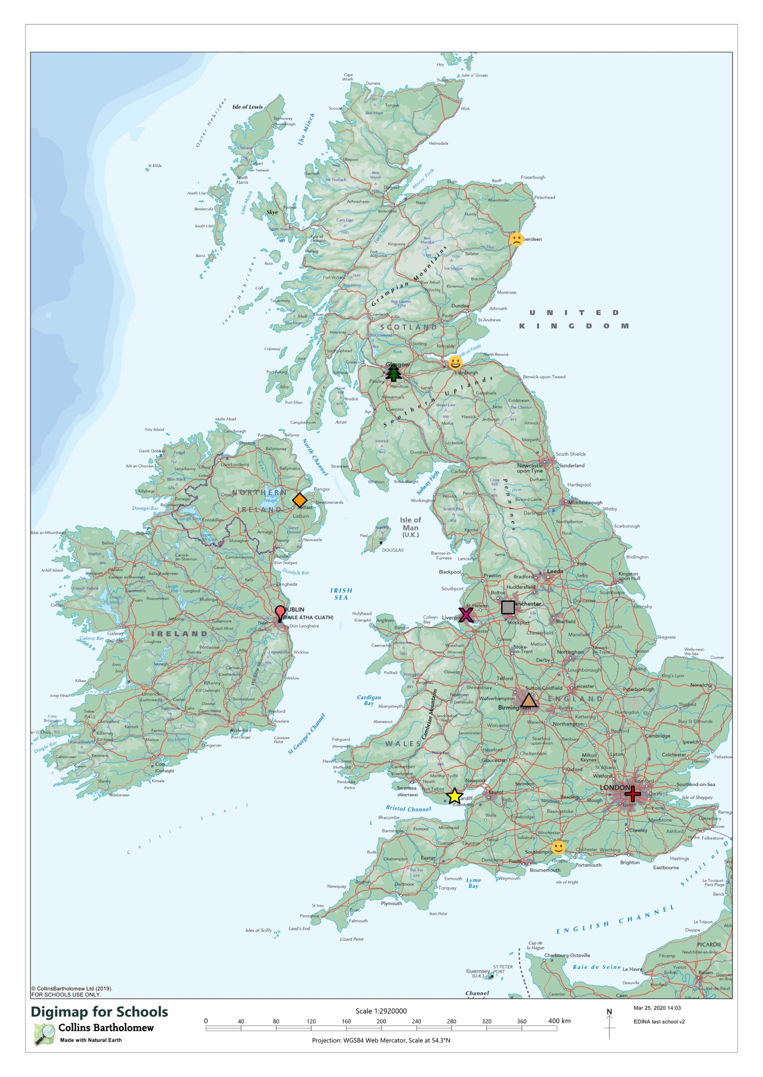

Symbol | City?
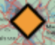

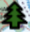

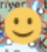

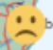

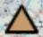

Copyright
©EDINA at the University of Edinburgh 2020
This work is licensed under a Creative Commons Attribution Non-Commercial Licence

Acknowledgements
© CollinsBartholomew Ltd (2019) FOR SCHOOLS USE ONLY
© Crown copyright and database rights 2020 Ordnance Survey (100025252). FOR SCHOOLS USE ONLY.
Aerial photography © Getmapping plc. Contains OS data. FOR SCHOOLS USE ONLY.
Historic mapping courtesy of the National Library of Scotland. FOR SCHOOLS USE ONLY.

