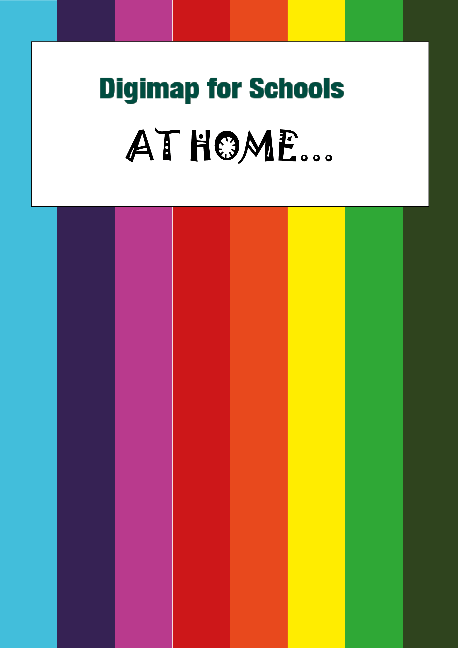

Writing our History!

What’s it about?

Let’s try and find out more about a place’s history. What has changed? What is still the same?
Talk to a parent, grandparent, other relative or friend to see what you can find out! You can do this for your own town or a different place.

Make a plan!
- WHO…are you going to talk to…a grandparent, aunt or uncle, a family friend? Ask a parent to organise a video or phone call.
- WHERE…what’s the place? Where did they grow up?
- WHAT… are your questions? Think about what you can ask… We’ve given you some ideas below.
- WRITE…it down. You can add the interesting things you find out to a map of your place in Digimap for Schools!

What…?

Here are some ideas for questions you could ask. Remember to check your list with a parent before your video or phone call.

- Where did you grow up?
- What was your home like?
- Is your childhood home still there?
- Where was your school?
- What did you like about school?
- What are your memories of school?
- Who was your best friend? Did they live nearby? What did you do or play together?
- Did you have a job? If yes, what was it? Do people still do that job today?
- Where did you shop for food? Small shops or a supermarket?
- Did you know where the food came from? What can you buy now that you couldn’t buy when you were a child?
- When did you leave home? Where did you go then?
- What was your job? Do people still do that kind of job now?
- What’s the first memory you have?
- What did you do for fun? Was there a cinema or places for dancing or sports?
- What places do you remember that are not there now?

Write…it down

First, find a map of your place.
- Login to Digimap for Schools.
  - Go to: https://digimapforschools.edina.ac.uk/
  - Select the Login button
  - Put in your username*
  - Put in your password*
  - Select Log In
*Ask a teacher if you don’t know this
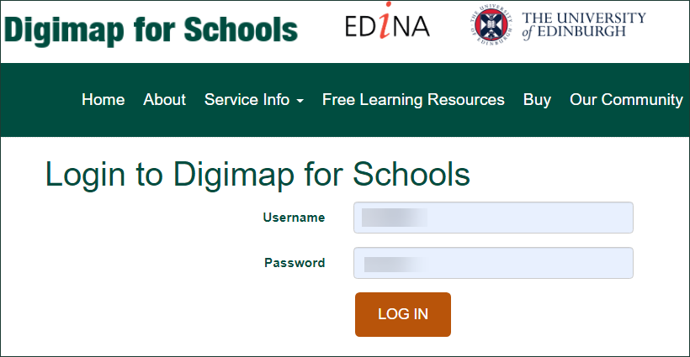

- Go to your place. You can type the place name or postcode in the Search box.
- Zoom in or out until you can see enough detail.
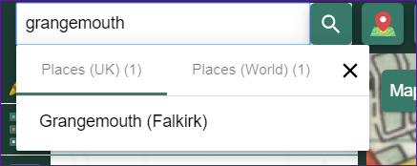

- Now open the Map Selector.
- Try the different maps…just select the button to the right of any map name to open it.
- What map works best? A historic map, or a current one? A 1950s map is ideal for the person I interviewed – they grew up in the 1940s. But your person may be much younger and so you might want an Ordnance Survey map or Aerial map.
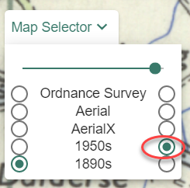

Now write down some answers
With the Drawing Tools, you can add text, emojis and shapes to a map. Try and record some of the answers you got.

- Select Drawing Tools – look on the left.
- Add a text label: maybe something like ‘Grandma’s town’ or ‘Talking to Aunty Louise’.
- Can you find where they lived (if it’s still there) and add a marker? Just choose your marker then select the house or street.
- Try and add markers or emojis for important places like their school, places they had fun or worked.
- Add labels or text boxes with any of the interesting things they told you.
- Keep adding emojis, text and labels until you are happy with your map

Share your work
- Select Print – look above the map
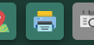
- Type in a title, your name.
- Select Generate Print file.
- Your computer will ask you where to save your PDF file.
- You now have a map you can share with your family, teacher, friends or US! We would love to see it. Tweet us @digimap4schools.

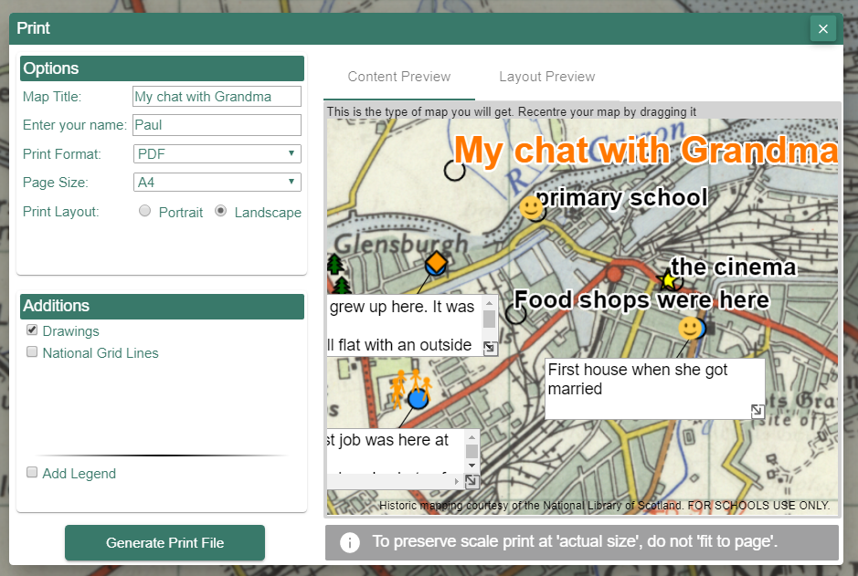

Copyright
©EDINA at the University of Edinburgh 2020
This work is licensed under a Creative Commons Attribution Non-Commercial Licence

Images
Image by Anastasia Gepp from Pixabay
https://pixabay.com/photos/girl-young-board-phone-mobile-3718512/

Acknowledgements
© CollinsBartholomew Ltd (2019) FOR SCHOOLS USE ONLY
© Crown copyright and database rights 2020 Ordnance Survey (100025252). FOR SCHOOLS USE ONLY.
Aerial photography © Getmapping plc. Contains OS data. FOR SCHOOLS USE ONLY.
Historic mapping courtesy of the National Library of Scotland. FOR SCHOOLS USE ONLY.

