Identifying Change in River Channels
Janet Hutson
Geography Teaching Resource
GCSE
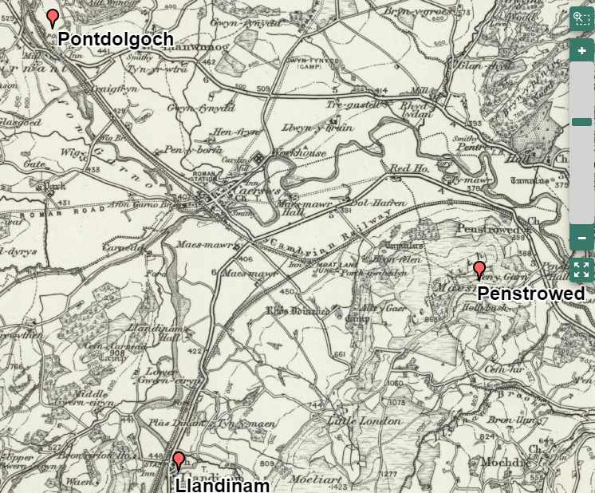

Contents
Digimap for Schools Geography Resources 3
Content and Curriculum Links 3
Summary 5
Introduction 5
Main activity 6
River Severn maps 7
Sources of further information 8
Identifying change in river channels 9
Locate the rivers Carno and Severn 9
Mark river features 9
Questions 9
Compare historical map with present day 10
Taking it further 11
Other locations 11
Copyright 12
Acknowledgements 12

Digimap for Schools Geography Resources
These resources are a guide for teachers to demonstrate to the whole class or direct individual students as appropriate. Each activity has several ideas within it that you can tailor to suit your class and pupils. Some resources contain worksheets for direct distribution to pupils.

Content and Curriculum Links

Level | Context | Location
GCSE | Fluvial erosion & deposition, river channel features and change are part of KS4 examination specifications. | Examples used are Afon Drwsy-Coed, Gwynedd and the Yorkshire Derwent. Practical activities use the Afon  Carno/River Severn at Caersws In Powys. Alternatives are suggested.

Knowledge
Prior knowledge about river erosion, transportation and deposition and channel features, in particular meanders, cutoffs (ox-bow lakes), though some background is provided. Identification of river channel characteristics on Ordnance Survey maps. Use of Digimap for Schools including annotation and measuring tools.
Curriculum links (England)
Develop and extend their knowledge of locations, places, environments and processes.
Gain understanding of the interactions between people and environments, change in places and processes over space and time, and the interrelationship between geographical phenomena at different scales and in different contexts.
Develop and extend their competence in a range of skills including those used in fieldwork, in using maps and Geographical Information Systems (GIS) and in researching secondary evidence including digital sources.
Physical geography: Processes and Change
How geomorphic processes (e.g. weathering, slope movement and erosion by water, wind and ice) have influenced and continue to influence the landscapes of the UK and the interaction of those processes with human activity.
Scottish Curriculum for Excellence
Geography: Physical Environments (National 4)
In this unit learners will develop geographical skills and techniques in the context of physical environments. Learners will develop a straightforward knowledge and understanding of the processes and interactions at work within physical environments.
Key topics include location of landscape type and formation of landscape features; land use management & sustainability, and weather.

Geography: Physical Environments (National 5)
In this Unit, learners will develop geographical skills and techniques in the context of physical environments. Learners will develop a detailed knowledge and understanding of the processes and interactions at work within physical environments. Key topics include: Location of landscape type; formation of key landscape features; land use management & sustainability; and weather.
Curriculum Links (Wales)
GCSE Specifications in geography must require learners to demonstrate knowledge and understanding of:
Aspects of physical and human geography and their associated processes, including relationships between people and environments.
GCSE Specifications in geography must require learners to: Extract and interpret information from a range of sources including maps (including Ordnance Survey maps of different scales).
Describe, analyse and interpret evidence.

Summary
Students frequently seem to think the landscape is either changing constantly or has not really changed at all. There can be confusion over the connection between processes of landscape change, erosion and deposition, change events, and persistence of features. The human lifetime is long enough for very minor features to be created or modified, though at a given point in time, major changes can occur, suddenly, and dramatically.
The real extent of landforms creates another issue. What would students expect to be able to identify and measure on a map? Local knowledge and fieldwork, where possible, help to give a context. If not seen in situ, do students have a good idea how big features are? Diagrams in books or on websites may not help with this. Practical activities using rope, in corridors, or better still, outside will indicate how close to reality students’ mental images are.
This activity attempts to identify changes in river channel features. It also enables teachers and students to consider whether changes are natural or man-made and perhaps to speculate on the future. The time interval between the maps is not huge in terms of landscape change but the fact that significant change generally happens infrequently but suddenly means that some rivers will demonstrate alteration. However, the question of scale is critical and students should consider what could be visible on a map compared with in reality. There is opportunity to draw upon fieldwork experience and/or the use of projected images to increase appreciation.

Introduction
River channel features in the UK range in size from square centimetres to tens of square metres. They are created over a few thousand years or less and persist for a similar length of time. They result from the interaction of atmospheric processes with rock structure and texture. For features to form or change, erosion and deposition take place.
Erosion can be considered the active wearing of channel wetted perimeter and not just temporary entrainment of loose material in the channel. Few British channels are being eroded in bedrock; it is the covering, often metres thick, of sediment in a range of sizes that is being worn away. Erosion increases with discharge using energy not required to simply move the water along.
Key erosional processes are: corrasion; hydraulic action; corrosion; cavitation; attrition.
Note: PowerPoint Presentation “Channels form and change” could be used here.

Main activity
This activity encourages students to look at river channels and courses to identify change over time. It requires careful study of river channels on current and historical maps, to identify where erosion and deposition might have taken place, students are also asked to describe that change and to consider the role of humans.
Use the 1890s toggle to fade between the historic and the modern map. When the historic maps were made the national grid reference framework did not exist, so detail on the old map may sometimes not fit exactly to the modern map and you may notice that the fit between the two maps worsens as you zoom in. If you see a difference in, for example, the course of a river, it does not mean the old maps were very inaccurate, or that a feature has since completely moved, but it is not possible to completely correlate the 1890s and modern mapping frameworks within a seamless GB dataset.
There may also sometimes be a noticeable difference between details on the old map at what would have been the edges of the paper map sheets. This can be caused by sheets being of a different date, and sometimes due to a difference in the meridians used between the old maps. If you come across these you can point them out to your students so they can understand the limitations of using old and new resources together. Uncovering and noticing these locations where the maps don’t fit exactly could even become part of the activities you plan.

River Severn maps
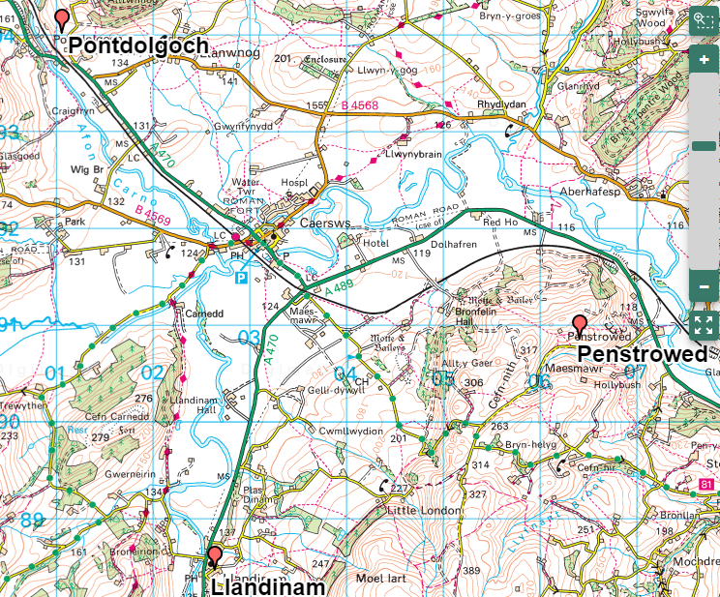

Sources of further information
- A number of photos of the Severn at/near Caersws showing the channel and floodplain: www.geograph.org.uk
- An app showing the underlying geology of the UK. Historical layer available. www.bgs.ac.uk/igeology/

Identifying change in river channels

Locate the rivers Carno and Severn
- Search for “Caersws” in Digimap for Schools
- Using the annotationas toolbar add markers to the following places:
- Pontdolgoch on Afon Carno
- Penestrowed – east of the River Severn
- Llandinam – south of the River Severn
- Afron Carno is a tributary of the River Severn, which one has more meanders?

Mark river features
- Enlarge the map so that Caersws is in the top left quarter and the zoom level is at 5 from the top.
- Place different style of marker on the Severn in a place of erosion.
- Place another style of marker in a place of deposition.

Questions
- Is the course more or less sinuous today than on the historical map?
- Are there more or fewer meanders on the River Severn section? On the Afon Carno section?
- Have any meanders changed size or shape?
- Are there any other channel features present on one map but not the other?

Compare historical map with present day
- Use the ’draw a line’ tool to draw along the middle of the river.
- Open the Map Selector Tool. Select 1890s and 1950s map.
- Do you notice any differences?
- Is the course more or less sinuous today?
- Have any meanders changed size or shape?
- Are there any other channel features present on one map but not the other?

Taking it further
Look at the two photos of Caersws and the River Severn. The first is taken from the north-west and the second, more distantly, from the east.

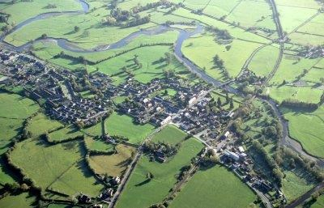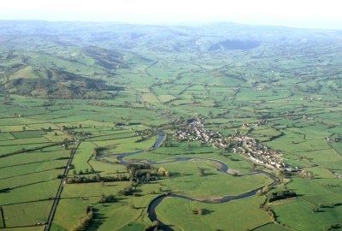
Images reproduced by kind permission of Clwyd-Powys Archaeological Trust

Identify the area on the map
- How do the photos emphasise the likelihood of many changes being a result of natural processes?
- Some settlements on the River Severn suffered severe flooding in 2007. How safe do you think Caersws is?

Other locations
- Yorkshire River Esk, south and south-east of Houlsyke.
- The Cumbrian River Derwent at the southern end of Lake Bassenthwaite shows channel changes mainly from human interference. Streams which appear to have been initiated between the two maps are probably a result of mapping convention; check the map key for historic maps.

Copyright
©EDINA at the University of Edinburgh 2016
This work is licensed under a Creative Commons Attribution-Non Commercial Licence

Acknowledgements
© CollinsBartholomew Ltd (2019) FOR SCHOOLS USE ONLY
© Crown copyright and database rights 2020 Ordnance Survey (100025252). FOR SCHOOLS USE ONLY.
Aerial photography © Getmapping plc. Contains OS data. FOR SCHOOLS USE ONLY.
Historic mapping courtesy of the National Library of Scotland. FOR SCHOOLS USE ONLY.

