Lighthouse for Sale!

Lighthouses and Coast

Paula Owens

Geography Teaching Resource

Primary
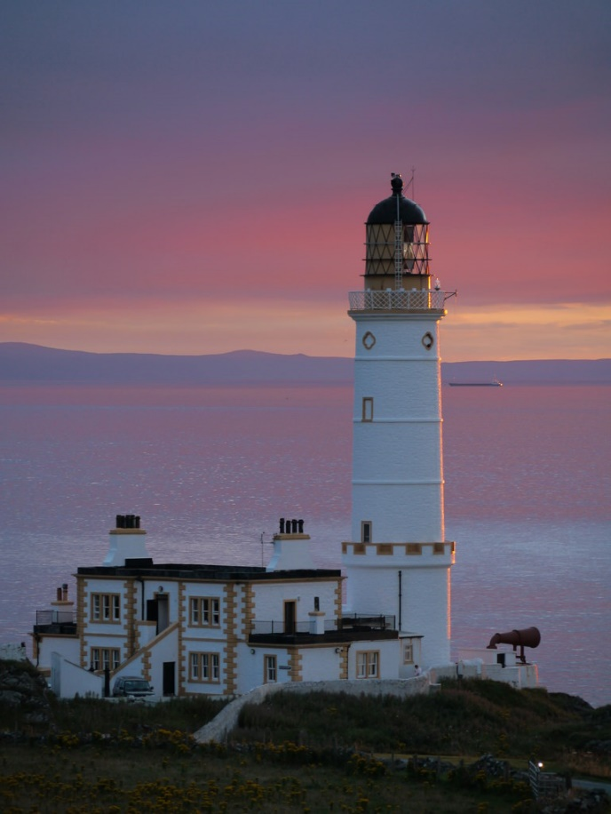

Contents
Digimap for Schools Geography Resources 3
Content and Curriculum Links 3
Activity 4
Introduction 4
Main activity 4
Support Sheet: ‘lighthouse for sale’ example 5
Lighthouse for sale 5
Task: Write an advert 6
Create Map 1 6
Create Map 2 7
Further research 8
Advert worksheet 9
Taking it further 10
Web links 10
Copyright 11
Acknowledgements 11

Digimap for Schools Geography Resources
These resources are a guide for teachers to demonstrate to the whole class or direct individual students as appropriate. Each activity has several ideas within it that you can tailor to suit your class and pupils. Some resources contain worksheets for direct distribution to pupils.
https://digimapforschools.edina.ac.uk/

Content and Curriculum Links
Level | Context | Location
Primary | Lighthouses and coast | Coastlines around Great Britain

Knowledge | Interpreting Ordnance Survey symbols and map features.  Annotating maps. Measuring and highlighting areas on maps. Adding labels.
Curriculum links (England) | Name and locate geographical regions of the UK and their identifying human and physical characteristics, key topographical features (including hills, mountains, coasts and rivers), and land-use patterns; and understand how some of these aspects have changed over time.  Use digital/computer mapping to describe features studied.
Curriculum links (Wales) | Identify and locate places; use maps, imagery and ICT to find and present locational information.  Describe the causes and consequences of how places and environments change.
Scottish Curriculum for Excellence | Social Studies Outcomes: People, Place and Environment 2-13a, 2-09a, 2-14a, 2-10a.

Activity
Pupils have to act as estate agents and create a selling blurb with maps for Muckle Flugga lighthouse.

Introduction
A lighthouse is a structure, often a tower, which emits light to aid navigation for those at sea or on inland waterways. Lighthouses serve many purposes: they mark dangerous coastlines; warn of hazardous reefs or shoals, show where safe access is to harbours and also help with aerial navigation.
Muckle Flugga lighthouse was built on the most northerly rock in the British Isles: the rocky stack of Muckle Flugga, north of the Island of Unst in the Shetland Islands, Scotland.

Main activity
Muckle Flugga lighthouse is up for sale and pupils have the job of trying to sell it! They need to create a one page overview of its selling points and plan what they might put on a web page. Pupils also need to create one map showing its location on a large scale map and one showing its location in GB.

Support Sheet: ‘lighthouse for sale’ example

Lighthouse for sale

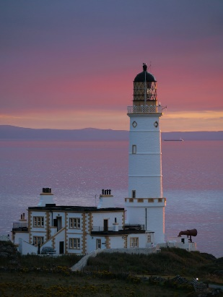
© Copyright James T M Towill, www.geograph.org.uk
Price: offers in excess of £1.25 million.
Location and getting there: the Hotel is located 15 minutes from the town of Stranraer. Take the A718 signposted to Kirkcolm and thereafter the B738 to Corsewall and the lighthouse.
Views: The stunning location – there are views of Arran, Ailsa Craig and over to the coast of Ireland – has made the hotel one of the most unusual in Britain, with real prospects as a going concern.
The Property: Luxury is not a word you normally associate with lighthouses, but Corsewall in Kirkcolm, combines spectacular views with a four star hotel rating. It was first lit over 185 years ago as a warning for ships approaching the mouth of Loch Ryan. And Corsewall lighthouse still performs that same function, casting a powerful beacon into the night sky from its rocky location on the very edge of the west coast of Scotland. These days, however, the lighthouse is most famous for its award-winning hotel. The lucky owner will get six individually styled rooms, many with unique features, and a beautiful 28-cover restaurant. Within the 20 acre grounds are five recently renovated cottage style suites – four two-bed and a one-bed cottage – which can be run on a self-catering basis.
Opportunity: Knight Frank’s hotel expert, said: ‘Corsewall Lighthouse Hotel is a great opportunity which should easily appeal to buyers from Scotland, England and Ireland.’ (Details adapted from original property advertisement Knight Frank Estate Agents.)

Task: Write an advert
Use the example above and Advert worksheet provided to help you write your own advert for Muckle Flugga lighthouse:

- Decide how much the lighthouse might be worth. You may want to revise this when you have finished describing the property and the opportunities.
- Research

Create Map 1

- Search Digimap for Schools using the term ‘Unst’ and find Muckle Flugga.
- Describe the location of Muckle Flugga and how to get there. Create a map to show the lighthouse clearly identified and labelled.
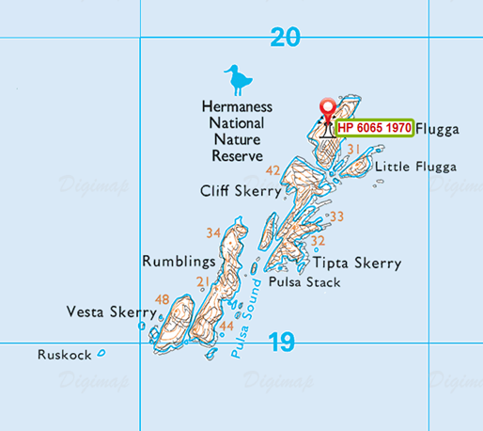
- Locate the Ordnance Survey symbol on the map for ‘lighthouse in use’ on Muckle Flugga.
- Open the Drawing Tools.
- Select the ‘Grid reference tool’ and click on the lighthouse. A grid reference number will appear at the point you click. Highlight and copy the number, then click on ‘Place standalone label’, choosing text size of 20. Click near to Muckle Flugga and when the text box appears paste the grid reference number into it and then select Ok.
- Measure the area of Muckle Flugga. Select Measurement Tools from the sidebar, select Area. Measure the area of Muckle Flugga rock and note it. This is useful for your sales pitch.
- Zoom in and out of your map and decide what the best scale is to show the area of Muckle Flugga and its lighthouse.
- When you are happy, print your map.
- Select Print above the map.
- Give the map a title and select options:
  - Format: JPEG as your print format.
  - Orientation: Portrait.
  - Size: A4.
  - Select 'Make printable map'. You will be prompted to open the map. Do this to check that you are happy with it then select 'save as', give the JPEG image a name and save to your computer.

Create Map 2
- Make another map to show the location of the lighthouse in relation to GB. First, add a marker to the lighthouse position. When you zoom out to a smaller scale map, the lighthouse symbol and the entire detail of the islands will be lost so you need to have a marker to show where the lighthouse is.
- Zoom out until you are happy you can see the location of the lighthouse and most of the GB. You might need to move your grid reference label if it is not clearly placed or overlaps the marker you have added. For this select your label and move it. Don’t move your marker as this shows exactly where the lighthouse is.
- Use your maps to help you add additional information to your advert such as what kind of views might be had.
- Insert your JPEG images of maps into your advert document.
- Zoom in and out of your map and decide what the best scale is to show the area of Muckle Flugga and its lighthouse. When you are happy with this, give the map a title and select printing options. Print your map as a JPG. You will be prompted to open the map. Do this to check that you are happy with it then select 'save as', give the jpeg image a name and save to your computer.
- Insert your JPEG images of maps into your advert document.
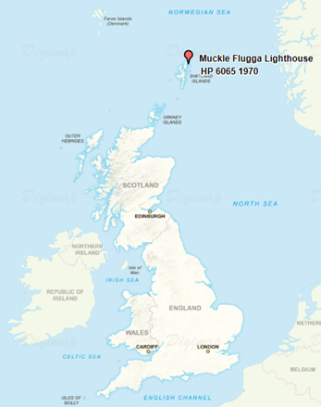

Further research
Use the maps in Digimap for Schools to help you add additional information to your advert such as:
- What kind of views might be had from the lighthouse.
- The history of the location.
You also research the Internet to find some images of the lighthouse or surrounding area to add to your advert.

Advert worksheet

Lighthouse for sale Name
Offers in the region of £
Grid reference
Location and getting there

Maps

Views

The property

Opportunities

Contact Estate Agent name

Taking it further
- Choose a lighthouse with good public access and imagine it is going to be a new visitor centre. Write an advert for it.
- Locate the five nearest lighthouses to Muckle Flugga and measure the distances between them.
- Some lighthouses are on land and some at sea on rocks or small islands. Can you find out which lighthouse in GB is furthest away from the mainland? What is the name of this remote lighthouse?

Web links
Corsewall Lighthouse http://www.visitscotland.com/info/accommodation/corsewall-lighthouse-hotelp204531
Water features: images and Ordnance Survey symbols http://www.geograph.org.uk/article/OSSymbols---Water-features
Map of lighthouses England and Wales: http://www.photographer-sresource.co.uk/A_heritage/Lighthouses/Maps/Lighthouse_map_EW.htm
Map of lighthouses Scotland: http://www.photographers-resource.co.uk/A_heritage/Lighthouses/Maps/Lighthouse_map_SCT.htm
Geograph gallery resource - lighthouses: http://www.geograph.org.uk/gallery/lighthouses_8677
Muckle Flugga reef image Mike Pennington: http://www.geograph.org.uk/photo/624640
Muckle Flugga and its lighthouse, the most northerly in the British Isles as seen from Hermaness, Unst. Image John Dally: http://www.geograph.org.uk/photo/116630
History of Muckle Flugga Lighthouse: https://www.nlb.org.uk/lighthouses/muckle-flugga-2/
Trinity House: http://www.trinityhouse.co.uk/

Copyright
©EDINA at the University of Edinburgh 2016
This work is licensed under a Creative Commons Attribution-Non Commercial Licence

Acknowledgements
© CollinsBartholomew Ltd (2019) FOR SCHOOLS USE ONLY
© Crown copyright and database rights 2020 Ordnance Survey (100025252). FOR SCHOOLS USE ONLY.
Aerial photography © Getmapping plc. Contains OS data. FOR SCHOOLS USE ONLY.
Historic mapping courtesy of the National Library of Scotland. FOR SCHOOLS USE ONLY.

