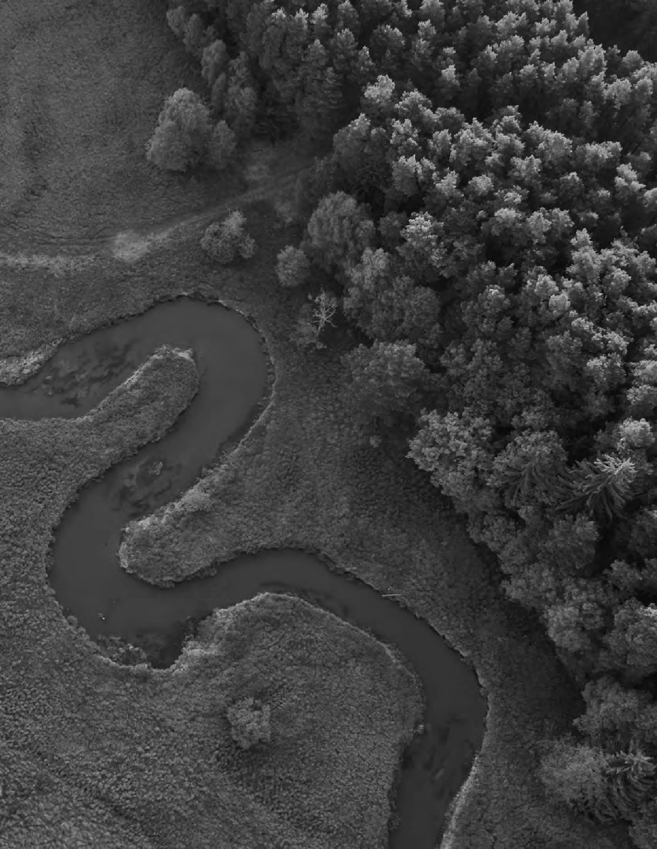
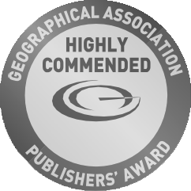
GEOGRAPHY FOR PRIMARY

TE ACHING MAP SKILLS TO

Planning for pupil progress from 5- 11 years:
the national curriculum and Ordnance Survey (OS) maps

Dr. Paula Owens

2021




‘A high-quality geography education should inspire in pupils a curiosity and fascination about the world and its people that will remain with them for the rest of their lives.’

National Curriculum Geography Programme of Study (England)

Contents

Using Ordnance Survey maps 5
- What are you trying to achieve? 10
The Ofsted education inspection framework 12
Pupils and maps 14
- How will you organise learning? 18
Considerations for progression across primary 22
KS1 Planner focusing on progression in map skills 23
Pedagogical approaches to teaching 30
Enquiry and conceptual understanding 31
Some mapping ideas for early years 34
- How well are you achieving
your aims? 35
Useful pages 36
Sources 37




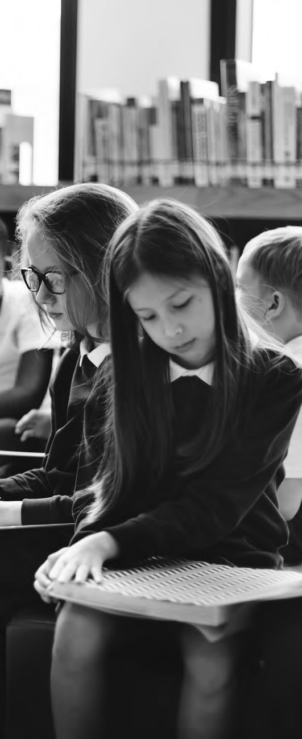
Geography for primary

The national curriculum for geography (DfE 2013) is an essential starting point for planning effective, challenging and coherent learning opportunities for pupils.
The national curriculum for geography aims to ensure that all pupils:

Develop contextual knowledge of the location of globally significant places

- Both terrestrial and marine
- Including their defining physical and human characteristics and how these provide a geographical context for understanding the actions of processes

Understand the processes that give rise to key physical and human geographical features of the world, how these are interdependent and how they bring about spatial variation and change over time

Are competent in the geographical skills needed to:

- Collect, analyse and communicate with a range of data gathered through experiences of fieldwork that deepen their understanding of geographical processes
- Interpret a range of sources of geographical information, including maps, diagrams, globes, aerial photographs, and Geographical Information Systems (GIS)
- Communicate geographical information in a variety of ways, including through maps, numerical and quantitative skills and writing at length

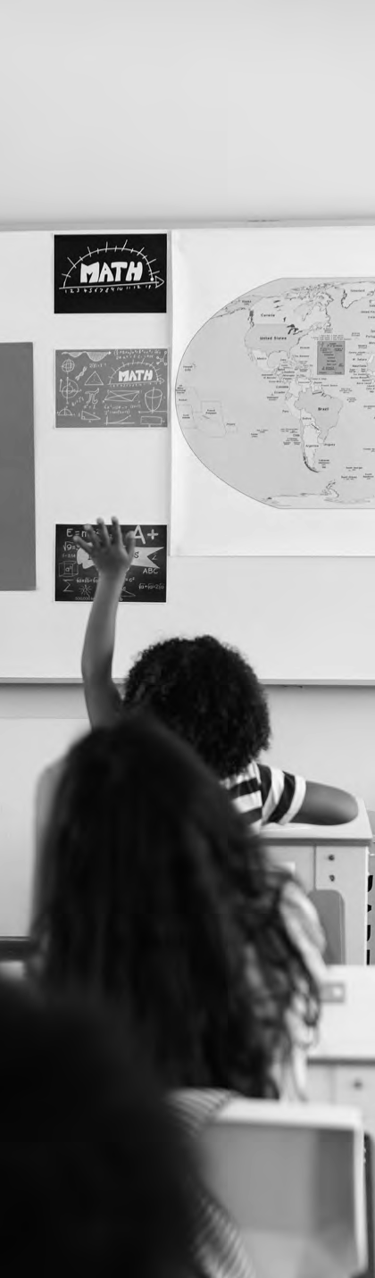
Using Ordnance Survey (OS) maps progressively from key stages 1 – 3 is important if pupils are to achieve all aspects of
these aims at primary and continue to do so at KS3.
The geography programme of study includes the following reference to maps:

Key Stage 1

- Use world maps, atlases and globes to identify the United Kingdom and its countries, as well as the countries, continents and oceans studied at this key stage
- Use simple compass directions (North, South, East and West) and locational and directional language [for example, near and far; left and right], to describe the location of features and routes on a map
- Use aerial photographs and plan perspectives to recognise landmarks and basic human and physical features; devise a simple map; and use and construct basic symbols in a key
- Use simple fieldwork and observational skills to study the geography of their school and its grounds and the key human and physical features of its surrounding environment

Key Stage 2

- Use maps, atlases, globes and digital/computer mapping to locate countries and describe features studied
- Use the eight points of a compass, four and six- figure grid references, symbols and key (including the use of Ordnance Survey maps) to build their knowledge of the United Kingdom and the wider world
- Use fieldwork to observe, measure, record and present the human and physical features in the local area using a range of methods, including sketch maps, plans and graphs, and digital technologies

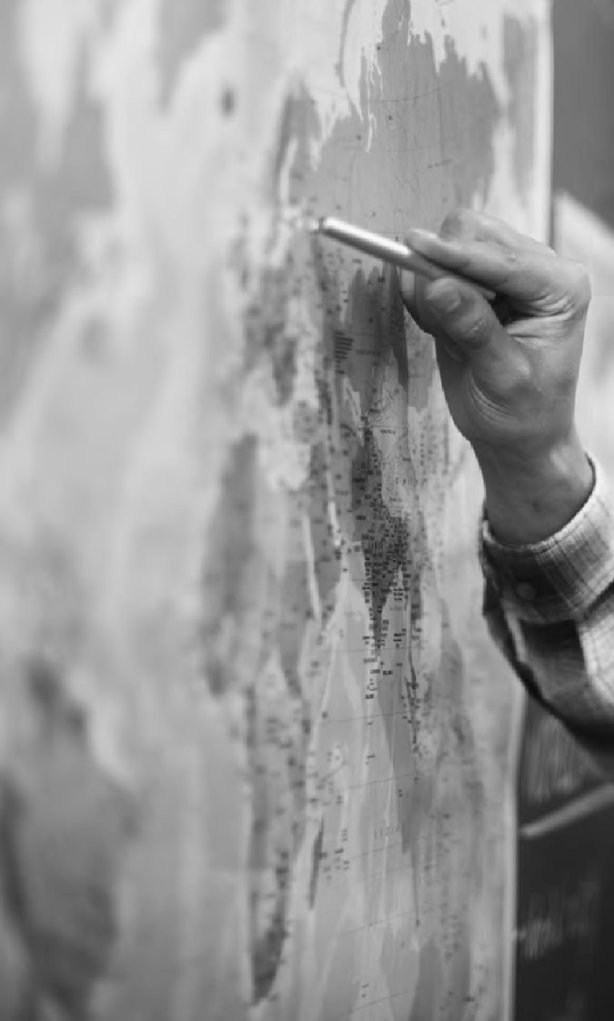
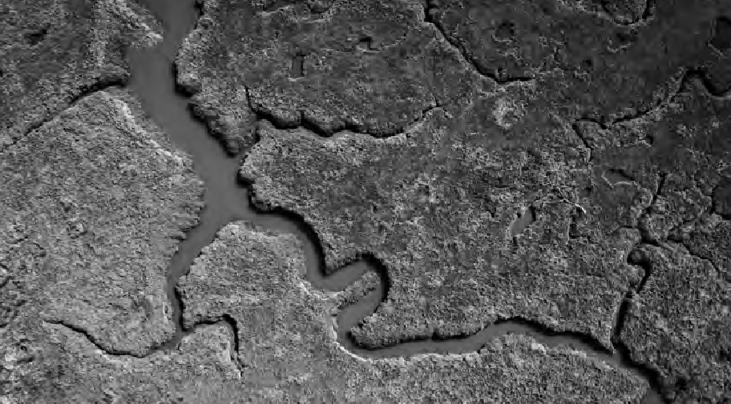
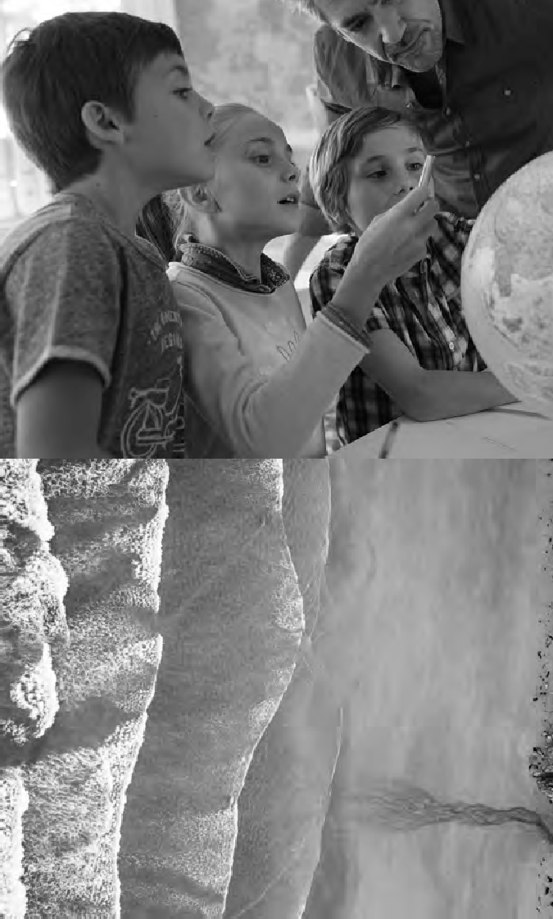
6 GEOGRAPHY FOR PRIMARY
6

“Maps are fundamental to our learning in Primary Schools, and, used well, they help to create continuously developing learning opportunities: in drawing and creating them, the children reveal and explore their own understanding of scale, nested hierarchies, and of course the World as a whole. In encountering them in lessons, through studying geography, history, MFL and current affairs, the children learn to be increasingly critical and questioning of how the world and our landscape is represented. And through
careful map selection and lesson planning, our staff continuously learn the best ways to engage and challenge the children.”

– Philip Maudsley, Headteacher Coatham Church of England Voluntary Controlled Primary School

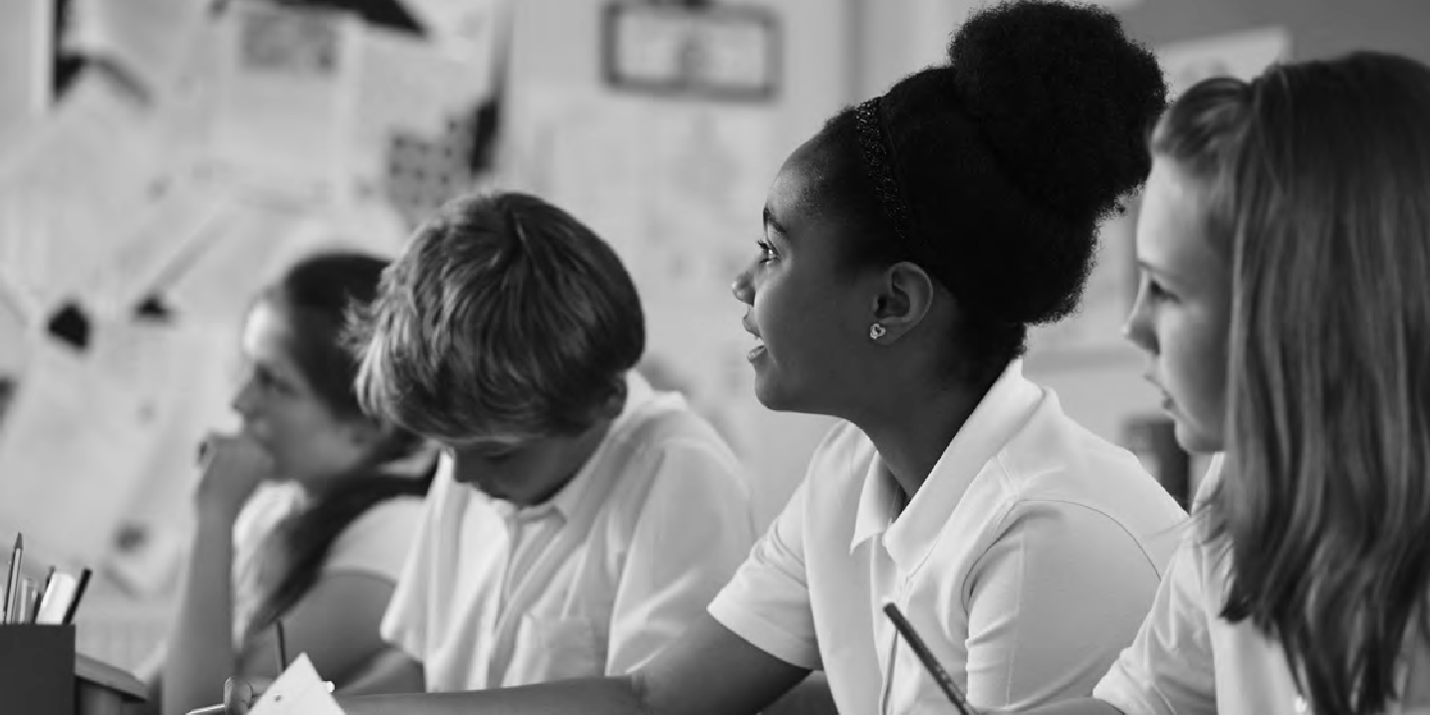

The spatial skills associated with the use of maps and map-making are not just essential to geography but valuable across the curriculum.

‘Children are remarkably adept at making maps and appear to develop the spatial awareness required from an early age. The maps that they draw not only provide a fascinating insight into their practical engagement with the world but also provide an insight into the places that they value or that worry them.’
(Vujakovic et al (2018) p.12)

Research supports the conclusion that spatial thinking and STEM learning are correlated (Newcombe 2017) and this is evident even in young children, as spatial training has been shown to improve mathematical achievement in six to
eight-year olds (Cheng and Mix 2014), and generally improve outcomes in STEM achievements (Stieff and Uttal 2015).

Maps also help children express their inner thoughts and feelings about the world, and inspire their sense of place and adventure. They can be used to encode and communicate personal information, as well as technical data. Maps are malleable tools that help to bring ever-evolving places and the possibility of
exploring them to life – especially in the digital world.

But it is in geography where locational knowledge comes into its own, if it is contextualised in a relevant way that engages and connects with children and inspires their sense of curiosity and wonder.

‘We have nine school years in which to help pupils develop their locational knowledge and to give their growing
sense of the World geographical context. It is not isolated knowledge, for pub/TV quiz use. It is vital in not just a globalised World but also for making the most of
our local, regional and national lives. We ignore locations, our knowledge of what they are like and their interrelationships at our peril.’

(Catling, S. (2014) https://www.geography.org.uk/download/ga_thinkpiece_ locationalknowledgeingeogteaching.pdf)

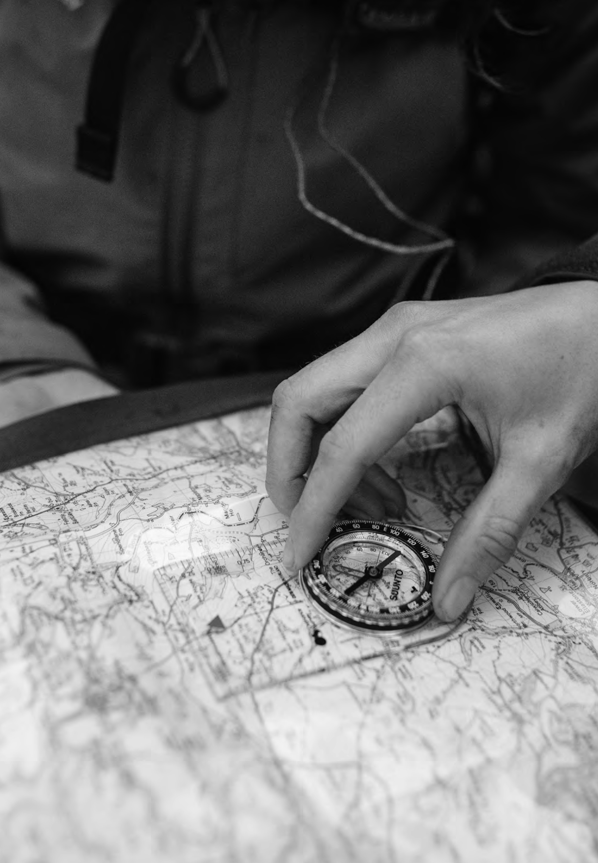


SEE ► BETTER PLACE

What are you trying to achieve?
1

The national curriculum (DfE 2013) is a minimum entitlement for pupils, but there are still choices to be made. A renewed emphasis on curriculum from Ofsted (2019a) means that geography content really matters, as does the creative act of curriculum- making.

‘Curriculum matters, as it defines the knowledge and experiences that learners will receive beyond their home environment. To this extent, what is taught and how (Biesta, 2009), and who is included (Young,
2013), appear to be key principles of curriculum design’.
Ofsted (2019a)

How are you putting your geography curriculum together?

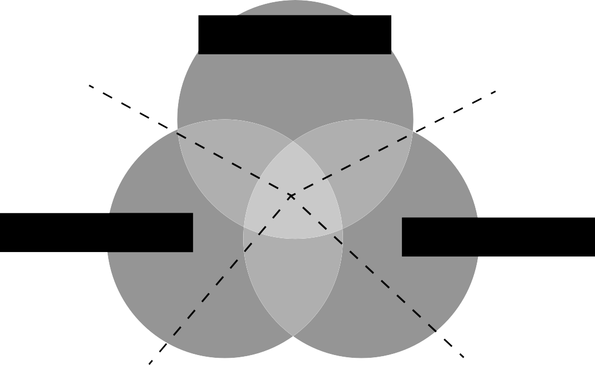
Pupil experiences

Does this take the learner beyond what they already know?
Which learning activity?

Teacher choices Geography: the subject

Underpinned by concepts
Thinking geographically

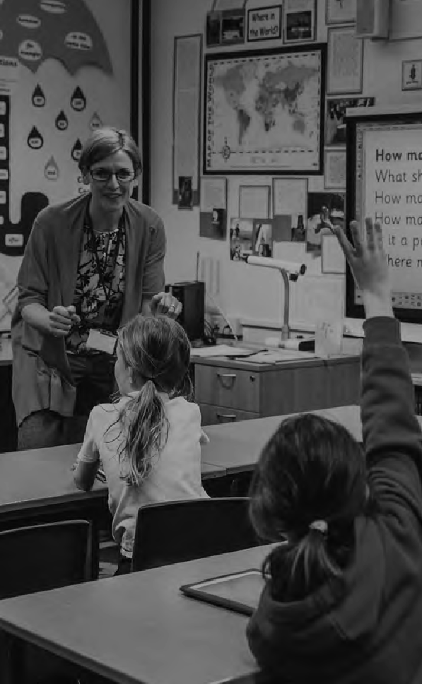

Geographical Association Curriculum Making Explained https://www.geography.org.uk/Curriculum-Making-Explained

Curriculum-making question | Geographical knowledge | Teacher choices | Pupils’ experiences and interests
What shall I teach? (Content) | What are the key ideas / concepts here? | What context and location shall I select for this knowledge? | What do pupils already know and think? What do I need to extend and challenge?
Why am I teaching | What is significant | How will my selection | How does it connect to
this? (Purpose) | content and why? | help pupils to make | pupils’ interests and / or
 |  | progress in their | concerns?
 |  | geographical thinking?
Maps provide a rich context for dialogic debate and thinking about the significance of location.
How am I going to | What is the best way | What opportunities are | How will I involve the
teach this? (Pedagogy) | to help pupils learn and | there for pupils to know, | pupils to make the
 | remember these aspects | understand, apply and be | content memorable?
 | of knowledge? | critical thinkers?
Maps are part of the geographer’s toolkit. Map-skills support enquiry and critical-thinking pedagogies.

Adapted from Martin F. (2013)

The concept of ‘space’ is a key ‘big idea’ of geography. Maps connect, embed and
communicate different kinds of knowledge: they help to develop conceptual schema and spatial reasoning; offer memory prompts for recalling and unlocking information, and as
a vital pedagogical approach they can be a critical thinking tool for investigating values and other perspectives. They are vital for geographical understanding.

GESAG Curriculum-making for all https://geognc.wordpress.com/about/curriculum-making-for-all/

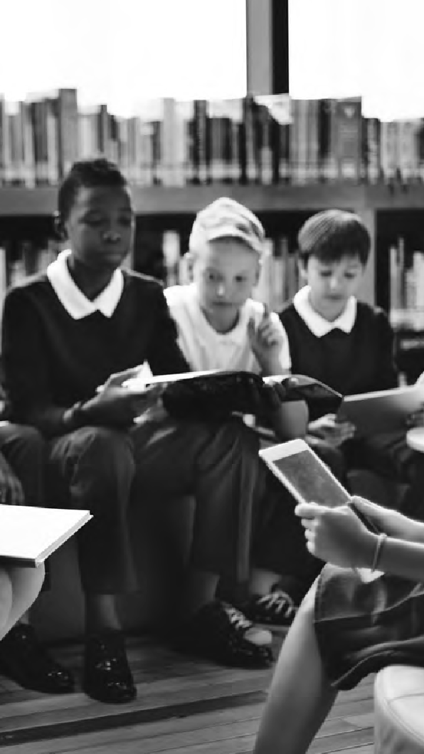
12
12
GEOGRAPHY FOR PRIMARY
The Ofsted Education Inspection Framework
In 2019, Ofsted introduced their new, research-informed education inspection framework – designed to combat a perceived ‘narrowing of the curriculum’. The three ‘I’s of Intent, Implementation and Impact are central to this. Put simply, these equate to the following ideas:

- Intent: what are you going to teach? What content have you selected and why?
- Implementation: how do you intend to teach it?
- Impact: what is the impact and how do you know?

These are not new ideas, they equate to: what am I teaching? How will I teach it? How effective is it? Or, to put it another way: ‘planning’, ‘teaching’ and ‘assessment’. These key ideas, no matter how they are phrased, are the fabric of teaching and learning, and working together.
Which teaching approaches work best in specific circumstances and why?
How does the curriculum develop understanding about key geography concepts such as place, space, environment
How do high-quality rescources and specialist approaches such as fieldwork support learning?
How has curriculum content been selected and sequenced and how does this reflect the vision?
How well does teaching embed secure understanding and how does assessment support this?
Is there a vision for geography and how does it reflect and support the school context?
How good is teachers’ subject knowledge and knowledge
of how geography is taught and learned?
How clearly are expectations and end goals built into the curriculum?

How do geography knowledge and skills prepare all pupils for the next stage
of education?
What do pupil outcomes tell us about the appropriateness of curriculum intent?
To what extent have pupils progressed towards curriculum ‘goals’ and evidenced
what they can remember about the content studies?

Kinder and Owens (2019) p.12
Intent
Implementation
Curriculum making
Impact

These questions can prompt careful thinking about the purpose, role and selection of mapping content and activities, as well as the context.

High quality geography, or not?

Yes No

An integrated and contextualised use of maps is in place across the geography curriculum to help pupils identify and cement understanding of key concepts.
Teaching of maps is planned and varied to ensure breadth and depth of progression.

Maps are deliberately current, or historical, from varied sources, and invite participation, critical thinking and debate.
An intensive unit of work called ‘ mapping’ focuses on map skills at the expense of relevant geography knowledge and context.

‘Pirate’ maps, collage maps and outdoor maps comprise the majority of pupils’ mapping experience, ‘because they are fun’ and happen in a haphazard way.
Maps are outdated, promote stereotypical thinking and misrepresentation. They tell a single story.



Pupils and Maps

Pupils love reading, creating, and using maps once they are given opportunities to do so. Making maps a familiar part of the indoor, and outdoor, classroom environment and culture from early years builds on children’s natural curiosity and develops their spatial skills.

Primary-aged pupils come to school with some existing geographical knowledge about their surroundings and the wider world: their home, street, local areas, places to play, places where they go shopping, or that they visit with their parents, places where relatives live, places that they have visited
on holiday, or places seen and learnt about on the television or through other media.
Whilst pupils may have gained some valuable geographical knowledge and language relating to places through prior first-hand experience, or through mediated sources such as tv, books and websites, they may also have gained unhelpful misconceptions about aspects of locality and place. Finding out what pupils know and what needs challenging, and deciding what they need to learn, and how to sequence this to better develop their understanding, is a vital part of curriculum-making.

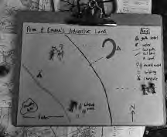
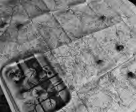

“I like maps because you can go on adventures with them. You can use maps for different things like geocaching, when you are lost or when you want to find the cafe at a National Trust place. I use maps to tell stories. There are also maps in books I like, like Harry Potter, Beast Quest and the Princess Poppy books.”
Primrose, aged 7 from Clophill St Mary’s C of E Lower School, Bedfordshire.

Primrose made a story map with some adult support following a discussion about the purpose of a key, generated by story stones painted with OS symbols.

Images: Nell Lee

‘… the learning progression for drawing maps proceeds from pictorial maps, through plans to large-scale and then small-scale maps. Pictorial maps portray the features of places by pictures of buildings, roads and rivers, while plans are more abstract maps of small areas, such as the child’s school. Large-scale maps are maps of a small area, such as a neighbourhood or suburb, because the
scale is a relatively large ratio. Small-scale maps show a large area, like the whole of a state or country. Large-scale maps are taught first because they are about areas that students are familiar with, and this is how they learn to relate a map to the real world it portrays’.

Robertson et al (2019)p.20

Pupils and Maps

Asking pupils to draw maps of their home spaces and localities and to talk or write about which places hold meaning for them and why, can help unlock geographical thinking. This approach has formed part of the Meaningful Maps project in which more than 500 primary-aged pupils drew maps of places with special meaning to them and explained why.

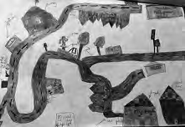
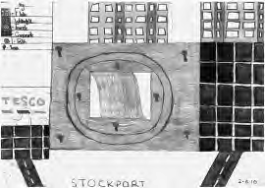
“I decided to do where I live to school because I know them places the most and I thought of all the shops I remember near my house and school. I think that there are so many shops that it makes the places special and I think that the factory makes the places special.”

Boy aged nine Broadstone Hall primary School.

“On my map, the main thing is the waterfall. I chose this place because I love going here, especially with my friends. I did everything surrounding the waterfall, like Tesco, flats and car parks. It’s special because it’s so peaceful and really fun.”

Child aged nine www.meaningfulmaps.org

Teachers who took part in the project reported how drawing maps freehand like this helped their pupils to access and understand formal mapping conventions more easily. The activity was also useful as a diagnostic tool, revealing their level of cartographic skill and understanding.

Although they have a natural ability for spatial thinking at an early age, without specific teaching and support, children’s spatial skills may not progress further, and because of this, it is essential to include formal teaching of mapping and map interpretation throughout the primary years (Robertson et al 2019).

Geographical skills were particularly well developed when the schools had a very comprehensive fieldwork programme and when a variety of maps, aerial photographs and other geographical resources was used frequently, as in this example.

Mapwork was threaded into teachers’ plans wherever possible and mapwork skills were developed sequentially through the school.
Beginning in the Reception class, pupils used photographs of rooms and features in school and could place them accurately on a blank map of the corridor. They could describe a journey along the corridor, using appropriate vocabulary such as ‘opposite’,
‘next to’, ‘forward’, ‘right’ and ‘left’. In a Year 2 lesson, pupils were able to locate a number of physical features using coordinates and follow accurately a number of routes to enable them to arrive at destinations. By Year 6, pupils were able to recall the route they had taken to the Pennines, particularly the roads, towns and villages visited on the journey. They had then used Ordnance Survey maps to trace the route, revised key symbols and used this to draw their own maps accurately, complete with keys.

Ofsted (2011) p.10
Research shows that pupils can struggle to correctly interpret several features of maps, including:

- The use of colours to show climate or vegetation zones, different states or territories, relief (height above sea level) and other characteristics of areas, For example, they may fail to understand that the colour on a map may not correspond with the colour of what is being represented.
- The use of symbols that show roads, the location of towns, the population of cities, economic activities, and other features. For example, they may fail to understand that a dot represents the location of a place and not its size.
- The relationship between two spatial distributions when high values on one distribution are associated with low values on the other.

Robertson et al (2019) p.20

Maps play a central role in enabling pupils to think geographically and help them develop their knowledge and understanding of the subject. Ofsted (2011) reported that map skills were clearly evident in schools where geography was done well and they advised that to combat weaker instances of geography, map skills should be developed rather than repeated, and given genuine contexts.

“Typically, the teaching of geographical skills, including the use and construction of maps, is not particularly strong in primary schools.
Too little attention is given to accuracy and conventions followed by geographers, such as the use of scale.”

Iain Freeland (2020)
In 2020, the development of mapping in primary schools still has some way to go, as Her Majesty’s Inspector for Schools (Geography) comments:

Weaker teaching was associated with:

‘.. over-use of worksheets which required pupils only to label diagrams and maps, and the work was not directly related to examples of real places.’

Ofsted (2011) p.10

How will you organise learning?
2

An effective geography curriculum will:

Enable pupils to learn and make progress.

Build on conceptual understanding and ensure pupils remember what they have learnt through opportunities to consolidate and check learning.

Have carefully chosen content and sequencing. Develop more complex and abstract thinking.
Evidence a broad range of opportunities and deep learning experiences, that includes fieldwork.

Combine knowledge, skills and values in relevant contexts. Ensure enquiry is underpinned by core knowledge.
Have coherence with other subjects in the curriculum.

Have linked, relevant texts for each topic or area of learning (fiction and / or non-fiction).

Contextualise maps and mapping as part of its geographical lens on the world.

Be led by teachers who are knowledgeable and have benefit from recent Continuing Professional Development (CPD).

The geography national curriculum is viewed as a minimum entitlement for pupils by Ofsted (2019b).
Even those schools who are not legally obliged to teach the national curriculum are mindful of the content. Whilst setting out the expectation in learning at the end of a key stage, the national
curriculum for geography in England offers scope to decide precise locations and the sequence of learning within a key stage. While it is tempting to buy in a scheme of work, it can be very worthwhile to think how the national curriculum can be tailored to fit your school and pupils.
There are some easy choices to be made when selecting national curriculum material for geography and attempting to sequence it. In Key Stage 1 this
is straightforward, as there are just two years of schooling to consider, and sequencing appears to be mostly common sense. For example, there is a requirement to learn about the local area and a
contrasting non-European locality. It seems obvious to learn about the local area first, preferably through fieldwork, and then to build on this concrete experience through more abstract thinking about a distant locality that cannot be visited.

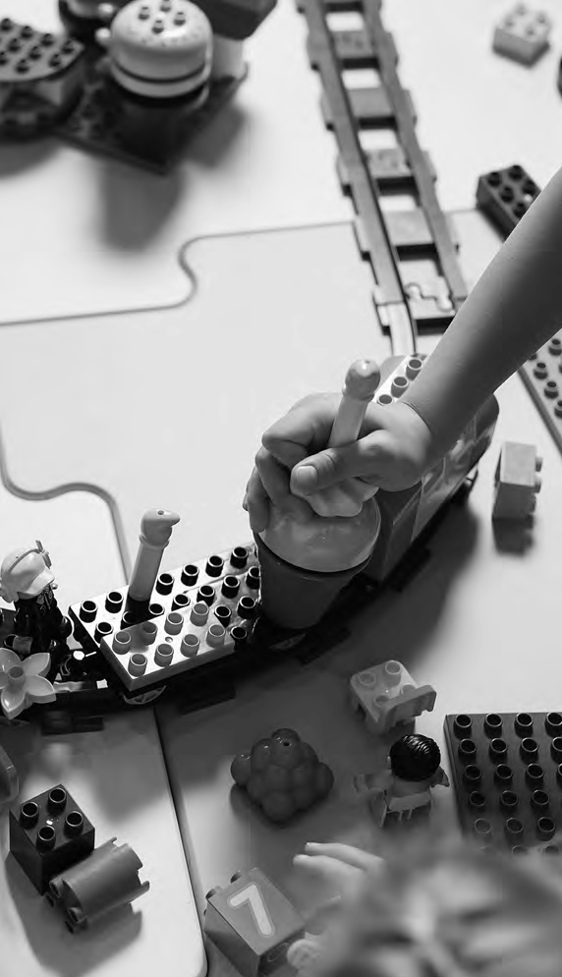
Example

Year 1
Exploring your immediate locality in year 1 will help develop pupils’ geographical vocabulary and knowledge of built and natural features. Pupils’ mental maps of the area could be used to compare feelings and impressions as a starter
to generate discussion, revealing what pupils know (and don’t know). Maps of the school grounds and surrounding area could be created to record a variety of data from vegetation to wildlife, from improvements that need doing to favourite places to play. Design the purpose to suit your school context and pupils’ needs.

In local area studies in year 1, you could investigate aerial imagery using e.g. OS maps, Google Earth or Bing maps, and talk about the features that can be seen and identified, using geographical vocabulary. 3D junk mapping could be used
to build a map of the school grounds or the High Street, while digital mapping could show the route of a walk, with images, around a local park.

Developing fieldwork experience and techniques alongside relevant geographical knowledge and vocabulary facilitates a greater depth of enquiry and understanding in follow up questions e.g. Why are there so many cars here? How is this place changing and why?

With the techniques for fieldwork firmly engaged, and a base of geographical knowledge and vocabulary established, this will enable a greater depth of enquiry in follow up questions, e.g. why is the park shut? Why are there so many cars here?

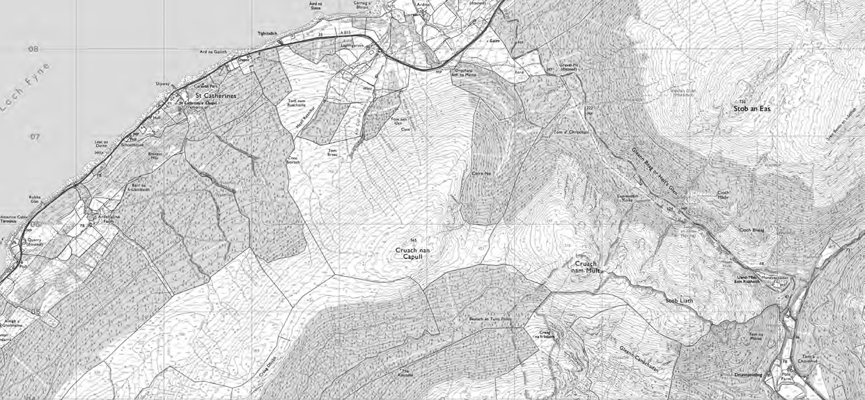
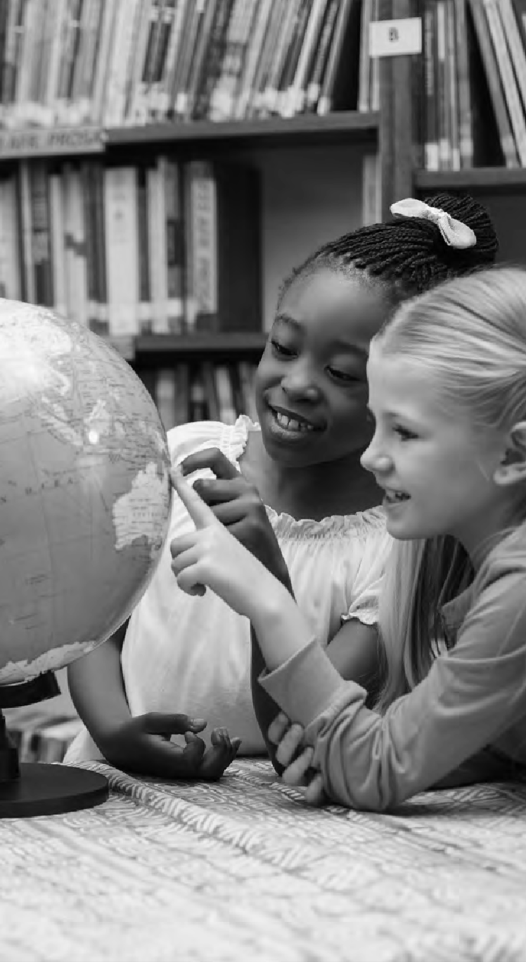
20 GEOGRAPHY FOR PRIMARY
20

Example

Year 2
In year 2 you could follow up work on local weather and discuss scale, by locating hot and cold places in the world in relation to the Poles and Equator. While it’s important to teach maps in a valid context, everyday conversations
with maps and globes can help reinforce basic map skills and geographical vocabulary.

Key stage 2
In Key Stage 2 there is a lot more content but here some common sense and your own school setting can help the decision-making process about which places to study and when to do it. For example, before starting out on a
regional study, let alone a comparison, pupils will need some basic understanding of the components of that geography, such as global patterns of climate and vegetation, as well as patterns of settlement and land use.

Since one regional study will be in North or South America it makes sense to get an overview of those two continents first and then build on that knowledge. Before studying food or trade, it is important to know how climate patterns vary and the impact this has on global farming and produce, and before studying river processes in detail, it is helpful
to understand the role of the water cycle. There is no one exact ‘right’ way, but there are sensible questions to be asked. The important thing is that choices can be explained and justified and that they are having the desired impact on pupils’ learning.

Range of scales

Critiquing

Analysing

Contours

Patterns

Relationships

Change

Keys

Projections

GIS tools and software

Grid references

Connections

Statistics

Infographics

Explaining
Depth of techniques and understanding

Describing

Routes

Patterns

Symbols

Paper and digital maps
Diagrams

Compass directions
Practice
Tourist maps, Street maps, OS maps, Schematic maps, Story maps, Fantasy maps

Recognising

Plans
Aerial photographs and digital imagery

Sketches

Vocabulary
Globes Maps Atlases

Local scales
Fieldwork Enquiry Core knowledge
and concepts

Skills Values

Simple

Breadth of rescources and experiences
Complex

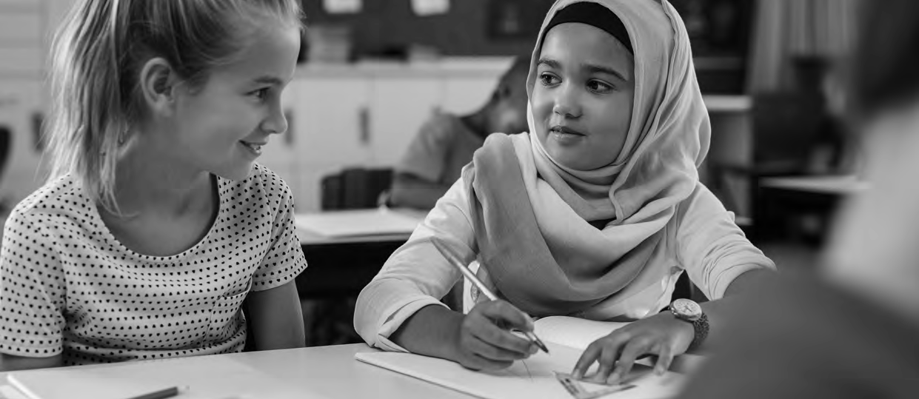

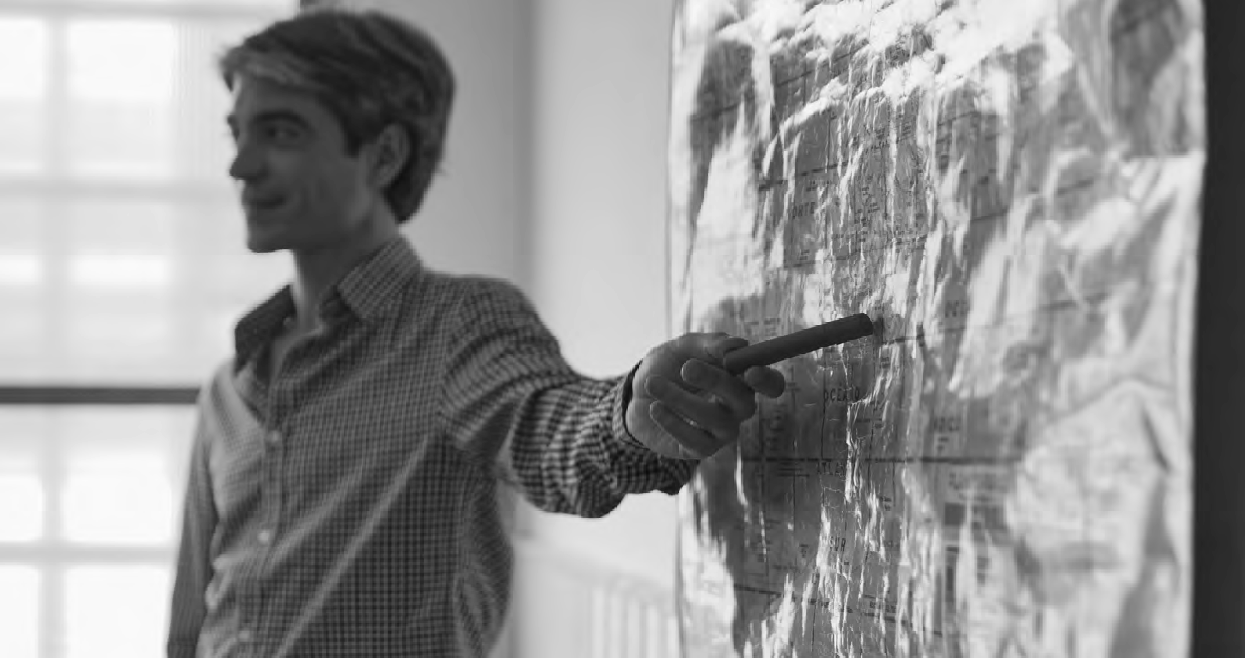
22 GEOGRAPHY FOR PRIMARY

Considerations for progression across primary

 | From | To
Vocabulary | Using a limited geographical | Wider range of vocabulary used more
 | vocabulary | appropriately
Knowledge of | Limited knowledge at a local scale | Wider knowledge of places at a range of
places |  | scales and of connections between them
Processes | Beginning to recognise simple | Explaining geographical patterns and
and spatial | processes and patterns | processes
patterns
Geographical | Geographical thinking from concrete | Thinking in increasingly more complex and
thinking | and first-hand experiences | abstract ways
Investigation | Asking simple questions with help | Asking own questions using increasing
and enquiry |  | base of core knowledge
Map skills | Using simple drawings, maps and | Using increasingly complex techniques and
 | diagrams to represent geographical | a range of formal and informal mapping
 | information | approaches
Fieldwork | Guided practical and play-led | Increasing confidence to select and use a
 | exploration in the field | range of techniques in the field
Critical | Aware of personal feelings and | Open to other’s views and opinions and
thinking | responses to ‘place’ | beginning to understand the difference
 |  | between fact and opinion.
Adapted from Gardner, D. (2014)

KS1 Planner focusing on progression in map skills
Pupils coming up from Foundation Stage will have had a wide range of experience in planned outdoor and play-based activities, and their vocabulary relating to features of the outdoors should provide a solid base to build on. This vocabulary is an essential part of developing spatial skills, not just in terms of feature names, but through relational and positional language. It is a vital opportunity at the beginning of a more formal learning setting to consolidate and extend this essential language and continue to provide
play-based opportunities for informal map-making and exploration. Below are some possible map-related activities for Years 1 and 2.

Year Focus Map opportunities

- A local scale study of ‘our place’
- Hand drawn maps of the school grounds / home area / special places – auditing map-skills and existing vocabulary.
- Introduction to aerial imagery, topographical scale plans of school and its grounds, 1:2500.
- Vocabulary – actively building spatial vocabulary: using compasses and naming features and their orientation e.g. North, South, East, West through outdoor learning.

Weather · Recording weather in one or more places in the school grounds
and mapping location(s) on a topographical plan of the grounds.
  - Mapping weather data on a map of the UK and adding simple symbols.
  - Using an atlas to find other places in the UK and looking at boundaries between the countries of the UK.

World · Globes and atlases: continents and oceans, familiarising through games and quick activities. North and South Poles, continents and oceans.

- Contrasting non – European locality

- Local scale study of a village and town e.g. in Kenya, revisit continents.
- Atlas – locate continent, country, key features and digital maps to zoom into local scale study, compare urban and rural ways of living, avoid single story.

Hot and Cold places · Locate Poles, Polar Regions, Equator. Use a globe to locate
hot and cold places, and ‘zoom’ in to introduce other local factors such as altitude – eg Kilimanjaro, a cold summit near the Equator. Map and describe place examples and link vocabulary and spatial knowledge to places studied eg Kenya is on
the Equator.

UK
(ongoing from y1)

  - Mapping the countries of the UK and major features and cities. Using a blank map to research and map places and features using an atlas.
  - Adding information to digital maps, e.g. text and pictures.

Year Focus Map opportunities

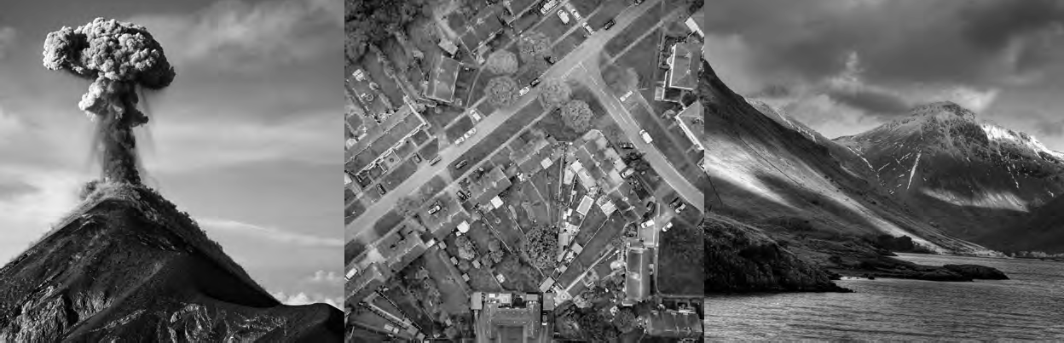
- Climate regions and water cycle
24
GEOGRAPHY FOR PRIMARY

Mountains and volcanoes
- Use world maps and globes to introduce latitude, longitude, and climate patterns. Locate and map major rivers in the world and UK. Zoom in to places and features studied e.g. a local river, the Amazon.

- Map major mountain ranges and link to work on continents, identify mountains on each continent and link to latitude and longitude. Recap Kilimanjaro. Investigate mountains using Google Earth and Bing imagery. Map using ARC GIS.

European overview · Map countries in Europe and their key characteristics.
Investigate in more depth e.g. The Mediterranean - link to climate, latitude and mountain ranges, significant volcanoes such as Mount Etna and why people live so close, pros and cons of farming close to a volcano.

UK · Investigate major physical features and mountain ranges of the UK, map and compare to global ranges. Link to patterns of settlement and major cities and towns and explain why mountains are more sparsely populated.
· Local area fieldwork to investigate patterns of land use locally.

- UK

Local area fieldwork

- Online map challenges to help locate and memorise counties of the UK.
- Develop map and compass skills. Create routes to visit using OS Apps and do a ‘flyover’ before going out in the field. Map features found and create StoryMaps.

Americas · Revisit continents and investigate North and South America
and their key features. Revisit mountain ranges, climates and identify major biomes. Link to work on rivers and sources of fresh water.

Vegetation belts and biomes

- Investigate and map rainforests around the world and explain why they are where they are. Map imports of foodstuffs from around the world using e.g. Scribble maps and their icons. Link to climate and introduce trade.

2424

Time zones · Introduce time zones and link to Digimap for School maps.
Investigate time sones across America. Map major cities around the world and give their time relative to noon in Greenwich, UK.

Year Focus Map opportunities

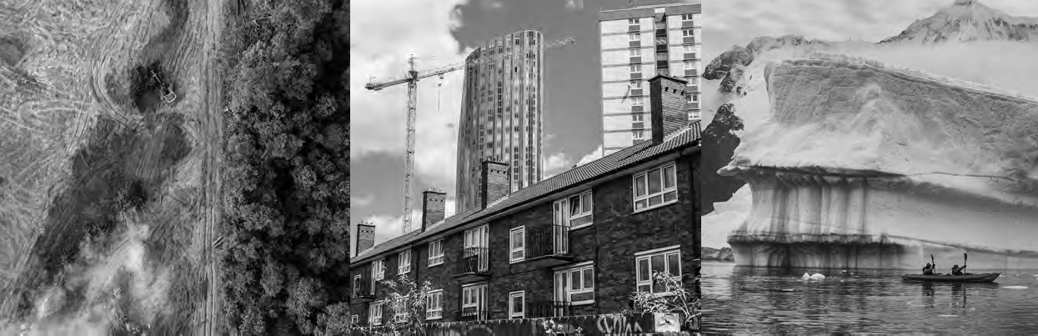
- Natural resources and Amazon
HOW WILL YOU ORGANISE LEARNING?
25

Energy and climate change
- Investigate and map natural resources around the world and discuss impacts of human activity. Link to work on climate, biomes, fresh water and major rivers. Map regions of the Amazon and the countries within it. Focus on the Amazon as a region, zoom into Manaus, and map impacts of farming on the rainforest.

- Investigate links between energy use around the world e.g. using fossil fuels, especially wood, and deforestation and climate change. Map and investigate alternative energy use. Use NASA Earth’s visible light map to discuss energy use around the world.

Earthquakes · Link to work on mountain formation and map tectonic plates and major earthquake zones. Investigate and map natural causes of earthquakes and some human ones e.g. fracking.
- UK · Use maps and graphs to investigate local issues and quality of
life through a neighbourhood survey with residents. Link up with secondary schools as a transition project. Pupils to explain maps created and outcomes of surveys.

Regional comparisons

Developing Antarctica

- Building on previous work, regional comparisons between UK / Europe and North or South America. Using maps to show features and regional scales of comparison. Use appropriate maps for different scales of enquiry.

- Taking a futures perspective and debating whether Antarctica should be developed or not and how it may already be changing. Mapping human activity and physical changes on the continent.

2525

Identify and link each topic or area of learning to rich texts, fiction and non-fiction.

See www.digimapforschools.edina.ac.uk www.rgs.org and www.geography.org.uk for resources and activity ideas

26 GEOGRAPHY FOR PRIMARY

 | Year 1 | Year 2 | Year 3
Locational knowledge  General  geographical knowledge, position and  significance UK and Global | North and South Poles, Equator, 4 Compass points N, S, E, W Locational language, name & locate: 7 continents & 5 oceans.  Name, locate, identify: 4 countries and capitals of UK & surrounding seas. |  | Latitude, longitude, Equa zones, 8 Compass points on regions, key physical features, land use & chan
GA Benchmarking at ages 7,9,11 | Have simple locational knowledge about individual places and environments, especially in the local area, but also in the UK and wider world. |  | Have begun to develop a knowledge, including kno and wider world, and so human features.
Place knowledge  Compare and contrast | Local scale study UK & Non - European country |  | Regional comparison UK
Human and physical  Local and Global scales | Identify seasonal & daily weather patterns (UK & local scales) Identify hot & cold areas of the world in relation to Equator & North & South Poles |  | Describe and understand Types of settlement & la
GA Benchmarking at ages 7,9,11 | Show understanding by describing the places and features they study using simple geographical vocabulary, identifying some similarities and differences and simple patterns in the environment. |  | Demonstrate their kno wider world by investiga surroundings, including h patterns, how places cha and environments. They places and understand s differences.
Skills  Enquiry, mapping, fieldwork,  critical thinking, vocabulary | Begin to ask questions. Identify places using maps, atlases,  globes, aerial images & plan perspectives, make maps, devise basic symbols, fieldwork, geographical vocabulary. |  | Develop questioning. Loc communicate using a ran locality – residential.
GA Benchmarking at ages 7,9,11 | Be able to investigate places and environments by asking and answering questions, making observations and using sources  such as simple maps, atlases, globes, images and aerial photos. |  | Be able to investigate pl responding to geographi using sources such as ma photos. They can expres others may think differe

Text from National Curriculum for Geography (DfE 2013) indicates what needs to be covered in a Key Stage. Text in blue boxes is from GA Progression Document www.geography.org.uk/curriculum2014/assessment

Year 4 Year 5 Year 6
tor, N. & S. hemispheres, Tropics Cancer & Capricorn, Arctic and Antarctic Circle, Prime / Greenwich Meridian & time 4 & 6 figure grid references. Locate world’s countries, Europe, (including location of Russia), Americas, concentrating nd human characteristics, countries, major cities. Counties, cities, geographical regions, characteristics, topographical ges over time.

framework of world locational  wledge of places in the local area, UK me globally significant physical and |  | Have a more detailed and extensive framework of knowledge of the world, including globally significant physical and human features and places in the news.
European country, North or South America

key aspects of: Climate zones, biomes, vegetation belts, rivers, mountains, volcanoes, earthquakes, water cycle nd use, economic activity, trade links, distribution of natural resources: energy, food, minerals, water cycle.

ledge and understanding of the  ting places beyond their immediate uman and physical features and  nge and some links between people become more adept at comparing ome reasons for similarities and |  | Understand in some detail what a number of places are like, how and why they are similar and different, and how and why they  are changing. They know about some spatial patterns in physical and human geography, the conditions which influence those  patterns, and the processes which lead to change. They show some understanding of the links between places, people and environments.
ate, describe, explain using maps (including OS maps), atlases, globes, digital mapping, measure, record and
ge of methods including maps, plans, graphs, writing at length. Fieldwork in local & wider localities & more distant

aces and environments by asking and cal questions, making observations and ps, atlases, globes, images and aerial  s their opinions and recognise that ntly. |  | Be able to carry out investigations using a range of geographical questions, skills and sources of information including a variety  of maps, graphs and images. They can express and explain their opinions, and recognise why others may have different points  of view.

 | Year 1 | Year 2 | Year 3 | Year 4 | Year 5 | Year 6
Locational knowledge  General geographical knowledge, position and significance UK and Global | North and South Poles, Equator, 4 Compass points N, S, E, W Locational language, name & locate: 7 continents & 5 oceans. Name, locate, identify: 4 countries and capitals of UK & surrounding seas. |  | Latitude, longitude, Equator, N. & S. hemispheres, Tropics Cancer & Capricorn, Arctic and Antarctic Circle, Prime / Greenwich Meridian & time zones, 8 Compass points, 4 & 6 figure grid references. Locate world’s countries, Europe, (including location of Russia), Americas, concentrating on regions, key physical and human characteristics, countries, major cities. Counties, cities, geographical regions, characteristics, topographical features, land use & changes over time.
GA Benchmarking at ages 7,9,11 | Have simple locational knowledge about individual places and environments, especially in the local area, but also in the UK and wider world. |  | Have begun to develop a framework of world locational knowledge, including knowledge of places in the local area, UK and wider world, and some globally significant physical and human features. |  | Have a more detailed and extensive framework of knowledge of the world, including globally significant physical and human features and places in the news.
Place knowledge  Compare and contrast | Local scale study UK & Non - European country |  | Regional comparison UK, European country, North or South America
Human and physical  Local and Global scales | Identify seasonal & daily weather patterns (UK & local scales) Identify hot & cold areas of the world in relation to Equator & North & South Poles |  | Describe and understand key aspects of: Climate zones, biomes, vegetation belts, rivers, mountains, volcanoes, earthquakes, water cycle Types of settlement & land use, economic activity, trade links, distribution of natural resources: energy, food, minerals, water cycle.
GA Benchmarking at ages 7,9,11 | Show understanding by describing the places and features they study using simple geographical vocabulary, identifying some similarities and differences and simple patterns in the environment. |  | Demonstrate their knowledge and understanding of the wider world by investigating places beyond their immediate surroundings, including human and physical features and patterns, how places change and some links between people and environments. They become more adept at comparing places and understand some reasons for similarities and differences. |  | Understand in some detail what a number of places are like, how and why they are similar and different, and how and why they are changing. They know about some spatial patterns in physical and human geography, the conditions which influence those  patterns, and the processes which lead to change. They show some understanding of the links between places, people and environments.
Skills  Enquiry, mapping, fieldwork,  critical thinking, vocabulary | Begin to ask questions. Identify places using maps, atlases, globes, aerial images & plan perspectives, make maps, devise basic symbols, fieldwork, geographical vocabulary. |  | Develop questioning. Locate, describe, explain using maps (including OS maps), atlases, globes, digital mapping, measure, record and communicate using a range of methods including maps, plans, graphs, writing at length. Fieldwork in local & wider localities & more distant locality – residential.
GA Benchmarking at ages 7,9,11 | Be able to investigate places and environments by asking and answering questions, making observations and using sources such as simple maps, atlases, globes, images and aerial photos. |  | Be able to investigate places and environments by asking and responding to geographical questions, making observations and using sources such as maps, atlases, globes, images and aerial photos. They can express their opinions and recognise that others may think differently. |  | Be able to carry out investigations using a range of geographical questions, skills and sources of information including a variety  of maps, graphs and images. They can express and explain their opinions, and recognise why others may have different points of view.
28
GEOGRAPHY FOR PRIMARY

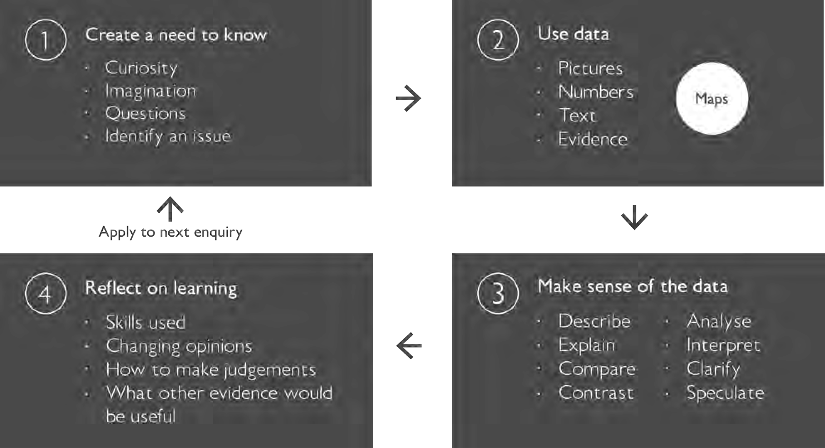
Margaret Roberts

Pedagogical approaches to primary geography teaching

Maps and enquiry cycle

Create a need to know – maps invite questions, discussion and debate.
Use data – maps provide and encode data in many different guises.
Make sense of the data – maps help to
show patterns, cause and effect, relationships and connections.
Reflect on learning – maps can help you reflect on what has been learnt and provide a record of thinking.

30 GEOGRAPHY FOR PRIMARY
30

Enquiry and conceptual understanding
Place, space and scale are concepts which stand at the heart of geography, and which provide fundamental organising principles.

By linking key concepts to enquiry questions, teachers can engage children in thinking like geographers, as set out in the diagram below (Scoffham and Owens 2017). Enquiry approaches need questions and questions need vocabulary.
Hence, there is a direct relationship between core knowledge, especially geographical vocabulary, and the quality of enquiry questions.

The diagram below indicates some of the essential questions that geographers ask when investigating place. Some answers will require facts e.g. ‘where is this place?’. This question requires an answer that is almost certainly to be
a reference point that can be agreed as fact, whether it is a postcode, a grid reference, or the name of a town or village. This answer can be represented spatially through maps or spatial language. However, should the question be ‘what is this place like?’, the answer is likely to be in part factual – a data capture for example, of features, both built and natural that can be mapped with factual accuracy; but will also
be in part subjective, as there may be feelings associated with a place, or parts of a place, that vary from person to person. Asking the ‘right’ questions then and being aware of the limitations, or potential of different forms of enquiry is important. Maps can convey both factual and subjective data although the map-maker bears a responsibility as to what is left in and what is left out. In this sense, maps themselves can be the object of an enquiry.

Core geography

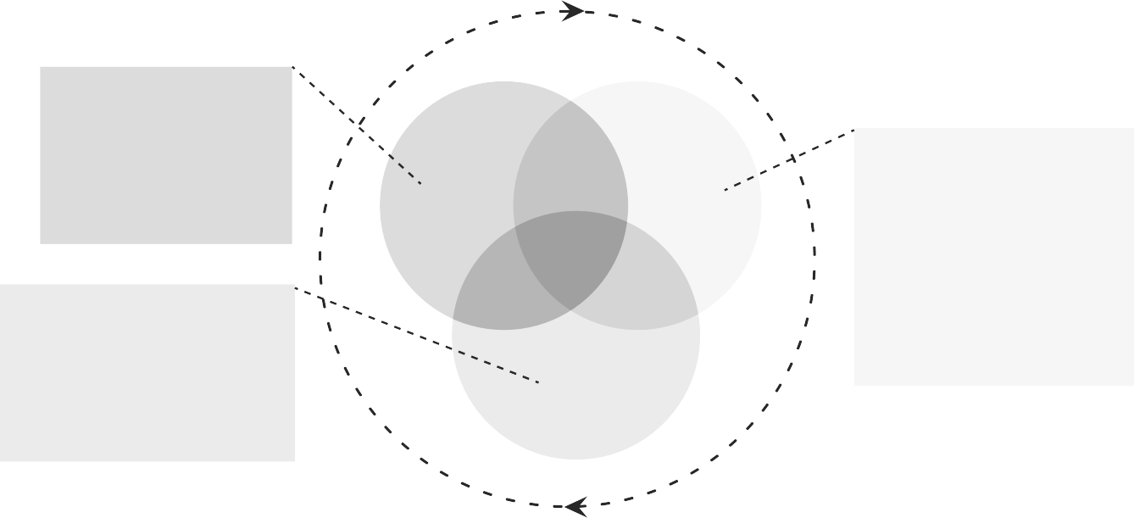
Where is this place? How does it connect to other places?
How can it be mapped? What is unique about its location?

How does my view of this place change when I zoom in or out?
How and why are places connected?
What is the local/global story?

Space Place

Scale

What is this place called? What is it like?
What kind of features does it have? (Human and physical) How and why is it changing? What do people do here?
How do I feel about it? How does it compare to other places?

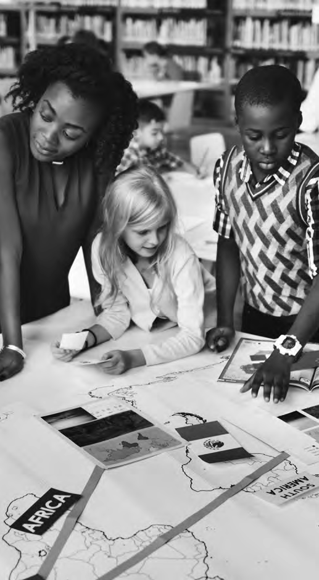

Enquiry

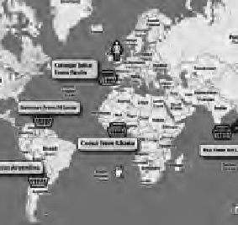
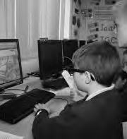
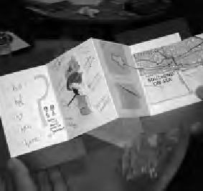
Year 6 pupils at Ysgob Morgan have been learning about WW2 in History. They found some diary extracts from families who were evacuated from Liverpool to St Asaph and wanted to find out about their journey and the places they stayed. They used a combination
of 1890 and modern day OS mapping to answer their questions. They were surprised to see railroads and even a rail station in the old maps, but not in the current maps, and were astonished to think that their town once had its own railway station. They were also surprised that a large manor house used to home several of the evacuees was still standing and in use. Maps helped bring the stories of
these evacuees to life and explained in part how the landscape had changed since.
Creating a need to know
Example 1
Teachers on a CPD course learnt about Journey Books and how these could be a tool to help pupils enquire about their local area through fieldwork. The Journey Books use enquiry questions and a mix of core knowledge and sense of place data. For example, this one has coded sensory impressions, core and factual knowledge through relevant map extracts at different scales, and even a small hand drawn secret map.
Use data
Example 2

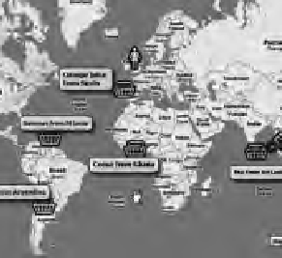
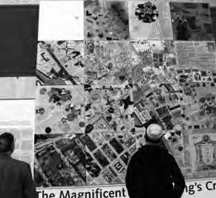
Scribble Maps is used here to record where different food produce has originated from. The icons have an easy click and drag feature and can help make a quick visual representation of global food trade. When the information is laid out spatially it is easy to see patterns, such as where certain types of foodstuffs are likely to come from.
Make sense of data
Example 3
In a collaborative project at the British Library that could be replicated across different year groups in school, or across a local community, groups were each given a kilometre square grid map of the local area to illustrate however they saw fit. These maps were then put
back together to reveal an image of the rich diversity at work in the Kings Cross area of London. This patchwork map highlights how different users might map the same space.
Reflect on learning
Example 4

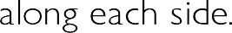
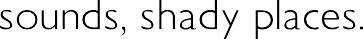

Some mapping ideas for early years

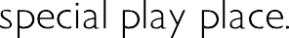

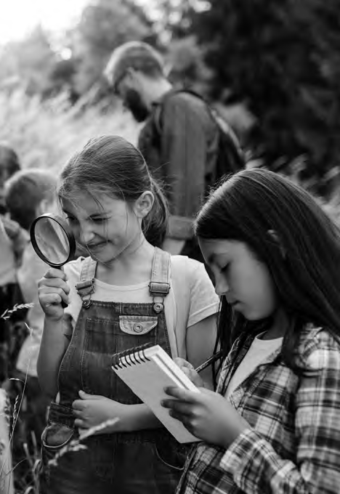

3 How well are you achieving your aims?

Whether you are a classroom leader, a geography subject lead, or a headteacher, the questions you will need to ask yourself are very similar.

- Are all learners making progress towards identified goals?
- How do I know?
- What do I need to do next?
- How well do pupils and teachers enjoy their learning?

When maps are taught and used confidently, pupils and teachers can benefit from the enjoyment
that greater clarity of understanding and communication can bring.

Discuss what tools, resources and professional development might need to be put in place to allow the use of maps to flourish. Build this into an action plan.

Build evidence of mapwork across the school using photographs, photocopies and / or online documentation. Develop a portfolio of mapwork from a selection of pupils in each class that evidences the kinds of mapping opportunities and progression from one year- group to the next. There are Quality Marks and Chartered Geographer awards that could be achieved as part of professional development. These show recognition of work that has been done and provide tools for evaluating progress too.

Have school leader-boards for mapping awards, with badges and certificates highlighting excellent work. This could also record for example, pupils’ scores in online mapping challenges such as those highlighted in the resource section.

Primary Geography Quality Mark https://www.geography.org.uk/The-Primary-Geography-Quality- Mark-PGQM
Chartered Geographer https://www.rgs.org/professionals/chartered-geographer/
MetMark https://www.metoffice.gov.uk/about-us/who/sustainability/community/metmark

HOW WILL YOU ORGANISE LEARNING? 35
35

Useful pages

  - Arc GIS mapping for schools (Esri) www.arcgis.com
  - BBC Bitesize Maps https://www.bbc.co.uk/bitesize/topics/zvsfr82/articles/ zdk46v4
  - Bing Maps https://www.bing.com/maps/
  - Connecting Primary Geography – planning links https://www.geography. org.uk/write/MediaUploads/Support%20and%20guidance/GA_leading_ primary_purposeful_geography_download_3.pdf
  - Developing early spatial skills https://www.kqed.org/mindshift/43090/ steps-to-help-foster-a-preschoolers-spatial-reasoning-skills
  - Digimap for Schools www.digimapforschools.edina.ac.uk
  - Get outside safely https://getoutside.ordnancesurvey.co.uk/
  - Globe Tossing ideas from Simon Catling https://www.geography.org.uk/ download/GA_EYPInflatableGlobes.pdf
  - Google Earth https://maps.google.co.uk/intl/en_uk/earth/
  - Google Maps https://www.google.co.uk/maps
  - Mapping challenges
  - (world) https://www.theguardian.com/global-development/ interactive/2012/dec/20/geography-game-how-well-know-world and https://world-geography-games.com/
  - (Counties of England) https://online.seterra.com/en/vgp/3146
  - Making map skills fun https://getoutside.ordnancesurvey.co.uk/guides/make- maps-fun/
  - Meaningful Maps www.meaningfulmaps.org
  - Met Office www.metoffice.gov.uk
  - NASA earthlights – maps of the visible light from Earth https://www. earthobservatory.nasa.gov/images/90008/night-light-maps-open-up-new- applications
  - Ordnance survey education resources (includes map outlines and map 25k flashcards, information re UK geography curricula) https://www. ordnancesurvey.co.uk/education/teacher-resources
  - Ordnance survey open access zoomstack https://www.ordnancesurvey. co.uk/business-government/products/open-zoomstack
  - Ordnance Survey maps (access the App from your phone on all devices) https://osmaps.ordnancesurvey.co.uk/
  - Scribble maps – a free mapping and annotation service https://www. scribblemaps.com/
  - Teaching young children about maps https://getoutside.ordnancesurvey. co.uk/guides/teaching-younger-children-about-maps/
  - Street Map and animated mapping combined www.tripgeo.com

36 GEOGRAPHY FOR PRIMARY
36

Sources

- Catling, S. (writing as part of the Geography Expert Subject Advisory Group (GESAG) (2013) Developing Map Skills and Understanding https://geognc.files.wordpress.com/2013/07/developing-map-skills-and- understanding-sc-may-2013.pdf
- Catling, S. (2014) Where Is It? – What is it? Why does it matter? Locational knowledge in geography teaching https://www.geography.org. uk/download/ga_thinkpiece_locationalknowledgeingeogteaching.pdf
- Cheng, Y. L., & Mix, K. S. (2014). Spatial training improves children’s mathematics ability. Journal of Cognition and Development, 15(1), 2—11
- DfE (2013) geography Ks1-3 The National Curriculum (England) https:// www.gov.uk/government/publications/national-curriculum-in-england- geography-programmes-of-study
- Freeland, Iain (2020) HMI Her Majesty’s Inspector, Schools Subject Lead (Geography) Curriculum Unit pers comm. 18.08.2020
- Gardner, D. (2014) KS3 Geography Planning for Pupil Progress
- Geographical Association (2020) Curriculum Making Explained https:// www.geography.org.uk/Curriculum-Making-Explained
- Jasper Green Big Ideas in curriculum design (2018) https:// thescienceteacher.co.uk/big-ideas-in-the-curriculum/
- Kinder, A. & Owens, P. (2019) The new Education Inspection Framework – through a geographical lens’ Primary Geography Autumn 2019 pp.10-13
- Martin, F. (2013) The place of knowledge in the new curriculum Primary Geography Autumn 2013 pp.9-11. Sheffield: Geographical Association
- Newcombe, N. (2017), “Harnessing Spatial Thinking to Support Stem Learning”, OECD Education Working Papers, No. 161, OECD Publishing, Paris, https://doi.org/10.1787/7d5dcae6-en .
- Ofsted (2011) Geography: learning to make a world of difference February 2011, No. 090224 www.ofsted.gov.uk/publications/090224
- Ofsted (2019a) Education inspection framework. Overview of research January 2019, No. 180045
- Ofsted (2019b) The education inspection framework. May 2019 Reference no: 190015
- Robertson, M., Maude, A., Kriewaldt, J. (2019) Aligning Mapping Skills With Digitally Connected Childhoods to Advance the Development of Spatial Cognition and Ways of Thinking in Primary School Geography Geographical Education Volume 32, 2019 pp.15-25
- Scoffham, S., & Owens, P. (2017) Teaching Primary Geography London: Bloomsbury
- Stieff, M and Uttal, D. (2015) How Much Can Spatial Training Improve STEM Achievement?Educational Psychology Review December 2015, Vol. 27, No. 4, Special Issue: Myth or Reality? Evaluating Common Practices and Beliefs in Education (December 2015), pp. 607-615 Springer Stable URL: http://www.jstor.com/stable/24761210
- Vujakovic, P. (2017) What is a map? http://meaningfulmaps.org/what-is-a- map/
- Vujakovic, P., Owens, P. and Scoffham, S. 2018. Meaningful maps: what can we learn about ‘ sense of place’ from maps produced by children? Bulletin of the Society of Cartographers. 51 (1 & 2), pp. 9-19.

