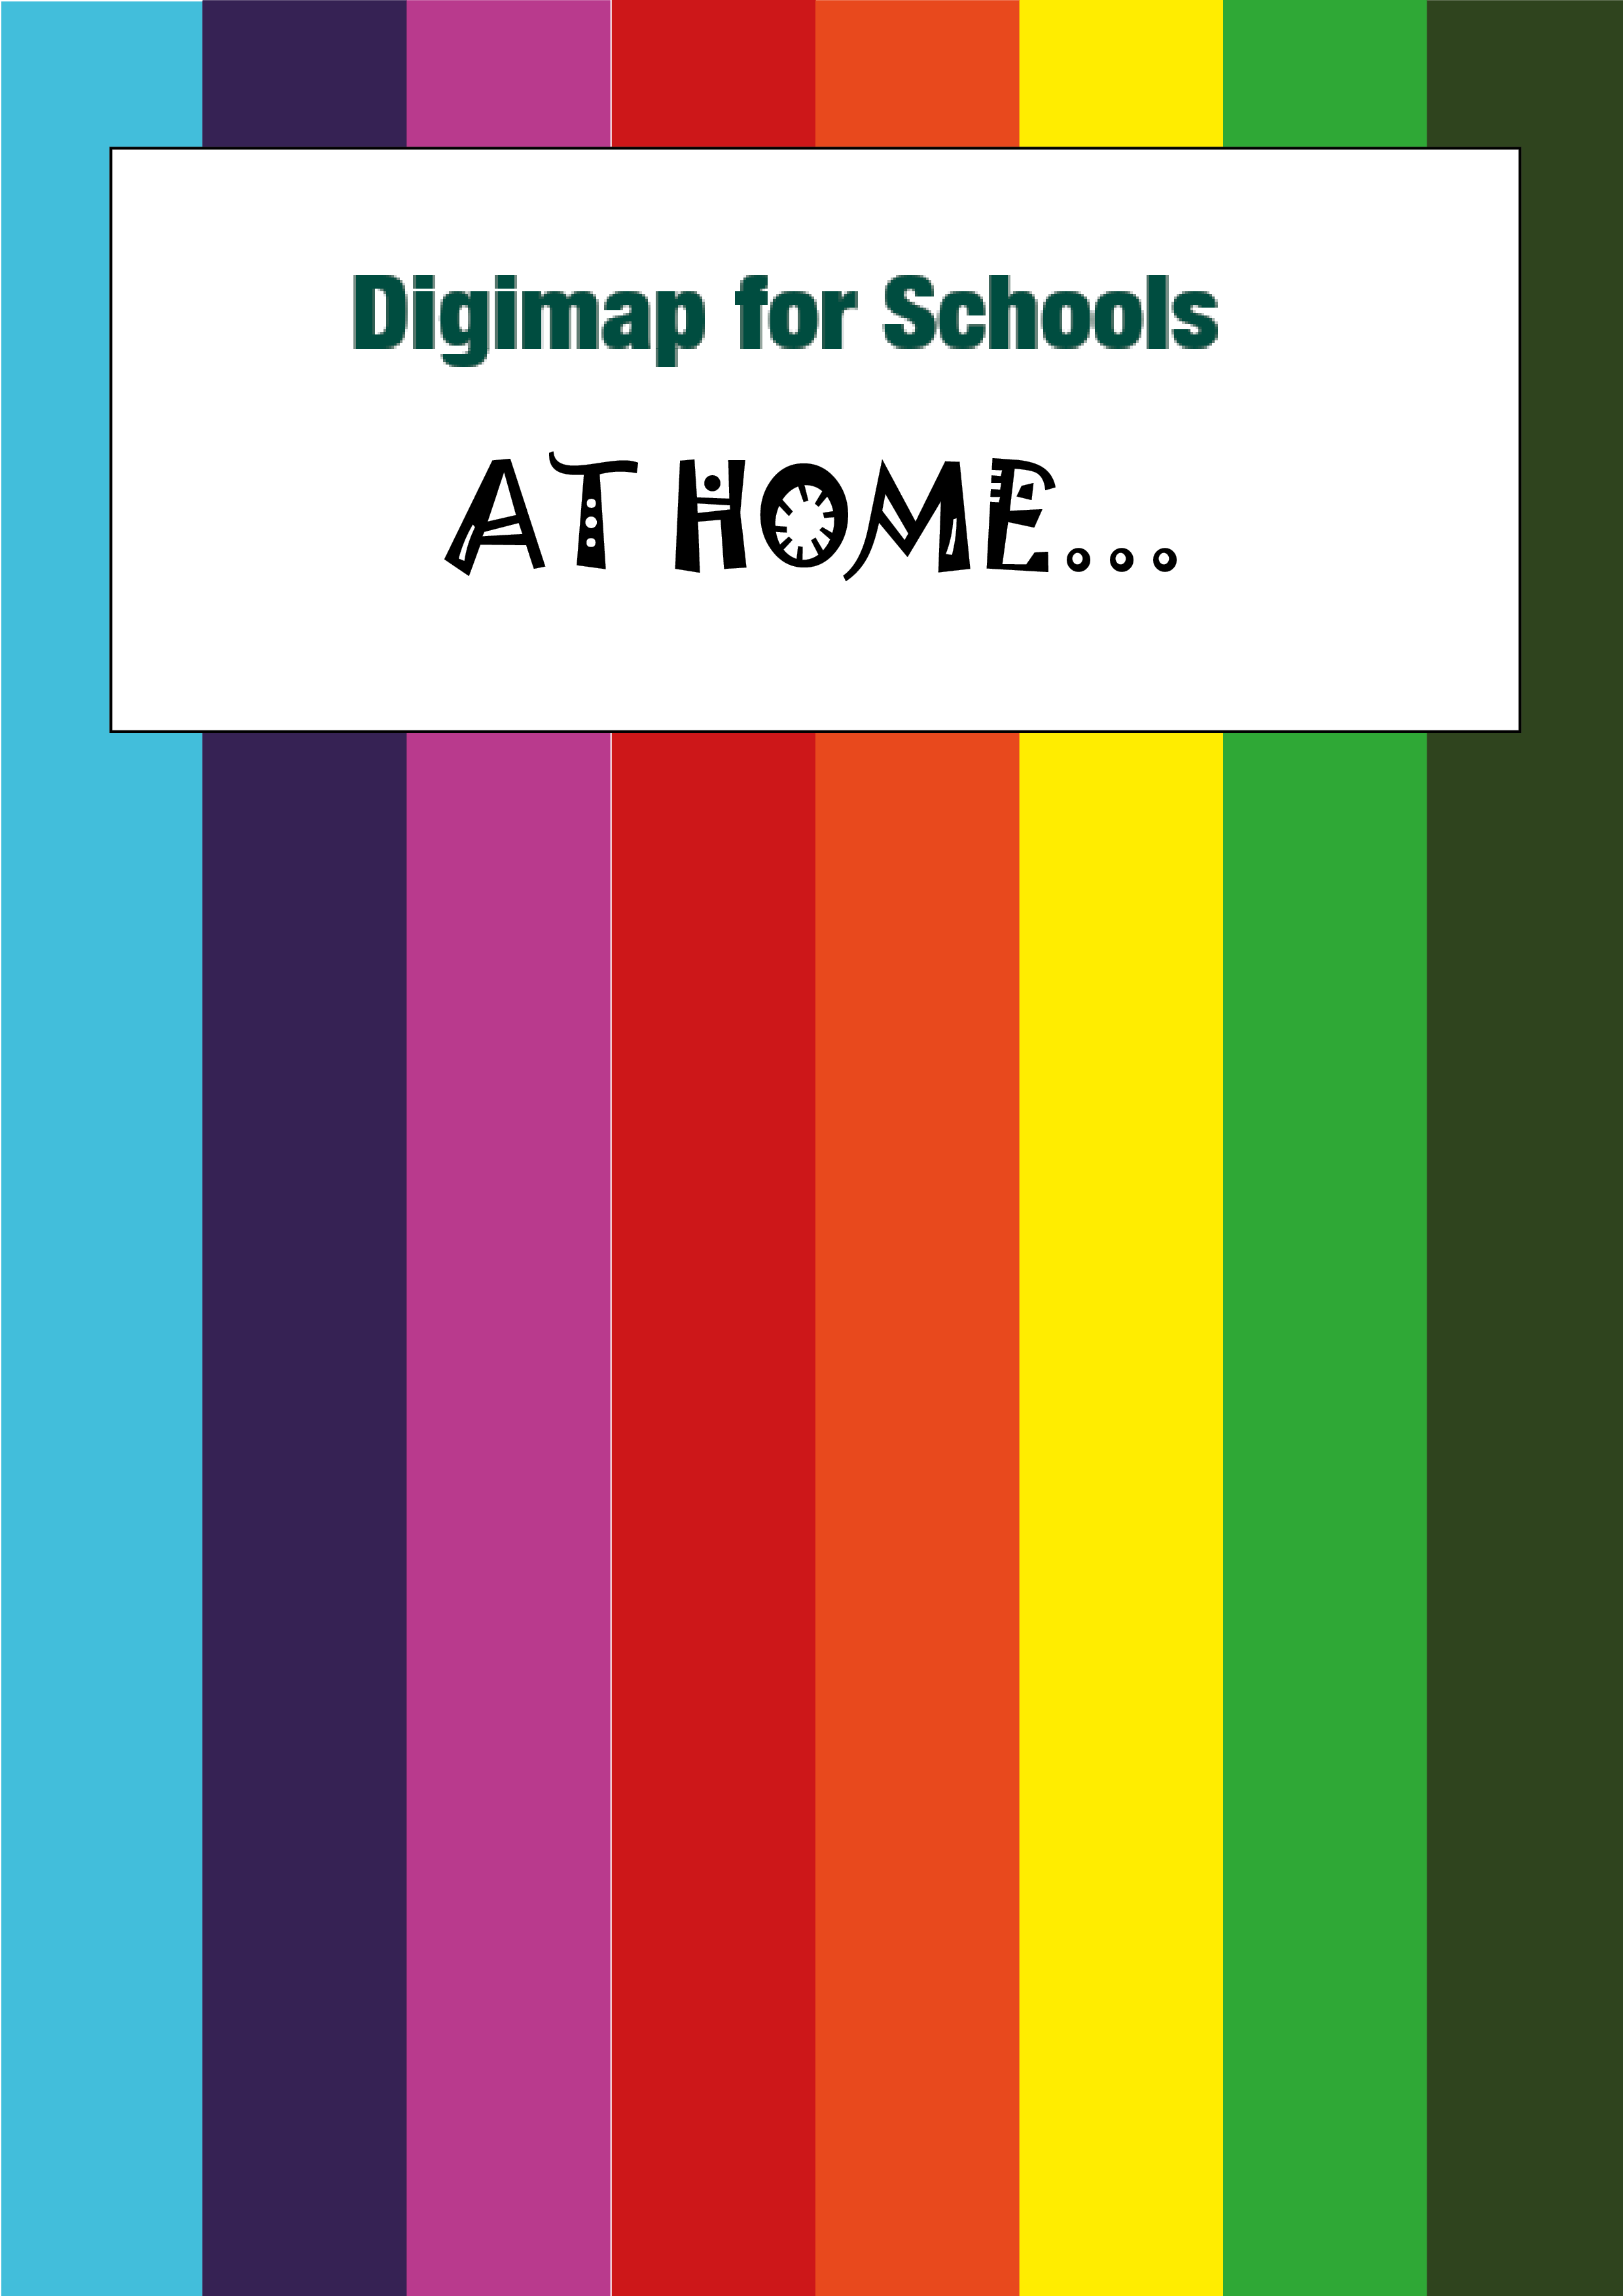

Map symbols crossword

# Crossword

* Test your knowledge of OS Explorer map symbols. Use the picture clues to fill in the crossword.

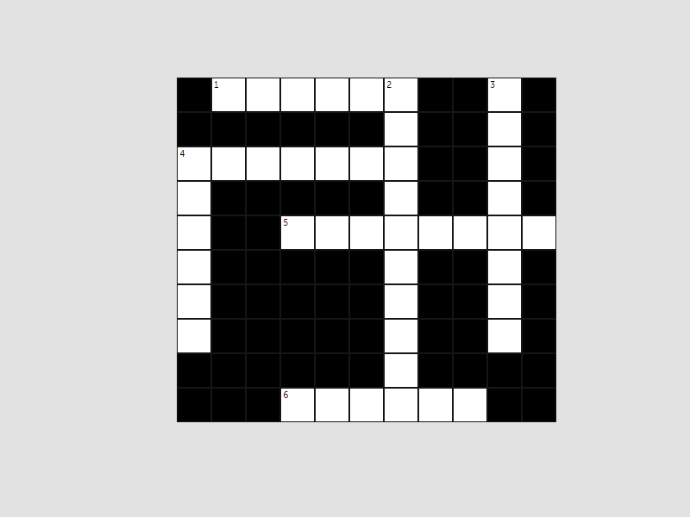

|  |  |
| --- | --- |
| **Across** | **Down** |
| 1 school symbol | 2 lighthouse symbol |
| 4 parking symbol | 3 motorway symbol |
| 5 contours symbol | 4 picnic symbol |
| 6 museum symbol |  |

# List of symbols

You’ll find all the symbols shown in 2 images below. These are the symbols on OS Explorer maps.

## Symbols image 1

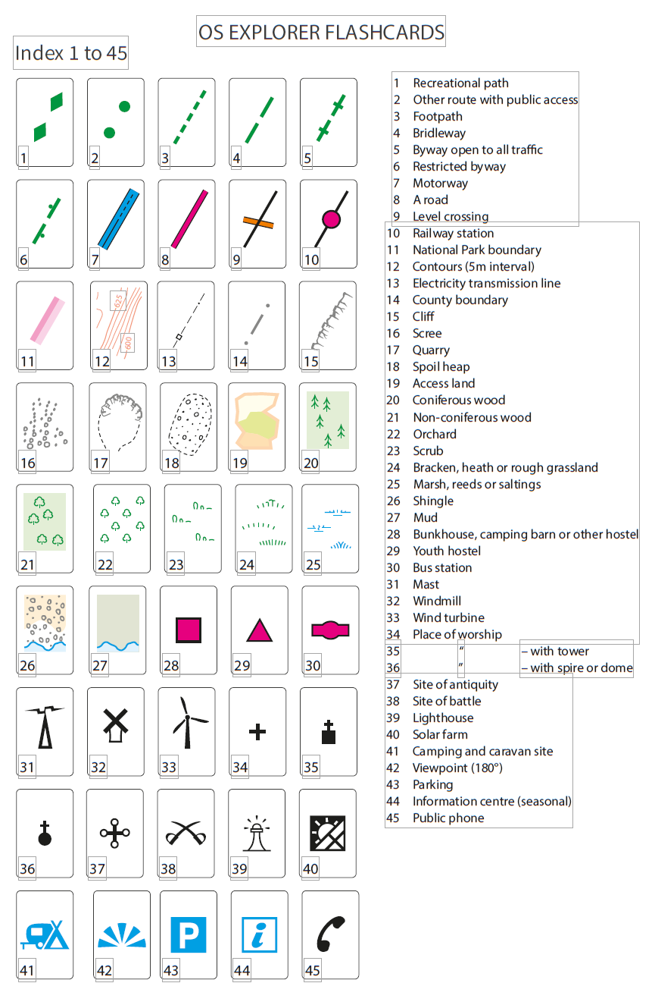

## Symbols image 2

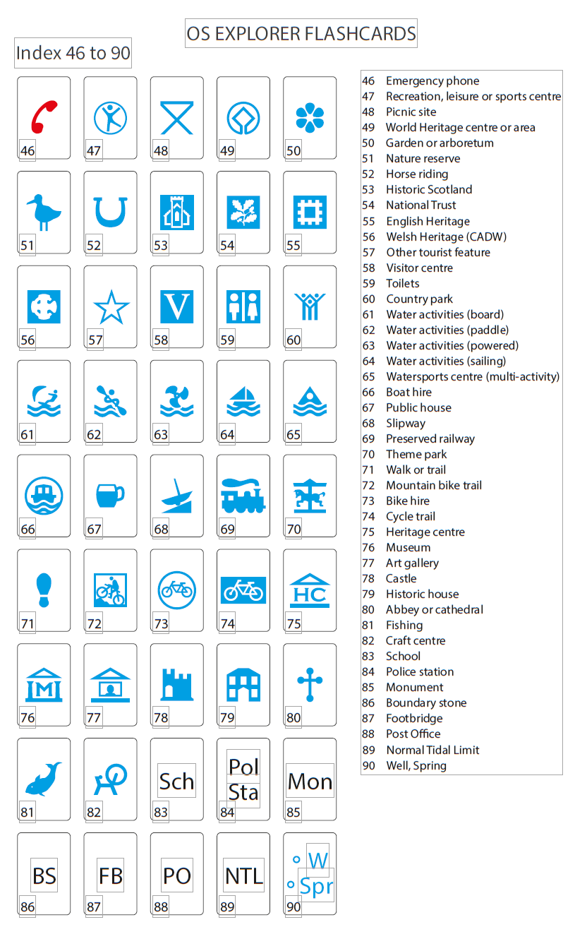

# Answers!

