Ideas for #Homeschooling with Digimap for Schools
Peter O’ Hare Services and User Engagement
EDINA

Introduction to Digimap for Schools
- Online resource
- Contemporary and historical maps and aerial photography for all of GB
- Web based
- Pc, laptops, smartboards, tablets
- Single username/password
- Save and export work
- Print
- Homework

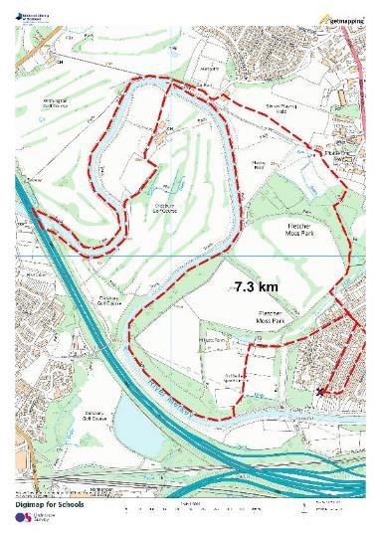

Activity 1:
One walk per day: Make the most of it!

- Plan your route
- Measure your distance
- Document your route (take photos of human and physical features)

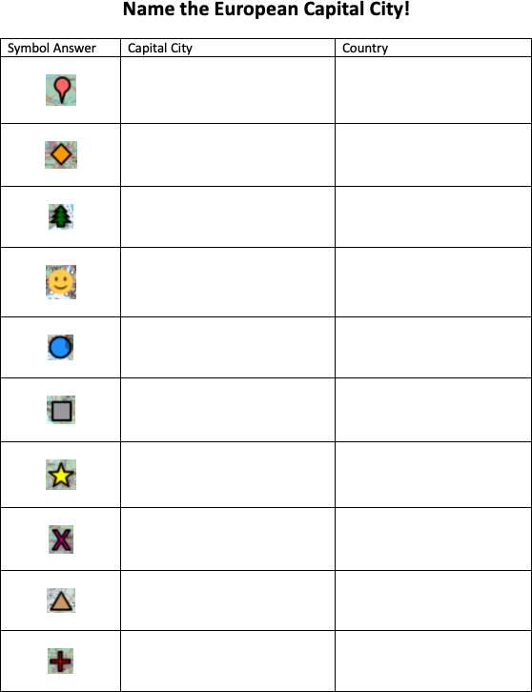
Activity 2: Find the City:

  - Easily adaptable for any city.
  - Once you have created a map its just a matter of changing the locations of each symbol to create a new exercise

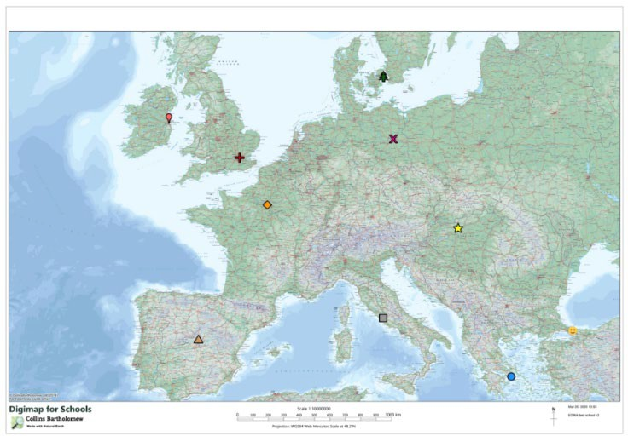

Great Britain Towns and Cities:
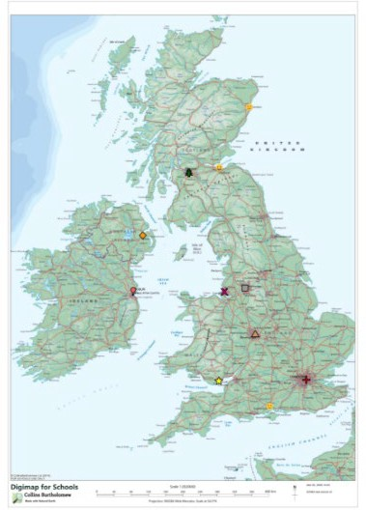

Activity 3: Treasure Hunt-
Using OS Map symbol flash cards

https://www.ordnancesurvey.co.uk/documents/resources/25k-map-symbol-flashcards.pdf
Or google: Ordnance Survey Map symbol flash cards

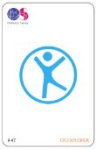
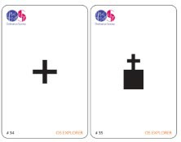
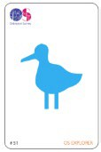

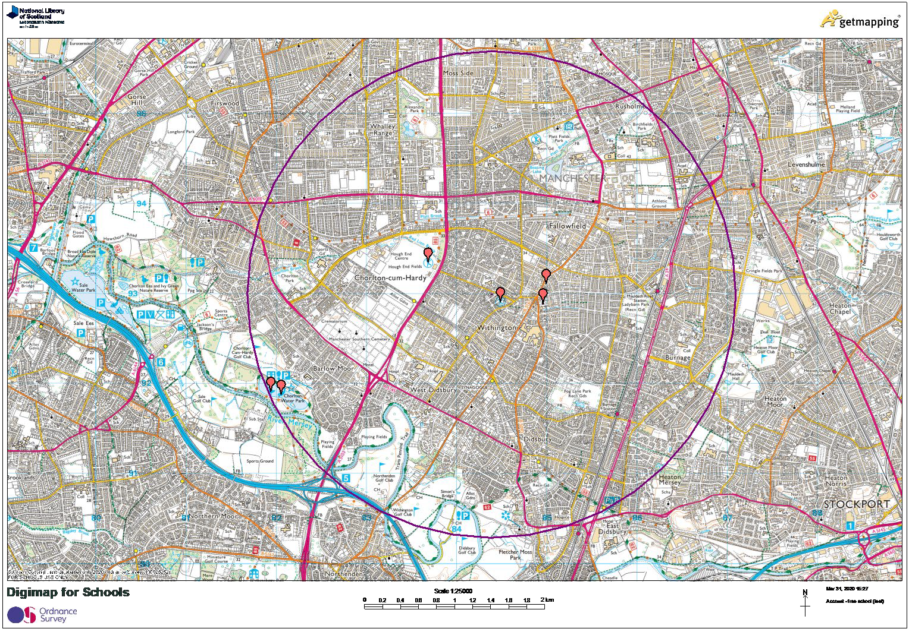

Activity 4: Capital Cities Game:
https://random.country/capital?

Youtube video of the game here
https://www.youtube.com/watch?v=7t0Rf-UdDRs

City | Country | Distance from Pin
Port of Spain | Trinidad and Tabago | 1112
Nuuk | Greenland | 982
Andorra la Vella | Andorra | 47
Lisbon | Portugal | 100
Cairo | Egypt | 56
 | Total | 2338

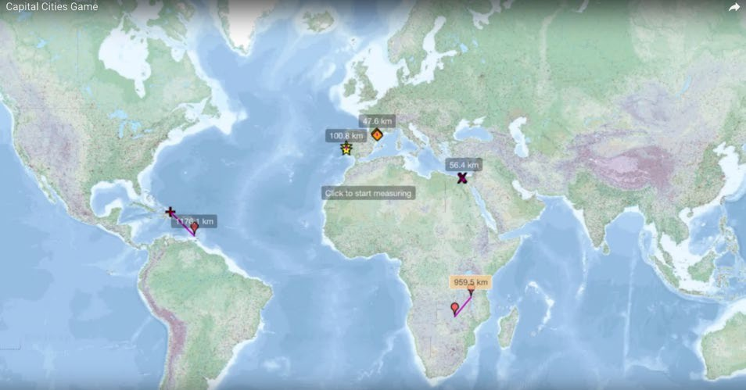

Activity 5: Land Use

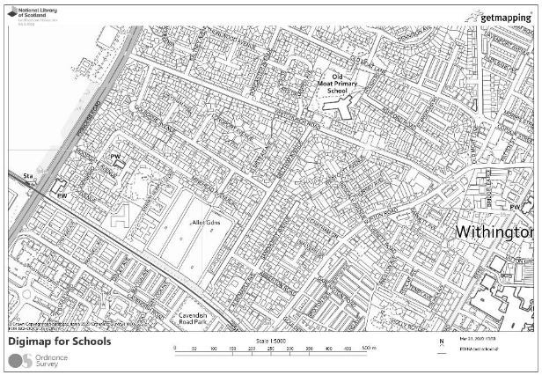
Can be done within Digimap with Drawing Tools or by printing and colouring in.
Create a key:
- Public buildings
- Medical buildings
- Council buildings
- Offices
- Shops
- Residential

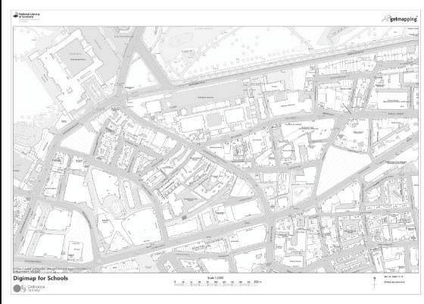
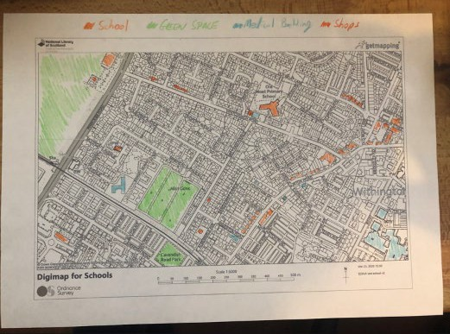

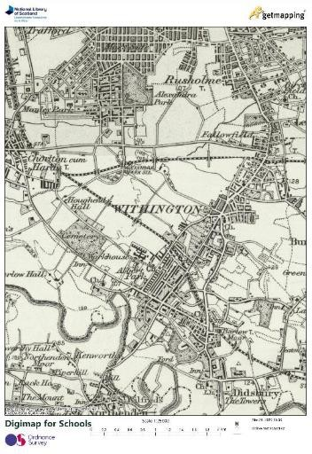
Activity 6: Spot the difference?

What has changed in your area?
  - Was your house there in the 1890’s or 1950’s?
  - Find all the things that have changed?
  - Why have things changed?

Activity 7: Urban Expansion
Look at your town or village in the 1890’s
- Measure the changes from then to now, using the measurement tools.
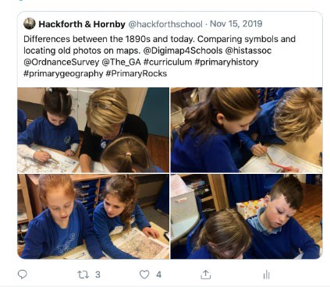

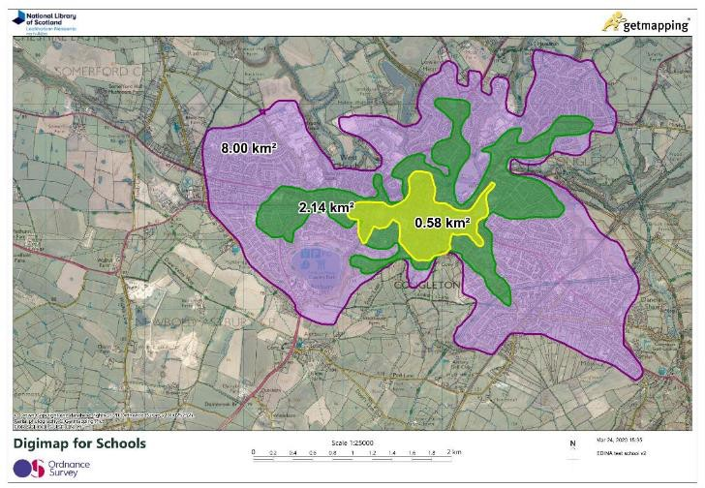

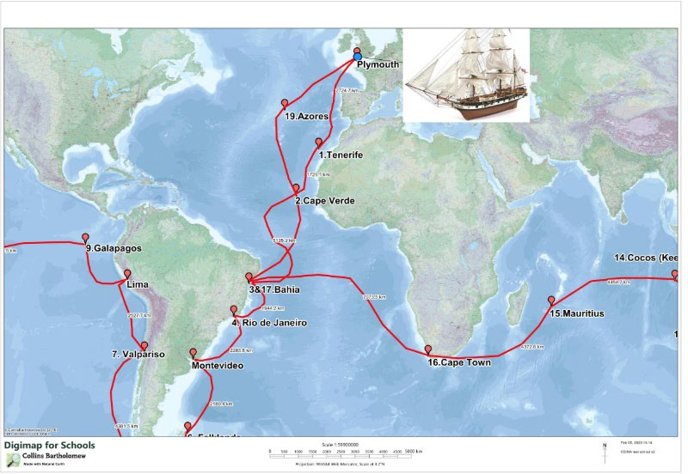
Activity 8: Story Maps

Home Schooling resources: https://digimapforschools.edina.ac.uk/resources/scavenger hunt/

Youtube:
https://www.youtube.com/user/digimapforschools

Twitter:
https://twitter.com/Digimap4Schools

