Using Digimap for Schools to Develop Locational Geography Across the Curriculum.

Judy Clarke

Why is Locational Geography Important?

**Locational Understanding Across the Curriculum Powerful anecdotes from subject lead HMIs:**

* Despite studying the Roman Empire and its impact on Britain in depth, pupils could not locate Italy or Rome on a European map or globe.

***A powerful opportunity to embed locational knowledge lost.***

*HMI Subject Lead Geography, Primary Geography Spring 2021:*

* Despite obvious enjoyment of a class text, some pupils believed that the WW2 refugee had arrived in England from Australia, rather than Austria.

***Locational confusion.***

**The use of Digimap for Schools develops and secures locational knowledge across the curriculum.**

Geography is the fifth in the current Ofsted Research Review Series (June 2021)

Ofsted Geography Review: June 2021

***Knowing Where’s Where*** *is one of the mainstays of geographical education.*

[https://www.gov.uk/government/news/ofsted-publishes-research- review-on-geography](https://www.gov.uk/government/news/ofsted-publishes-research-review-on-geography)

Using Digimap for Schools to Support Historical Enquiry

1

**Enquiry: Where did the Romans come from?**

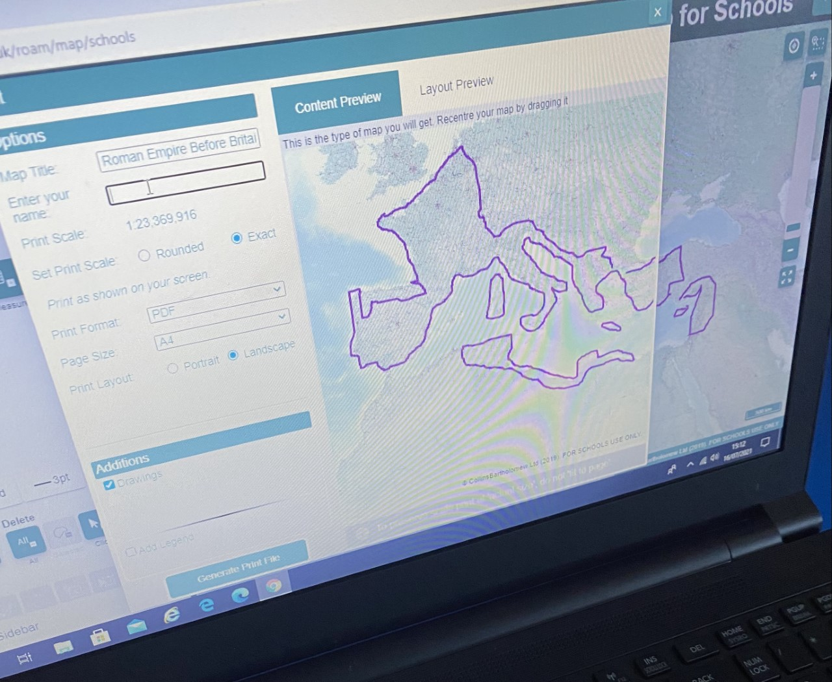

@hackforthschool

***Knowledge of locations & topography enhances historical knowledge*,**

**Iain Freeland, Primary Geography, Spring 2021**

Using Digimap for Schools to Support Historical Enquiry

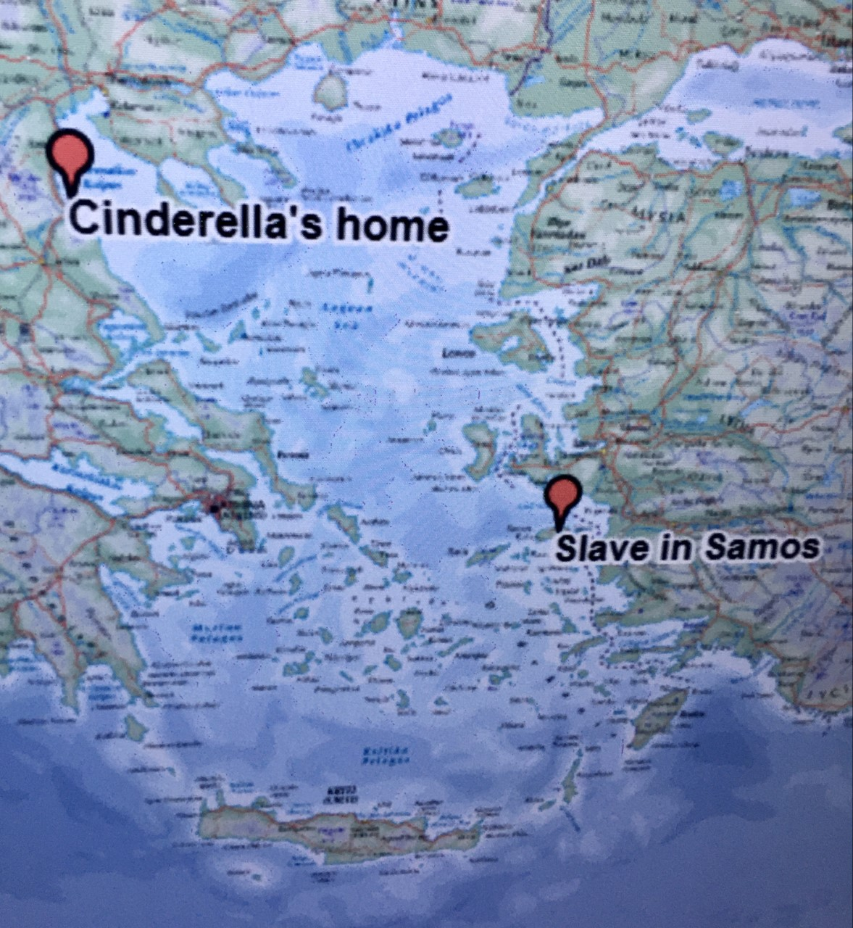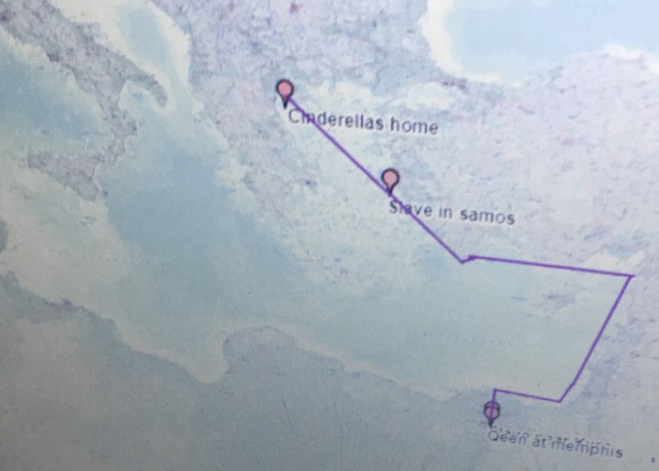

2

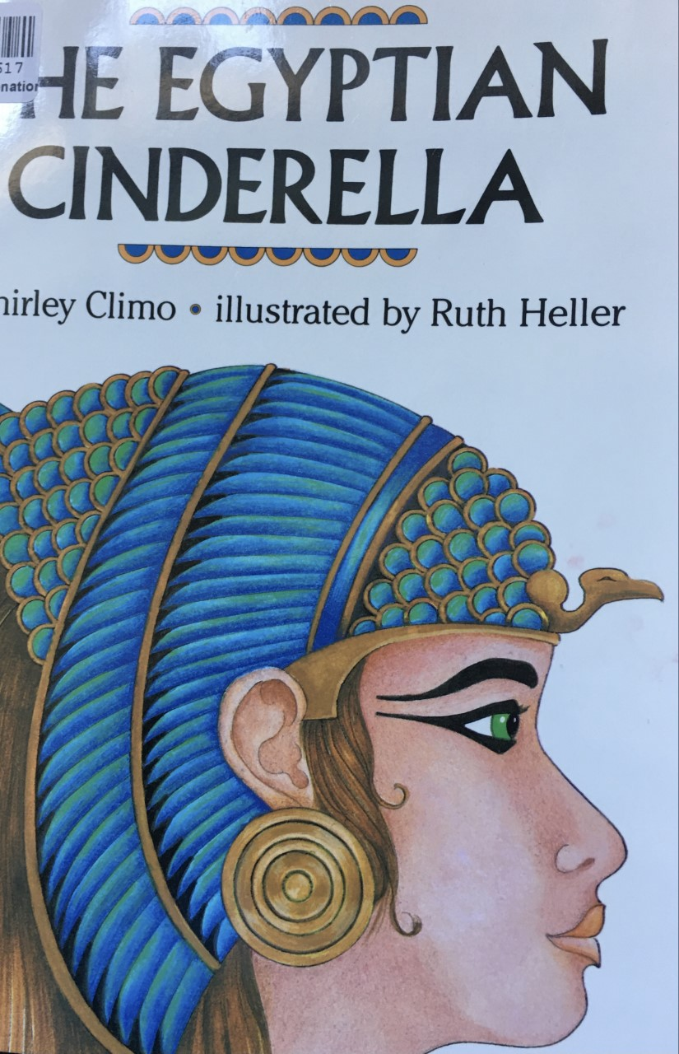**Not just the Ancient Egyptians!**

Evidencing wider global history.

@hackforthschool

Significance of the River Nile:

Geographically & Historically.

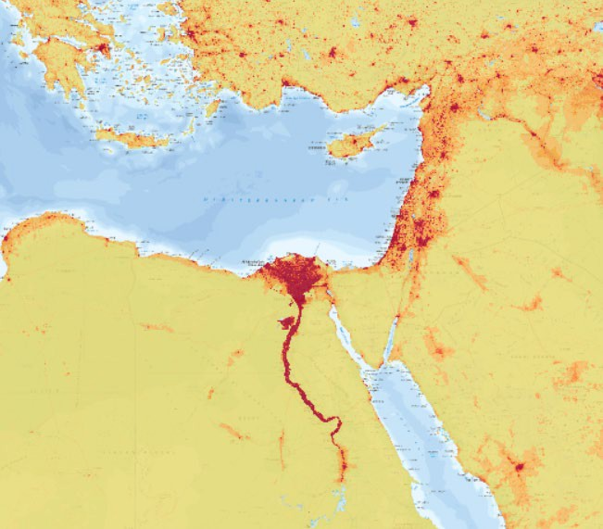**Digimap for Schools: Population Overlay.**

@hackforthschool

***Palaeolithic***

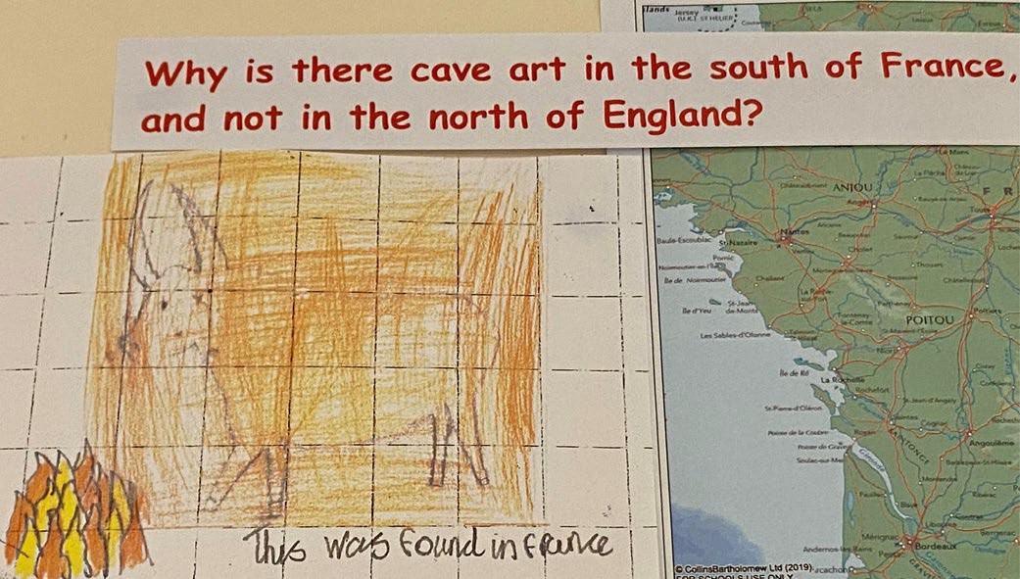Using Digimap for Schools to Support Historical Enquiry

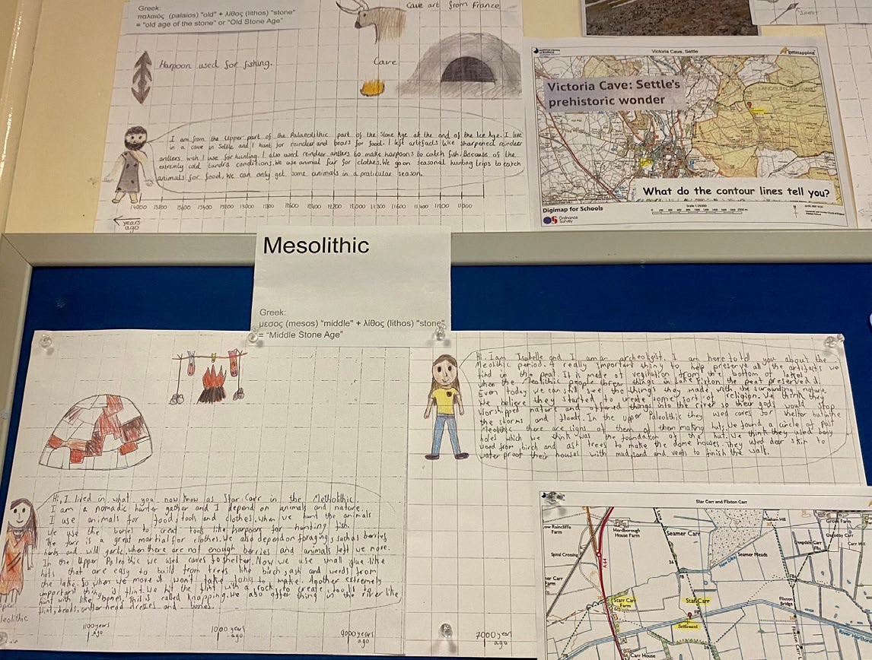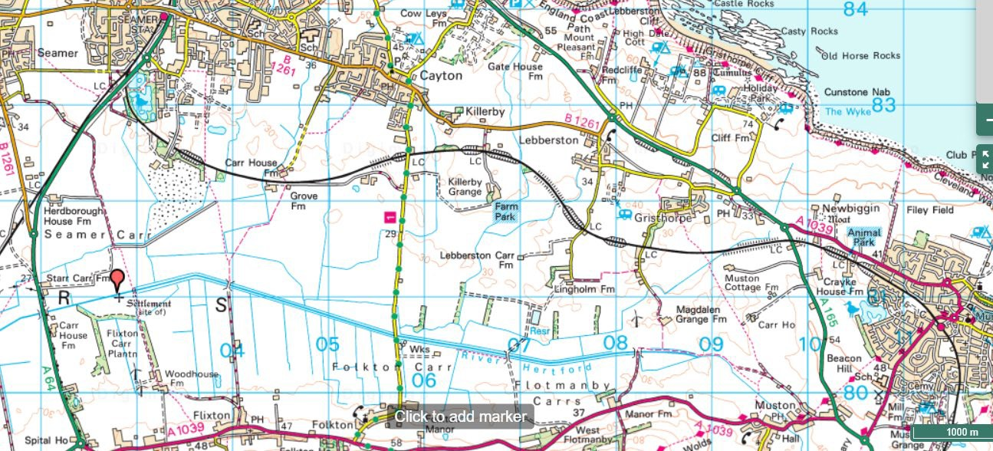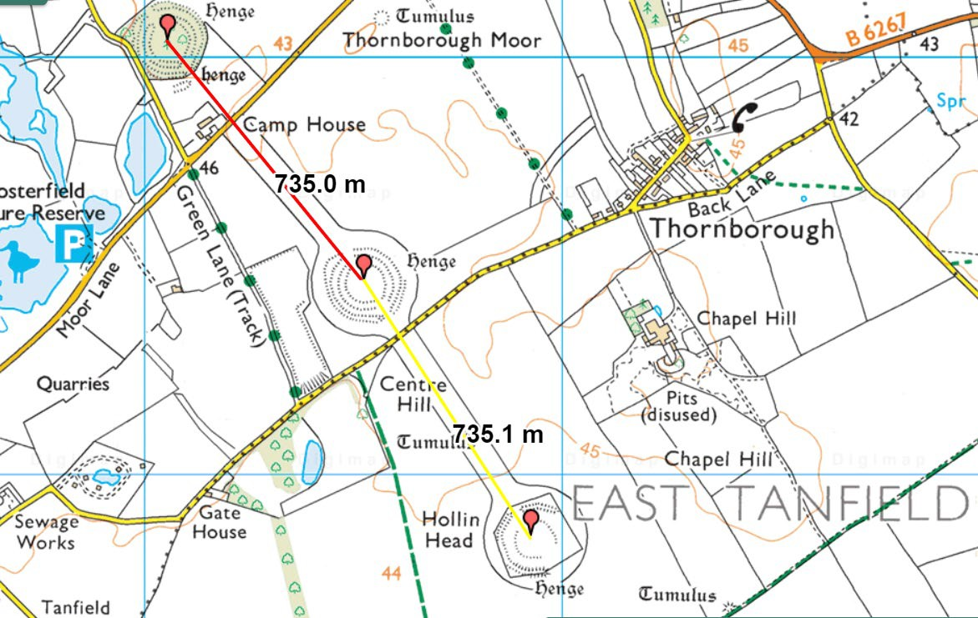

***Mesolithic***

**Investigating the Stone Age**

**in the north of England.**

***Neolithic***

3

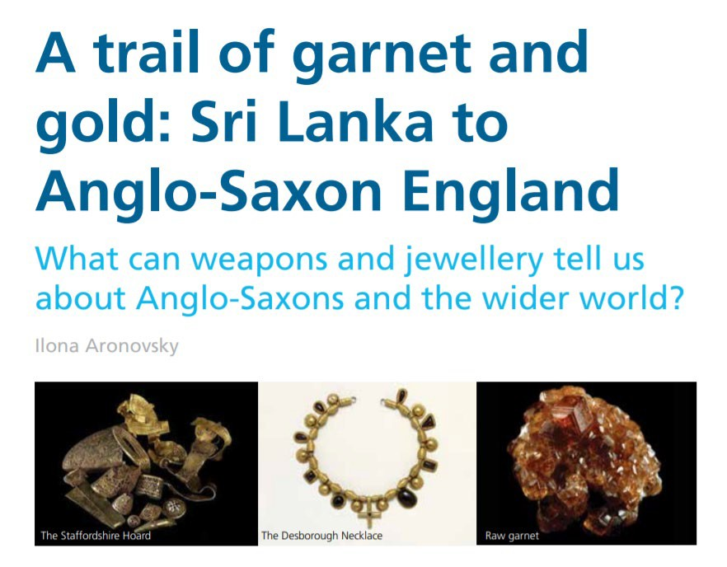

Using Digimap for Schools to Support Historical Enquiry

4

**Enquiry inspired by this Historical Association (HA) Resource:** Primary History 76, Summer 2017

**Supporting the Enquiry:**

***The Dark Ages?* Evidencing Global Trade**

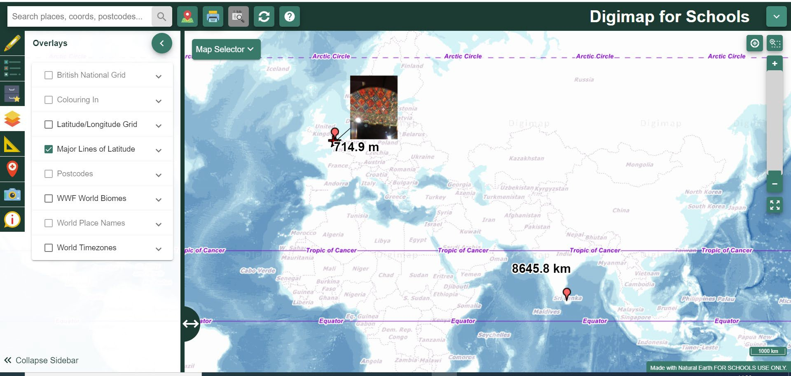**Approximately 8600 km, *as the crow flies*:**

**Use your knowledge of Saxon travel to devise a route to Sutton Hoo.**

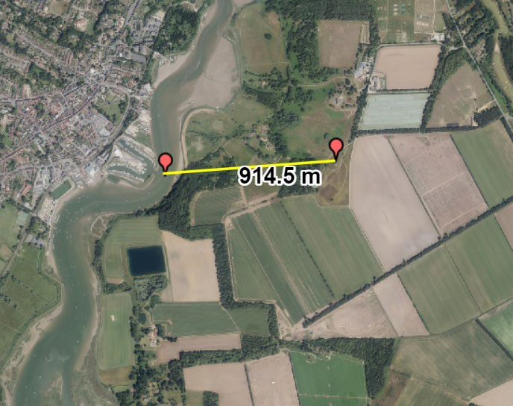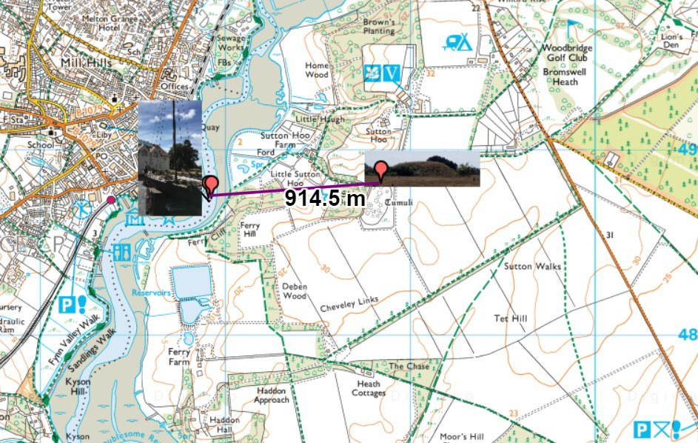

**What do the maps tell you about the difficulties of moving the ship to the burial mound?**

Using Ordnance Survey Maps to Develop the Sutton Hoo Enquiry

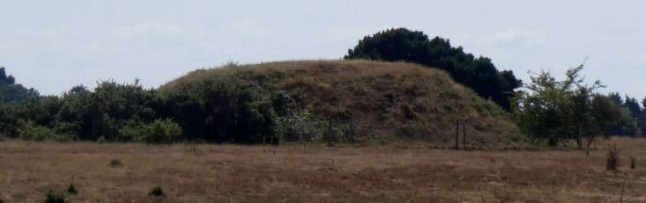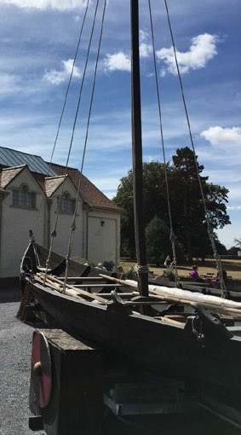

**Add photos…**

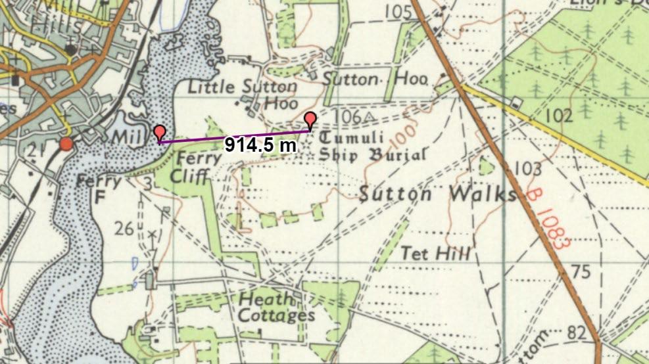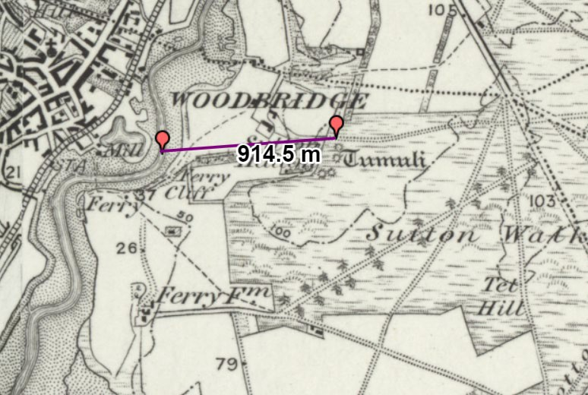

**1950s**

**1890s**

Develop through Historical Maps of the Area

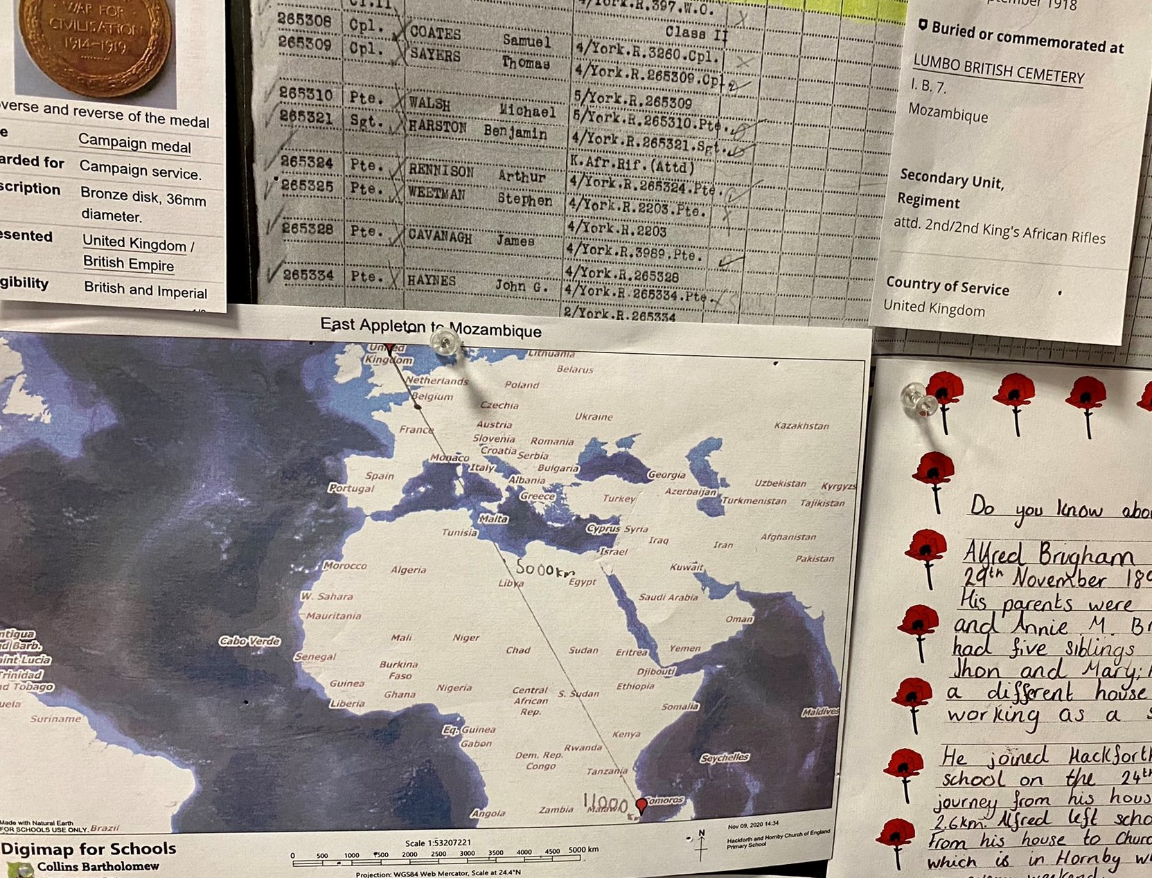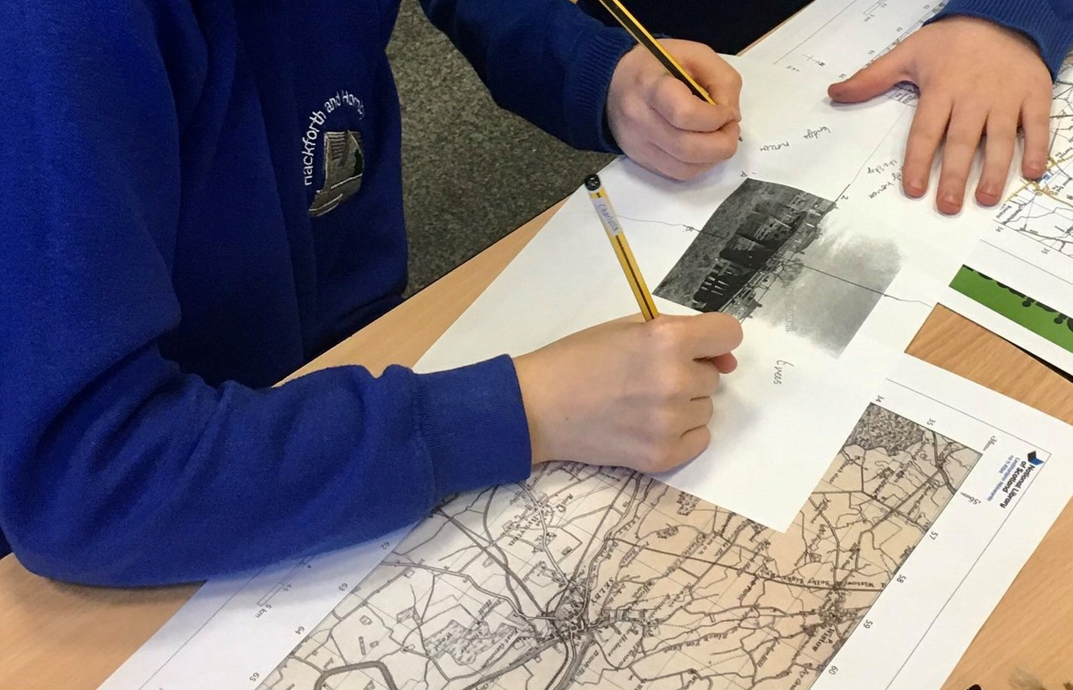

**Historical mapping**

**investigating change…**

**Using Digimap for Schools to research**

**the lives of past pupils.**

@hackforthschool

Using Digimap for Schools to Support Historical Enquiry

5

Remembrance

**Progression in Geographical Skills and Fieldwork**

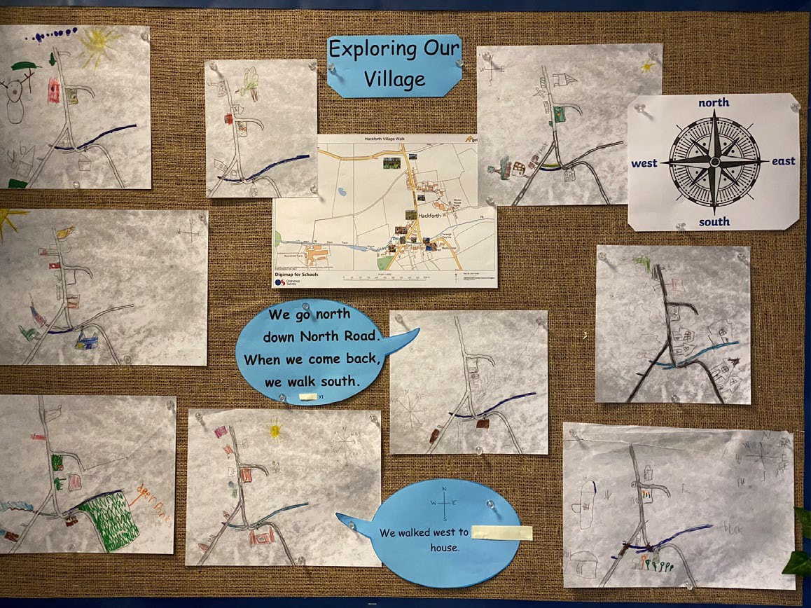**R/KS1: Geographical Skills and Fieldwork.**

@hackforthschool

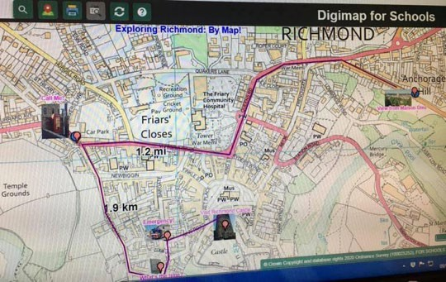**KS2 Virtual Fieldwork During Lock Down.**

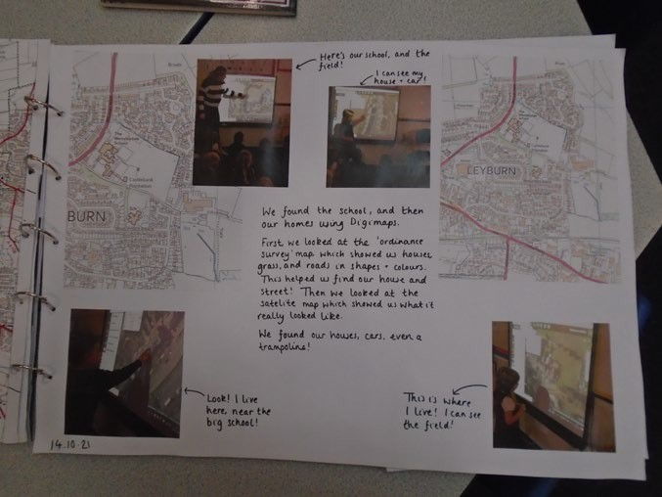***A map shows you where the things are…***

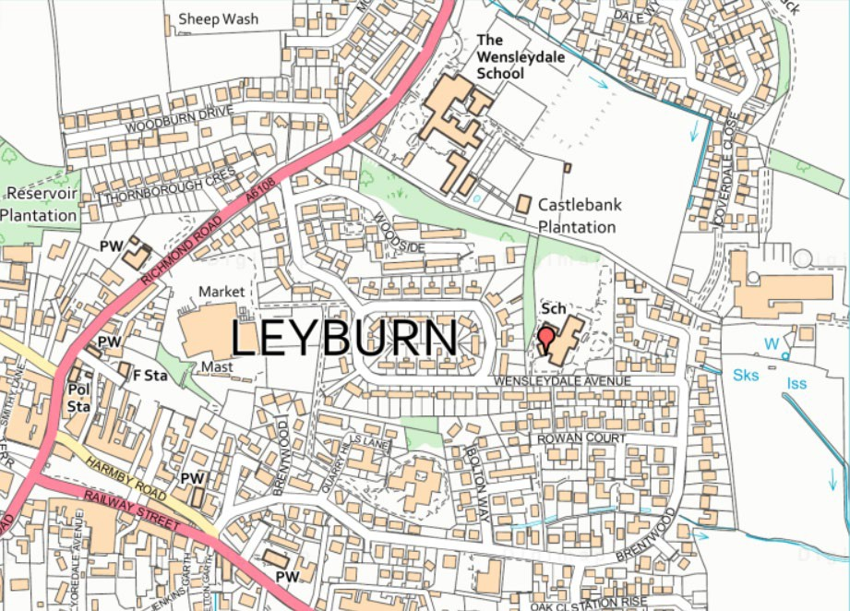

**Preparing for KS1: Key**

**human & physical features**

Good Practice at EYFS

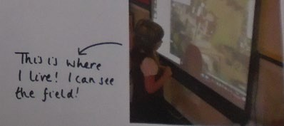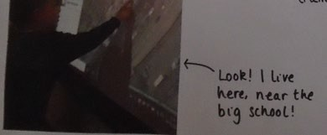

Leyburn Primary School : Developing a Sense of Place…

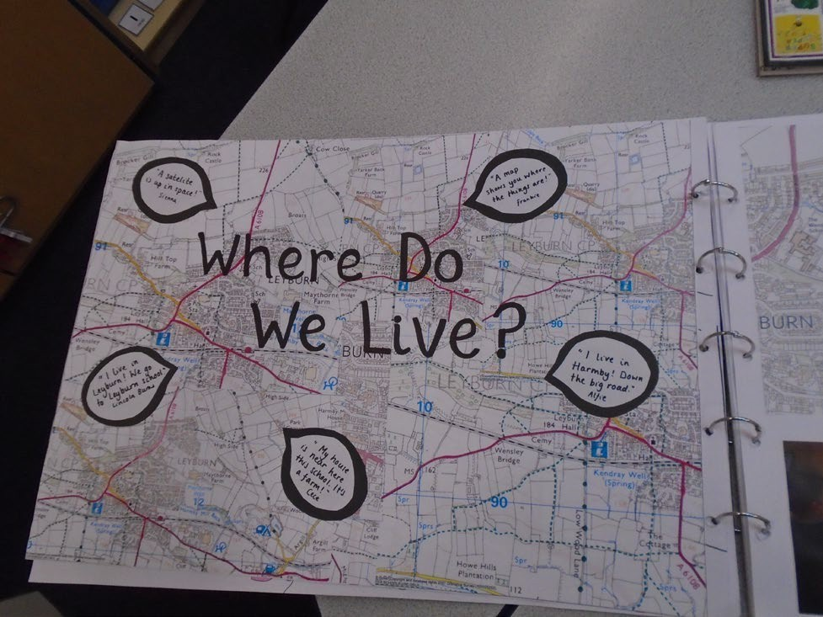

***We used shapes and colours to find our houses…***

***A satellite is up in space…***

***What it really looks like…***

**@leyburn_school**

***Geography Enhances a Rich Primary Curriculum***

Supporting

English 1

Texts

**Developing pupils’ locational knowledge will promote tier 2 and tier 3 vocabulary across a rich primary curriculum:**

**English:**

Reference locations across **text types, including class readers**:

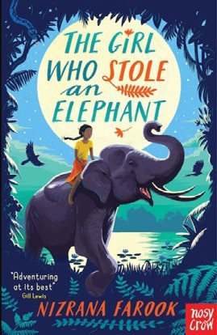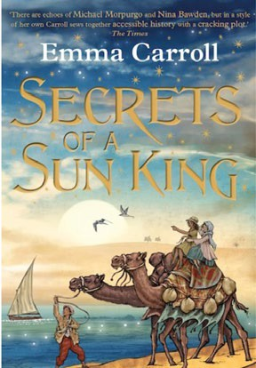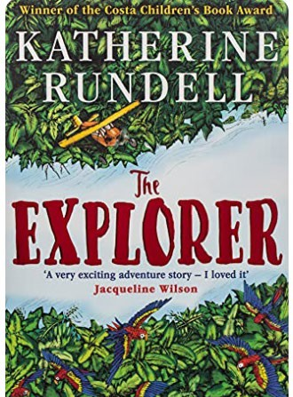

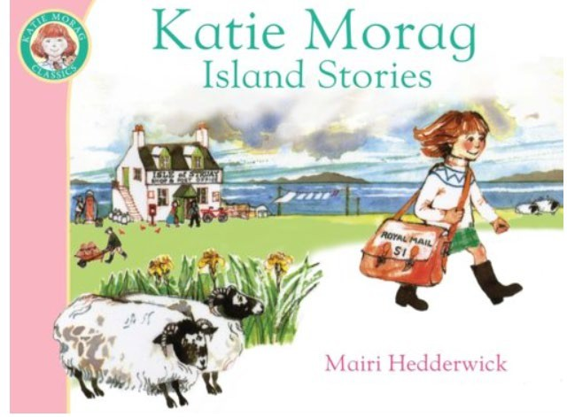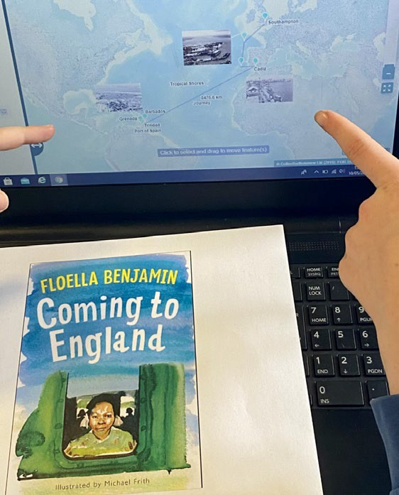

@hackforthschool

* Use Digimap for Schools to investigate locations and journeys. Look at climate and time zones (Digimap for Schools Overlays).
* If historical, compare with today’s journeys.

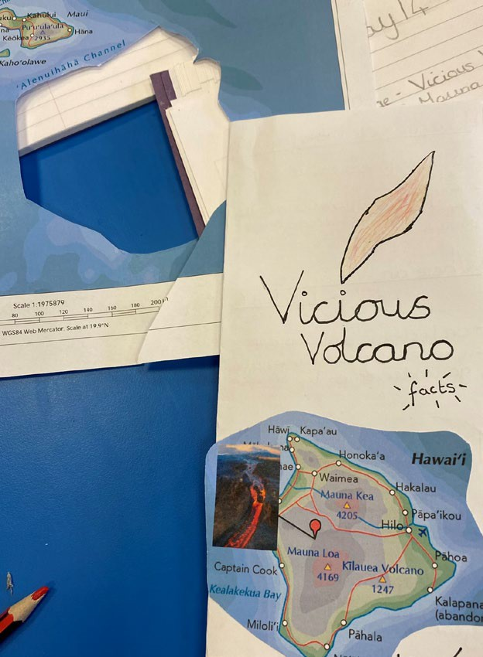Supporting

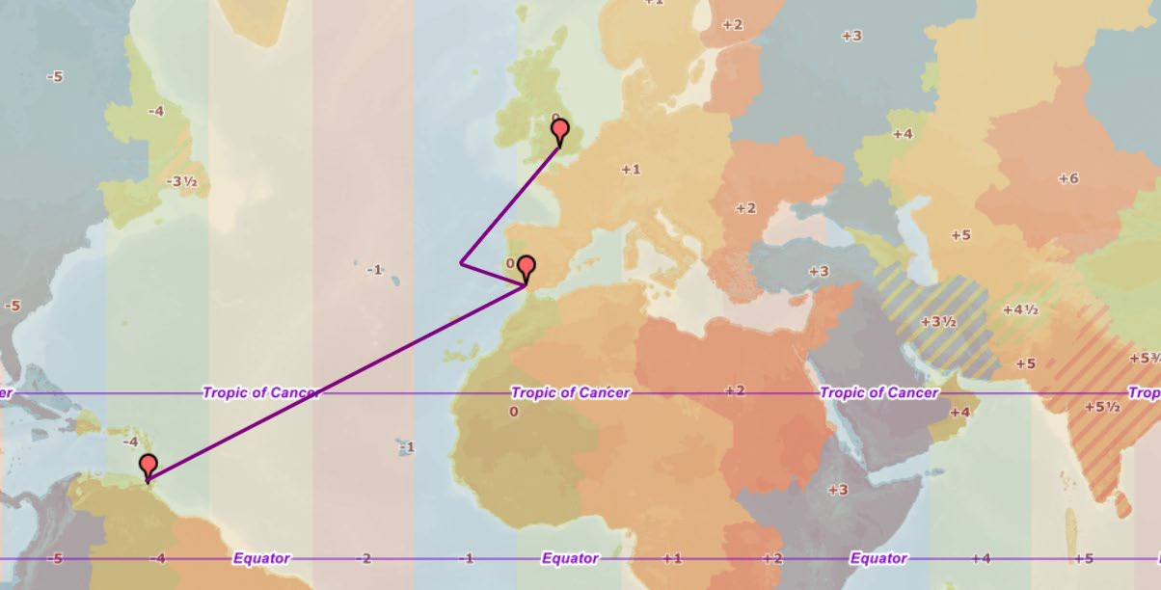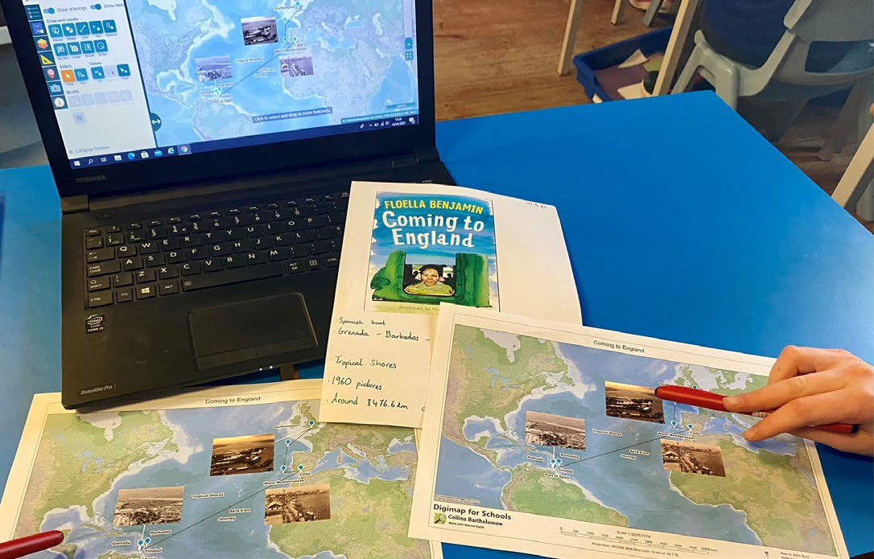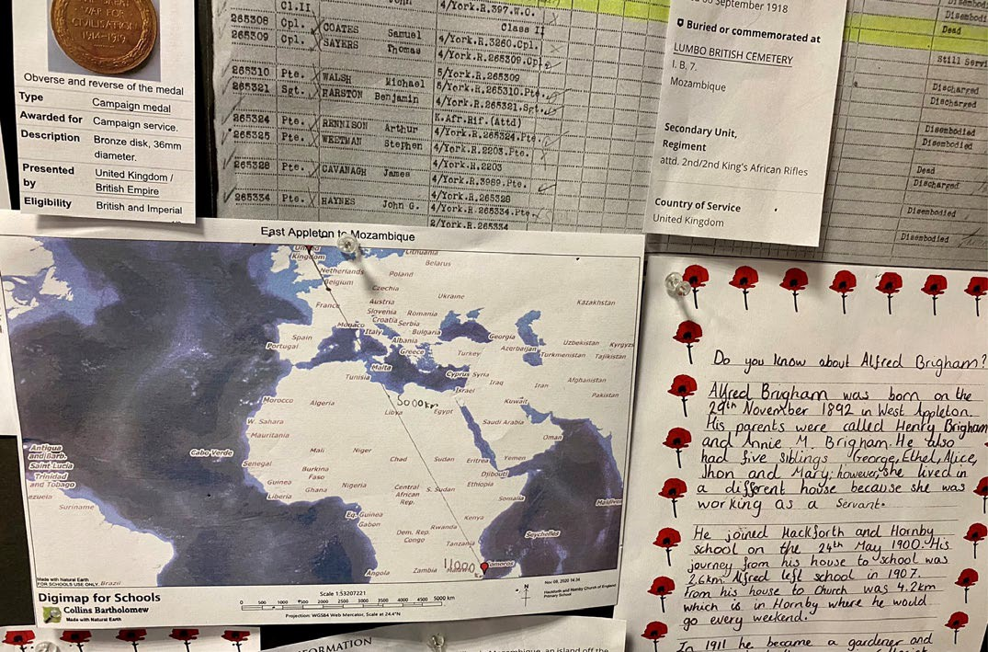

@hackforthschool

**Reports**

English 2

Research to Support Non Fiction Writing

**Leaflets**

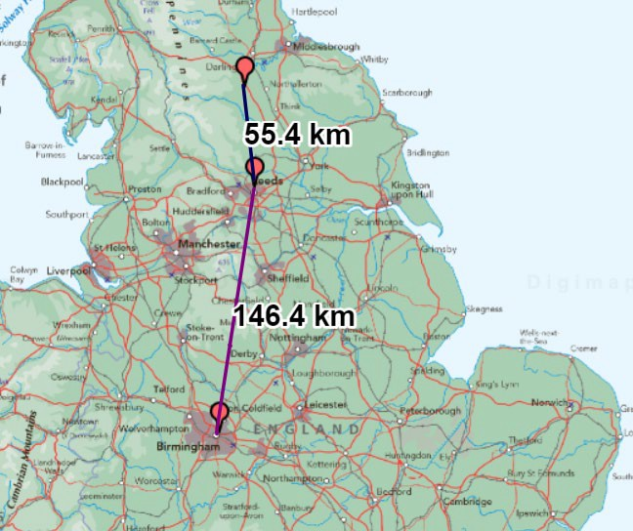**Supporting Maths**

**Major Cities of the UK**

**How far from school to Birmingham via Leeds?**

Mapping the News…

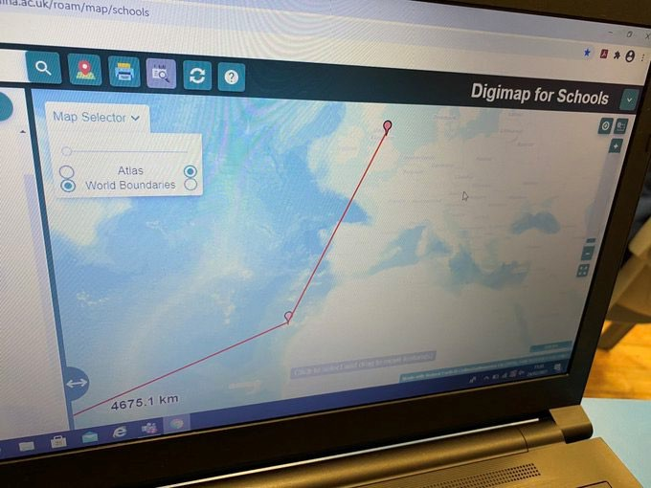@hackforthschool

**Thirsk teacher, 21, becomes youngest solo female to row Atlantic.**

Looking to the Future…

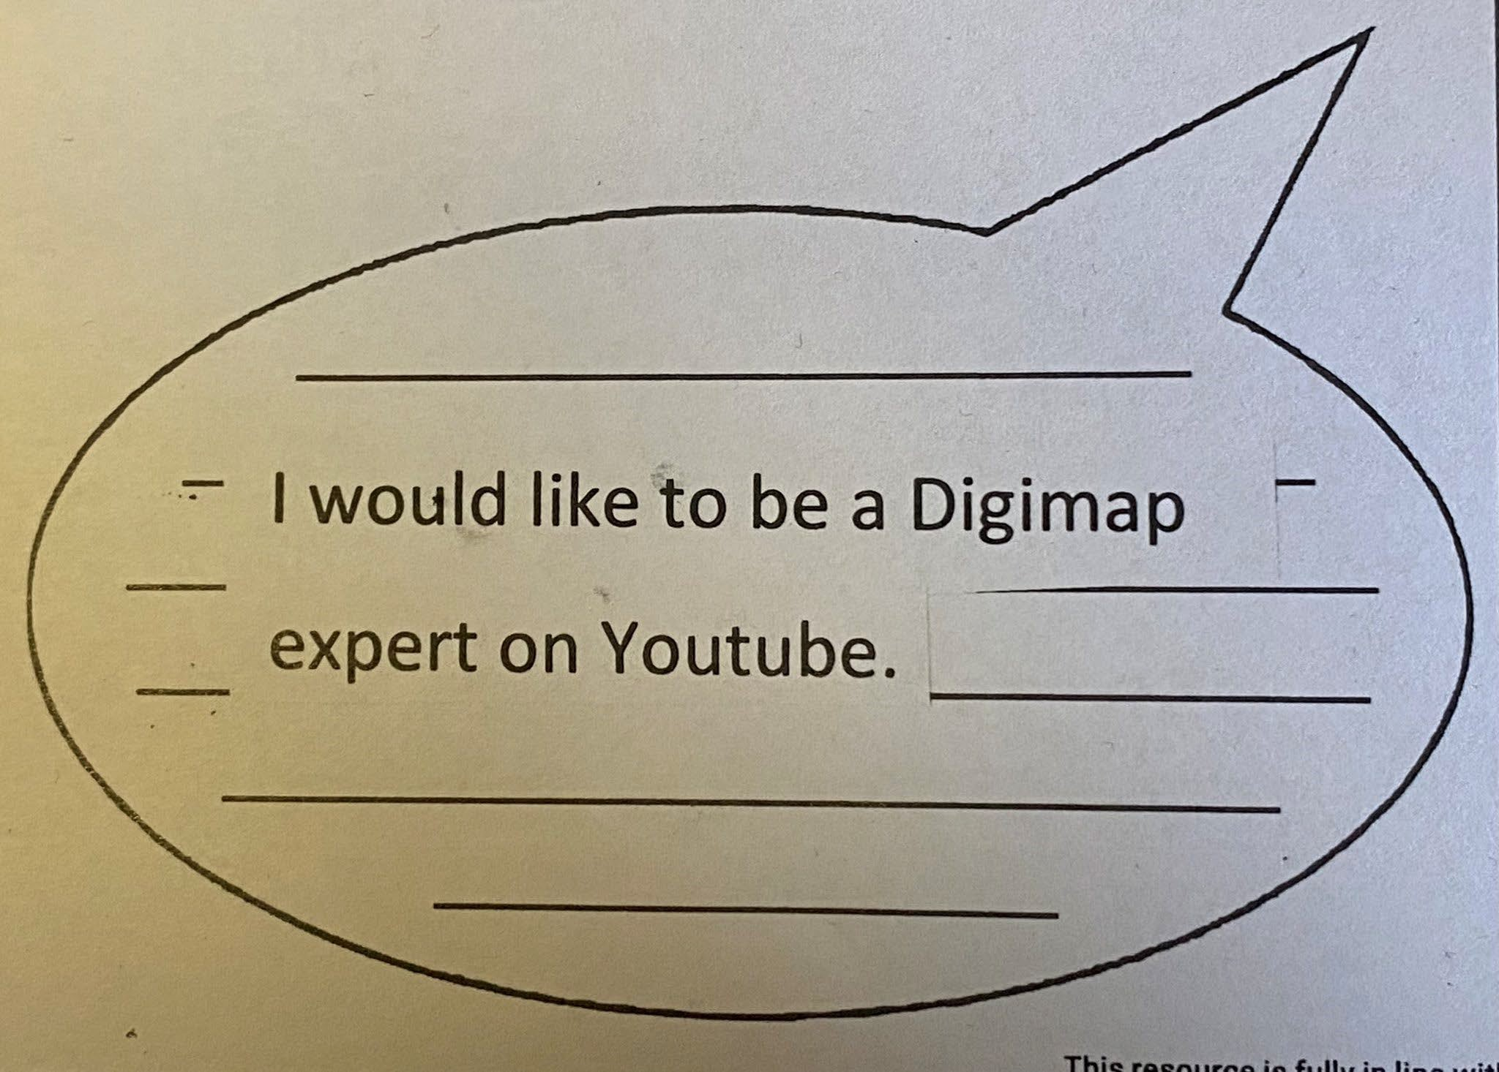@hackforthschool

**Pupil Questionnaire Response, 2021**