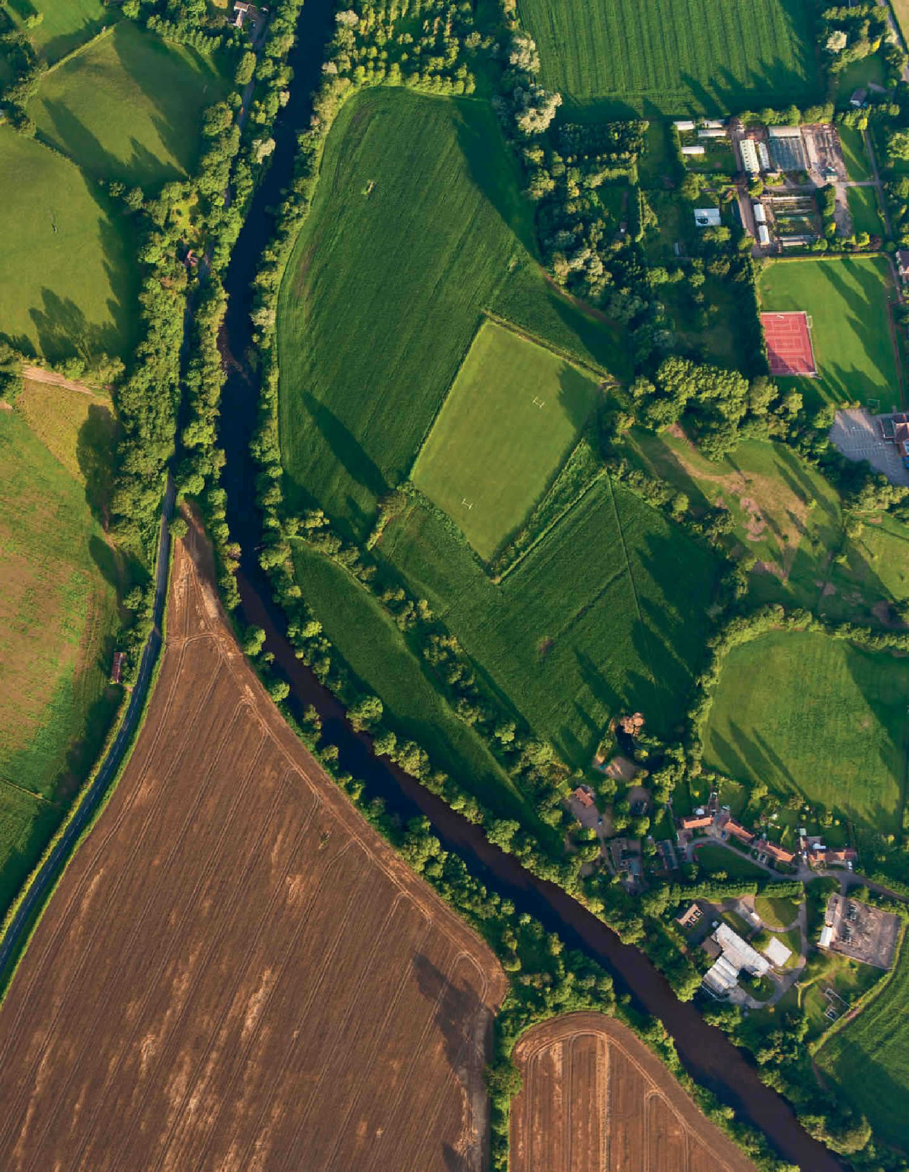
GEOGRAPHY FOR SECONDARY

FOR 1 1 - 1 6 YEAR OLDS

Planning for pupil progress in the use of Ordnance Survey maps.
David Gardner




2
GEOGRAPHY FOR SECONDARY

Contents
2
Introduction 3
Who is OS? 7
The significance of maps skills 8
Graphicacy and spatial thinking 10
OS mapskills in the DfE national curriculum 12
Evidence of poorly developed map skills 17
Towards a curriculum design process 19
- Curriculum Intent 21
Graphicacy and spatial thinking in your curriculum 25
Examples of curriculum making in action 28
Planning for progress in your 11-16 geography curriculum 34
Designing a curriculum 37
Progress in geography 41
Geographical Information Systems 53
- Curriculum Implementation 55
Creating a need to know using OS maps 58
Making sense of OS maps as data 59
- Curriculum Impact 60
Resources and online resources 62

INTRODUCTION 3

Much has happened in education since the publication of the first edition of ‘Planning for Pupil Progress in the use of Ordnance Survey maps Key Stage 3 Geography’, in 2015. As well as the development of new GCSEs and A-Level specifications, Ofsted have designed a new education inspection framework (EIF) – with a focus on the quality of the curriculum.

One of the first indicators of new Ofsted focus came when Her Majesty’s Chief Inspector, Amanda Spielman, commissioned a major research study into the curriculum (Ofsted, 2017). The goal of this research was to make sure Ofsted could assess – in a valid and reliable way – the ‘quality of education’ on offer in schools, with a welcome and radically new focus on the curriculum itself. Spielman (Ofsted, 2017a) launched her commentary on phase one of Ofsted’s curriculum research with a bold statement:

“At the very heart of education sits the vast accumulated wealth of human knowledge and what we choose to impart to the
next generation: the curriculum ... Without a curriculum, a building full of teachers, leaders and students is not a school. Without receiving knowledge, students have learned nothing, and no progress has been made – whatever the measures might indicate. This is why exams should exist in the service of the curriculum rather than the other way round.”

- GEOGRAPHY FOR SECONDARY

Ofsted’s research (2019) used a working definition of the curriculum, which recognises that it passes through different states: how it’s conceived, taught, and how students experience it. Thus:
“The curriculum is the substance of what is taught. It is a specific plan of what pupils need to know and should be able to do. The curriculum shapes and determines what pupils will get out of their educational experience. It is distinct from pedagogy, which is how the curriculum is taught. And, it is distinct from assessment, which is a means of setting out the desired outcomes we wish pupils to achieve and evaluating whether they have achieved those outcomes.” (p. 4)

The working definition of curriculum that emerged was:
“The curriculum is a framework for setting out the aims of a programme of education, including the knowledge and understanding to be gained at each stage (intent); for
translating that framework over time into a structure and narrative, within an institutional context (implementation), and for evaluating what knowledge and understanding pupils have gained against expectations (impact/achievement).”




The three I’s – intent, implementation and impact – are similar to the three curriculum questions used in the first edition of this Ordnance Survey (OS) curriculum guidance:
5
INTRODUCTION
5
- What are you trying to achieve?

- How will you organise the learning?

- How well are you achieving your aims?

Alan Kinder and Paula Owens were both members of an Ofsted geography reference group that worked throughout the summer term of 2019. The aim was to help devise training guidance for Ofsted inspectors, so they would be better equipped to apply the
new framework to inspect the quality of geography education in schools. Kinder and Owen have used this experience to write an invaluable article (2019), published in GA journals, Teaching Geography and Primary Geography, to provide an overview of the interconnected steps involved in the curriculum:
“Subject leaders should note that, overall, the EIF is built around the idea of the
connectedness of curriculum, teaching, assessment and standards. In that sense, it echoes the GA’s take on curriculum making, which suggests that effective teaching draws on the rich resources offered by the subject discipline, specialist pedagogies and students’ own experiences.”’ (p. 99)

The article includes an excellent overview diagram, reproduced here, to illustrate this thinking, by showing how curriculum intent, implementation and impact – the ‘three Is’ – interconnect around the process of curriculum making. Curriculum development, design or making is an ongoing process driven by questions. A number of important questions relating to each of the three I’s are helpfully included in the diagram.

Which teaching approaches work best in specific circumstances and why?
How does the curriculum develop understanding about key geography concepts such as place, space, environment
How do high-quality resources and specialist approaches such as fieldwork support learning?
How has curriculum content been selected and sequenced and how does this reflect the vision?
How well does teaching embed secure understanding and how does assessment support this?
Is there a vision for geography and how does it reflect and support the school context?

6 GEOGRAPHY FOR SECONDARY
Intent
Implementation
Curriculum making
Impact
How good is teachers’ subject knowledge and knowledge
of how geography is taught and learned?
How clearly are expectations and end goals built into the curriculum?

How do geography knowledge and skills prepare all pupils for the next stage
of education?
What do pupil outcomes tell us about the appropriateness of curriculum intent?
To what extent have pupils progressed towards curriculum ‘goals’ and evidenced
what they can remember about the content studies?

Figure 1: key questions link intent, implementation and impact around the notion of curriculum making.

Adapted from Kinder and Owen (2019)

The curriculum research that informed the 2019 EIF(Ofsted, 2019) and the framework itself, provides an important context for the ideas and approaches outlined in the original version of Planning for pupil

progress in map skills. This second edition integrates key aspects of the Ofsted EIF, as well as expanding the context of the guidance, from incorporating the changes at GCSE level, to supporting the the design of a coherent 11-16 geography curriculum.

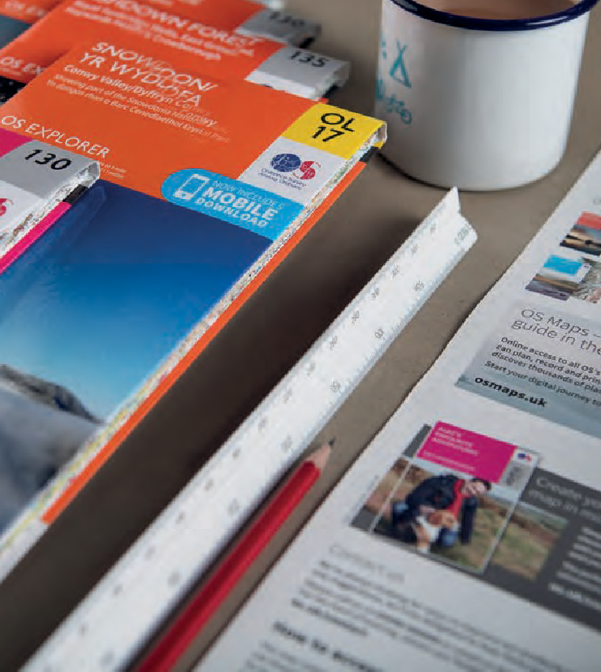
Who is OS?
7
WHO IS OS?
7
The GA’s manifesto for geography, ‘A different view’ (2009) refers to the idea of ‘Living Geography’, explaining that it “brings contemporary context and real world enquiry to the curriculum.” (p 13)

https://www.geography.org.uk/GA-Manifesto-for- geography

A school’s curriculum intent could embed this philosophy. There’s an echo of this idea in the first sentence of the DfE National Curriculum Geography’s purpose of study statement:

“A high-quality geography education should inspire in pupils a curiosity and fascination about the world and its people that will remain with them for the rest of their lives.”

Let’s reflect on these two ideas about a geography curriculum, and apply them to OS.

Do we spend any curriculum time sharing with students who OS is, and what they do?

Do we begin year 7 with an introduction or recap on four and six figure grid references, OS map symbols and contour patterns etc.?

In a curriculum where ‘Living Geography’ and ‘inspiring in pupils curiosity and fascination about the world’ are part of the intent, then time spent exploring with students who OS is – what they do, their history, and how their maps are used – is a great way to spike pupil’s curiosity, and give map skills a real-world context.
The OS homepage is a great place to start, currently providing an introductory video – ‘See a better place’, an excellent overview of the work and customers of OS.

The About section of the OS website - The what we do section

A video clip, explaining what OS do, is a resource that brings OS and its maps to life.

The about section also includes a detailed history of OS, including an introductory online video.

230 years ESRI Arc GIS storymap provides an overview of the history of OS.

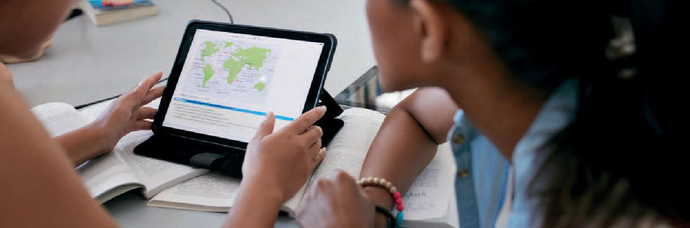

The significance of maps skills, graphicacy and spatial thinking in a curriculum

Patrick Wiegand (2006) in his excellent book ‘Learning and Teaching with Maps’ highlights the growing importance and interest in maps, across society.
Maps help quench people’s thirst for knowledge about places. Mike Parker in his book Map Addict sums it up well in his introduction:

“Locational knowledge has pervaded most aspects of everyday life so that few serious leisure time aviators, boaters, motorists and walkers are unaware of the benefits of Global Positioning System (GPS) receivers for satellite navigation.” p1

People’s fascination with maps should not be underestimated. Many people collect antique, vintage and quirky maps. Old school hanging maps are now sold in trendy designer furniture stores, and maps on gifts and homewares are proving increasingly popular.
“Maps not only show the world, they lubricate its easy movement. On an average day, we consult them dozens of times, often almost unconsciously; checking
the AA road atlas or the satnav, scanning the tube and bus map, doing a quick search online…..watching the weather forecast; visiting
a theme park or stately home, conference centre or industrial estate, catching up on the news, booking a holiday or a hotel.” p9

Ramblers, walkers, cyclists and tourists are all avid customers of OS maps. This fascination can be stimulated in the geography classroom and built upon to explain how and why maps and spatial data are used by
so many organisations and businesses today. Maps are used by people for work and leisure. They are an important tool to support everyday life.

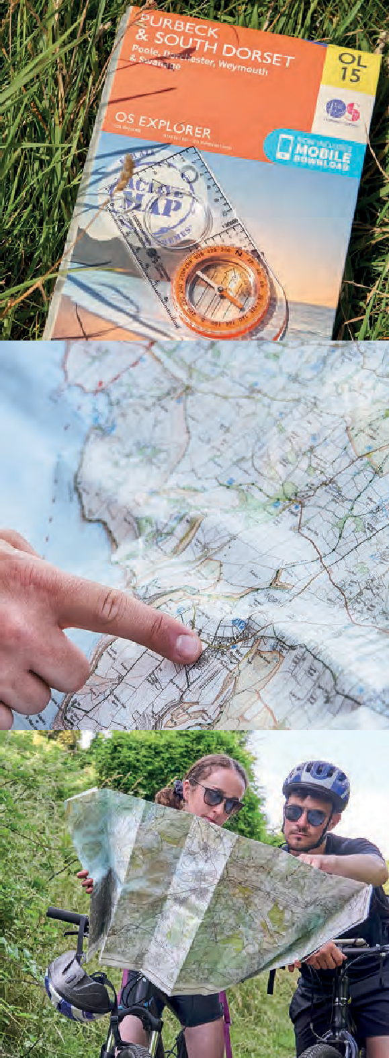
Maps help:

- Planners to decide where a new road or a new housing estate should be built.

- A home-delivery pizza company trying to make sure that our pizza gets to us whilst it’s still hot.

- Tourists to travel to a resort or ramble through a National Park, or trying to get across London by tube train.

- Cyclists out on their mountain bikes finding a way over a large hill.

- Motorists planning and following a route or a car journey.

- Young people at a theme park trying to find the new ride they’ve seen advertised.

- A supermarket using data and GIS to track the catchment area and requirements of its customers.

It’s important these real-life applications of maps and GIS are embedded in teaching to bring learning to life and
demonstrate the importance of maps to pupil’s lives now, and in their futures.

Graphicacy and spatial thinking

The GA ITE guidance for using maps defines graphicacy:
The GA holds that thinking about the world in spatial terms (spatial thinking) allows students to describe and analyse the spatial patterns and organization of people, places, and environments on Earth. Such thinking is clearly a fundamental aspect of student learning in geography. The GA maintains “that every time a student uses a map, they are thinking spatially.”

GA ITE guidance on using maps https://www.geography.org.uk/Spatial-thinking
“The ability to read and understand a map and the accompanying symbols.
More generally it is the ability to understand and present information in the form of graphic images. The information can be directly representative of what we see (as in photographs) or it can be more abstract e.g. graphic information which is spatial (as in maps/plans).”

The Ofsted research review for Geography (2021) highlights the significance of spatial thinking, building on the GA’s view above, pointing out that:

As long ago as 1965, W.G.V Balchin and Alice Coleman wrote in the TES, that ‘graphicacy should be the fourth ace in the pack’, along with oracy, literacy and numeracy. Interestingly, they explained their belief that using maps and diagrams at a range of scales, from local to global, develops an appreciation of spatial relationships, which provides a framework of knowledge into which students can classify new information logically. Unfortunately, graphicacy is rarely taught explicitly (unlike literacy) except in geography classrooms. Despite this, a level of graphicacy is assumed of adults, as demonstrated by the widespread use of maps and graphics in the media.
“through the use of maps, pupils are presented with a spatially referenced framework and visual cues. Through such visualisation,
pupils draw on concepts they have already learned, such as location, distance, direction, shape and pattern. Taught well, spatial thinking develops a meaningful sense of place and appreciation of the interconnectedness of the subject.”



The GA identifies what they think students need to be able to do with maps:

- understand and interpret maps (and other geographic representations) and know what a map can – and cannot – show

- describe and analyse spatial patterns of people, places, and environments

- collect and display information on maps, graphs, and diagrams

- make maps – from hand-drawn sketch maps to more complex representations using a range of appropriate technologies such as GIS.

Weedon (1997) suggested four strands of learning through maps — using, making, reading, and interpreting — defining these command words more precisely as:

using maps — relating features on a map directly to features in the landscape;

making maps — encoding information in map form;

reading maps — decoding successfully the elements of map language;

interpreting maps — being able to relate prior geographical knowledge to the features and patterns observed on the map.

12


OS mapskills in the DfE national curriculum and GCSE documents
12
GEOGRAPHY FOR SECONDARY
The national curriculum for geography - introduced in September 2014 - provides the ideal opportunity for schools to reflect on current practice, and plan for the future.

Aims of the National Curriculum Geography Programme of Study (England)
The national curriculum for geography aims to ensure that all pupils:

- Develop an understanding of social and physical characteristics and processes within the context of significant areas of the world.

- Understand the processes behind key physical and human geographical features, how these are interdependent and how – and why – things differ from place to place on the surface of the earth.

- Are competent in the geographical skills needed to:

  - collect, analyse and communicate information gathered through fieldwork

  - interpret the likes of maps, diagrams, globes, aerial photographs and Geographical Information Systems (GIS)

  - communicate geographical information in a variety of ways, including through maps, numerical and quantitative skills and writing at length

Fig 2. Aims of the National Curriculum Geography DfE

Using OS maps progressively from Key stages 1 to 3 is very important if pupils are to achieve all aspects of these aims.

Key Stage 3 geography programme of study includes the following reference to maps:

Geographical skills and fieldwork

- build on their knowledge of globes, maps and atlases, and use this knowledge routinely in the classroom and in the field

- interpret OS maps, including using grid references and scale, topographical and other thematic mapping, and aerial and satellite photographs

- use Geographical Information Systems (GIS) to view, analyse and interpret places and data

- use fieldwork in contrasting locations to collect, analyse and draw conclusions from geographical data

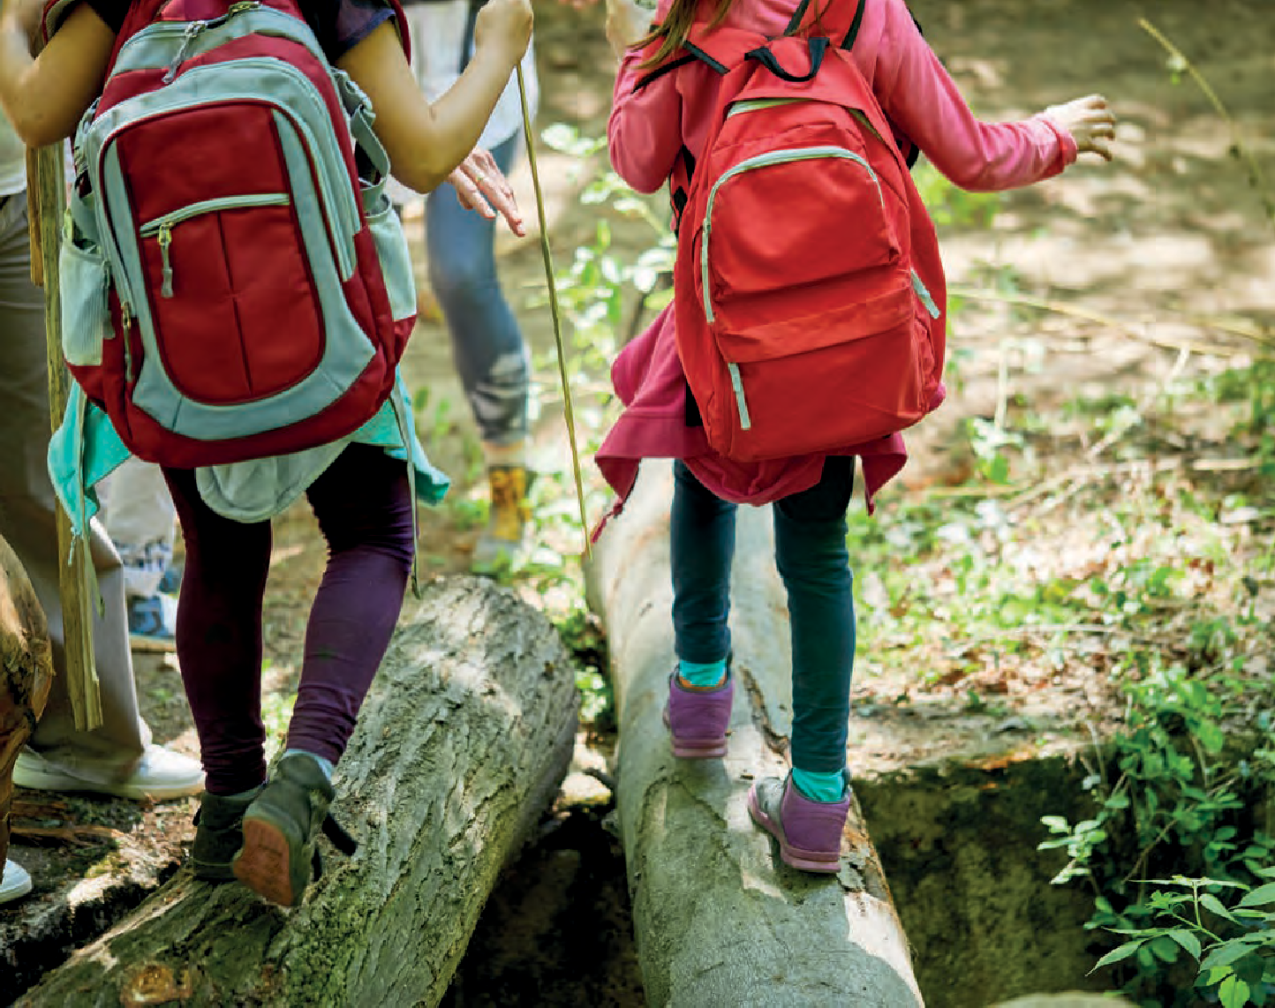
https://www.gov.uk/government/publications/national-curriculum-in-england-geography-programmes-of-study/ national-curriculum-in-england-geography-programmes-of-study



At GCSE the DfE geography subject content provides the prescribed content from which awarding bodies developed their specification.

Aims for GCSE geography

GCSE specifications in geography should enable students to build on their key stage 3 knowledge and skills to:

Aim | Aspect of learning | Assessment objective
Develop and extend their knowledge of places, locations, environments and processes, and of different scales including local and global, as well as social, political and cultural contexts. | Know geographical material | AO1: Demonstrate knowledge of places, locations, processes, environments and different scales (15%).
Gain understanding of the interactions between people and environments, change in places and processes over space and time, and the interrelationship between geographical phenomena at different scales and in different contexts. | Think like a geographer | AO2: Demonstrate geographical understanding of concepts and how they’re used in relation to places, environments and processes; the interrelationships between places, environments and processes (25%).
Develop and extend their competence in a range of skills including those used in fieldwork, maps and Geographical Information Systems (GIS), and in researching secondary evidence including  digital sources, as well as develop their competence in applying sound enquiry and investigative approaches to questions and hypotheses. | Study like a geographer | AO4: Select, adapt and use a variety of skills and techniques to investigate questions and issues and communicate findings (25%, including 5% used  to respond to fieldwork data and context(s)).
Apply geographical knowledge, understanding, skills and approaches appropriately and creatively to real world contexts, including fieldwork, and to contemporary situations and issues; and develop well- evidenced arguments drawing on their geographical knowledge and understanding. | Applying geography | AO3: Apply knowledge and understanding to interpret, analyse and evaluate geographical information and issues to make judgements (35%, including 10% applied to fieldwork context(s)).

Fig 3 Aims of GCSE Geography DfE

The scope of study in the GCSE subject content specifies that GCSE specifications in geography should require students to extend their Locational Knowledge
(1) and to develop competence in Maps, Fieldwork and Geographical Skills (2) as they study the content of the following four areas of geography: Place: processes and relationships (3); Physical geography: processes and change (4); People and environment: processes
and interactions (5); Human geography: processes and change (6).

In terms of map skills, it states that GCSE specifications should require students to develop and demonstrate the following skills throughout their study of the specification as a whole:
The use of a range of maps, atlases, O S maps, satellite imagery and other graphic and digital material, including the use of Geographical Information Systems (GIS),
to obtain, illustrate, analyse and evaluate geographical information. To include making maps and sketches to present and interpret geographical information.

Further prescribed content regarding using maps is provided in Appendix : Use of Mathematics and statistics in geography.

Cartographic skills
- use and understand gradient, contour and height on OS and other isoline maps (e.g. weather charts, ocean bathymetric charts)

- interpret cross sections and transects

- use and understand coordinates, scale and distance

- describe and interpret geo-spatial data presented in a GIS framework (e.g. analysis of flood hazard using the interactive maps on the Environment Agency website).

DfE (2014) GCSE Geography subject content

https://assets.publishing.service.gov.uk/government/ uploads/system/uploads/attachment_data/file/301253/ GCSE_geography.pdf

This prescribed content links well to Weedon’s suggested four strands of learning through maps. It also makes clear that skills need to be embedded and progressed throughout the GCSE course.
The GCSE subject content emphasises the need for progression from KS3, not duplication.

Aims and Assessment Objectives are carefully aligned as shown in the table. At KS3 the emphasis regarding OS maps is on interpretation, but at the same
time, ensuring basic skills such as locating using grid references and scale are in place. Subject content at GCSE is more focused on embedded use of maps as data across the specification, as a matter of routine, analysing and evaluating the evidence shown in maps.



Each GCSE geography specification has embedded the DfE prescribed subject content within their specifications. Each emphasises the need for schools to progress map skills across the topics within the specification, as part of curriculum design. Two examples are used here to illustrate this point.

“Geographical skills are fundamental to the study and practice of geography. They are integrated into all aspects of the subject. ….Learners will be able to apply the skills listed
below and overleaf in familiar and novel contexts. Teaching and learning should embed and contextualise the listed geographical skills into the content of Living in the UK Today
(01) and The World Around Us (02).”
OCR A GCSE specification (p. 13)
“Students are required to develop and demonstrate a range of geographical skills, including cartographic, graphical, numerical and statistical skills, throughout their study of the specification. Skills will be assessed in all three written exams. OS maps or other map extracts may be used in any of the three exams. “
AQA GCSE specification (p. 29)

Evidence of poorly developed map skills in 11-16 geography
As in previous versions of the national curriculum and GCSE geography, use of OS maps is clear and prominent, and yet successive Ofsted reports for geography state that in many schools, pupils’ map skills are poorly developed.

Ofsted inspections of geography in a wide range of schools has identified a significant issue in the use of maps, Iwaskow (2013) comments:
“Mapwork skills continue to be poorly developed. It is not uncommon for students to be unfamiliar with Ordnance Survey maps. Maps are a basic tool of geography but students admit to being uncomfortable reading maps and have little opportunity to use maps in lessons. They are expected
to develop an understanding of places and issues without being clear about where these places are, or knowing about the unique characteristics of their landscape. In far too many schools, map use is limited to specific examination requirements, rather than the progressive development of these specific geographical skills.” (p. 53-54)

Poorly developed mapwork skills and specific examination requirements were also highlighted in the 2011 Ofsted geography report.
“Most of the students had poorly developed mapwork skills. Predominantly, this was because using maps was often limited to specific examination requirements or to a unit on geographical skills, usually early in Key Stage 3. The students said that they rarely had the opportunity to use maps in many of their lessons. Frequently, teachers gave students insufficient opportunities to develop real competence in map skills.” (p. 22)

Margaret Roberts, in her book ‘Geography Through Enquiry’ (2013), also comments on the failure to embed use of maps through KS3 units of work:
“Many geography courses devote a lot of time when students start secondary school teaching map skills….What I find astonishing is that they emphasize the importance of these skills but then fail to
make much use of them when investigating themes and places. In my experience as external examiner for PGCE courses I have rarely seen information on maps used as evidence, in spite of their relevance to what was being studied …..If the skills are not used for several years, such as six-figure grid references, then students will forget how to use them. If skills are not applied in meaningful contexts students are less likely to perceive their value.” (p. 58)

Teaching pupils how to read and interpret different types of OS maps is a fundamental aspect of geography teaching. It would appear, however, that a significant number of schools don’t plan for pupil progress in use of OS maps. In many schools, pupils are introduced to OS maps in an initial unit of work in Key Stage 3 geography lessons, in part, to consolidate skills they hope have already been developed, as part of geography in key stages 1 and 2. The basic skills of direction, compass points, scale, measuring distance, map symbols, four and six figure grid references, representation of height on maps – spotting heights, contours, describing routes are introduced and tested. Once established, these aspects of map use and interpretation can be developed studying different places and topics. It’s not helpful if
the next time students use an OS map is as part of their GCSE course! At GCSE, students are often again taught a skills unit, designed to refresh these map skills. Unfortunately, opportunities to develop these skills are often not embedded in the GCSE curriculum. In the run- up to the exam, year 11 students will undertake further revision of these map skills.

This lack of coherence can at times be inadvertently encouraged by awarding bodies, as identified by Rynne, Hinchliffe, Hopkin, Gardner and Pilkinton (2020) in an analysis of the Awarding Bodies Examiners Reports from GCSE 2019. At times these reports offer pointers on how to plan and teach the curriculum comments.
For example:
‘Rehearsing how to respond to statistical data, different types of graph and a range of maps at different scales is important prior to taking the exam (AQA, 2018, repeated in 2019);

‘Teachers should practise using a variety of different graphs with candidates throughout the geography course’ (Edexcel B, 2019).
Such comments can be unhelpful, and actually encouraging a silo approach to skills in GCSE teaching, to be ‘rehearsed’ and ‘practised’ for the exam. Rynne et al make it clear that enquiry and making sense of geographical data ,such as maps, is a key element of curriculum design, linked to the aims of GCSE as the vision for the intent of a GCSE curriculum:
“However, practising for the exam should not take the place of designing a coherent GCSE geography curriculum. The curriculum should be planned at a strategic level to enable students to know geographical material, think like a geographer, study
like a geographer and apply what they have learnt. In this curriculum experience, using geographical data is embedded and progressed in each unit of work, rather than rehearsed for the exam.” (p. 24)
It’s clear that a more progressive use of maps would be hugely beneficial for pupils. This guide offers a curriculum design process developing
a progression framework of mapping skills and knowledge for learners aged 11–16.

Towards a curriculum design process
The former, Qualifications and Curriculum Authority (2008) developed guidance for a process of ‘disciplined curriculum innovation’ built around three curriculum questions:

- What are you trying to achieve?

- How will you organise learning?

- How will you know when you’re achieving your aims?

Gardner (2021) has adapted this process to establish a curriculum design approach for a coherent 11-16 geography curriculum, that underpins guidance in ‘Planning your coherent 11-16 geography curriculum: a design toolkit’ published by the GA. The three I’s of the Ofsted definition of curriculum, and EIF, form the arrows on the outside of the circular process to demonstrate their interconnected nature. This process is shown in Figure 4 identifying a seven-stage process. This is designed to aid the development of an ambitious and coherently planned curriculum that clearly supports the intent, sequenced towards cumulatively sufficient knowledge and skills for future learning and employment.
Intent

1 Create a vision
Impact

7 Maintain, change or move on
6 Evaluate and record the impact

5 Teach and assess pupil progress towards the curriculum intent

Implementation
2 Record your staring point

- Set clear goals

- Design your curriculum

Fig 4 The curriculum design process source : Gardner, D (2021) ‘Planning your coherent 11-16 geography curriculum: a design toolkit’ published by the GA, (p. 60)

The rest of this guide will use this process to support you to develop a progression framework of map skills and knowledge for learners aged 11–16.

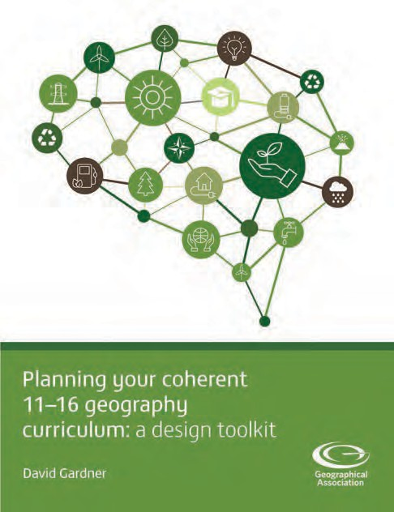
‘Planning your coherent 11-16 geography curriculum: a design toolkit’ published by the GA
This book consists of three distinct but interconnected sections, on curriculum design theory, guidance and practice. The first three chapters provide an overview of the evolution of the concept of curriculum in an education system controlled by central government. The impact this has had on school’s perception of the concept of curriculum is explored. A summary is provided of the ideas and approaches to curriculum, developed by the geography education community and Ofsted, in response to the evolving phases of this control, and its impact on schools. The guidance section
of the book introduces and explains a seven-step curriculum design process. The practice section provides five case studies of how schools have approached the opportunities, provided by Ofsted and the 2014 curriculum review, in highlighting

the role of the teacher in curriculum enactment, identified by Spielman (2017) as ‘the real substance of education.’ All three sections of the book provide a wide range of design tools and activities to support geography departments in planning a coherent 11-16 geography curriculum.

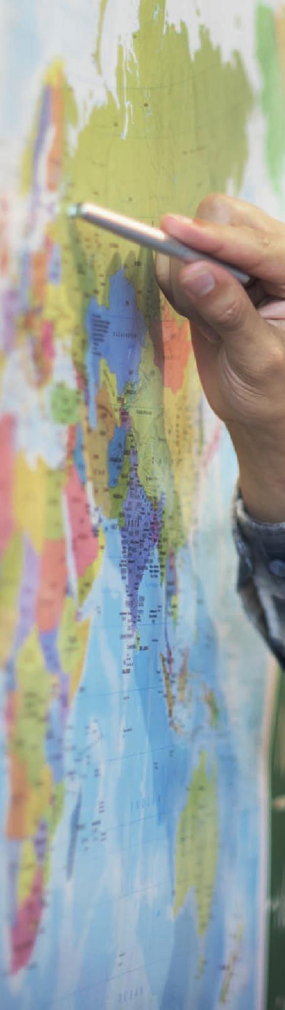
CURRICULUM INTENT
21

Curriculum Intent – what are you trying to achieve?
1

Curriculum design process - Stages 1-4
Heather Fearn, senior Curriculum HMI outlines the Ofsted thinking about curriculum intent in an Ofsted blog, Busting the ‘intent’ myth (2019) :
‘Intent is about what leaders intend pupils to learn. It’s as simple as that. Intent is everything up to the
point at which teaching happens ...all the curriculum planning ...what do you want pupils to know? ... Does
it contain the right knowledge in the right order? Is the curriculum providing pupils with the building blocks of what they need to know and be able to do to succeed in each subject? So, when we’re talking
about intent, we’re talking about how ambitious, coherently planned and sequenced, how broad and balanced and inclusive the curriculum is. That’s all in a school’s curriculum planning, up until the point that a teacher teaches the curriculum.’

The Ofsted EIF makes clear the importance of this strategic thinking, in judgements inspectors will make about the curriculum, in particular:
The review explains:

- leaders take on or construct a curriculum that is ambitious and designed to
give all learners, particularly the most disadvantaged and those with special educational needs and/or disabilities (SEND) or high needs, the knowledge and cultural capital they need to succeed in life

- the provider’s curriculum is coherently planned and sequenced towards cumulatively sufficient knowledge and skills for future learning and employment

p9

Ofsted curriculum research (2018) acknowledged the importance of subject knowledge. As a result, from April 2021, Ofsted began publishing a series of documents, coordinated and led by the HMI subject leads including :
“There is a need to identify both the content (substantive knowledge) that is to be taught and the knowledge of relationships that allow pupils to understand the connections between ideas (disciplinary knowledge). Pupils’ combined
appreciation of both substantive and disciplinary knowledge can be described as geographical understanding.”
  - Research reviews: which collate available research evidence about a high-quality education in each subject.

  - Subject reports: designed to inform the education community, what inspection evidence, particularly deep dives

Ofsted (2021) envisage that these reviews for each subject will provide a shared understanding of high- quality education for each subject, what they call the ‘conception of subject quality.’ Ofsted believe the reviews outline subject-specific principles that can be used by inspectors to conduct deep dives in schools.

The research reviews, therefore, provide an idea of what Ofsted are looking for in terms of a high-quality subject curriculum, making them a significant starting point for designing a coherent
11-16 geography curriculum. The Ofsted Research Review for geography (2021) provides a very useful overview of the thinking behind the DfE curriculum content, as presented in the National Curriculum and GCSE content. In a section entitled ‘Forms of knowledge’ the review presents the diagram shown in Fig 5 on the next page

The review maintains that the national curriculum, since its inception in 1991 and through its revisions since, has maintained a focus on four forms of geographical knowledge:
- locational knowledge

- place knowledge and understanding

- knowledge of environmental, physical and human geography processes


- geographical skills


23
Place knowledge
The connection of location and physical and / or human geography processes with personal experience
Locational knowledge
For example: name and locate locations; positioning systems
CURRICULUM INTENT
23

Fig 5 Geography knowledge types Ofsted diagram (2021) geography research review
Geographical skills and fieldwork
For example: using maps and globes; collecting first-hand evidence
Environmental, physical and human geography
For example: migration; glaciation; climate change
Disciplinary knowledge
Insight into the ways geography experts think
Substantive knowledge

There is a dynamic interrelationship between the different elements of substantive knowledge and the big ideas or concepts of disciplinary knowledge. The National Curriculum and GCSE content and specifications provide a flat view or one-dimensional view of these elements of knowledge, a list of content. This does not represent a curriculum. A curriculum develops the interconnections between these forms of knowledge to create an almost three-dimensional or holistic view. The evidence presented earlier regarding poorly developed map skills is symptomatic of a lack of curriculum thinking, using the national curriculum and GCSE specification as a proxy for a school’s curriculum. Each form of knowledge is considered separately, as outlined in the DfE documents and GCSE specifications. As a result, map skills are presented and taught separately to the other forms of substantive and disciplinary knowledge. This silo approach makes learning, geographical understanding and the capability to think geographically more difficult for pupils to achieve.

The GA manifesto ‘A Different View’ (2009) argued that teachers ‘are autonomous professionals driven by educational goals and purposes: that is, they are the curriculum makers and the subject leaders.’ The GA define curriculum making as the creative act of interpreting a NC or examination specification and turning it into a coherent, challenging and engaging sequence of teaching and learning: curriculum enactment in practice.

The model shown in Fig 6 identifies three main ingredients (described as sources of energy or resources) available to teachers enacting the curriculum in the classroom, by drawing from their knowledge of:
- the discipline of geography – its key ideas and purposes, the ‘what’

- subject-specialist teaching – its techniques and general approaches, the ‘how’

- their students – who they are and how they learn, the ‘who’.

Teachers should usually aim for somewhere in the middle, where the competing priorities of teaching, students and the subject are balanced.




Pupil experiences
Does this take the learner beyond what they already know?
Which learning activity?
Geography: the subject
Underpinned by concepts
Thinking geographically
Fig 6 Curriculum making GA

The GA provides online guidance explaining curriculum-making https://www.geography.org.uk/Curriculum-making
Teacher choices

It is, therefore, very important that geography departments spend time thinking strategically about what they are trying to achieve with their curriculum. It is for the teachers in your school to work together to create a coherent curriculum sequenced with student progress in mind, ‘towards cumulatively sufficient knowledge and skills for future learning and employment’. Map skills represent one aspect of this curriculum, an aspect that needs to be considered and integrated with other aspects.

In considering your starting point, (stage 2 of the curriculum process) it’s useful to reflect on the way in which you introduce and develop geographical skills. It’ll be useful to compare what you currently do with the Ofsted findings, and the experience of Margaret Roberts, in the earlier section of this guide.


Do you currently consider or prioritise graphicacy and spatial thinking in your curriculum?
CURRICULUM INTENT
25

Ofsted have also identified examples of good practice in developing geographical skills. This also provides a good starting point to create a vision for progressing map skills for your students. Leszek Iwaskow, in his GA Teaching Geography article (2013) states:

“Inspection evidence shows that the most effective geography teaching develops breadth and depth in students’ knowledge and understanding of key geographical concepts of place, space, scale, diversity, interdependence and sustainability. Frequent opportunities are provided for pupils to develop and consolidate key geographical skills of enquiry, graphicacy and geographical communication. Regular fieldwork – in a variety of locations – is integrated with classroom teaching. Good use is made of the outside environment and fieldwork to support learning with a range of multimedia resources used appropriately. Effective teaching makes frequent use of maps at
a variety of scales. Good use is made of ICT and GIS to promote learning, enabling students to use data and information sources to search and investigate, select, organise, refine and present information well.” P54
Ofsted (2014) ‘Geography survey visits: Supplementary subject-specific guidance for inspectors on making judgements during visits to schools’, provides invaluable support in thinking about what makes an ambitious curriculum. The document outlines how greater attention should be paid to the use of maps and in particular locational knowledge. As part of the outstanding description for quality of teaching OFSTED state the following:

25
“Maps, at a variety of scales, are used frequently as a matter of routine and are an intrinsic part of learning in geography. This ensures that pupils have good spatial awareness and are very secure in their ability to locate the places they are studying.”

This excellent statement could be incorporated into your strategic vision for your geography curriculum (stage 1 in the curriculum design process), at both KS3 and GCSE, forming a good starting point for planning for progress in map skills.

The Ofsted Research Review for geography (2021) is also very clear about the importance of developing map skills.
“Within geographical skills, pupils learn to interpret spatial representations, particularly maps, globes and atlases, and construct their own plans and maps. Pupils also draw on these skills to support their knowledge of environmental, physical and human systems and also to gain a sense of place….Pupils need to learn how to interpret resources such as aerial photography, satellite imagery and digital mapping. As well as thinking about the technical, or procedural, knowledge that pupils need, teachers and leaders also need to ensure that pupils can apply that knowledge.”

The review also focuses attention on maps in particular.
“Maps are, to a certain extent, the language of geography”
“A high-quality geography curriculum also includes sufficient opportunity for pupils to practise:
- decoding information from maps
- constructing (or encoding) maps
- analysing distributions and relationships route-finding
- interpreting the information to draw conclusions”
“Integrating opportunities to develop these skills throughout the curriculum supports pupils’ development of fluency and automaticity. For example, once they become familiar with the symbols used on an Ordnance Survey 1:50,000 scale map, pupils no longer need to routinely reference the key. This both speeds up their map reading and frees up working-memory space to process the information more efficiently.”

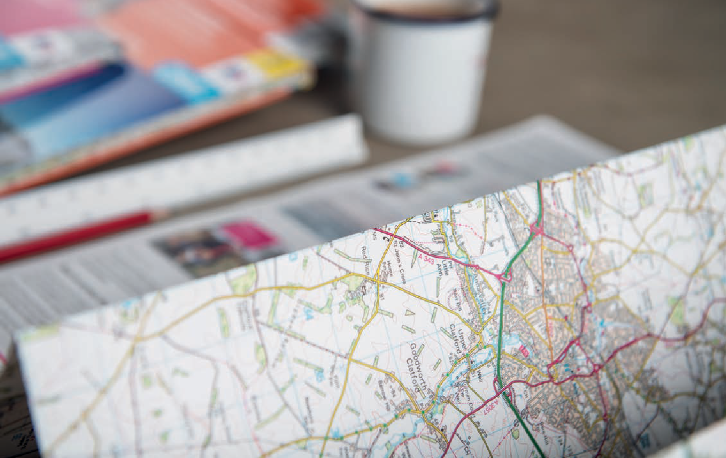

The review also emphasises the holistic nature of the subject, and the key role that using maps has in developing your pupils to think geographically.
The more proficient a pupil is in using maps, the stronger their ability to relate to geographical concepts. For example, pupils are better able to interpret the spatial information and identify increasingly complex patterns, such as land use.”

The review also highlights the significance of integrating the use of aerial and satellite imagery into your curriculum, maintaining that
“If used effectively, it helps pupils to visualise the physical or human phenomena that is present.”

Examples of curriculum making in action – planning for progression in mapskills
Curriculum making is a complicated and collaborative process, it is at the heart of the professional role of a teacher. Curriculum making in practice is not a linear endeavour, and there is no one right way to create a curriculum plan. The enacted curriculum is more a series of interactions between teachers, students and the knowledge to be imparted, and understood. The advice and guidance offered by the geography subject community, as well as Ofsted need to be considered along with the content to the national curriculum and GCSE, in the context of your school community, to begin planning and designing your curriculum intent. A subset of curriculum questions need to be considered, as illustrated in Fig 1 developed by Kinder and Owen:

What big ideas and concepts will be introduced, and progressed across the Key Stage?

What important geographical skills will be introduced and progressed? What is the starting point for your pupils as they begin this Key Stage? Which aspects of your vision are currently weaknesses in your students? How does your existing curriculum support progress towards the vision? What are the strengths and weaknesses of your existing curriculum?
What changes do we need to make to the existing curriculum?

Which aspects of your vision do you need to develop new units of work, ideas, resources?

How do you plan for student progress across the whole key stage, each unit, and lessons?

How have you selected and sequenced curriculum content to reflect and support student progress towards our vision?

The following section provides examples of how schools are beginning to develop their curriculum intent, considering many of these questions.
Example 1

Judy Gleen, former Associate Assistant Headteacher at Cheney School in Oxford (2020) p110 explains how the geography department at the school developed their curriculum intent. She makes an important point that considering intent, is ‘not just to tick the box for Ofsted’.

She goes on to share her initial experiences of this process, reflecting that “I really hope that this direction from Ofsted achieves what it set out to do: encourage departments to discuss their intent, jointly plan the shape of their curriculum and agree their priorities for ensuring all students make good progress.”
The department team spent a long time considering the purpose of geography she states “Geographers are found in all walks of life
– from government, to planning, to cutting- edge research – because we know that geographers are uniquely able to draw together research, apply it spatially and look for innovative solutions that take all stakeholders into account.”
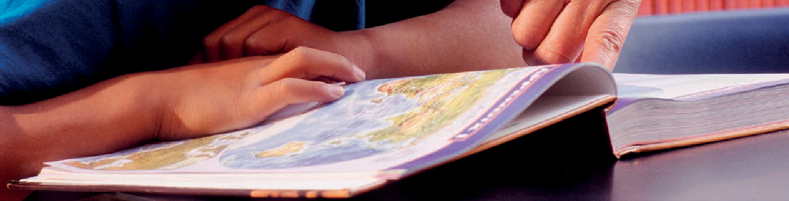
Tasked with developing a school wide intent, she was drawn to the work of Peter Hyman (Hyman, 2019), who believes that education can be divided into three components: head (academic), heart (character) and hand (problem-solving and creativity), but that too often, due in part to the exam system, the majority of what is taught sits in the ‘head’ component. He suggests that we need to rebalance our curriculum to be ‘bigger and more rounded’.
All heads of department at the school were asked to produce a short vision statement that captured the purpose of the subject that the department teams agreed to, to ensure curriculum development was grounded in a vision or intent. The team settled on:
“Geography is the subject which opens the door to our dynamic world and prepares each one of us for the role of global citizen in the 21st century. Geography puts this understanding of social
and physical processes within the context of place – recognising the great differences in cultures, political systems, economies, landscapes and environments across the world, and exploring the links between them.”

30 GEOGRAPHY FOR SECONDARY

Geography was linked to the school’s wider curriculum intent by adding the following:

Head
Geographers should acquire key enquiry skills including research, presenting evidence, analysis and evaluation. Geographers should also acquire map and fieldwork skills.

Heart
Geographers should have experienced a good mix of human, physical and environmental geography so that they can become engaged citizens of the world, able to ask pertinent questions, analyse evidence and provide sustainable solutions to the world’s problems.

Hands
Geographers should become critical and reasoned thinkers, compassionate, resilient and good citizens. Geographers are able to develop practical wisdom through decision- making activities.



Gleen goes onto explain, in the article, how they turned the vision into a curriculum, (stage 4 of the curriculum design process). This is the really important phase planning. Part of this process involved identifying the key concepts and key skills the department felt were important at Key Stage 3.

These were summarised (Fig 7 ) and then mapped into a curriculum plan, (Fig 8) to see if the concepts and skills are revisited and progressed over the key stage.
Fig 7 Summary of concepts and skills underpinning curriculum Gleen (2020)

Concepts | Skills
Place, space and scale | Map skills
Interdependence | Graphicacy skills
Physical and human processes | Using qualitative and
 | quantitative data
Environmental interaction and | Enquiry and forming an
sustainability | argument
Cultural understanding | Fieldwork

 | Term 1 |  | Term 2 |  | Term 3
 | Concepts | Skills | Concepts | Skills | Concepts | Skills
Year 7 | Adventure landscapes  Place  Environmental interaction | Map: introduction to and OS map, relief and 4-figure grid references  Enquiry: code of conduct | Flooding  Physical processes  Environmental interaction | Map: using OS map, GIS activity  Enquiry: mystery | Valentines roses  Environmental interactions  Physical and human processes | Data: satellite photos  Enquiry: where to buy roses from (debate and writing)
 |  |  |  |  | Interdependence
 |  |  |  |  | Cultural understanding
Year 8 | Tectonics  Physical processes | Graphicacy enquiry: using a scatter graph to test a hypothesis | The globalisation of fashion  Interdependence | Mapping: HDI, continents and countries | Wild weather  Physical processes | Map skills: location of weather events
 | Interdependence  Cultural understanding |  | Human processes Place | Graphicacy: reading graphs to measure development | Environmental interaction  Place, scale | Numeracy: measuring severity
 |  |  | Cultural understanding

Fig 8 KS3 curriculum plan with concepts and skills Gleen (2020)

Once the team established the broad shape of the curriculum, they were ready to plan in detail, in particular to plan for student progress by considering how to sequence the building blocks they had identified. This is the really
important phase, designing a coherent and sequenced curriculum designed to support pupil progress. Gleen offers the following advice
“Not only is the specific content important, but also the order in which it is taught and developed. Is learning progressing? For example, if you are teaching coasts in year 7 and rivers in year 8, how do you increase the level of demand of the processes you teach (for instance, do you teach ‘erosion’ in year 7 and then ‘types of erosion’ in year 8)? How does the challenge of thinking increase (for example, we know that houses fall down/flood but where and how are we challenging students more with the next topic)? …A good rule of thumb is if your topics are interchangeable then they can’t be properly planned for progression.“ p110
Example 2

The new national curriculum has prompted many teachers to review their Key Stage 3 curriculum. Simon Renshaw and Rebecca Aston, Heads of Geography at Soar Valley College in Leicestershire (2014) made the following points about developing progression in the use of OS maps:

“Prior to the 2007 curriculum, our first year 7 unit was an introduction to geography and map skills, which aimed to develop students’ capacity to read and use Ordnance Survey (OS) maps. When planning our 2007 curriculum, we decided a more engaging introduction to geography would be desirable, so we replaced it with a student-led enquiry into the local area. This featured some map use, but focused on supporting students in developing their own enquiry.

Our intention was that OS map skills would be built into the various learning sequences across Key Stage 3, but we felt on reflection that this approach had not secured the foundation for a transferable base of OS map skills. With this in mind, our 2014 programme of study will include an enquiry into land use in Leicester explicitly developing OS map skills during year 7.
We hope this will lay a solid foundation of OS map skills, but the intention will still be for map skills to be featured at every available opportunity in geography lessons. A subscription to Digimap for Schools, the subscription OS map service, is going to greatly assist in this regard!”

Example 3

When planning the use of maps in her new Key Stage 3 plan, Kirsty Cook (2014) from The King’s School, Pontefract, also looked at progression and attainment by the end of the key stage, asking:

What does good progression look like?

and: How will we measure it?
Attainment targets are linked to a student’s ability to interpret and use a variety of maps. To clarify how they could develop students’ knowledge and confidence they produced the table in Figure 9.

“This was helpful in getting us to think about progression and developing our students’ abilities to interpret different maps at a variety of scales and in different contexts.”

Type of map | Year group | Topic / purpose
Climate maps | Year 8 | Students analyse and create a global map showing world climate zones, and link to ocean currents
Economic or resource maps | Year 7 | Students analyse a resource map of Africa (atlas) to identify / think about which countries might be ‘resource rich’?
Physical maps | Year 7  Year 8 | Students analyse and use physical maps of UK and Africa.  Students analyse physical maps of Brazil and Iraq
Political maps | Year 7  Year 8 | All topics as intro to and locations of, from national to international scale
OS maps | Year 7  Year 8 | Use 1:25 000 OS map of Pontefract area and complete a murder mystery task.  Year 8 use 1:10 000 street view of Pontefract to create a Ponte-opoly game
Topographic maps | Year 7 | OS map Pontefract and designing a car rally
Topological maps | Year 8 | Use of Worldmapper maps of World Military expenditure for e.g. in ‘The geography of conflict”
Google Maps, Google Earth and atlases | Year 7  Year 8 | Use Google Maps and Google Earth on our IWB. Atlases are also used regularly

Fig 9 Summary of maps used in KS3 curriculum Cook (2014)



Planning for progress in your 11-16 geography curriculum
The former chief HMI for geography, Trevor Bennetts (1995) defined progression as
“how pupils’ learning advances. It can be applied both to the design of a curriculum, in particular how the structure of the content and sequence of learning activities are intended to facilitate advances in
learning, and to the gradual gains in knowledge, understanding and skills and competencies which pupils actually achieve. Progression has to
be planned for and monitored, and the only effective way of doing the latter is by the use of assessment“ p75

The importance of planning is abundantly clear, a point made clear by Bennetts -
“Planning for progression should, therefore, take account of the past, present and future: what pupils have already experienced and achieved; what they can reasonably be expected to do at the time; and what will best serve their future needs.” p75

GA - A progression framework for Geography
The Geographical Association makes the following statement to support planning for pupil progress, in the progression and expectations section of its support and guidance for teachers on its website.

What does this progress in geography look like? These broad dimensions of progress, or what it means to get better at geography are essential when thinking about both planning for progression and assessment.

The dimensions of progress in geography:
- demonstrating greater fluency with world knowledge by drawing on increasing breadth and depth of content and contexts
- extending from the familiar and concrete to the unfamiliar and abstract
- making greater sense of the world by organising and connecting information and ideas about people, places, processes and environments
- working with more complex information about the world, including the relevance of people’s# attitudes, values and beliefs
- increasing the range and accuracy of pupils’ investigative skills, and advancing their ability to select and apply these with increasing independence to geographical enquiry.

https://www.geography.org.uk/Progression-and-Expectations-in-Geography

The GA have also published ‘A progression framework for geography’ (2020), which connects GA guidance on aspects of achievement, dimensions of progress and benchmarks in geography. It is based on a clear vision of what it means to make progress in geography, anchored by age-specific national expectations for pupils aged 7 – 16 years. This guidance aims to support teachers in planning a geography curriculum that is ambitious, coherently planned and sequenced, and which enables high standards for their pupils. In other words, it supports teachers, to show how they connect the intent, implementation and impact of their geography curriculum.

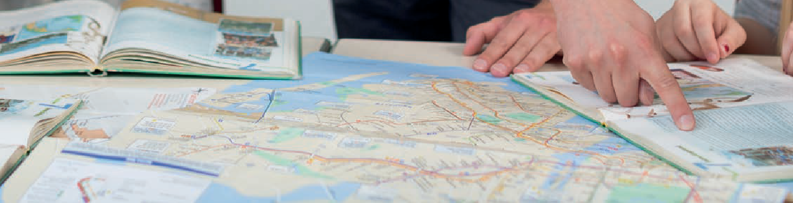
The framework for progression has used the aims of the geography National Curriculum as three aspects of achievement, which can act as ‘progression strands’ around which you can design your curriculum.

These aims / aspects of achievement / progression strands are:
- Contextual world knowledge of locations, places and geographical features.
- Conceptual Understanding of the conditions, processes and interactions that explain features, distribution patterns, and changes in places over time and space.
- Competence in geographical enquiry, and the application of skills in observing, collecting, analysing, evaluating and communicating geographical ideas and information.

The strands underpin achievement and progress, and help bring a sense of coherence to learning geography. They naturally progress and interconnect with the aims and Assessment Objectives for geography at GCSE, thus forming the basis for planning a coherent 11-16 geography curriculum.

Benchmark expectations
By combining the progress strands, teachers can gain an overview of what they expect pupils to achieve. The GA has developed age-related benchmark statements for 7, 9, 11, 14 and 16 years. These statements are based explicitly on the three progression strands, providing a ‘map’ of the ‘expected’ geographical achievement up to and including GCSE (See Fig 10). They are by necessity quite generalised – and always open to some debate and refinement. But they are a good starting point for teachers to use in their planning.
Increasing the range and accuracy of pupils’ investigative skills and advancing their ability to select and apply these with increasing independence to geographical enquiry
Competence in geographical enquiry, and the application of skills in observing, collecting, analysing, evaluating and communicating geographical information

Expectations by | by age 9 | by age 11 | by age 14 | by age 16
age 7 | Be able to | Be able to carry | Be able, with | Be able to plan
Be able to | investigate places | out investigations | increasing | and undertake
investigate places | and environments | using a range | independence, to | independent
and environments | by asking and | of geographical | choose and use a | enquiry in which
by asking and | responding to | questions, skills | wide range of data | skills, knowledge
answering | geographical | and sources | to help investigate, | and understanding
questions, making | questions, making | of information | interpret, make | are applied
observations and | observations and | including a variety | judgements and | to investigate
using sources such | using sources such | of maps, graphs and | draw conclusions | geographical
as simple maps, | as maps, atlases, | images. They can | about geographical | questions, and
globes, images and | globes, images | express and explain | questions, issues | show competence
aerial photos | and aerial photos. | their opinions, and | and problems, and | in a range of
 | They can express | recognise why | express and engage | intellectual and
 | their opinions and | others may have | with different | communication
 | recognise that | different points of | points of view | skills, including the
 | others may think | view | about these | formulation of
 | differently |  |  | arguments, that
 |  |  |  | include elements
 |  |  |  | of synthesis and
 |  |  |  | evaluation of
 |  |  |  | material

Fig 10 Benchmark statements for geographical skills and enquiry, GA (2020)


Designing a curriculum using progression strands and benchmark statements

It is possible to use the progression strands and benchmark statements to create a coherent key stage 3 geography curriculum. As a starting point, at KS3, compare the benchmark statements for each aspect of achievement/ progression strand for an 11 to 14 year old. This will help you to consider the nature of progression you will be planning for. You can use them to plan a curriculum journey to take your pupils from the benchmark statement for an 11 year old to those of a 14 year old, following a journey along the GAs dimensions of progression.

To plan a curriculum that is “coherently planned and sequenced towards cumulatively sufficient knowledge and skills for future learning and employment” you could use these progression strands to determine an approach to sequencing in order to better support pupil progress, for example, how a geographical concept or skill can be introduced or progressed across topics, or how they build and progress KS2 geography.

Fig 11 shows how the topics that make up a KS3 curriculum can be interconnected in a coherent way by the three progression strands. This represents an approach to the curriculum design process that puts progression at the very heart. Once initiated, this approach makes the need for sequencing units (topic 1-6) in each year group shown in Fig 11, transparent, to create logical stepping stones in teaching and learning. Each unit can be assigned ‘responsibilities’ to introduce or progress an aspect of achievement to work towards the long-term vision of the key stage course. Planning in this way, has the potential to naturally align geographical concepts, core knowledge and skills.

How do you plan for progression?
Year 7 - plan for student progress across each topic
Topic 1 Topic 2 Topic 3 Topic 4 Topic 5 Topic 6
Contextual world knowledge - how do you plan for opportunities for students to demonstrate greater fluency with world knowledge by drawing on an increasing breadth and depth of content and contexts?
Geographical understanding - how do you plan for opportunities for students to demonstrate that they can make greater sense of the world, organising and connecting more complex information about people, places, processes and environments?
Competence in geographical enquiry and skills - how do you plan for opportunities for students to demonstrate increasing range and accuracy of investigative skills, with advancing ability to select and apply these with increasing independence to geographical enquiry?

Year 8- plan for student progress across each topic
Contextual world knowledge - how do you plan for opportunities for students to demonstrate greater fluency with world knowledge by drawing on an increasing breadth and depth of content and contexts?
Geographical understanding - how do you plan for opportunities for students to demonstrate that they can make greater sense of the world, organising and connecting more complex information about people, places, processes and environments?
Competence in geographical enquiry and skills - how do you plan for opportunities for students to demonstrate increasing range and accuracy of investigative skills, with advancing ability to select and apply these with increasing independence to geographical enquiry
Plan for progression across topics in each year group
Topic 1 Topic 2 Topic 3 Topic 4 Topic 5 Topic 6
Contextual world knowledge - how do you plan for opportunities for students to demonstrate greater fluency with world knowledge by drawing on an increasing breadth and depth of content and contexts?
Geographical understanding - how do you plan for opportunities for students to demonstrate that they can make greater sense of the world, organising and connecting more complex information about people, places, processes and environments?
Competence in geographical enquiry and skills - how do you plan for opportunities for students to demonstrate increasing range and accuracy of investigative skills, with advancing ability to select and apply these with increasing independence to geographical enquiry

Year 9 - plan for student progress across each topic
Topic 1 Topic 2 Topic 3 Topic 4 Topic 5 Topic 6
Contextual world knowledge - how do you plan for opportunities for students to demonstrate greater fluency with world knowledge by drawing on an increasing breadth and depth of content and contexts?
Geographical understanding - how do you plan for opportunities for students to demonstrate that they can make greater sense of the world, organising and connecting more complex information about people, places, processes and environments?
Competence in geographical enquiry and skills - how do you plan for opportunities for students to demonstrate increasing range and accuracy of investigative skills, with advancing ability to select and apply these with increasing independence to geographical enquiry?

Fig 11 Interconnecting unit topics with progression strands at KS3 Source : Gardner, D (2021) Planning your coher- ent 11-16 geography curriculum: a design toolkit, GA, p46

Recording your starting point
If your primary feeder schools have developed map skills as part of Key Stages 1 and 2 your new Year 7 students should already be able to do the basics, but you will need to find out. This is why many secondary schools have a skills unit of work at the beginning of year 7. Paula Owens has produced a progression framework for map skills for primary schools, in ‘Teaching map skills to inspire a sense of place and adventure - planning for progress from 5-11 years’, published by the Ordnance Survey. It will be useful to look at this and ensure early in year 7 your pupils have a good grasp of the skills outlined here.

https://digimapforschools.edina.ac.uk/files/resource-hub/downloads/pupils%20planning%20document-low%20ink%20 version_2.pdf

Using the progression strands to create your curriculum plan
The Key Stage 3 progression framework grid outlined below is a useful device to support your curriculum-making process. It can be used by a geography department to consider how to plan for pupil progress. It can be used
as a starting point before evolving schemes of work to develop students that can think geographically and work independently. The age-related expectations for an 11-year-old from the GA’s progression framework, are provided for each progression strand or aspect of achievement at the bottom of the grid. The benchmark statements for a 14-year-old are placed at the top of the grid. You can adapt these statements to embed your vision of where your students should be in their learning at the end of key stage 3. Year 7 units begin at the bottom of the grid, and work upwards, planning progress towards the 14-year-old statements at the top. The left-hand column is provided for you write in the sequence of units you devised in the previous activity. For each unit you can begin to map out the contextual knowledge, understanding, and skills you plan to develop. As you do this, you will begin to build a progression map of your curriculum. Recording planning in this detail on one grid will allow you to see issues you perhaps had not considered in your initial planning.

 | The three aspects of pupil achievement in the National Curriculum | Contextual world knowledge of locations, places and geographical features | Understanding conditions, processes and interactions that explain geographical features, distribution patterns, and changes over time and space |  |  | Competence in geographical enquiry, and the application of skills in  observing, collecting, analysing, evaluating and communicating geographical information |  | Judgements could be expressed and recorded as, ‘working towards’ ‘meeting’ and ‘exceeding’ the expectations for their age or whatever system is in place in your school.
 | By the age of 14 pupils should : | Have extensive knowledge relating to a wide range of places, environments and features at a variety of appropriate spatial scales, extending from local to global. | Understand the physical and human conditions and processes which lead to the development of, and change in a variety of geographical features, systems and places. They can explain various ways in which places are linked and the impact such links have on people and environments. They can make connections between different geographical phenomena they have studied. |  |  | Be able with increasing independence to choose and use a wide range of data, to help investigate, interpret, make judgements and decisions to draw conclusions about geographical questions, issues and problems, and express and engage with different points of view about  these.
 |  |  | Physical geography process- landform | Human geography process | Physical human interaction | Geographical skills | Fieldwork | Key assessment opportunity
15
14
13
12
11
10
9
8
7
6
5
4
3
2
1
 | By the age of 11 pupils should : | Have a more detailed and extensive framework of knowledge of the world, including globally significant physical and human features and places in the news. | Understand in some detail what a number of places are like, how and why they are similar and different, and how and why they are changing. They know about some spatial patterns in physical and human geography, the conditions which influence those patterns, and the processes which lead to change. They show some understanding of the links between places, p eople, and environments. |  |  | Be able to carry out investigations using a range of geographical questions, skills and sources of information including a variety of maps, graphs and images. They can express and explain their opinions, and recognise why others may have a different point of view.
Fig 12 Curriculum planning grid to create key stage 3 long-term plan with progression in mind

Fig 13 provides a similar planning grid for GCSE. The aims for GCSE (see fig 3) match the progression strands and aims for the National Curriculum geography, they also align with the GCSE Assessment Objectives. These form the progression strands for planning a GCSE curriculum. The age-related benchmark expectations for a 14 year-old are now at the base of the grid; the expectations for a 16 year-old at the top.

Initially you will use the curriculum grids to create your key stage 3 and/or key stage 4 curriculum, with statements or lists of content, concepts and skills for each unit, to think through and evolve the coherence and sequencing. As this becomes established, you can begin to replace the lists with key performance indicators (KPIs). In effect, these lists identify the key elements of world contextual knowledge, understanding and skills for each sequenced unit of work that, if mastered, demonstrate students’ grasp of that facet of your emerging curriculum.

Key Stage 4 Plan |  |  | The 3 aspects of pupil achievement in the National  Curriculum | Contextual world knowledge of locations,  places and geographical features | Understanding of the conditions, processes and interactions that explain geographical features, distribution patterns, and  changes over time and space |  |  | Competence in geographical enquiry, and the application of skills in observing,collecting,  analyzing,evaluating and communicating geographical information
 |  |  | GA age related expectations By the age of 16 pupils should : | Have a broader and deeper understanding of locational contexts, including greater awareness of the importance of scale and the concept of global | Gain a deeper understanding of the processes that lead to geographical changes and the multivariate nature of human- physical relationships and interactions, with a stronger focus on forming valid generalisations and abstractions, together with a growing awareness of the importance of theoretical perspectives and conceptual frameworks in geography. |  |  | Be able to plan and undertake independent enquiry in which skills, knowledge and understanding are applied to investigate geographical questions, and show competence in a range of intellectual and communication skills, including the formulation of arguments, that include elements of synthesis and evaluation of material.
GCSE AOs |  |  |  | AO1 know geographical material Demonstrate knowledge of locations, places, processes, environments and different scales. 15% | AO2 think like a geographer  Demonstrate geographical understanding of concepts and how they are used in relation to places, environments and processes, and the inter-relationships between places, environments and processes.  25% |  |  | AO3 applying geography  Apply knowledge and understanding to interpret, analyse and evaluate geographical information and issues 25%  AO4 study like a geographer Select, adapt and use a variety of skills and techniques to investigate questions and issues and communicate findings.  and to make judgements. 35%
Year | Term | Time | Theme/enquiry question | Locational contexts | Physical geography process-  landform | Human geography process | Physical human interaction | Interpret,analyse  evaluate | Geographical skills | Fieldwork
11
10
 |  |  | GA age related expectations  By the age of 14 pupils should : | Have extensive knowledge relating to a wide range of places, environments and features at a variety of scales, extending  from local to global | Understand the physical and human conditions and processes which lead to the development of, and change in, a variety of geographical features, systems and places. They can explain various ways in which places are linked and the impact such links have on people and environments. They can make connections between different geographical phenomena they have studied |  |  | Be able with increasing independence to choose and use a wide range of data to help investigate, interpret, make judgements and draw conclusions about geographical questions, issues and problems, and express and engage with different points of view about  these.

Fig 13 Curriculum planning grid to create a key stage 4 long-term plan with progression in mind



Examples of curriculum planning using the progression framework

Progress in Geography Key Stage 3,
Hodder Education https://www.hoddereducation.co.uk/geography/progress-in-geography

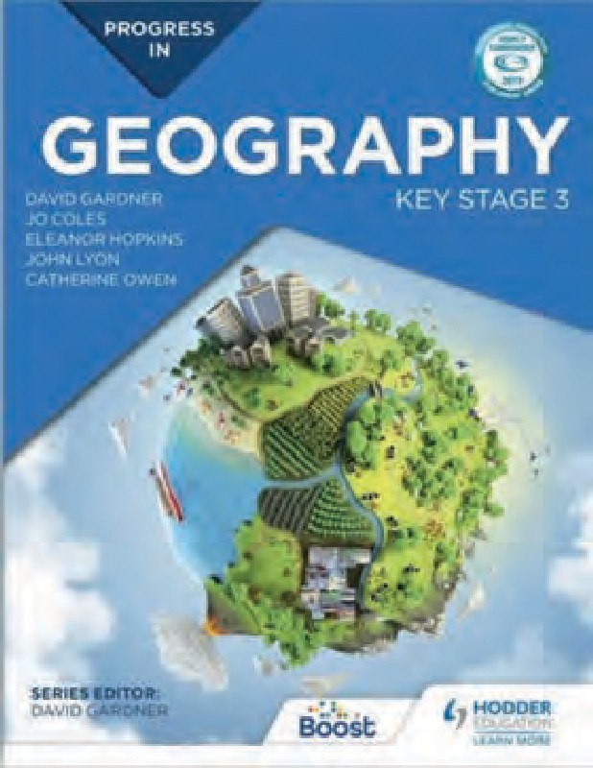
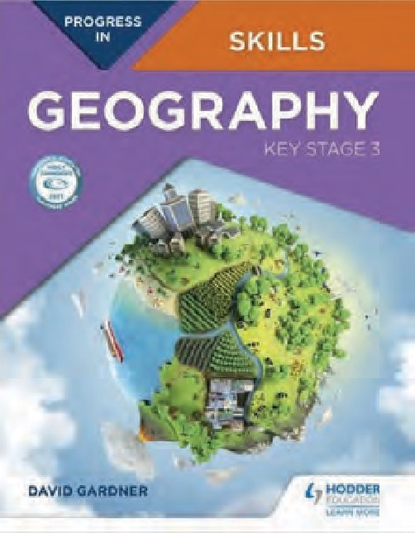
I have put these principles of curriculum design into practice with the Hodder Education series
‘Progress in Geography Key Stage 3.’ In 2019 the book was awarded the GA’s Publisher’s Award, Highly Commended, the judges commented that it
“provides a logical framework for the development of understanding of each topic, which will help students to think more deeply and enable them to
make links a between space, place and process.”

In 2021 Progress in Geography Skills received a similar award from the GA, this time judges stated
“It can be used as a standalone text and is packed full of resources, well-framed activities, support and practice to help students to develop key geographical skills and think critically about what they’re learning.”
Fig 14 Progress in Geography Hodder Education

These publications are used here to demonstrate the progression framework in practice, as well as the relationship between the curriculum intent and implementation. The author team for Progress in Geography, initially worked together to create a
vision of intent, and then a key stage curriculum plan, sequencing units of work to support student learning and progress. A progression framework plan was developed to plan for progress. The final version to emerge is available at the Hodder Education website, above, downloadable as a A2 pdf, or as a spreadsheet. Hodder Education have also printed A2 poster copies of the progression framework, with the intent vision for the course printed on the reverse (copies are freely available from the publisher). The vision is also printed as a flap attached to the cover of the book, its use is integrated into activities across different lessons, to remind and reinforce with students the curriculum learning journey to progress as a geographer.

Fig 15 Progress in Geography Key Stage 3 Curriculum vision/intent Hodder Education (2018)
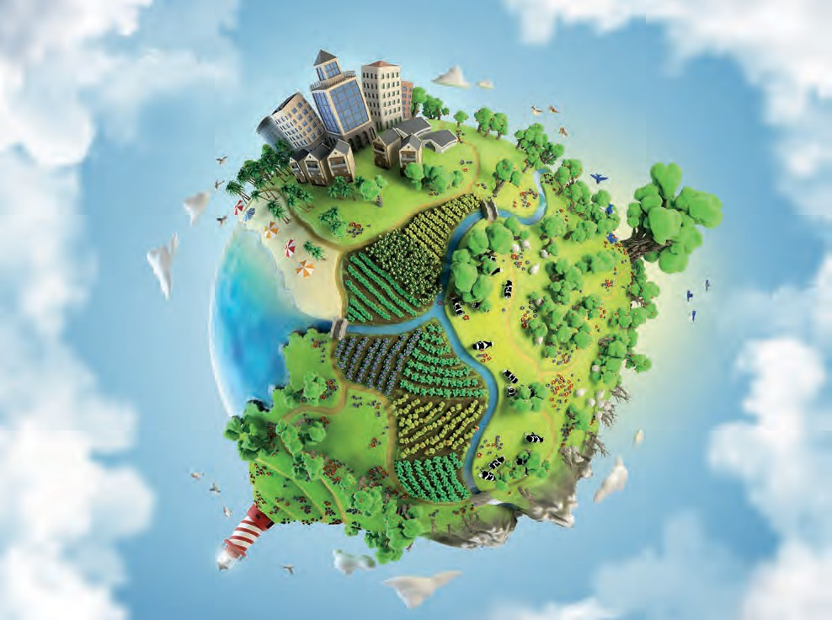
Investigate the world through increasingly complex geographical enquiry
Identify and challenge bias when thinking critically about different viewpoints
Consider what places are like and how the past helps to explain the present and predict the future
Develop your understanding of the big ideas of Geography and how they interconnect
Use different maps routinely to develop your spatial awareness of a variety of places at different scales
Be curious about people and places
Appreciate the world and
understand how physical and human landscapes are interdependent and interconnected
Investigate issues affecting a diverse range of places and people, now and in the future
Engage with and enjoy your studies, developing a passion for learning about our rich and diverse planet
Expand your geographical vocabulary and use it to communicate your geographical ideas through discussion, debate and writing
Investigate places at all scales, from personal to global
Make sense of people and places using a wide range of
geographical data
Expand your world knowledge of places and their location
Investigate and ask your own geographical questions

Strengthen your arguments by justifying your views when reaching conclusions and
making decisions
Progress in Geography: Helping you to become a good geographer
You are on a journey to progress as a geographer. As you study this course you will see how important geography is, not just to your life now, but for the future.

Progress in Geography will give you the opportunity to:

Vision statement from Progress in Geography: Key Stage 3 by David Gardner, Jo Coles, Eleanor Hopkins, John Lyon and Catherine Owen, ISBN: 9781510428003 www.hoddereducation.co.uk/geography/progress-in-geography

Progressing map skills is a key element of the course, as you can see from the vision intent Fig 15, the Ofsted outstanding teacher descriptor for using maps, is incorporated into this vision. If this is the intent, then the use of maps needs to be embedded throughout the book, for a variety of places, and at different scales. Both student books, as well as, activity sheets and student workbooks, have been developed with the support of the Ordnance Survey.

The Progress in Geography student book includes 26 Ordnance Survey maps at a variety of scales, 59 atlas maps, 4 weather charts, 20 sketch maps, and 2 GIS map, as well as a topographical map for New Zealand. 8 OS maps are provided as flaps to the book, allowing the use of large map extracts, across different lessons. These maps are used repeatedly, and progressively through the course, for example Fig 16 shows how the Southampton extract is used through the book.

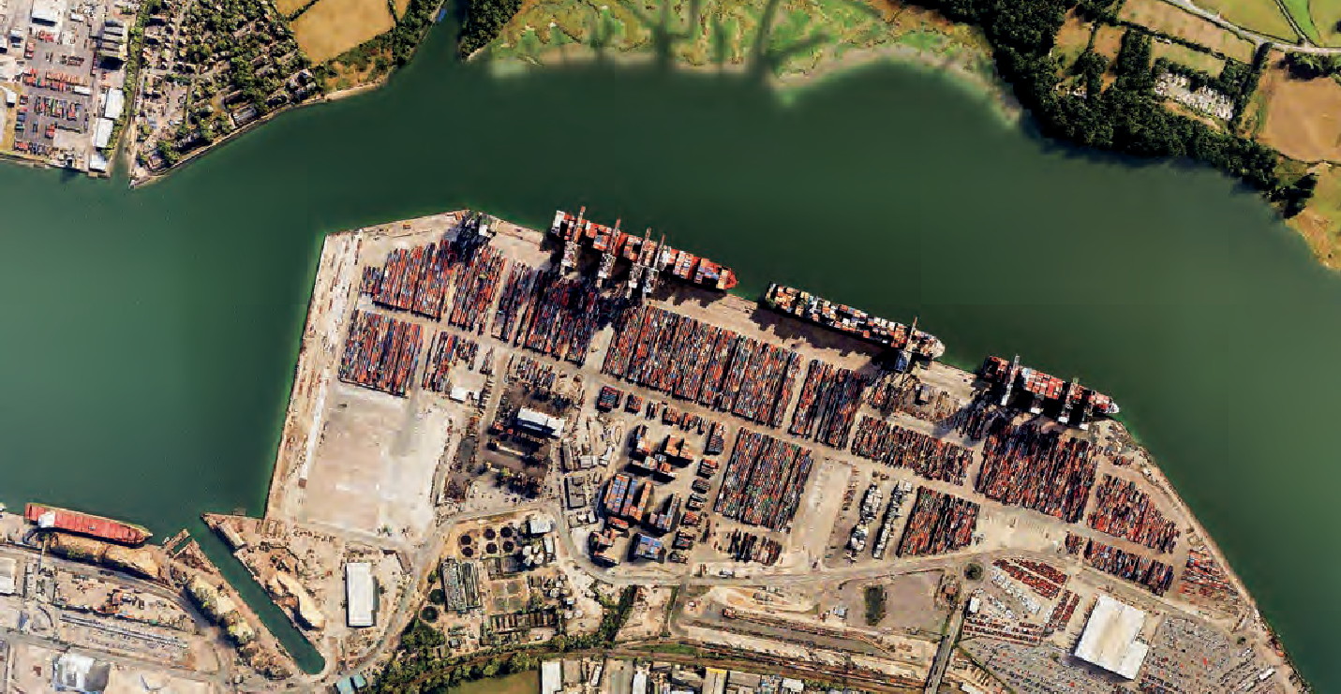
43
CURRICULUM INTENT
43

Lesson | Use of Southampton 1:50 000 OS map
1.8 How can we use aerial photos with OS maps? | Locating places on vertical aerial photo and OS map providing grid references; draw a sketch map.
3.7 How does the UK trade with other countries? | Compare aerial photo of port of Southampton, with OS map, locate and give grid references of port features labelled on photo; determine direction of the view; use map and photo to identify advantages of Southampton as a port.
8.8 How did urbanisation change Southampton? part 1 | Compare 1: 50 000 OS map with 1890 OS map of Southampton to identify change.
8.9 How did urbanisation change Southampton? part 2 | Compare 1 : 50 000, OS map with 1: 10 000 OS map extracts to identify land use patterns.
9.1 What happens where the land meets the sea? | Compare 1: 50 000 OS map with aerial photos to identify features and land uses.
15.6 What are the consequences of climate change for the UK? | Compare 1: 50 000 OS map with online Environment Agency flood risk GiS map give grid references of areas at risk of flooding.

Fig 16 Use of Southampton map extract flap across Progress in Geography student book

A similar approach was taken with ‘Progress in Geography Skills Key Stage 3’. Four OS maps are provide as flaps, to be used across different lessons:

1: 25 000 Nant Ffrancon; 1: 50 000 Liverpool; 1: 50 000 Isle of Purbeck focussed around Swanage; 1: 50 000 Cockermouth, 11 other OS maps are also provided for pupils to make sense of, and interpret in the book, as well as 11 atlas maps, 4 weather charts, 4 GIS maps, 2 tourist maps, a port plan, 3 cartograms.

The Liverpool OS map extract flap is used across the following lessons

Lesson | Use of Liverpool 1:50 000 OS map
1.9 How can I use atlas maps and aerial photos with OS maps? | Compare the 1:50 000 OS map with a vertical aerial photo to describe the absolute location of Liverpool and identify features on the aerial photo and map with grid references.
1.11 How can I use qualitative data to investigate what Liverpool is like? | Compare the 1:50 000 OS map with a pictorial tourist map of Liverpool, locate places using grid references.  Identify the different functions of the two maps.
3.2 How can I use geographical data to determine what the port of Liverpool is like? | Compare the 1: 50000 OS map with the official Port of Liverpool plan to locate different port facilities.

Fig 17 Use of the Liverpool map extract flap across Progress in Geography Skills

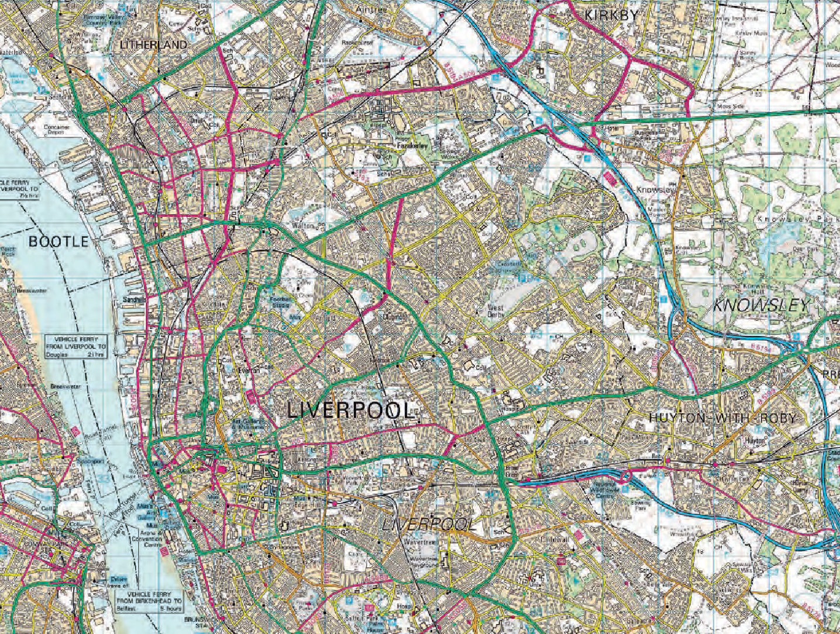

Fig 18 shows an extract of the ‘Progress in Geography’ progression framework to demonstrate how the approach can be used to plan a coherent and sequenced curriculum to support pupil progress towards an intent vision.

 |  | Competence in geographical enquiry, and the application skills in observing, collecting, analysing, evaluating and communicating geographical information.
 | By the end of the Progress in Geography course pupils should: | Be able, with increasing independence, to choose and use a wide range of data including OS maps at different scales, to help investigate, interpret, make judgements, and decisions, to draw conclusions about geographical questions. Write at length and discuss their geographical ideas, using a wide range of geographical vocabulary.
15 | What is the future of the planet? A geographer’s view | - Investigate controversial issues  - Consider a range of evidence of climate change  - Consider and critically reflect on different viewpoints, detecting bias  - Use a wide range of geographical data in this unit and those throughout the book marked with ‘cc’ symbol to identify and classify the causes and consequences of climate change  - Use of GIS with OS maps to identify flood risk in the UK  - Debate three options for the future  - Consider future personal actions as a geographer
14 | Why is the Middle East an important world region? | - Use atlas maps and photos to investigate the Middle East  - Interpret statistics, graphs, population density maps, population pyramids to investigate population change  - Describe and explain the impact of plate tectonics on the Middle East  - Apply understanding of development, population and economy to investigate UAE and Yemen, using a variety of geographical data  - Apply understanding of the Middle East, and migration, to investigate the causes and consequences of war in Syria, critically thinking about different viewpoints
13 | How does ice change the world? | - Compare OS maps with aerial and ground-level photos to identify glacial landforms  - Use OS maps to draw cross-sections to show glacial features  - Describe and explain how people use glacial landforms, using OS map  - Use evidence to describe how the world’s glaciers are changing
12 | What are the challenges and opportunities facing Africa? | - Interpret climate maps and graphs for Africa  - Use atlas maps and photos to investigate Africa  - Use latitude and longitude to locate places in Africa  - Interpret statistics, graphs, population density maps, population pyramids to investigate population change  - Consider different points of view and decisions that people make to change  - Apply understanding of migration and urbanisation to analyse a range of geographical information about Ethiopia  - Use a Development Compass Rose to classify and critically think about different viewpoints
11 | Will we ever know enough about earthquakes and volcanoes to live safely? | - Interpret atlas maps, eye witness accounts, scientific evidence, public information material, to investigate plate tectonics  - Describe and explain the theory of plate tectonics
10 | Diverse and dynamic: how is Asia being transformed? | - Interpret climate maps for Asia  - Use atlas maps and photos to investigate Asia  - Interpret statistics, graphs, population density maps, population pyramids, to investigate population change  - Consider different points of view# and decisions that people make to change  - Apply understanding of migration and urbanisation to analyse a range of geographical information about Karnataka
9 | What happens where the sea meets the land? | - Compare an OS map with aerial and ground-level photos to identify coastal landforms,# and how people try to manage the coast  - Consider different viewpoints and justify decisions about coastal management

 |  | Competence in geographical enquiry, and the application skills in observing, collecting, analysing, evaluating and communicating geographical information.
8 | One planet, many people: how are populations changing? | - Interpret statistics, graphs, models, population density maps, population pyramids, to investigate population  - Identify the latitude and longitude of cities  - Compare OS maps of different scales  - Use a range of historical data  - Identify change, comparing 1890 OS maps with a current OS map  - Identify and explain the world pattern of population distribution
7 | What is development? | - Use a Development Compass Rose to classify indicators of development  - Interpret statistics, Dollar Street website and choropleth maps to investigate patterns of development at different scales
6 | Why are rivers important? | - Compare an OS map with an aerial photo to identify river features and how people use rivers  - Use an OS map to draw a cross-section of a river valley  - Use ArcGIS to investigate the long profile of the River Tees  - Conduct a river fieldwork enquiry  - Describe and explain how rivers create landforms
5 | Is the geography of Russia a curse or benefit? | - Use atlas maps and photos to investigate Russia  - Use GiS GoogleEarth to investigate Russia  - Interpret and analyse a range of geographical data including different viewpoints about an issue  - Use enquiry questions to describe places in Russia  - Describe the physical landscape of Russia  - Explain the differences between the climate of Russia and the UK  - Describe and explain the population distribution of Russia
4 | What is weather and climate? | - Use the synoptic code, weather charts and satellites to analyse weather patterns  - Interpret and draw climate graphs for the UK  - Interpret climate maps for the UK and the world  - Describe and explain weather patterns and the climate of the UK  - Use new geographical terminology – weather and climate  - Conduct a geographical enquiry to identify patterns of weather for a locality for a week
3 | What is an economy, from local to global? | Compare an OS map with an aerial photo to identify location factors for a car plant and a port
2 | How can we use our planet as a natural resource? | Compare an OS map with an aerial photo to analyse the location of an oil refinery
1 | What is a geographer? | - Locate and describe places using latitude and longitude  - Demonstrate ability to use OS maps, scale, grid references, height, direction, with aerial photos  - Conduct fieldwork in a locality
 | By the age of 11 pupils should: | Be able to carry out investigations using a range of geographical questions, skills and sources of information including a variety of maps, graphs and images. Pupil can express their opinions and recognise why other may have a different point of view

Fig 18 Progress in Geography progression framework for geographical skills

Westminster City School, London plan for progress in OS map skills.

Rationale for including OS maps in our curriculum intent and progression framework:
Katherine Baulcomb, a geography teacher at Westminster City School, London, has been working with the geography department team to redevelop their KS3 and KS4 curriculum to make it more coherent and sequenced to support student progress, a significant aspect of this work is to plan for progress in the use of Ordnance Survey map, as she explains:

Our Geography curriculum has been purposely designed so that maps - and OS maps more specifically – form a central pillar of our progression framework and are a core vehicle through which we aim to deliver on achieving our curriculum intent.

In our introductory unit of KS3, pupils are introduced to OS maps as one of the fundamental tools of a geographer; they learn how to use them to interpret UK landscapes, developing the basic skills needed to identify human and physical features using symbols, contour lines and grid references.

We then aim to integrate OS maps consistently and routinely throughout the rest of KS3-KS4 in order to give pupils repeated opportunities to re-visit and build on these skills in other units. For example, pupils in Year 8 infer how the characteristics of a river basin change from source to estuary using OS maps, which allows them to apply and deepen their existing understanding of OS maps in a new and unfamiliar context. (see Fig.22 p59)

In deliberately weaving OS maps throughout our curriculum with increasing levels of complexity, we therefore aim to create young geographers who can interpret spaces and places with independence to gain a deep understanding of the geographical processes that shape the world around them.

This ambition is reflected in the intent vision for geography at the school. (Fig 19)
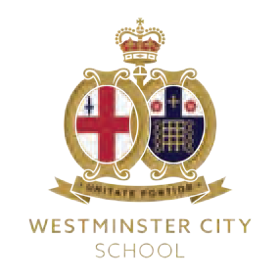

Wisdom, Integrity, Compassion, Excellence

Our vision for Geography at Westminster City School
At WCS, our intent when teaching geography is to inspire in our learners a curiosity and fascination about the world and the people within in, leading to a life-long passion for learning about the spaces and places that exist in our diverse and dynamic planet.

Through our teaching of geography, we aim to foster ‘bigger’ thinking about the interconnectedness of people, places and economies and seek opportunities for our learners to experience a sense of awe and wonder about the worlds’ diverse environments. We also strive to develop their awareness and understanding of places beyond their own doorstep, through routinely using real-world geographical data and maps as the lens through which they are able to explore the complex nature of spaces and places and develop a deep understanding of the physical and human processes that shape them.

We seek to nurture pupils; understanding of the challenges we face when deciding how to manage our planet’s precious and finite resources, aiming to inspire in our learners a sense of duty and responsibility to the environment as custodians of our planet who care about the future of the world and champion social, economic and environmental sustainability. We strive to empower our pupils to become active global citizens who understand the importance of working together to solve problems on a variety of scales - from local issues to the global - and as geographers who can communicate their ideas and opinions with clarity and confidence.

Wisdom  (Knowledge and understanding of the world) | Through our teaching of geography, we aim to foster ‘bigger’ thinking about the interconnectedness of people, places and economies and seek opportunities for learners to experience a sense of awe and wonder about the world diverse environments. We also strive to develop their awareness and understanding of places beyond their own doorstep through routinely using real-world geographical data and maps as the lens through which they are able to explore the complex nature of spaces and places and develop a deep understanding of the physical and human processes that shape them.
Integrity  (Sustainability and social / economic / environmental responsibility) | We seek to nurture pupils’ understanding of the challenges we face when deciding how to manage our planet’s precious and finite resources, aiming to inspire in our learners a sense of duty and responsibility to the environment as custodians of our planet who champion social, economic and environmental responsibility.
Compassion  (Caring about the future of the planet) | We strive to empower our pupils to become active global citizens who understand the importance of working together to solve problems on a variety of scales - from local issues to the global.
Excellence  (Developing the knowledge and skills to become excellent geographers) | At WCS, our intent when teaching geography is to inspire in our learners a curiosity and fascination about the world and the people within in, leading to a life-long passion for learning about the spaces and places that exist on our diverse and dynamic planet.  We aim to develop geographers who can communicate their ideas and opinions with  clarity and confidence.

Fig 19 Geography curriculum intent vision Westminster City School
How does our vision for geography link to the WCS values?
Wisdom, Integrity, Compassion, Excellence

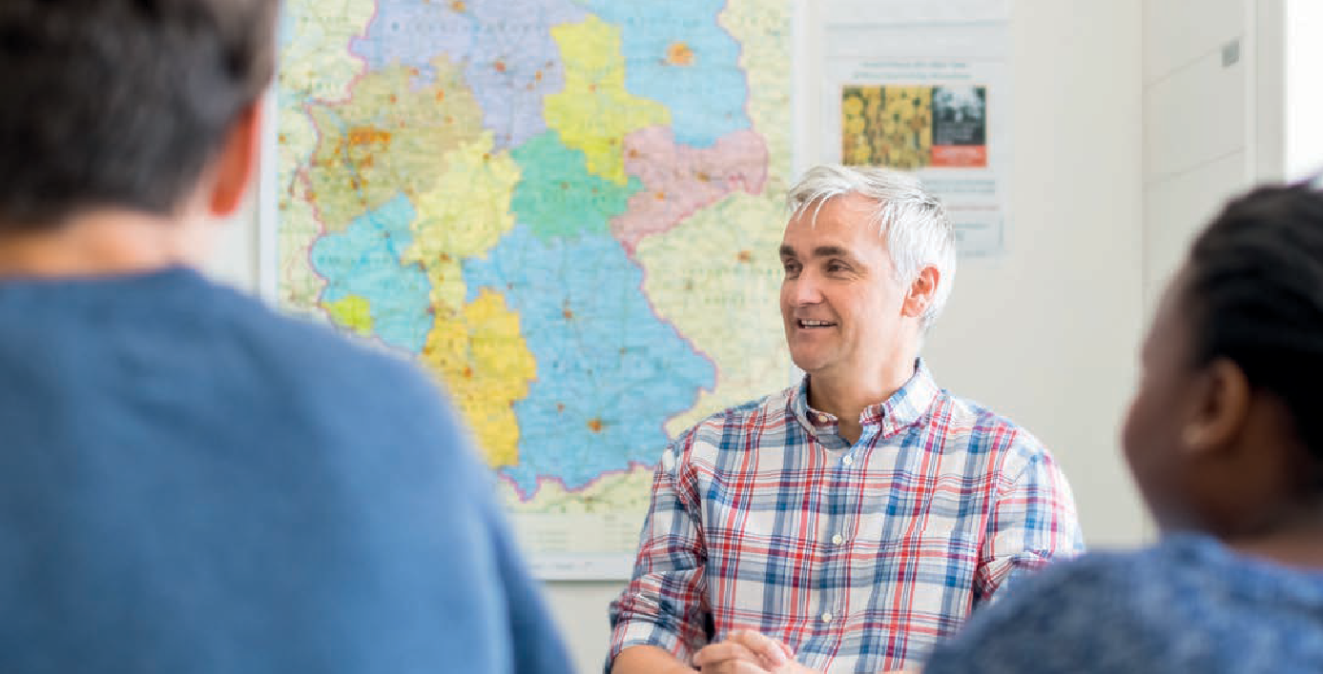

49

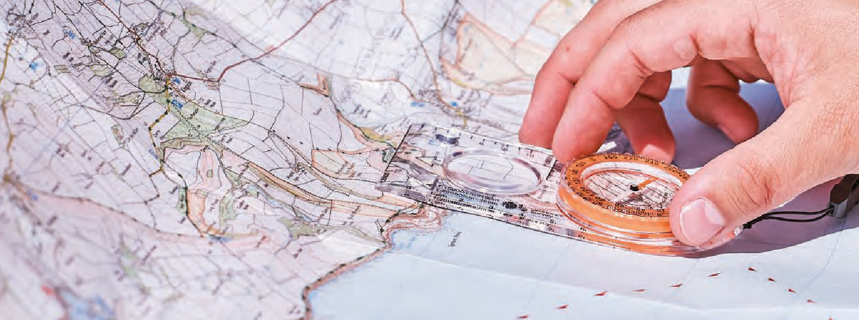
Fig 20 Westminster City School Progression framework for geography 11-16
CURRICULUM INTENT
49

By the end of Key Stage 4, pupils should be able to:
- interpret Ordnance Survey maps in the classroom and the field, including using grid references and scale, topographical and other thematic mapping, and aerial and satellite photographs
- use and interpret OS maps at a range of scales, including 1:50 000 and 1:25 000 and other maps appropriate to the topic
- use and understand coordinates - four and six-figure grid references
- use and understand scale, distance and direction - measure straight and curved line distances using a variety of scales
- use and understand gradient, contour and spot height
- identify basic landscape features and describe their characteristics from map evidence
- identify major relief features on maps and relate cross-sectional drawings to relief features
- draw inferences about the physical and human landscape by interpretation of map evidence, including patterns of relief, drainage, settlement, communication and land-use
- interpret cross sections and transects of physical and human landscapes
- describe the physical features as they are shown on large scale maps of two of the following landscapes - coastlines, fluvial and glacial landscapes
- infer human activity from map evidence, including tourism.
Key stage | Years | Unit focus | Progress in OS map skills – pupils should be able to:
Key | Year | 3.2.3 Section C: The | - Use contour lines on OS maps of the UK to make links between land relief and levels of
Stage | 10/ | challenge of resource | precipitation across the UK (orographic rainfall)
4 | Year 11 | management
Key | Year | 3.2.2 Section B: The | - Use 1:50 000 OS maps to identify the physical and human features that attract tourists to locations
Stage | 10/ | changing economic | within the UK and to identify evidence of tourist activity
4 | Year 11 | world | - Infer evidence of economic activity in the UK over time from OS maps (e.g. quarrying) and use this to explain how the landscape contributes to different sectors of the UK’s economy  - Compare social and economic changes in the rural landscape in an area of population growth and an area of population decline by identifying human and physical features of both places on OS maps  - Identify improvements to the UK’s infrastructure (road, rail, airports) using OS maps
Key | Year | 3.2.1 Section A: | - Evaluate the social, economic and environmental impacts of regeneration on Stratford by comparing
Stage | 10/ | Urban issues and | how the human and physical features have changed over time using past and present OS maps
4 | Year 11 | challenges | - Identify the human features of the rural-urban fringe of London using OS maps and describe the changes that take place along a transect  - Use OS maps of South London to identify evidence of sustainability in new urban residential developments (e.g. BedZED)  - Identify evidence of urbanisation by comparing OS maps of London over time  - Evaluate the options for urban development in the UK (brownfield/greenfield/greenbelt sites) using evidence from OS maps and aerial photographs

Key stage | Years | Unit focus | Progress in OS map skills – pupils should be able to:
Key | Year | 3.1.3 Section C: | - Identify the physical and human features of the river basin of the River Tees using OS maps, including
Stage | 10/ | Physical landscapes | using contour lines and spot heights to describe the relief and gradient and using the scale of maps
4 | Year 11 | in the UK | confidently  - Use 4-figure and 6-figure grid references to identify and locate fluvial landforms of the River Tees independently  - Draw long profiles and valley cross profiles of a river using an OS map and use this to describe and explain how and why the relief of the land changes from source to estuary  - Compare the characteristics of the source and estuary of rivers using OS maps and aerial photographs and explain the reasons for these differences  - Identify the physical and human features of the drainage basin of the River Valency/River Jordan that contributed to the 2004 flood event in Boscastle using OS maps  - Use photographs of fluvial and coastal landforms in conjunction with OS maps to identify the direction from which the photograph was taken  - Identify the physical and human features of the Swanage coastline using OS maps  - Use 4-figure and 6-figure grid references to identify and locate coastal landforms and features of the Swanage coastline (Dorset) independentlyUse OS maps of the coastline to identify coastal processes (e.g. longshore drift, erosion and deposition) that have shaped the coastline  - Draw annotated diagrams of coastal and fluvial landforms to scale (e.g. spits, meanders) using OS maps  - Compare an OS map of Lyme Regis with aerial and ground-level photos to identify coastal management strategies in place and evaluate the success of these strategies using the map and a range of other geographical data
Key | Year | 3.1.2 Section B: The | - N/A – global-scale and regional focus outside of the UK
Stage | 10/ | living world
4 | Year 11
Key | Year | 3.1.1 The challenge of | - Use OS maps to evaluate the likelihood of different areas of the UK being affected by climate change
Stage | 10/ | natural hazards | (e.g. flood risk)
4 | Year 11 |  | - Identify the physical and human factors that contributed to the 2018 ‘Beast from the East’ and 2020 ‘Storm Ciara’ extreme weather events using OS maps of the UK
Key | Year | 18. Climate change: | - Use GIS with OS maps to identify areas of flood risk in London and in the UK
stage | 9 | How and why is our | - Use OS maps and a range of geographical data to inform decision-making exercise about where to
3 |  | climate changing and what is the future of our planet?
 |  |  | locate a new wind farm
Key stage 3 | Year 9 | 17. Antarctica: The frozen continent? | - N/A – this unit has a regional-scale focus outside of the UK. Equivalent regional maps of this area will be used.
Key stage 3 | Year 9 | 16. Dynamic and diverse: How is Asia changing? | - N/A – this unit has a regional-scale focus outside of the UK. Equivalent regional maps of this area will be used.
Key | Year | 15. Tectonic hazards: | - N/A – this unit has a global-scale focus
stage | 9 | How can we live
3 |  | safely on our violent Earth?
Key stage 3 | Year 9 | 14. The Middle East: What is its sustainable future? | - N/A – this unit has a regional-scale focus outside of the UK. Equivalent regional maps of this area will be used.
Key | Year | 13. Tourism: What | - Use 1:50 000 OS maps to identify evidence of tourist activity in the UK – use as a starting point to
stage | 9 | is the future of | link to the unit’s main focus of evidence of tourism in Jamaica
3 |  | Jamaica’s economic development? | - N/A – this unit has a regional-scale focus outside of the UK. Equivalent regional maps of this area will be used.

Key stage | Years | Unit focus | Progress in OS map skills – pupils should be able to:
Key stage 3 | Year 8 | 12. Africa: Should Ethiopia build a dam on the Nile? | - N/A – this unit has a regional-scale focus outside of the UK. Equivalent regional maps of this area will be used.
Key stage 3 | Year 8 | 11. International development: What is development and how developed are different countries around the world? | - N/A – global-scale and regional focus outside of the UK
Key stage 3 | Year 8 | 10. Globalisation: How are the world’s economies interconnected? | - Use OS maps to identify evidence that places in the UK are connected to other more distant places  - Compare an OS map with an aerial photo to identify location factors for a car plant and a port
Key stage 3 | Year 8 | 9. Coasts: What happens where the land meets the sea and how does this affect people and the environment? | - Use 4-figure and 6-figure grid references to identify coastal landforms and features of the UK coastline with increasing independence (peer support)  - Compare an OS map with aerial and ground-level photos to identify coastal landforms, and how people try to manage the coast
Key stage 3 | Year 8 | 8. One planet, many people: How are populations changing? | - Identify areas of the UK that are likely to be sparsely or densely populated using OS map symbols to identify rural and urban locations  - Identify population change in the UK, comparing 1890 OS maps with a current OS maps
Key stage 3 | Year 8 | 7. Rivers: Why are rivers important and how do they affect our lives? | - Compare an OS map with an aerial photo to identify river features and how people use rivers  - Compare the characteristics of the source and estuary of the River Tees using OS maps and aerial photographs  - Draw a long profile for the River Tees using the contour lines on an OS map and use this to describe how the relief of a river valley changes as it flows downstream  - Identify the human and physical features of a river floodplain and estuary using an OS map and use this to explain the importance of these river features to people and the economy
Key stage 3 | Year 7 | 6. Russia: Is the geography of Russia a gift or a curse? | - N/A – this unit has a regional-scale focus outside of the UK. Equivalent regional maps of this area will be used.
Key stage 3 | Year 7 | 5. Ecosystems: What are the world’s main biomes and how  do humans interact with them? | - N/A – this unit has a global-scale focus
Key stage 3 | Year 7 | 4. Weather and climate: What is happening in our atmosphere? | - Use OS maps in conjunction with synoptic code to forecast the weather for different locations across the UK and explain how this might affect people living in those locations
Key stage 3 | Year 7 | 3. Natural resources: Is the Earth running out? | - Compare an OS map with an aerial photo to analyse the location of an oil refinery
Key stage 3 | Year 7 | 2. Living in London: What are the geographies of my local area? | - Identify the location of London’s human and physical features using 4-figure and 6-figure grid references  - Describe and compare the characteristics of different areas within London using OS maps to identify their main human and physical characteristics (e.g. relief)  - Use OS maps on a variety of scales when conducting fieldwork in our local area to interpret the landscape

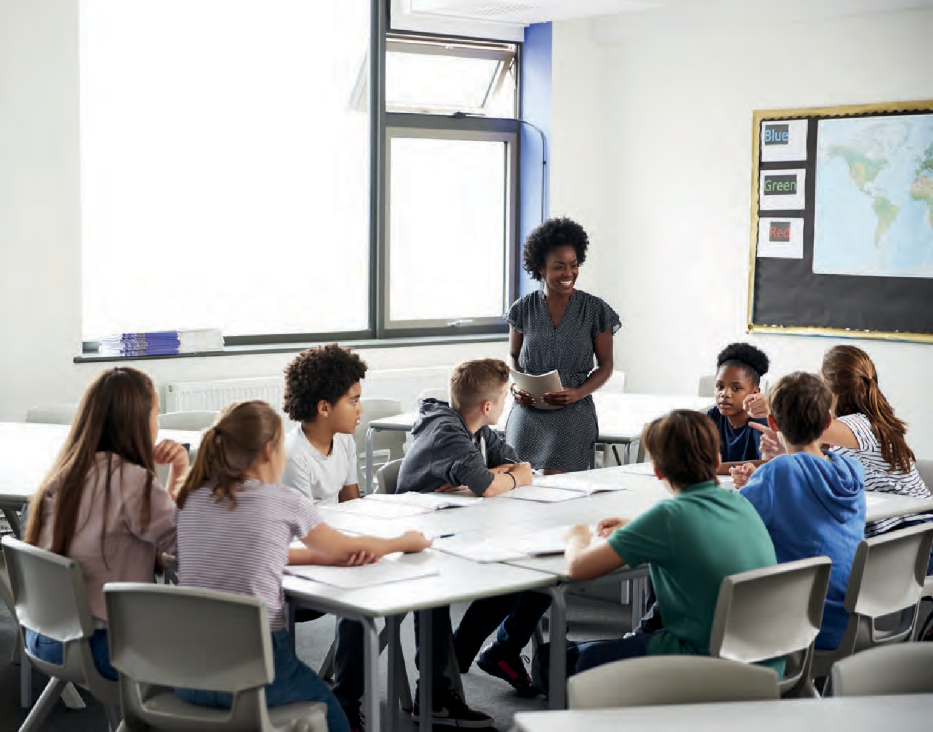

Key stage | Years | Unit focus | Progress in OS map skills – pupils should be able to:
Key | Year | 1. Introducing | • | Identify the meaning of a range of OS map symbols on maps of different scales (e.g. 1:25 000 and
stage | 7 | Geography: What |  | 1:50 000)
3 |  | is geography and | • | Use a key to identify physical and human features of different places using OS map symbols
what key skills do
geographers need?
 |  |  | • | Use 4-figure grid refences to locate features on OS maps
 |  |  | • | Use 6-figure grid references to locate features on OS maps
 |  |  | • | Use contour lines on an OS map to identify the height of the land and describe the relief
 |  |  | • | Use contour lines on an OS map to draw a cross section of the relief along a transect
 |  |  | • | Use aerial photos in conjunction with OS maps to identify and compare geographical features
By the start of Key Stage 3, pupils should be able to:
- use the eight points of a compass, four and six-figure grid references, symbols and key (including the use of Ordnance Survey maps) to build their knowledge of the United Kingdom and the wider world

Fig 20 Westminster City School Progression framework for geography 11-16

Geographical Information Systems

Even as far back as 2011 Ofsted referenced the advantages of using GIS in the geography classroom “For a small number of students, geographical information systems (GIS) were revolutionising and extending their experiences. Visual images from around the world provided via internet links gave immediacy to their learning, and satellite technology brought landscapes to life. P28. The Ofsted geography review (2021) continues to highlight the significance of embedding GIS across the curriculum:

“ArcGIS Story Maps are like a standard PowerPoint presentation, but with the facility to incorporate interactive maps.” P115
She goes on to explain the functionality of the online software and examples of how it can be used in the classroom.

“GIS is also a useful resource in developing pupils’ spatial ‘literacy’, in helping them navigate locally and
globally, and in combining datasets to identify relationships between them. The curriculum should incorporate opportunities to teach and make use of GIS throughout topics”.
“Story Maps provide a simple introduction to ArcGIS Online software, which could act as a springboard for both teachers and students to move to using the full GIS functionality. “ p117

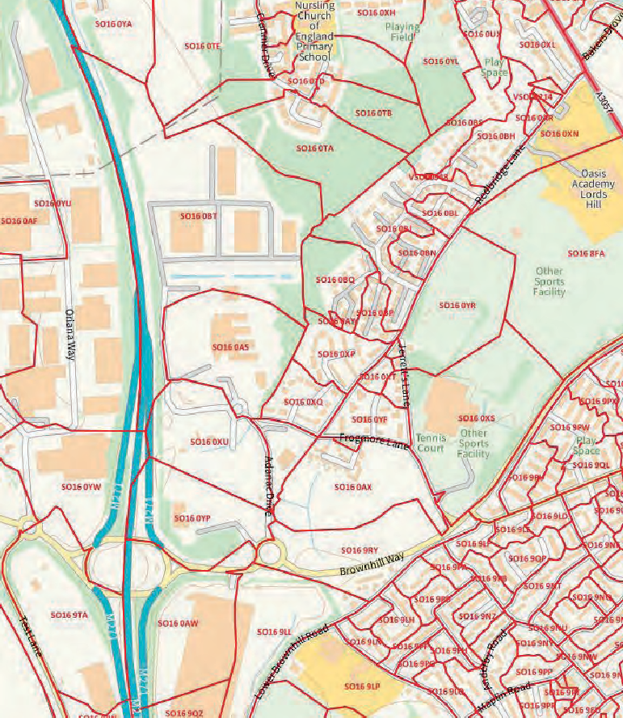
Reference is made to GIS in the aims and content of both Key Stage 3 national curriculum and GCSE subject content (see page 12-15). Yet there is often a reluctance in schools to embed its use in their curriculum. Walshe (2016) believes
“It can be seen as being too technically complex, too difficult to integrate into an already busy curriculum, too time- consuming to produce resources for or simply impossible to do in departments with limited access to computers.”

Walshe experimented with using GIS with trainee teachers, in particular recommending, ESRI’s ArcGIS Online which is a cloud-based GIS platform that supports teachers to create, view, interrogate and display a wide range of spatial data, in a relatively straightforward way. She highlights the benefits of ArcGIS storymaps.

Harry West (2021) has written an excellent article full of ideas and advice about introducing and developing the use of GIS, in just the manner advocated by Ofsted. One of the very important points he makes is:
“the answer to the question as to how to ‘teach GIS’ as well as subject content is simply – don’t. You do not need to ‘teach GIS’ as it is not, at school level, a topic in its own right (unlike in geography undergraduate study).” P14

He believes teachers are better integrating GIS into the curriculum, using it to introduce or reinforce content; for example, using ArcGIS Online to visualise spatial features and processes as part teaching different units of
work. The interactive nature of GIS and the ability to visualise spatial data is not only more engaging, for students, but also aids progress and geographical understanding. Even establishing the use of GoogleEarth ‘as a matter
of routine’ to locate different case studies, by zooming out of a satellite view of the school, on the interactive whiteboard to the location of the lesson’s case study for example Mount Etna in Sicily, is a simple way of supporting students to progress the world contextual knowledge progression strand.

West, provides a range of very helpful advice which is neatly summarised in a conclusion :
1. Start small. Explore some ‘oven-ready’ GIS platforms to familiarise yourself with navigating interfaces and interpreting spatial datasets.
2.
3.
Sign up to the ArcGIS Schools Programme.
Explore the Esri UK Learning Pathways – especially the ‘Getting started with maps and data in ArcGIS Online’ Learning Path.
4.
5.
Locate and map some of the datasets in Figure 2 using your ArcGIS Online account.
Try out a simple mapping activity in the classroom (teaching from the front). Figure 2 includes some suggestions.
6. Keep practising! Gradually build up your confidence using the interface and bring some more maps and spatial datasets into your teaching.
7.
Let the students have a go themselves. Set a learning task that requires them to explore a GIS interface online (either one that is freely available or one you have created yourself).

Digimap for schools, an online GIS providing access to OS maps at a variety of scales is used by over 3,500 British secondary and primary schools, and a growing number of international schools. Digimap for Schools enables students to understand and investigate their world while gaining crucial digital and data skills. https://digimapforschools.edina.ac.uk The website also provides a range of learning resources and guidance on the use of OS maps in the classroom.

ArcGIS for schools provides a free online resource with a wide range of GIS learning resource including a search facility to access storymaps. https://esriukeducation.maps.arcgis.com/

The Ofsted EIF (2019) identifies a number of indicators inspectors can make judgements about the implementation of the curriculum including:

- teachers have good knowledge of the subject(s) and courses they teach. Leaders provide effective support for those teaching outside their main areas of expertise

- teachers present subject matter clearly, promoting appropriate discussion about the subject matter they are teaching. They check learners’ understanding systematically, identify misconceptions accurately and provide clear, direct feedback. In doing so, they respond and adapt their teaching as necessary, without unnecessarily elaborate or differentiated approaches

- The resources and materials that teachers select – in a way that does not create unnecessary workload for staff – reflect the provider’s ambitious intentions for the course of study and clearly support the intent of a coherently planned curriculum, sequenced towards cumulatively sufficient knowledge and skills for future learning and employment

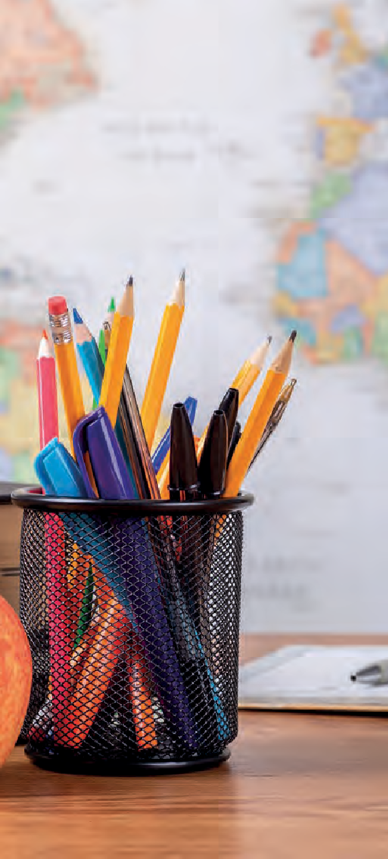
Curriculum Implementation – how will you
55
2
CURRICULUM IMPLEMENTATION
55
organise learning?

Curriculum design process Stage 5
Ofsted (2019) in the School Inspection Handbook, explains implementation as ‘the way the intended curriculum is taught and assessed’. P41

This is given a more focussed meaning for a geography curriculum. in the Ofsted research review (2021)
“In high-quality geography education, teachers are clear about the rationale for the teaching approaches they adopt and why they are successful. In doing so, teachers give considerable thought to how pupils learn geographical content most effectively so that they are able to reach ambitious curriculum goals.”

Kinder and Owens (2019), point out that particular thought needs to be given to:

- How the intent for the subject helps steer the teaching and assessment

- Why specific teaching approaches have been selected, and how they are appropriate for all students

- How specialist aspects, such as the provision of fieldwork across the curriculum, help build knowledge and skills

- The subject and specialist pedagogical knowledge of those teaching geography in the school – and what is being done to support them.

The GA Manifesto A different view (2009) is very clear about the significance of geographical enquiry in the implementation of a geography curriculum:
“The GA believes in geographical enquiry: that is, in students as active participants and investigators, not just the passive recipients of knowledge. Enquiry and investigation
lie at the heart of geographical thinking…” p19

Margaret Roberts’ book Geography through Enquiry (2013) begins by outlining her thinking about enquiry. Most importantly, she states:

“I think of enquiry not simply as a set of skills but as an approach to teaching and learning geography ... when students are learning geography through enquiry, they extend their geographical knowledge and understanding at the same time as they learn skills. I think that what students learn and how they learn are inextricably related; I do not think that the curriculum can be separated from pedagogy. How students learn influences what they learn. When we plan an enquiry-based unit of work, we have to focus on both what is being investigated and how it is to be investigated.” (p. 8)

This pedagogical approach to teaching geography is also highlighted in the Ofsted research review (2021).
“A high-quality geography education may have the following features:

- Pupils are proficient in carrying out enquiries and decision-making exercises because they are secure in the prior knowledge they need for these.

- Carefully structured tasks give pupils sufficient instruction, guidance and support.

- The enquiry approach supports the development of pupils’ disciplinary knowledge. For example, it increases their capacity to recognise and ask geographical questions, and to critique sources and reflect on what they have learned, as well as the methods used.”

Margaret Roberts (2003) has shown how this approach contains four central aspects including the creation of a ‘need to know’ through the use of an engaging stimulus. It then develops through the collection and use of data, processing and making sense of that data and finally reflecting on learning in order to apply it to future enquiries.

This process has been captured in a single diagram, shown in Fig 21

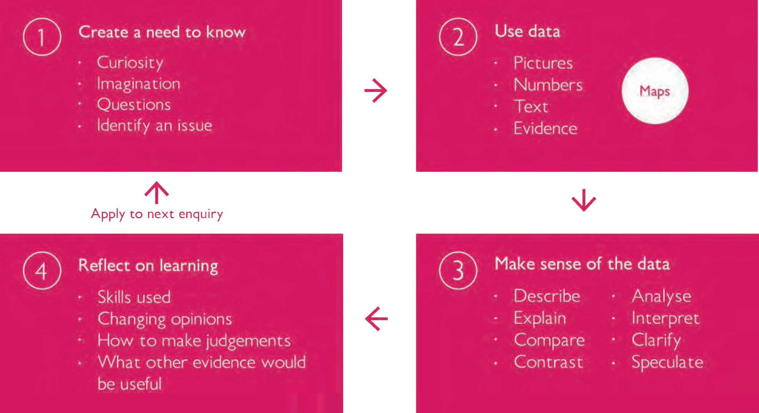
The GA provides online guidance about embedding geographical enquiry into your classroom https://www.geography.org.uk/Geographical-enquiry-in-the-classroom
Fig 21 A framework for learning through enquiry adapted from Roberts (2003) Fig 3 p44

Creating a need to know using OS maps

The class teacher could introduce OS maps at different scales as a ‘matter of routine’ to demonstrate how places are different. For example, in one lesson a mountainous area of the Lake District could be presented on the interactive whiteboard from Digimap for Schools. Pupils use the interactive whiteboard to label clues from the map about the area, for example contour lines close together showing steep slopes, roads following the valley floor etc.

At the beginning of the next lesson a flat lowland area in the Fens, for example, could be projected. This is clearly a very different landscape to be interpreted by pupils, helping them to realise how places are different and how OS maps show this.
The mystery map activity, developed by Alan Parkinson, available on Digimap for Schools, could also be used as a starter for lessons. https://digimapforschools.edina.ac.uk/ files/resource-hub/downloads/MysteryMaps%20.pdf

Such activities spark pupils’ natural curiosity about places and maps, and if used frequently student’s map interpretation skills will be progressed.

Teachers should also consider the classroom environment. Maps are a fundamental aspect of the subject, which should be highlighted, even celebrated in the geography classroom with displays of maps at a variety of scales. These maps should not take on the role of wallpaper, however, pupils should engage in
activities which make them use these maps as ‘a matter of routine’.

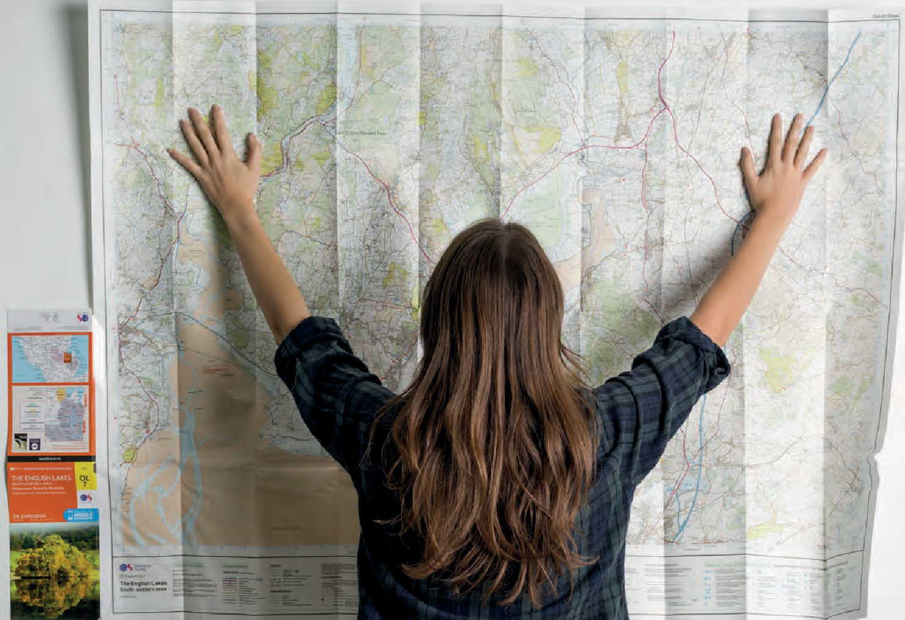

Making sense of OS maps as data
In a Y8 unit of work on rivers ‘Why are rivers important and how do they affect our lives?’ at Westminster City School students make sense of an OS map of the River Tees valley by annotating evidence on a copy of the map, which as Katherine Baulcomb, a geography teacher at the school explains “exploring how the characteristics
of a river basin change from source to estuary using OS maps, allows students to apply and deepen their existing understanding of OS maps in a new and unfamiliar context.” As Fig 22 demonstrates this is an aspect of a progression strand planned strategically by the department, to support students across a coherent 11-16
geography curriculum, to make progress towards the vision for a capability in map skills summarized at the top of the progression framework shown in fig 20.

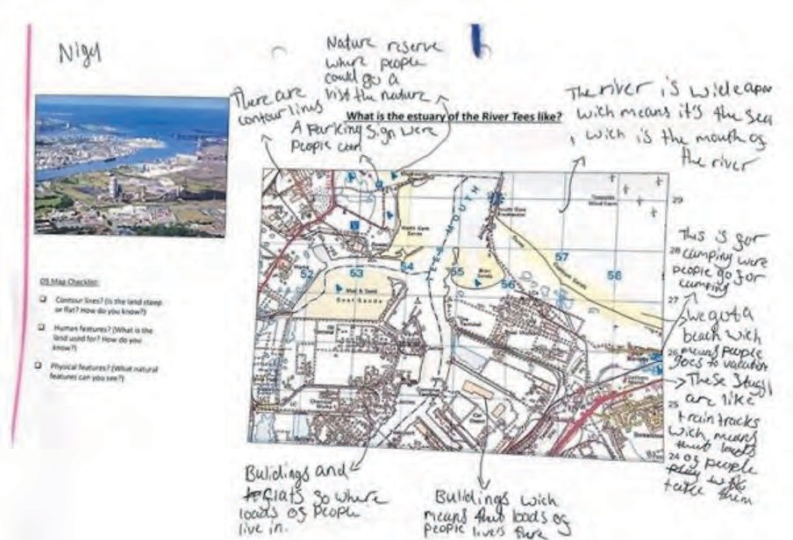
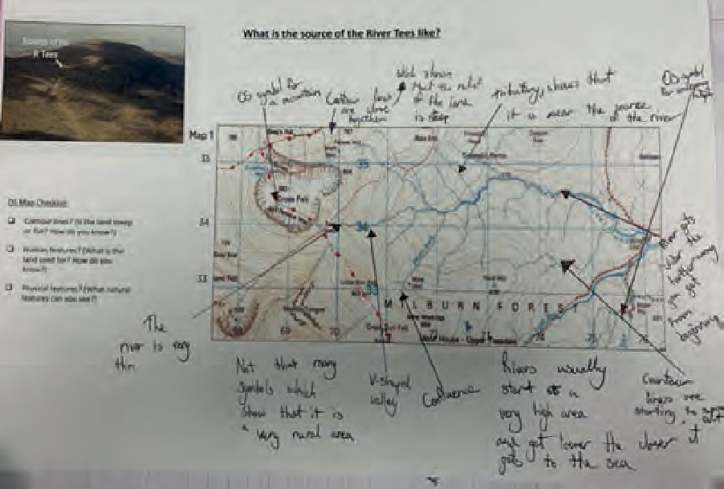
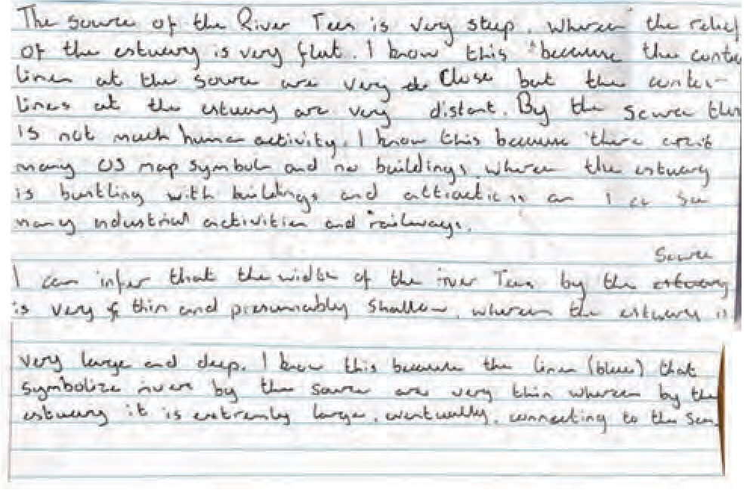
Fig 22 Y8 student map skills work, Westminster City School



Curriculum Impact
3
- how well are you achieving your aims?

Curriculum design process - Stages 6 and 7
There are two stages in this impact phase of the curriculum design process, shown in Fig 4:
- Evaluate and record the impact
- Maintain, change or move on.
The curriculum design process diagram, is presented as a circle, to demonstrate that the curriculum should be seen as being in a state of continuous development.

Ofsted make it clear that the end result of a good, well-taught curriculum is that students know more and are able to do more. The positive results of students’ learning can then be seen in the standards they achieve. This makes work scrutiny an important part of the inspection process as it is here, in particular, that student progress will be evident.
The impact indicators in the EIF (Ofsted, 2019a) are:

- Learners develop detailed knowledge and skills across the curriculum and, as a result, achieve well. Where relevant, this is reflected in results from national tests and examinations that meet government expectations, or in the qualifications obtained

- Learners are ready for the next stage of education, employment or training. Where relevant, they gain qualifications that allow them to go on to destinations that meet their interests, aspirations and the intention of their course of study. They read widely and often, with fluency and comprehension

The self-evaluation undertaken by a geography department to determine whether these indicators are achieved is a matter of professional judgment.

Evaluating your curriculum in these two phases of the design process are explained in detail, providing design tools to support these phases in Chapter 7 of ‘Planning your coherent 11-16 geography curriculum: a design toolkit’.

One of the key indicators for inspectors judgements in terms of curriculum implementation is:
· teachers have good knowledge of the subject(s) and courses they teach. Leaders provide effective support for those teaching outside their main areas of expertise

A key question to consider when evaluating impact is:
How do teachers ensure their subject, curriculum and pedagogical knowledge is up-to- date and influences the curriculum and its implementation towards our vision of student achievement?

Further support for developing subject knowledge in using OS maps
This curriculum guidance for planning for progress in OS map skills has been designed with this question in mind. The references provided below together with the useful links to online support and teaching and learning resources for map skills, is provided to support teachers to ensure their subject, curriculum and pedagogical knowledge is up to date.

Another useful starting point GA have produced this helpful checklist for subject knowledge about maps and globes as part of its guidance and support for ITE trainees and NQTs, it would also be useful for non-specialist teaching geography in your school.

https://www.geography.org.uk/write/MediaUploads/Teacher%20education/GA_ITE_SFT_Subject_knowledge_ maps.pdf
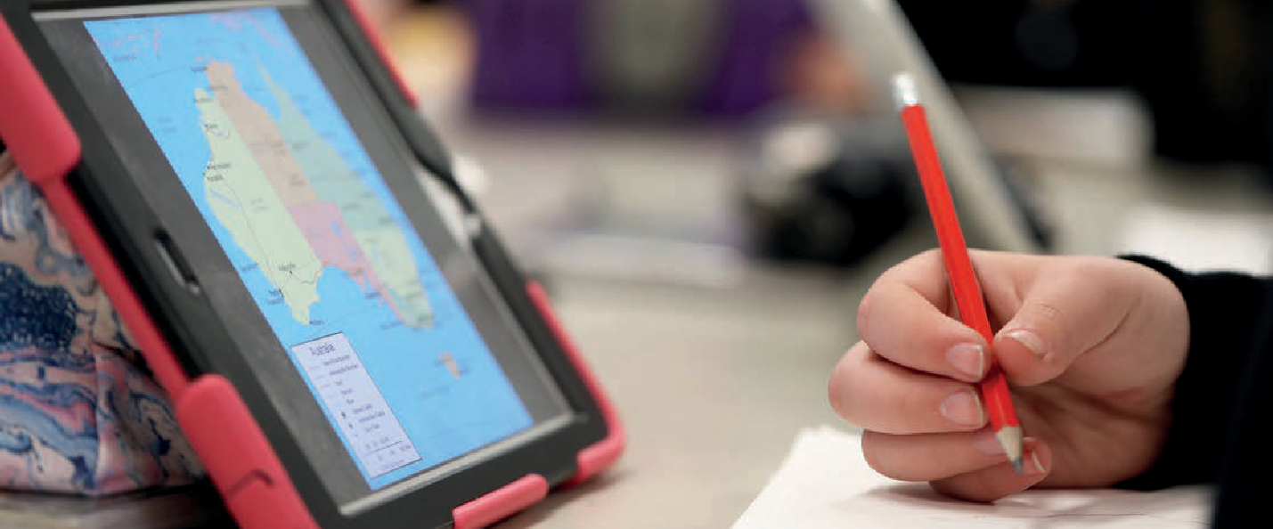
https://www.geography.org.uk/ITE-geography-content/Why-and-how-to-teach-geography




References
- AQA GCSE specification https://filestore.aqa.org.uk/resources/geography/specifications/AQA-8035-SP-2016.PDF
- Aston, R. Renshaw,S. (2014) ‘Planning a new key stage 3’ Teaching Geography, 39,2, 64-65
- Balchin, W.G.V. and Coleman, A.M. (1965) ‘Graphicacy should be the fourth ace in the pack’, The Times Educational Supplement, 5 November 1965.
- Bennetts, T.H. (1995) ‘Continuity and progression’, Teaching Geography, 20, 2, pp. 75–9.
- Cook, K. (2014) ‘Planning a new key stage 3’, Teaching Geography, 39, 1, pp. 16–17.
- DfE (2013) National Curriculum Geography https://www.gov.uk/government/publications/national-curriculum-in-england-geography-programmes-of- study
- DfE (2014) GCSE Geography subject content
- https://assets.publishing.service.gov.uk/government/uploads/system/uploads/attachment_data/file/301253/GCSE_geography.pdf
- Gardner, D, Coles, J, Hopkins, E, Lyon, J, Owen, C (2018) ‘Progress in Geography Key Stage 3, London, Hodder Education
- Gardner, D (2020) ‘Progress in Geography Skills Key Stage 3, London, Hodder Education
- Gardner, D (2021) ‘Planning your coherent 11-16 geography curriculum: a design toolkit’, Sheffield, Geographical Association
- Geographical Association (2009) A Different View: A Manifesto from the Geographical Association. Sheffield: GA. Available at www.geography.org. uk/GA-Manifesto-for-geography
- Geographical Association ITE guidance on using maps https://www.geography.org.uk/Maps-and-graphicacy
- Hyman, P. (2019) ‘What is a big education? Building a curriculum of head, heart and hand’ in Changing the Lens. Available at www.peterhyman.co.uk/ post/why-we-need-a-big-education-a-curriculum-of-head-heart-and-hand
- Gleen, J (2020) ‘Geography’s intent : developing your curriculum’, Teaching Geography, 45,3, 108-110
- Hopkin. J with Gardner. D, Kinder. A, Totterdell, R, and the GA Assessment and Examinations Special Interest Group (2020) ‘A progression framework for geography’ Sheffield, Geographical Association – e-book
- Iwaskow, L. (2013) ‘Geography: a fragile environment?’, Teaching Geography, 38, 2, pp. 53–5.
- Kinder, A. and Owens, P. (2019) ‘The new Education Inspection Framework – through a geographical lens’, Teaching Geography, 44, 3, pp. 97–100
- OCR A GCSE specification https://www.ocr.org.uk/Images/207306-specification-accredited-gcse-geography-a-j383.pdf
- Ofsted (2011) Geography : Learning to make a world of difference https://www.gov.uk/government/publications/geography-learning-to-make-a-world-of-difference
- Ofsted (2014) ‘Geography survey visits: Supplementary subject-specific guidance for inspectors on making judgements during visits to schools’ it can be accessed at: https://dera.ioe.ac.uk/19125/
- Ofsted (2017a) HMCI’s commentary: recent primary and secondary curriculum research. Phase 1: October 2017. Available at www.gov.uk/ government/speeches/hmcis-commentary-october-2017
- Ofsted (2018b) Curriculum research: assessing intent, implementation and impact. Phase 3. December 2018. Available at www.gov.uk/government/ publications/curriculum-research-assessing-intent-implementation-and-impact
- Ofsted (2019) Education inspection framework (EIF) https://www.gov.uk/government/publications/education-inspection-framework/education- inspection-framework
- Ofsted (2019a) School inspection handbook: Handbook for in- specting schools in England under section 5 of the Education Act 2005 available at: https://www.gov.uk/government/publications/school-inspection-handbook-eif/school-inspection-handbook
- Ofsted (2019) School inspection update: special edition. Available at https://assets.publishing.service.gov.uk/government/uploads/system/uploads/ attachment_data/file/772056/School_inspection_update_-_January_2019_Special_Edition_180119.pdf
- Ofsted (2019) ‘Busting the “intent” myth’. Ofsted blog. https://educationinspection.blog.gov.uk/2019/07/01/busting-the-intent-myth/
- Ofsted (2021) Curriculum subject research reviews https://www.gov.uk/government/collections/curriculum-research-reviews

- Ofsted (2021b) Research and analysis: Research review series: geography https://www.gov.uk/government/publications/research-review-series-geography/research-review-series-geography
- Owens, P (2021) ‘Teaching map skills to inspire a sense of place and adventure - planning for progress from 5-11 years’, Ordnance Survey. https://digimapforschools.edina.ac.uk/files/resource-hub/downloads/pupils%20planning%20document-low%20ink%20version_2.pdf
- Parker, M (2009) Map Addict, London, Collins
- QCA (2008) Disciplined curriculum innovation: Making a difference to learners London: QCA http://archive.teachfind.com/qcda/www.qcda.gov.uk/ resources/publicationdf21.html
- Roberts, M (2003) Learning through Enquiry : Making sense of geography in the Key stage 3 classroom, Sheffield, Geographical Association
- Roberts, M. (2013) Geography Through Enquiry: Approaches to teaching and learning in the secondary school. Sheffield: Geographical Association.
- Rynne, E., Hinchliffe, L., Hopkins, J., Gardner, D. and Pilkinton, E. (2020) ‘Using examiners’ reports from GCSE 2019 to improve future performance’, Teaching Geography, 45, 1, pp. 22–5.
- Walshe, N. (2016) ‘Using ArcGIS Online story maps’, Teaching Geography, 41, 3, pp. 115–17.
- Weedon (1997) ‘Learning through maps’ in Tilbury, D and Williams. M (eds) Teaching and Learning Geography, London, Routledge
- West, H (2021) ‘Taking the first steps towards bringing GIS into the classroom’ Teaching Geography, 46,1, 14-16
- Wiegand, P. (2006) ‘ Learning and teaching with Maps’ London, Routledge

Online resources
The Ordnance Survey website includes an education section which provides an amazing range of excellent teaching and learning resources including, video clips explaining basic map skills including grid references, contour patterns, and map symbols; guidance on using GIS in schools, downloadable pdf guides about teaching map skills, OS map symbol flashcards

https://www.ordnancesurvey.co.uk/education

Ordnance Survey Mapzone, has been developed for homework and independent learning for students and parents to work together to develop map skills, it’s a great resource to use in the classroom to.

https://www.ordnancesurvey.co.uk/mapzone/

Digimap for Schools an online mapping service for schools, providing access to a full range of OS maps at a variety of scales, incorporating mapping tools, and aerial photography, as well as overlays of historical OS map.

https://digimapforschools.edina.ac.uk

ArcGIS for schools https://schools.esriuk.com/ GoogleEarth https://earth.google.com/web

Geographical Association guidance on developing map skills in your curriculum https://www.geography.org.uk/Curriculum/Mapping

Geographical Association support and guidance for using GIS https://www.geography.org.uk/Support-and-guidance-with-GIS

Geographical Association ITE support

What do trainees need to know about maps, the different types to use and maps that students create? Training for using globes and atlases and teaching map-work skills. Reviewing how well trainees use maps in their teaching and develop their students’ graphicacy and spatial thinking.

https://www.geography.org.uk/ITE-geography-content/Using-resources-for- geography-teaching

As well as https://www.geography.org.uk/OS-maps

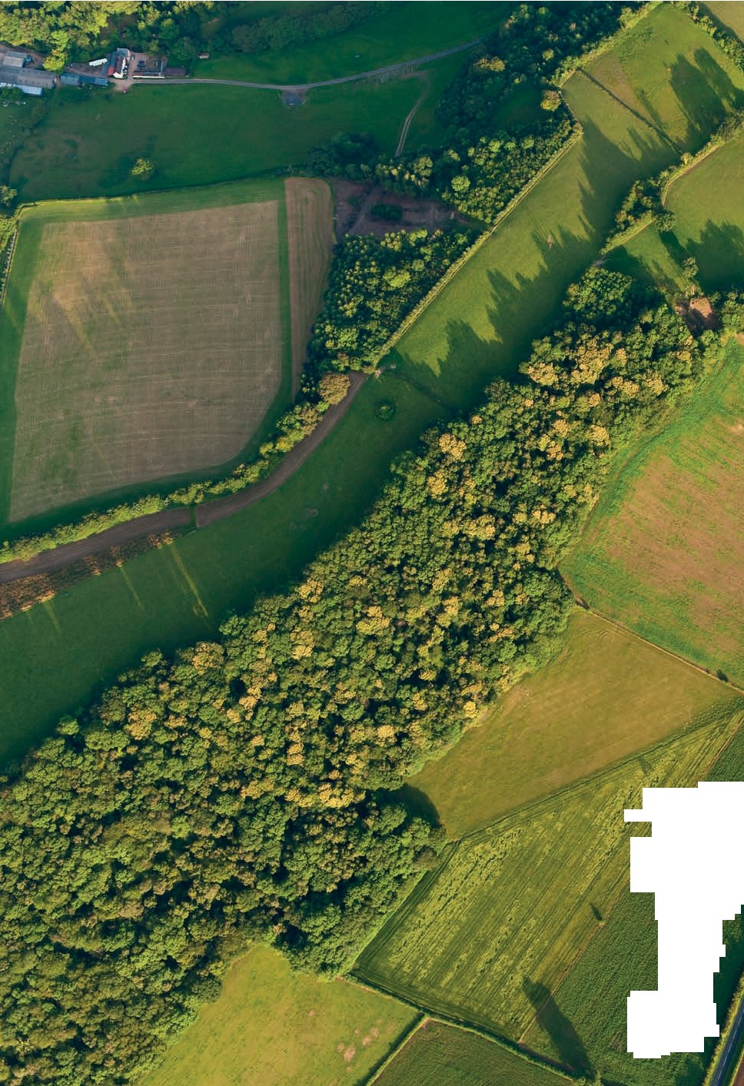
' / ,",

,_/

; , {,
16 - - /.·.·.-

(!,/.
I/
·.;:;'.,
_.\.,t,,_.:•-

,
·.i ,;,:;!,·
):-''
:.-;

. ·? .. .: _i. ;
,;{: ,:,;,1.I .',,;:':,•v{,;
, '/_; -··ill·

