Identifying Changes to Coastal Spits

Exploring coastal processes and landforms

Janet Hutson

Geography teaching resource

Secondary
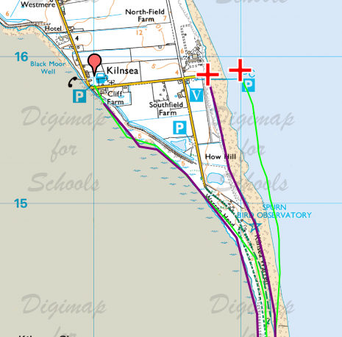

Contents
Digimap for Schools Geography Resources 3
Content and Curriculum Links 3
Activity 4
Introduction 4
Main activity 4
Taking it further 5
Web links 5
Example results 5
Changes to Spits 7
Copyright 9
Acknowledgements 9

Digimap for Schools Geography Resources
These resources are a guide for teachers to demonstrate to the whole class or direct individual students as appropriate. Each activity has several ideas within it that you can tailor to suit your class and pupils. Some resources contain worksheets for direct distribution to pupils.

Content and Curriculum Links
Level | Context | Location
Secondary | Exploring coastal processes and landforms | Example is Spurn Point but other locations are suggested from around Britain. Teachers and students could use their own, perhaps associated with field work or already chosen case studies.

Knowledge | - Mapping.  - Grid references.  - Labelling.  - Measuring.  - Background knowledge about beach features, longshore drift and spit formation.
Curriculum Links England | Aim:  - interpret a range of sources of geographical information, including maps.  - understand through the use of detailed place-based exemplars at a variety of scales the key processes in coasts  - understand how human and physical processes interact to influence and change landscapes.
Scottish Curriculum for Excellence | One of the three geography units is:  Physical Environments  Learning experiences will enable learners to develop a wide range of transferable skills including interpreting geographical phenomena, using maps.
Curriculum Links Wales | - learners to explore by investigation the diversity of the natural and human landscapes in Wales  - extend their locational knowledge and understanding of how processes shape both natural and human landscapes

Activity
This activity refers to dynamic coastal features and attempts to identify and measure change.
There can be confusion over the connection between processes of landscape change, (both erosion and deposition) change events, and persistence of features. The rapid and regular changes experienced on a beach, with each tide, is unique. The human lifetime is long enough for very minor features to be created or modified, though at a given point in time, major changes can occur, suddenly, and dramatically.
The areal extent of landforms creates another issue. What would students expect to be able to identify and measure on a map? Local knowledge and fieldwork help to give a context. When trying to identify change in historical time, remember that negative results are a result.

Introduction
Coastal spits are major beach structures associated with longshore drifting. They are dynamic coastal landforms with associated features. Each is unique but, around the British coastline, they routinely have curved ends. As water collects behind a spit, a depositional area can form leading to saltmarsh growth. Winds may deposit sand and coarser material to create dune systems.
The spit itself, the marsh and dunes are all subject to change in orientation and size. Daily tidal inundation as well as winter storms can effect change.

Main activity
A qualitative and quantitative set of tasks to investigate change to spits. This is based on Spurn Point on the North Sea coast of Yorkshire. Suggested alternative locations are listed below. When you first locate a spit, slide slowly between the modern and historic map to get an idea of the direction, extent and nature of any change.
- Hurst Castle
- Whiteness Head
- Fairbourne (Gwynedd)
- Dungeness
- Sunderland Point
- Dawlish Warren
- Orford Ness Sandbanks
- Culbin Forrest

Taking it further
Human use and modification of spits has changed over time. Look particularly at groynes and evidence of economic activity as themes for comparison.

Web links
https://www.nationaltrust.org.uk/lists/how-have-the-storms-affected-the-coast

Example results
Changes at Kilnsea and at Spurn Point
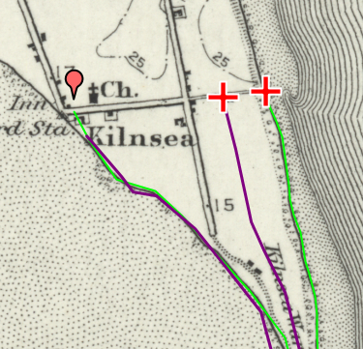

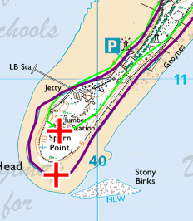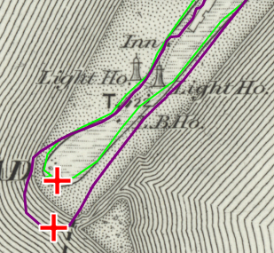

Changes to Spits
- Open Digimap for Schools and enter Spurn Head in the search box.
- Use the slider to view the1890s map and the modern map together. Notice the change in size and shape of the spit. Track north along the spit up to Kilnsea and you will see more differences. You are going to investigate and measure some of these changes.
- Open the Drawing Tools.
- Place a red marker at Kilnsea near the Inn.
- Choose either the modern or the old map to work on first and select an outline colour that will contrast, e.g. bright green.
- If you are using the modern map identify the Mean High Water line in purple. If you are using the 1890s map look for the solid black line. You are going to trace along these lines.
- Starting at Kilnsea carefully draw along the coastline all the way to Spurn head and back up to Kilnsea.
  - TIP – this is a long line to draw so you can do it in sections, just double click at any point and then start again where you left off.
- When you have finished on one map, choose another line colour and do it again on the other map.
- Look at Spurn head itself and put a red cross marker on the most southerly point.
- Find the end of the spit on the historic map and do the same.
- Open the Measurement Tools.
- Using the line measuring tool, measure the actual distance between the centre of each red cross. Note the measurement. You could add this as a label on the map if you wish.
- Now work your way back up the spit and see if you can find anywhere the difference between the two lines is just as big or greater. Highlight any places you want to measure with red crosses in the same way.
- Spits will vary but they will often have features such as sand dunes and marshes, see if you can see these. Look for other changes that have taken place to these over time and mark them with another symbol. If there is change write why you think this has taken place.
- Can any conclusions be drawn from your investigation? Has there been measurable change in the last 125 years?
- If you were looking at a map made 125 years from now what further change do you think you might see? Give your reasons.

Copyright
©EDINA at the University of Edinburgh 2016
This work is licensed under a Creative Commons Attribution-Non Commercial Licence

Acknowledgements
© CollinsBartholomew Ltd (2019) FOR SCHOOLS USE ONLY
© Crown copyright and database rights 2020 Ordnance Survey (100025252). FOR SCHOOLS USE ONLY.
Aerial photography © Getmapping plc. Contains OS data. FOR SCHOOLS USE ONLY.
Historic mapping courtesy of the National Library of Scotland. FOR SCHOOLS USE ONLY.

