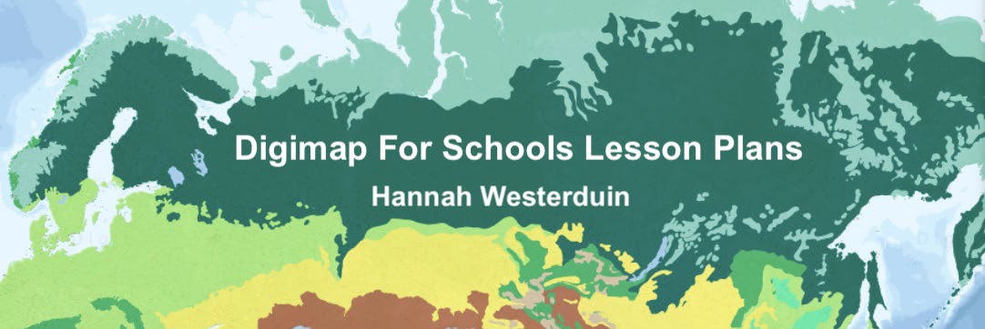

# Lesson 1 Worksheet: Tectonics, Mountain Ranges and Volcanoes

The aim of this worksheet is to explore physical processes through Digimap for Schools World Physical Geography overlays of mountain ranges, volcanoes, tectonic plates and tectonic plate boundaries.

## Learning Objectives:

By the end of this worksheet you should be able to:

* Use overlays to locate tectonic plates across the globe.
* Describe the different types of tectonic plate boundaries.
* Describe how tectonic plate movement has formed landscapes across the world.
* Understand how tectonic plate boundaries influence the presence of volcanoes.
* Describe the different types of volcano.
* Understand the extent of volcanic eruptions.
* Describe the potential consequences for people living nearby.
* Understand how the movement of tectonic plates can cause mountain forming events, such as the Himalayas.
* Understand how physical features dictate where people choose to live.
* Use Digimap for Schools to create a map.

## Tectonic Plates

The Earth’s crust is divided up by large slabs known as tectonic plates. Movement in the Earth’s core causes these plates to move, often a few centimetres a year which eventually leads to places on the Earth’s surface moving thousands of kilometres apart. This process is known as continental drift.

At the boundaries between tectonic plates, plates interact by moving apart, towards or under each other, this causes the Earth’s crust to be unstable. Tectonic plate interactions can cause earthquakes, volcanic eruptions and the creation of mountain ranges as the earth’s surface is distorted.

There are 4 types of plate boundary: convergent, divergent, transform and subduction, which are defined by the motion of the plates in relation to each other (Westerduin, 2021a). Sections of Earth’s crust can come together and collide (a “convergent” plate boundary), spread apart (a “divergent” plate boundary), or slide past one another (a “transform” plate boundary).

Learn about the different types of tectonic plate boundaries here: <https://www.bbc.co.uk/bitesize/guides/zyhv4wx/revision/2>

## Activity

Open Digimap for Schools.

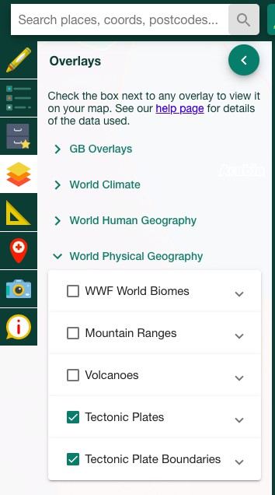First, select the Tectonic plate and the Tectonic plate boundaries overlays.

*Alt Text: Image showing where to find tectonic plate and tectonic plate boundary overlays in the Digimap for School overlays panel.*

* 1. How many tectonic plates make up the Earth’s crust?

1. 63

2. 36

3. 24

4. 52

Using the tectonic plate overlays, find the Burma tectonic plate (Hint it lies over the Andaman Islands between India and Thailand)

* 1. What type of plate boundary lies between the Indian and Burma tectonic plate? (hint use the map key to identify what each coloured line means.) Choose one from:
     1. Convergent
     2. Divergent
     3. Subduction
     4. Transform
  2. What type of plate boundary lies between the Burma and Sunda plate?

Choose one from:

* + 1. Convergent
    2. Divergent
    3. Subduction
    4. Transform

1. Which way are the Burma and Sunda plates moving relative to

each other?

Choose one from:

* 1. Moving away from each other
  2. Moving towards each other
  3. Sliding past each other
  4. One plate slides below the other

1. What might happen at this plate boundary as a result of the tectonic plate movements?

Choose 3:

* 1. The plates are forced upwards to form fold mountains.
  2. Friction between the plates triggers earthquakes
  3. New land is created in the gap between the plates
  4. Magma might rise up through cracks and erupt onto the surface.

## Volcanoes

Select the volcanoes overlay and locate Iceland on the map. Iceland is a hotspot for volcanic activity because a tectonic plate boundary runs through the middle.

* 1. What are the two tectonic plates and which way are they moving?

1.

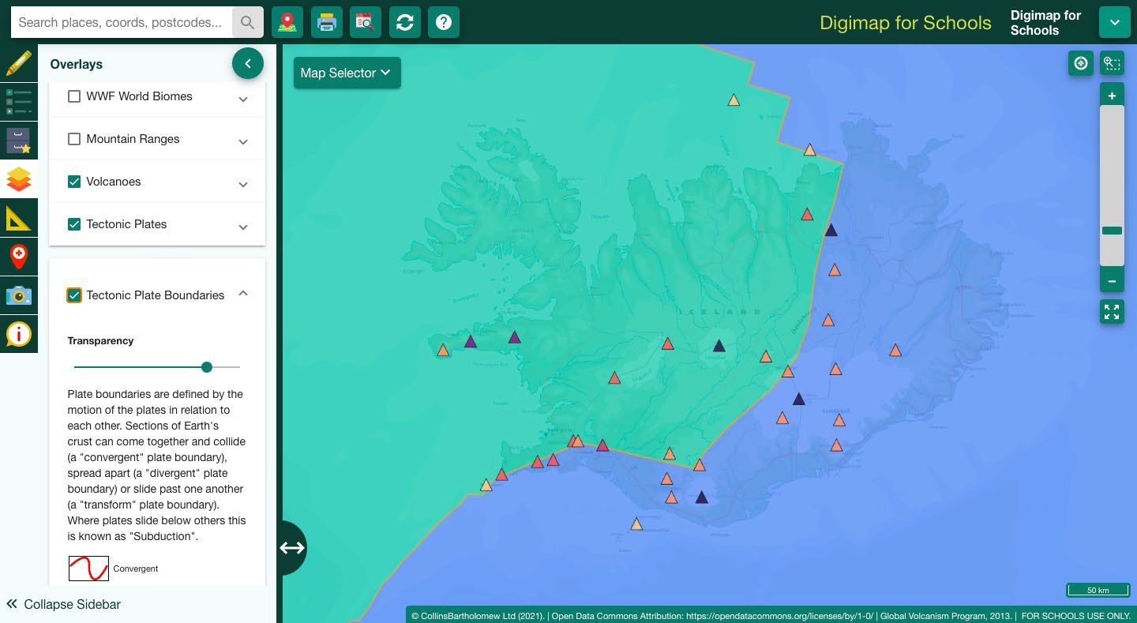

*Alt Text: Map showing Tectonic plates and Volcanoes over Iceland. A tectonic plate boundary runs through the middle and there are lots of volcanoes.*

Iceland is also home to a range of different volcano types. Learn about the different volcano types here: [https://digimapforschools.edina.ac.uk/files/overlay_guides/volcanoes_user_guide.](https://digimapforschools.edina.ac.uk/files/overlay_guides/volcanoes_user_guide.pdf) [pdf](https://digimapforschools.edina.ac.uk/files/overlay_guides/volcanoes_user_guide.pdf)

## Case study: Iceland’s Eyjafjallajokull volcano

Eyjafjallajokull erupted in April 2010. Learn about Eyjafjallajokull here: <https://www.bbc.co.uk/bitesize/guides/zvnbkqt/revision/4>

Latest activity report from the Global Volcanism Program:

<https://volcano.si.edu/volcano.cfm?vn=372020>

* 1. Write down 3 things that you learnt about the eruption. 1.

2.

3.

## Activity

Find Iceland’s Eyjafjallajokull volcano. (hint: use the Get Feature Information tool to see the volcano names).

Get Feature Info. tool 

Alt Text: Get Feature Information tool. A magnifying glass over an information icon

* 1. Once you found the volcano, use the ‘text box’ tool to label it, then click on

the volcano after selecting the ‘Gridref’ tool.



i. What is the grid reference?

1.

* 1. Ash and rock particles from the Eyjafjallajokull eruption reached a distance of 70km from the volcano, use the buffer tool to investigate the area that would be affected by volcanic ash. (hint: select the point buffer tool, input the distance and then click on Eyjafjallajokull)

1. What area does this cover? (hint use the measure tool and click on the buffer circle)

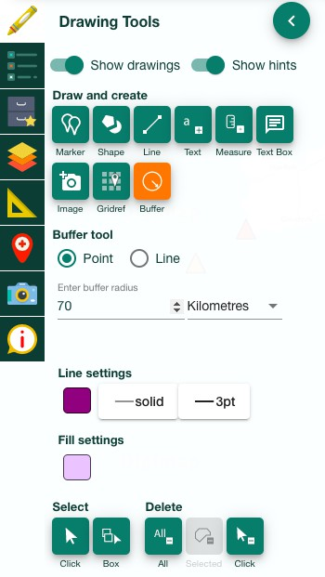

Alt Text: Digimap for Schools Drawing Tools

## Volcanoes and people

The number of people living in an area can be defined by population density. You can calculate this by dividing the number of people in an area by the size of the area.

Population density = the number of people per km2 / the size of the area in km2 <https://www.bbc.co.uk/bitesize/guides/zkg82hv/revision/2>

d. Select the Population density overlay under the ‘World human geography’ section. What is the name of the city that may be affected by another eruption?

1. Use the Distance tool under the measurement tab to calculate the distance between Eyjafjallajokull and Iceland’s capital city.
2. Describe what the consequences might be if there was a larger eruption. (hint use <https://www.bbc.co.uk/bitesize/guides/zvnbkqt/revision/3> to list 3 potential impacts of a big eruption)

1.

2.

3.

1. How might these consequences be managed?

1.

2.

3.

e. Select the “generate file for printing” tool to create a map of what you have done. Save this map.

Print button 

Alt Text: Print tool

## Mountain Ranges

The movement of tectonic plates can cause mountain forming events. Select the Tectonic plate and Mountain Ranges overlays and zoom to the Himalayas. (Hint: alter the transparency of the tectonic plate overlay to see the mountain ranges).

A convergent plate boundary has caused uplift of the crust between the Indian and Eurasian plates forming the Himalayan Mountain range.

## Activity

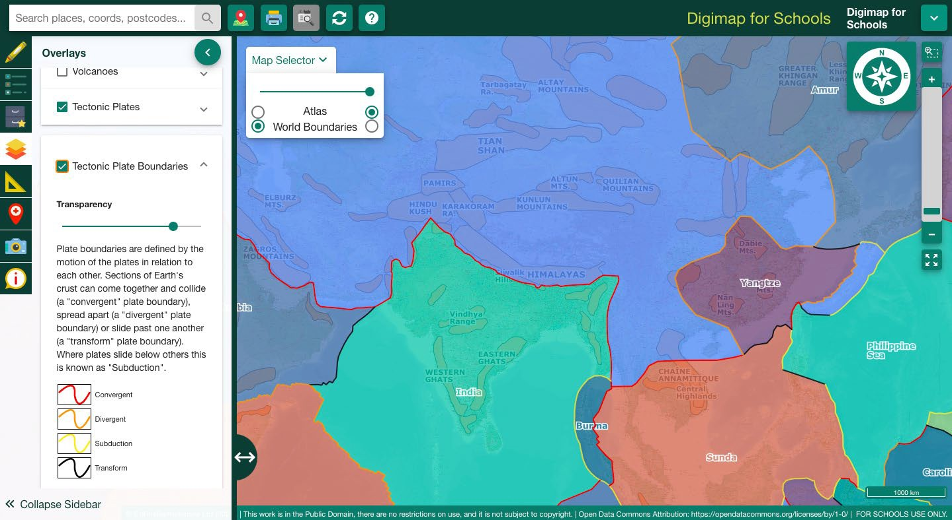

Alt text: Map showing the tectonic plates, tectonic plate boundaries and mountain ranges overlays over Asia in

the Digimap for Schools interface.

d. What is the area of the Himalayas Mountain range? (hint: use the freehand shape tool to trace the feature and then use the ‘measure’ tool to calculate the area)

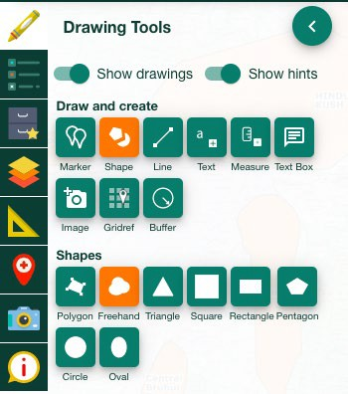

Alt Text: Digimap for Schools tool bar

## Settlements and physical features

Places where people live are called settlements, these can be described through a settlements site, situation and pattern.

**Site** - this is the place where the settlement is located, eg on a hill or in a sheltered valley.

**Situation**- this describes where the settlement is in relation to other settlements and the features of the surrounding area, eg is the settlement surrounded by forest or is it next to a large city?

Settlement situation can be described using the 3 main types of settlement patterns; dispersed, nuclear and linear.

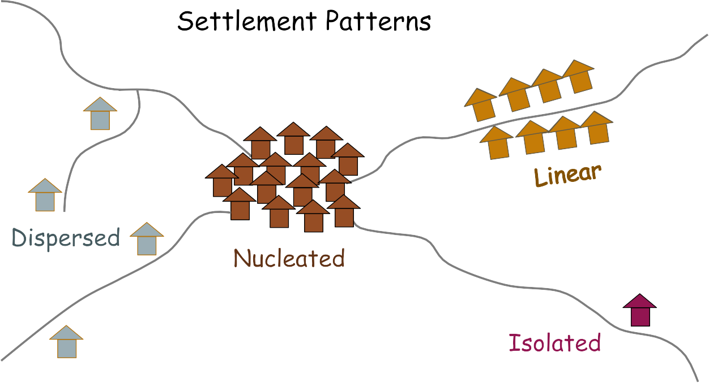

Alt text: Diagram showing settlement patterns. Dispersed, nucleated, isolated and linear settlements.

Select the population density overlay and turn off the tectonic plates overlay.

e. What are the ways in which physical features like mountain ranges

affect settlement patterns?

# Extra activity

Find your nearest Mountain Range. Either the Grampian mountains in Scotland or the Cambrian Mountains in Wales. Measure the area, how does this compare in size to the Himalayas?

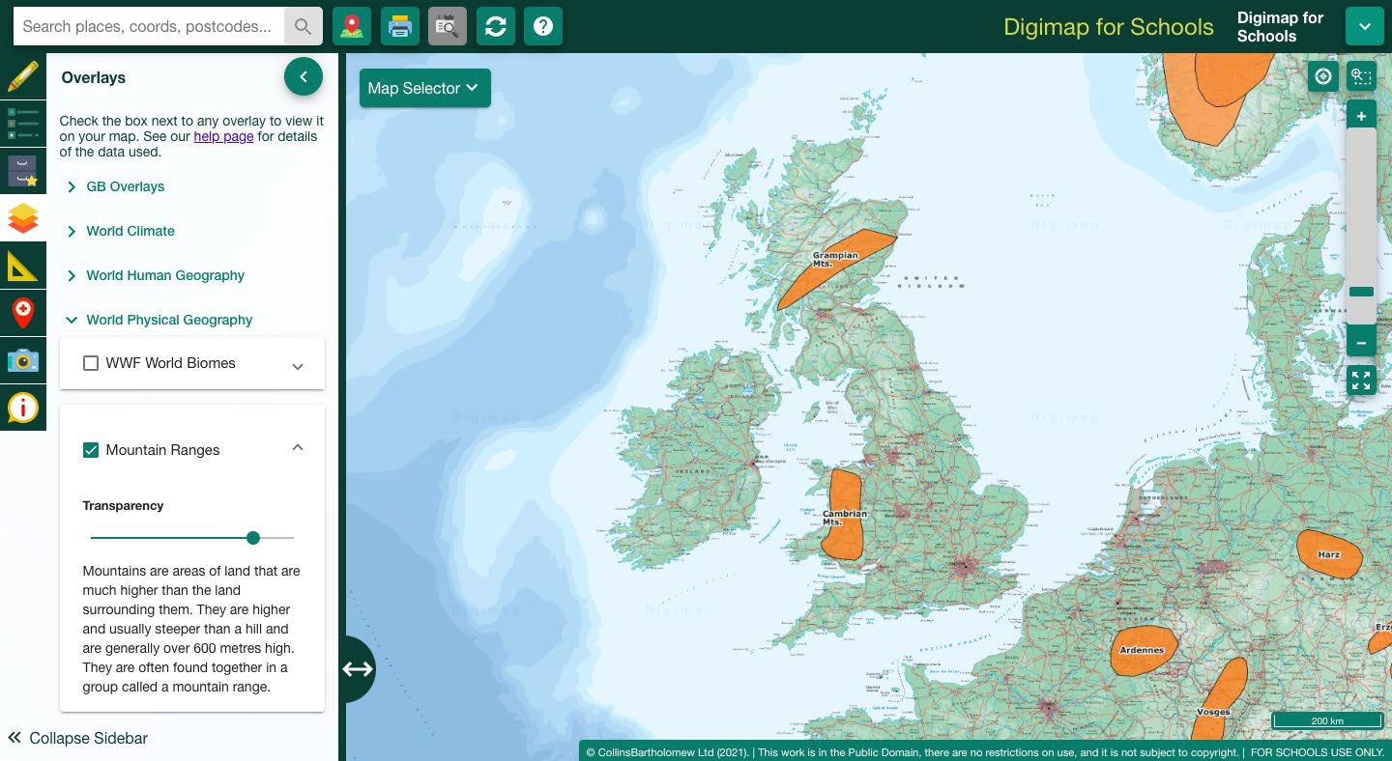

Alt Text: Map showing the Himalayan Mountain Range and population density overlay.

If you finish, have a go at the BBC bitesize quizzes:

Plate Tectonics: <https://www.bbc.co.uk/bitesize/guides/zyhv4wx/test>

Volcanoes: <https://www.bbc.co.uk/bitesize/guides/zvnbkqt/test>