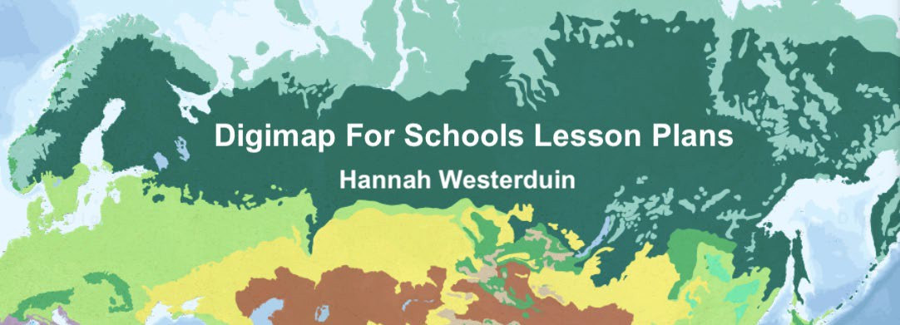



# LESSON PLAN 2

**World Biomes**

**Teacher Guide**

### Geography Teaching Resource Secondary Ages 11-14 KS3 and Level 3/4

**Teacher Guide**

# World Biomes

The aim of this resource is to explore Biomes across the World through the World Physical Geography Overlay of World Biomes and the World Human Geography overlay of Population Density. There is a corresponding worksheet for distribution to students that supplements this lesson plan. Note: This resource is estimated to take 2+ lessons of 45 minutes to complete.

### Table of Contents

Learning Objectives 3

Curriculum for Excellence Links 3

Introduction to Biomes 4

ACTIVITY 5

1. Deserts 5

Case study: Hot desert biomes 5

Animals in deserts 7

Desertification 7

People in deserts 10

1. Polar Biomes 12

Case Study: Tundra regions of the world 12

People in tundra 12

Animals in tundra 14

Extra Activity 14

BBC Bitesize quizzes 15

Bibliography 16

Copyright 16

#### Learning Objectives:

By the end of this worksheet students should be able to:

* Locate the Sahara Desert and the Sahel.
* Locate Tundra regions in the Northern Hemisphere.
* Describe the links between climate, physical features and living things in Desert Biomes.
* Describe the links between climate, physical features and living things in Tundra Biomes.
* Describe plant and animal adaptations to Desert and Tundra Biomes.
* Describe human adaptations to Desert Biomes.
* Identify the impacts of human activity on Desert Biomes.
* Describe desertification and the potential consequences.

|  |  |  |
| --- | --- | --- |
| **Level** | **Context** | **Location** |
| Secondary KS3  CfE Level 3  and Level 4 | World Biomes | Global with Case studies:   * Hot Desert Biomes * Sahara Desert * Sahel * Tundra Biomes |

#### Curriculum for Excellence Links

|  |  |  |
| --- | --- | --- |
| **Es and Os** | **Experiences and Outcomes for planning learning, teaching and assessment** | **Benchmarks to support practitioners’ professional judgement of achievement of a level** |
| SOC 3-10a | I can investigate the climate, physical features and living things of a natural environment different from my own and explain their interrelationship. | * Describes a natural environment different to their own, in terms of climate, physical features and living things. * Provides a simple explanation of at least three links between climate, physical features and living things in that environment. |
| SOC 4-10a | I can develop my understanding of the interaction  between humans and the environment by describing  and assessing the impact of human activity on an area. | * Describes and makes at least three valid conclusions about the impact of human activity on a chosen area. |

# Introduction to Biomes

Information from BBC Bitesize (2021a) <https://www.bbc.co.uk/bitesize/guides/zh2p34j/revision/1>

Biomes are areas on the planet classified according to their landscape, climate, planet and animals (NatGeo, 2022a). Biomes are generally characterised by a major habitat like a forest or a desert but can contain many different ecosystems (Forseth, 2010).

Ecosystems are ‘bubbles of life’, these can be as small as a tide pool or as big as whole rainforests (NatGeo, 2022b). Every part of an ecosystem depends on another part, e.g. animals depend on food and shelter and plants depend on climate (NatGeo, 2022b).

Therefore, climate, landscape and soils influence what types of animals live there. Extreme environments have very harsh conditions and only plants and animals that adapt to live there can survive (BBC Bitesize, 2021a)

|  |  |
| --- | --- |
| **Biome** | **Information** |
| Tropical rainforest | * 23.5° north - 23.5° south of the equator. * Hot and wet all year. * Rich in plants and animals. * Poor soils. |
| Tropical grassland or savanna | * Within the tropics. Mainly between 5° and 15° north and south of the equator. * Hot with a wet and dry season. * Mainly grass and a few specially adapted trees. |
| Hot Desert | * 15-30° north and south of the equator. * Very hot and dry. * Limited plants. |
| Mediterranean | * 30-40° north and south of the equator. * West coasts. * Hot, dry summers and warm, wet winters. * Mainly scrub vegetation - plants adapted to summer drought. |
| Deciduous forest | * 40-60° north and south of the equator. * Cool summers and mild winters. * Rain throughout the year. * Rich deciduous woodlands. |
| Temperate grassland | * 40-60° north and south of the equator. * Warm summer and very cold winter. * Quite low rainfall. * Mainly grassland vegetation. |

|  |  |
| --- | --- |
| Coniferous forest (Taiga) | * 60° north of the equator and on mountains. * Long, cold winters. * Short, mild summer. * Limited rainfall. * Coniferous trees. |
| Tundra | * Far north. * Below freezing for most of the year. * Ground permanently frozen. * Light snow. |
| Mountain | * Very cold. * Thin soils. * Limited vegetation. |
| Polar | * Very cold all year round. * Permanent or semi-permanent layer of ice. * Mainly found in the Arctic and Antarctic. |

BBC Bitesize (2021a).

## ACTIVITY

## Deserts

### Case study: Hot desert biomes

(BBC Bitesize, 2021a). <https://www.bbc.co.uk/bitesize/guides/znxsgk7/revision/1>

Open Digimap for Schools and select the WWF World Biomes overlay.

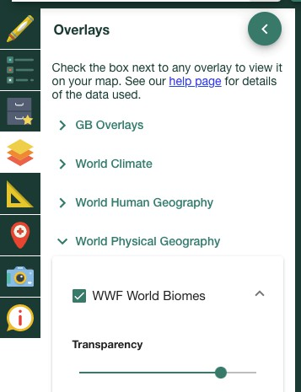

*Alt Text: Digimap for Schools toolbar. WWF world biomes overlay selected*

Locate the Sahara Desert on the map (hint use the Get Feature Information tool)

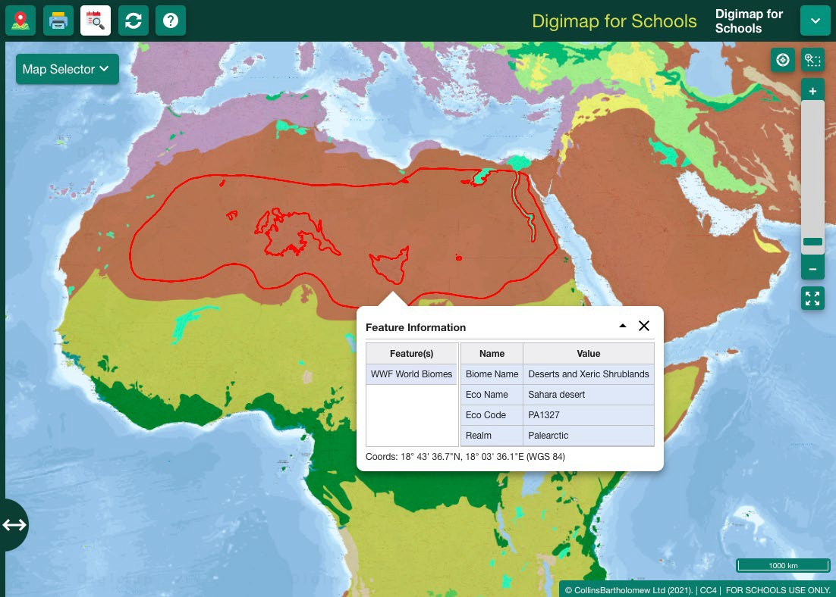

*Alt Text: World Biomes Map over Africa. Sahara Desert selected*

#### Animals in deserts

Deserts are hot or cold areas that are very dry and receive less than 250 mm of rain each year. Only animals and plants that have adapted to these dry conditions live here (BBC Bitesize, 2021a).

* 1. List 3 plants or animals that can survive in hot desert conditions Examples:
     1. Cactus
     2. Camel
     3. Rattlesnake
  2. How do these plants and animals adapt to cope with the climate and physical features in Hot Desert Biomes? Sample answers from BBC Bitesize (2021a).

Plants:

* + 1. thick, waxy skin to reduce loss of water and to reflect heat
    2. large, fleshy stems to store water
    3. thorns and thin, spiky or glossy leaves to reduce water loss
    4. spikes protect cacti from animals wishing to use stored water
    5. deep roots to tap groundwater
    6. long shallow roots which spread over a wide area
    7. plants lie dormant for years until rain falls Animals:
    8. long eye lashes, hairy ears and closing nostrils help to keep out sand
    9. thick eyebrows which stand out and shade eyes from the sun
    10. wide feet so they don't sink in the sand
    11. they can go without water for over a week because they can drink gallons in one go
    12. they can go months without food - they store fat in their humps
    13. body temperature can change to avoid losing water through sweating
    14. they are well camouflaged
    15. thick fur helps to keep them warm at night

#### Desertification

When productive land turns to non-productive desert, this process is called desertification (BBC Bitesize, 2022c). Find out more about it here: <https://www.bbc.co.uk/bitesize/guides/znxsgk7/revision/4>

Watch the video on the page to learn about the Sahel.

* 1. What are the three main ways that humans have contributed to desertification?
     1. Climate change
     2. Overgrazing
     3. Population growth- deforestation and soil erosion

The areas surrounding deserts are vulnerable to desertification; click on the strip of land directly below the ‘Saharan Desert’ and the ‘South Saharan steppe and woodlands’.

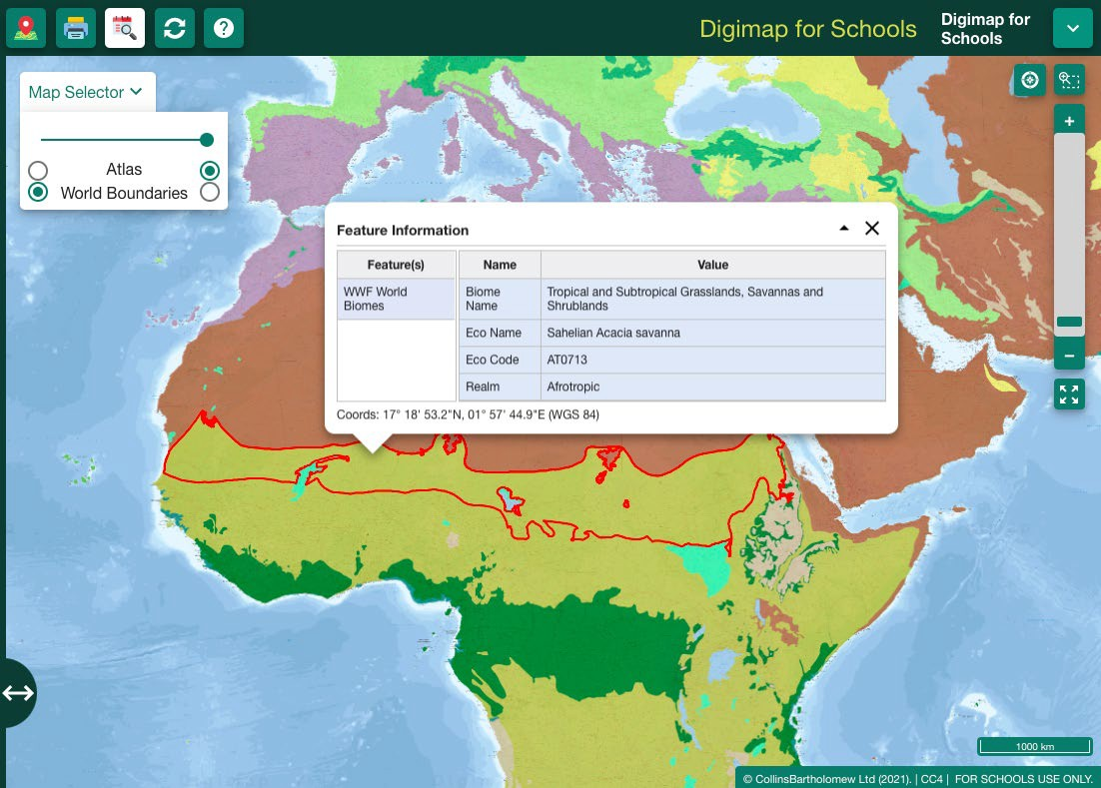This is the Sahel, or its eco name “Sahelian Acacia Savanna”.

*Alt Text: World Biomes Map over Africa. Sahelian Acacia savanna selected*

* 1. What is the size of this area vulnerable to desertification? (hint use the freehand shape tool to trace the feature and then use the ‘measure’ tool to calculate the area)

i. A= 3,053,200 Km2

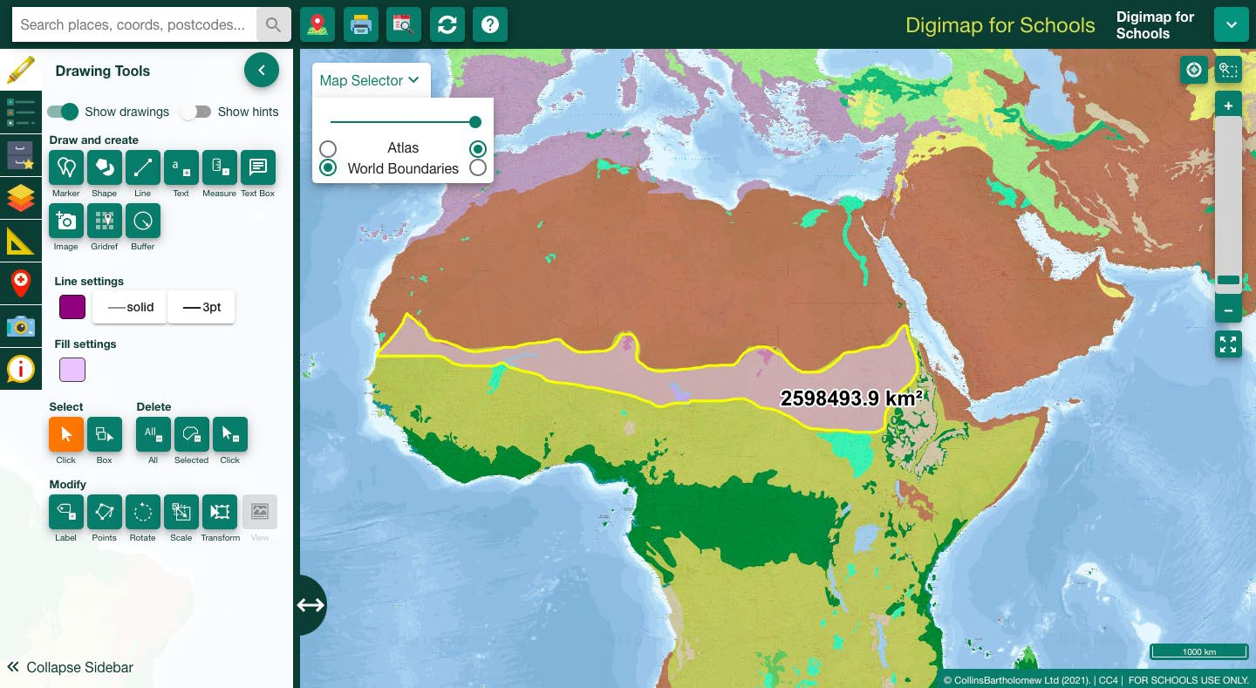

*Alt Text: World Biomes Map over Africa. Sahelian Acacia savanna selected*

Encourage Students to round up to the nearest value.

* 1. Print tool Select the “generate file for printing” tool to create a map of what you have done.

*Alt text: Print tool*

#### People in deserts

Select the population Density overlay. Use the transparency slider under World Biomes to see both maps at once.

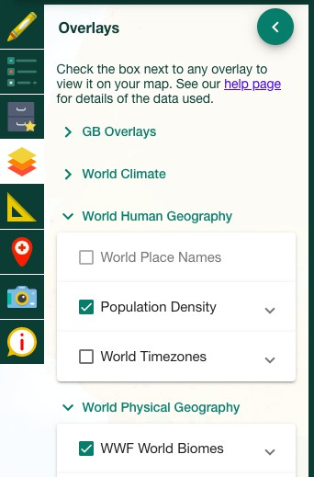

*Alt Text: Digimap for Schools toolbar. WWF world biomes and population density overlay selected.*

Learn about the people that live in the Sahel here: <https://www.bbc.co.uk/bitesize/guides/znxsgk7/revision/3>

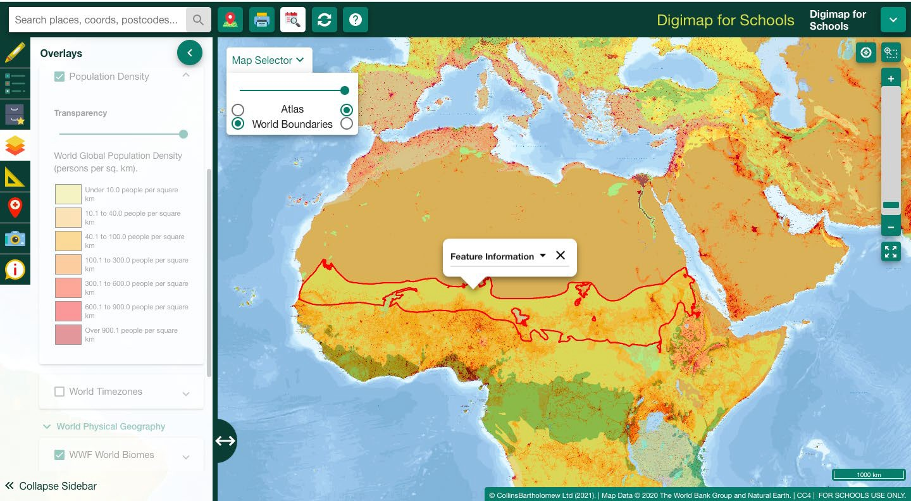

*Alt Text: World Biomes Map over Africa and the world population overlay. Sahelian Acacia savanna selected*

* 1. How do people adapt to Arid conditions? Name 3 ways.
     1. nomadic lifestyle
     2. They have herds of animals which are adapted to living in desert conditions, such as camels.
     3. tents are built to allow air to circulate within them, keeping them cool.
     4. Water is imported to Desert cities
  2. What might be the consequences of desertification on the people that live in the Sahel region?

A= 2) Desertification will eventually cause the displacement of 50 million people

## Polar Biomes

### Case Study: Tundra regions of the world

Tundra landscapes are sometimes referred to as cold deserts because the annual precipitation is less than 250mm. Learn more about these here: <https://www.bbc.co.uk/bitesize/guides/z66cvwx/revision/1>

#### People in tundra

Find a region of Tundra using the World Biomes overlay. (For example above Russia)

Now select the World population overlay. Adjust the transparency to look at Population in these areas.

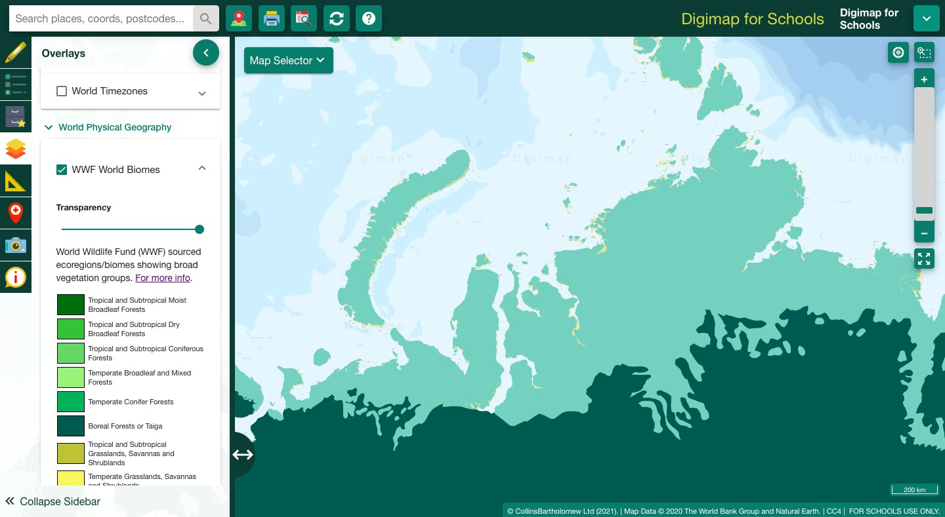

*Alt Text: World Biomes Map over Russia.*

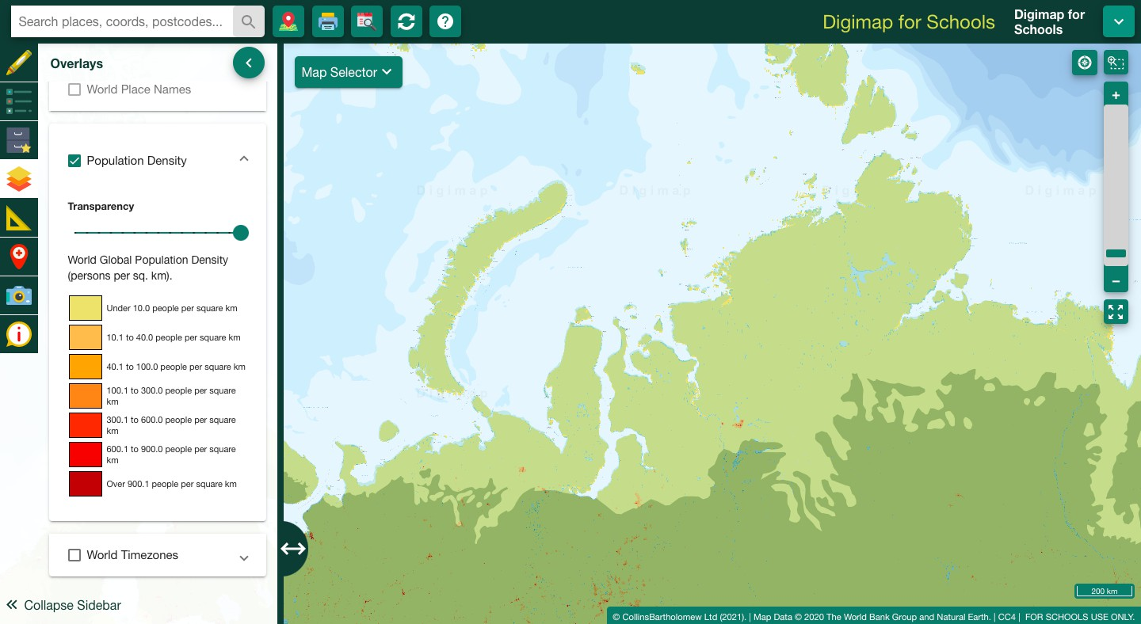

*Alt Text: World Biomes Map and population density over Russia.*

1. Can you find a settlement in the Tundra Biome region? (hint turn off both layers to read the place names on the map below)

Example Answers:

* 1. Noril’sk (Russia)
  2. Vorkuta (Russia)
  3. Novvy Urengoy (Russia)
  4. Harstad (Norway)
  5. Nuuk (Greenland)

1. Why do you think it is so sparsely populated?
   1. Humans haven’t adapted to harsh conditions
2. What conditions mean that Tundra biomes contain only a small variety of plants and animals?
   1. Frozen soils
   2. Below freezing conditions most of the year
   3. Doesn’t rain much
   4. For some weeks in winter the sun doesn’t rise
   5. Strong winds
   6. The growing season is only about 50 to 60 days long
   7. The thin soils are relatively infertile

#### Animals in tundra

While humans have not adapted to survive in very cold conditions, some animals have, learn about these here:

<https://www.bbc.co.uk/bitesize/guides/z66cvwx/revision/3>

1. How have the plants and animals in Tundra Biome adapted to these conditions? Example Answers:
   1. thick layers of fat and fur - for insulation against the cold
   2. a white appearance - as camouflage from prey on the snow and ice
   3. a small surface area to volume ratio - to minimise heat loss
   4. a greasy coat that sheds water after swimming - to help reduce heat loss
   5. large feet - to distribute their load and increase grip on the ice

### Extra Activity

If you could move anywhere in the world, where would you go?

Use the drawing tools to create a house. What biome is your new house in? How might you have to adapt to live here?

For example: a house in Australia

Students might come up with inventive answers like grow long eye lashes, hairy ears and nostrils help to keep out sand

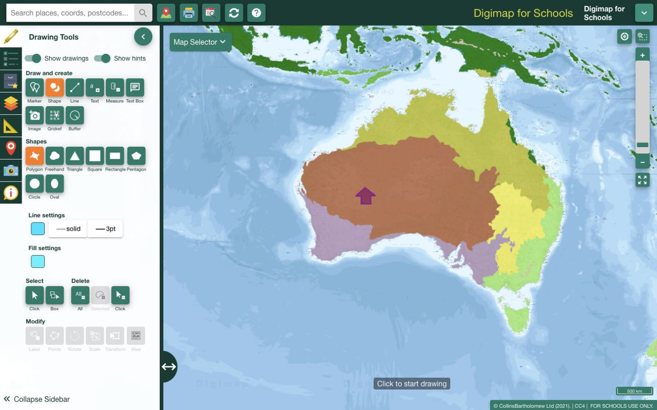

*Alt Text: World Biomes Map over Australia, a house has been drawn using shape tools.*

### BBC Bitesize quizzes

Extra activity for students that finish ahead of time.

Biomes test: <https://www.bbc.co.uk/bitesize/guides/zh2p34j/test>

Desert Test: <https://www.bbc.co.uk/bitesize/guides/znxsgk7/test>

Tundra Test: <https://www.bbc.co.uk/bitesize/guides/z66cvwx/test>

### Bibliography

BBC Bitesize (2022a). Biomes. KS3 Geography. Available at: <https://www.bbc.co.uk/bitesize/guides/zh2p34j/revision/1>

BBC Bitesize (2022b) Desert Biomes. KS3 Geography. Available at: <https://www.bbc.co.uk/bitesize/guides/znxsgk7/revision/1>

BBC Bitesize (2022c) Desertification- Desert Biomes. KS3 Geography. Available at: <https://www.bbc.co.uk/bitesize/guides/znxsgk7/revision/4>

BBC Bitesize (2022d). Tundra regions of the world. Weather and Climate. 3rd Level Geography. Available at:

<https://www.bbc.co.uk/bitesize/guides/z66cvwx/revision/1>

BBC Bitesize (2022e). Animal Adaptation to the Tundra Climate- Tundra regions of the world. Weather and Climate. 3rd Level Geography. Available at: <https://www.bbc.co.uk/bitesize/guides/z66cvwx/revision/3>

Forseth, I., (2010). Terrestrial Biomes. Nature Education Knowledge 3(10):11 NatGeo, (2022a) *Biomes*. [online] National Geographic Society. Available at:

<https://[www.nationalgeographic.org/encyclopedia/biomes/](http://www.nationalgeographic.org/encyclopedia/biomes/)> [Accessed 5 May 2022].

NatGeo, (2022b) *Ecosystem*. [online] National Geographic Society. Available at:

<https://[www.nationalgeographic.org/encyclopedia/ecosystem/](http://www.nationalgeographic.org/encyclopedia/ecosystem/)> [Accessed 5 May 2022].

Olsen et al. (2001) Bioclimatic classification scheme which was developed for the WWF Global 200 project

WWF (2012). Global 200. Available at: <https://www.worldwildlife.org/publications/global-200>

### Copyright

© EDINA at the University of Edinburgh 2022

This work is licensed under a Creative Commons Attribution-Non-Commercial-ShareAlike Licence

