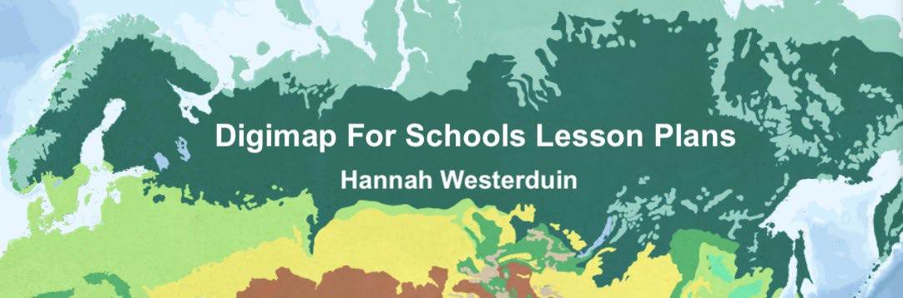

# Lesson 2 Worksheet: World Biomes

The aim of this worksheet is to explore biomes across the world through the physical geography overlay of world biomes in Digimap for Schools.

## Learning Objectives:

By the end of this worksheet students should be able to:

* Identify the climatic conditions of each Biome i.e. hot places- desert like the Sahara
* Describe the links between climate, physical features and living things in Desert Biomes
* Describe the links between climate, physical features and living things in Tundra Biomes
* Describe animal adaptations to Desert and Tundra Biomes.
* Describe human adaptations to Desert Biomes.
* Identify the impacts of human activity on Desert Biomes.
* Identify the potential consequences of desertification.

## Introduction to Biomes

Introduction to Biomes from BBC Bitesize (2021a) <https://www.bbc.co.uk/bitesize/guides/zh2p34j/revision/1>

Biomes are areas on the planet classified according to their landscape, climate, planet and animals. Biomes are generally characterised by a major habitat like a forest or a desert but can contain many different ecosystems.

Ecosystems are ‘bubbles of life’, these can be as small as a tide pool or as big as whole rainforests. Every part of an ecosystem depends on another part, e.g. animals depend on food and shelter and plants depend on climate.

Therefore, climate, landscape and soils influence what types of animals live there. Extreme environments have very harsh conditions and only plants and animals that adapt to live there can survive.

# ACTIVITY

## Hot Deserts

#### Case study: Desert biomes

Learn about these here: <https://www.bbc.co.uk/bitesize/guides/znxsgk7/revision/1>

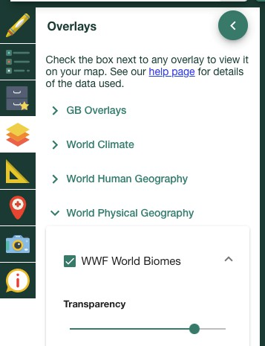Open Digimap for Schools and select the WWF World Biomes overlay.

Alt Text: Digimap for Schools toolbar. WWF world biomes overlay selected.

Locate the Sahara Desert on the map (hint: use the Get Feature Information tool).

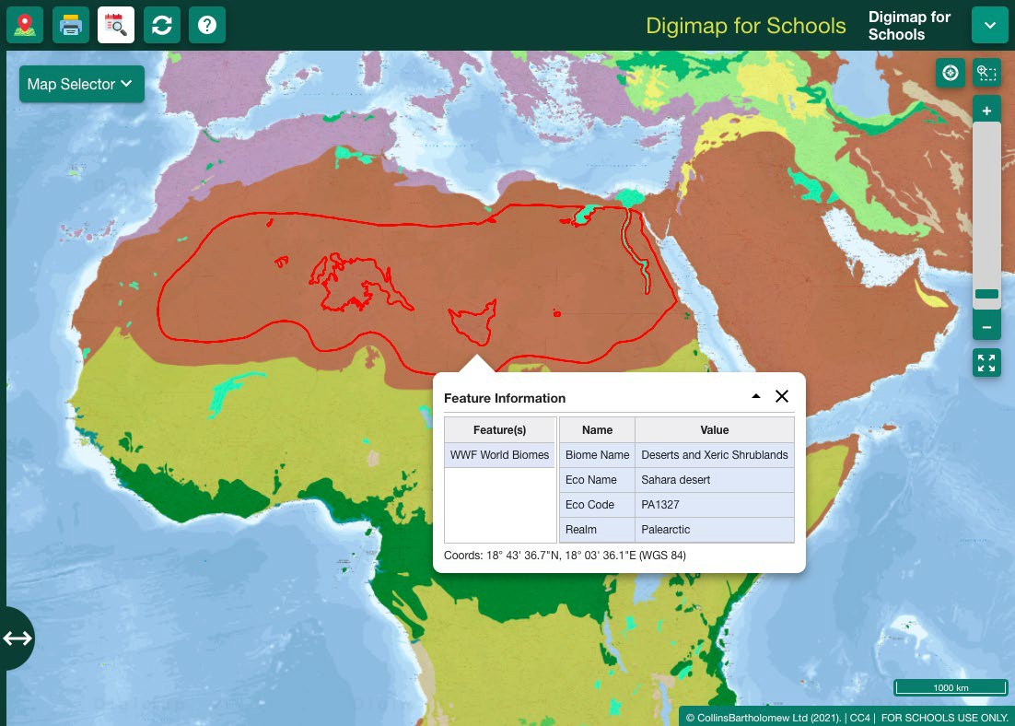

Alt Text: World Biomes Map over Africa. Sahara Desert selected

### Animals in deserts

Deserts are hot or cold areas that are very dry and receive less than 250 mm of rain each year. Only animals and plants that have adapted to these dry conditions live here.

a. List 3 plants or animals that can survive in hot desert conditions 1.

1. ​
2. ​
3. How do these animals adapt to cope with the climate and physical features in hot desert biomes?

1.

2.

3.

### Desertification

When productive land turns to non-productive desert, this process is called desertification. Watch the video on the page: <https://www.bbc.co.uk/bitesize/guides/znxsgk7/revision/4>

1. What are the three main ways that humans have contributed to desertification?

1.

2.

3.

The areas surrounding deserts are vulnerable to desertification; click on the strip of land directly below the ‘Sahara Desert’ and the ‘South Saharan steppe and woodlands’.

This is the Sahel, or its eco name “Sahelian Acacia Savanna” (see image below).

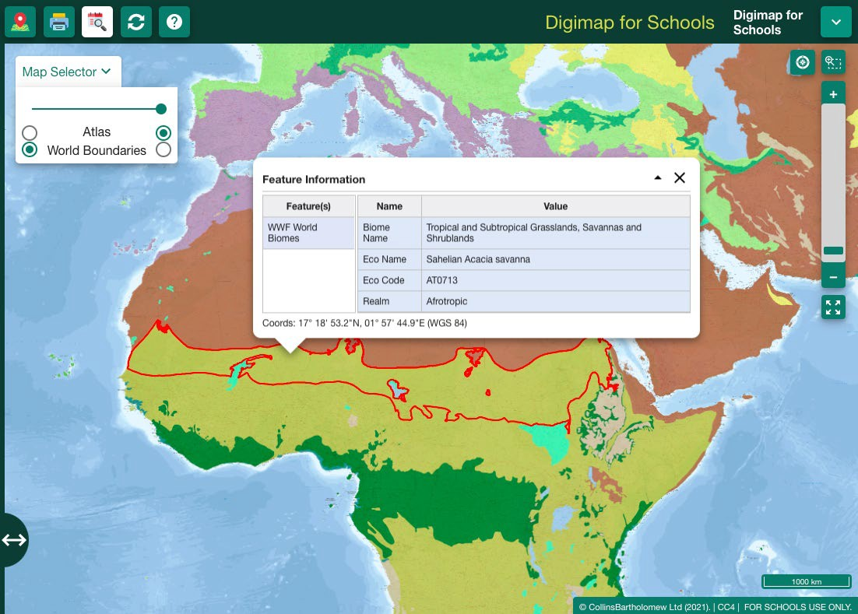

Alt Text: World Biomes Map over Africa. Sahelian Acacia savanna selected

1. What is the size of this area vulnerable to desertification? (hint use the freehand shape tool to create a polygon covering the rough size of the Sahel and then use the ‘measure’ tool to calculate the area) Choose the value closest to your area:
   1. 60,020 Km2
   2. 587,040 Km2
   3. 3,053,200 Km2
2. Select the “generate file for printing” tool to create a map of what you have done, select add legend. Save this map.

Print tool 

Alt text: Print tool

### People in deserts

Select the population density overlay, under the ‘World Human Geography’ category. Use the transparency slider under World Biomes to see both maps at once.

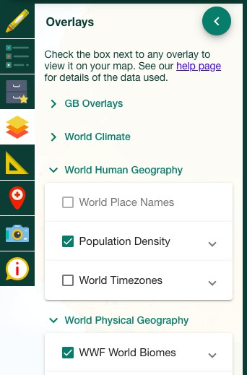

Alt Text: Digimap for Schools toolbar. WWF world biomes and population density overlay selected.

Learn about the people that live in the Sahel here: <https://www.bbc.co.uk/bitesize/guides/znxsgk7/revision/3>

1. How do people adapt to Arid conditions? Name 3 ways. 1.

2.

3.

1. What might be the consequences of desertification on the people that live in the Sahel region? Choose one:
   1. Desertification will not affect many people because not very many people live in the Sahel
   2. Desertification will eventually cause the displacement of 50 million people
   3. There aren’t any cities and all the people who live there

are Nomadic so they can just move on to somewhere else.

## 2. Tundra Biomes

### Case Study: Tundra regions of the world

Tundra landscapes are sometimes referred to as cold deserts because the annual precipitation is less than 250mm. Learn more about these here: <https://www.bbc.co.uk/bitesize/guides/z66cvwx/revision/1>

### People in tundra

Find a region of Tundra using the World Biomes overlay. (For example in North Russia). Now select the World population overlay. Adjust the transparency to look at Population in these areas.

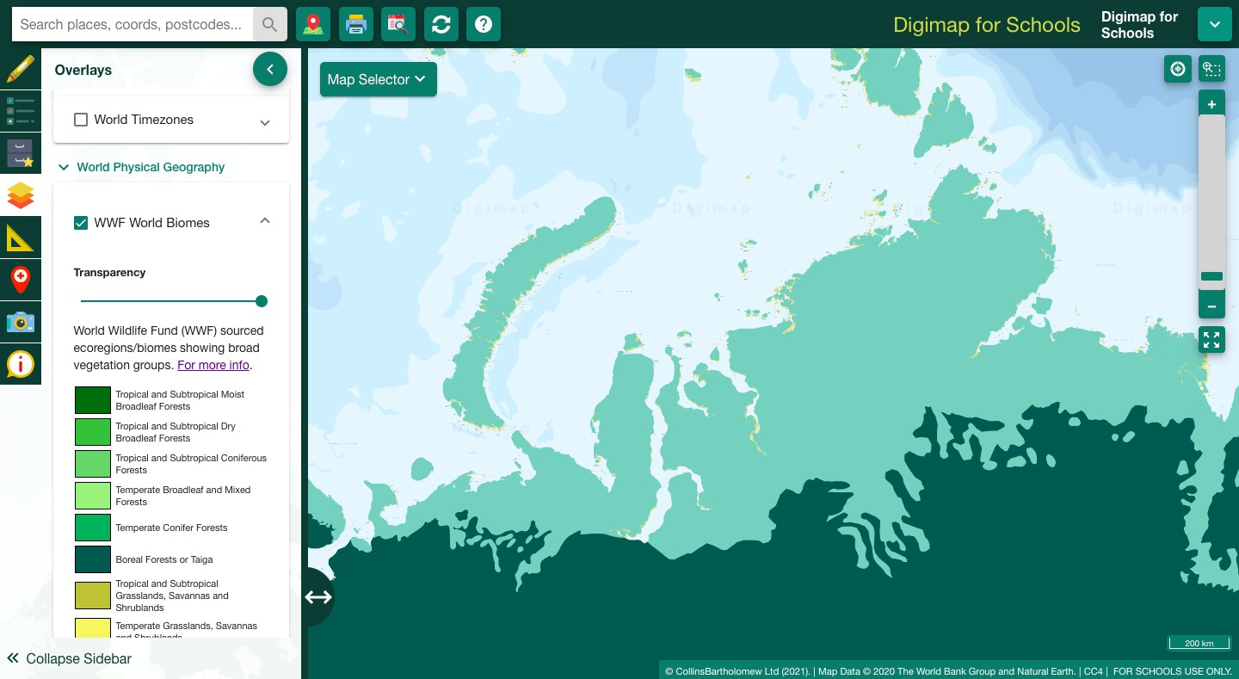

Alt Text: World Biomes Map over Russia.

1. Can you find a settlement in the Tundra Biome region? (hint: once you have located a high population within a Tundra region, turn off both layers to read the place names on the map below) Name one place.

1.

1. Why do you think it is so sparsely populated? 1.
2. What conditions mean that Tundra biomes contain only a small variety of plants and animals? Name 3 conditions.

1.

2.

3.

### Animals in Tundra

While humans have not adapted to survive in very cold conditions, some animals have, learn about these here: <https://www.bbc.co.uk/bitesize/guides/z66cvwx/revision/3>

1. How have the plants and animals in Tundra Biome adapted to these conditions? Name 3 ways.

1.

2.

3.

## Extra Activity

If you could move anywhere in the world, where would you go?

Use the drawing tools to create a house (a square and triangle will do). What biome is your new house in? How might you have to adapt to live here?

Save your map when you are finished.

## BBC Bitesize quizzes

#### If you finish, have a go at these:

Biomes test: <https://www.bbc.co.uk/bitesize/guides/zh2p34j/test>

Desert Test: <https://www.bbc.co.uk/bitesize/guides/znxsgk7/test>

Tundra Test: <https://www.bbc.co.uk/bitesize/guides/z66cvwx/test>