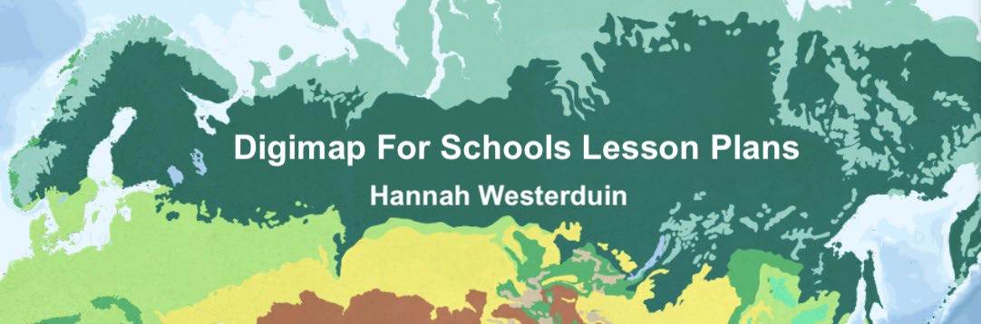

Lesson 3 Worksheet:

## Climate change, World temperature, Precipitation and Population

The aim of this worksheet is to explore climate change through the Digimap for Schools world climate overlays of temperature and precipitation and the world human geography overlay of population density.

# Learning Objectives:

* Describe a natural environment different to their own, in terms of climate, physical features and living things.
* Identify the possible consequences of Climate change.
* Use climate overlays to explore changes in temperature and precipitation
* Identifies strategies to slow or reverse the impact of climate change.
* Can make links between climatic changes and increases in migration

# ACTIVITY

1. **Cairo case study**

## Temperature

* 1. Open Digimap for Schools.
  2. Find Cairo, at the estuary of the Nile. Select the world climate overlays 1970-2000 and 2010-2018.

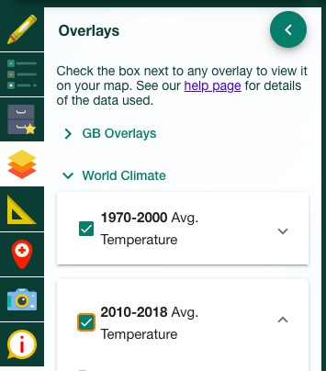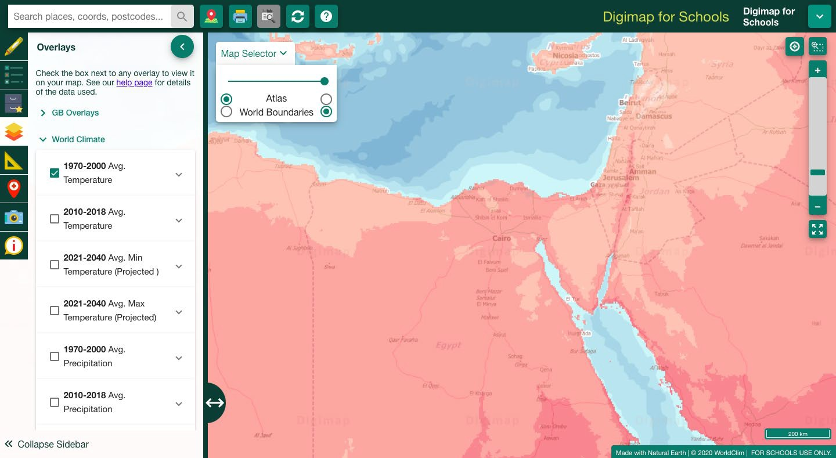

* + 1. What was the average temperature in Cairo from 1970 to 2000? (hint: use the map key to help you identify temperature gradients.)
    2. What was the average temperature in Cairo from 2010 to 2018?
    3. What is the change in temperature in the last 50 years?

## Population

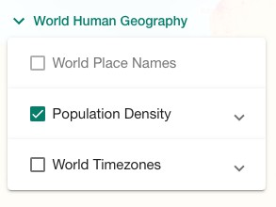Select the world population overlay.

1. How many people per square km live in Cairo?
   1. 40.1 to 100.0 people per square km
   2. 300.1 to 600.0 people per square km
   3. Over 900.1 people per square km
2. What kind of settlement pattern does the population in this area follow?

Refer to <https://www.3dgeography.co.uk/settlement-patterns> from Lesson 1.

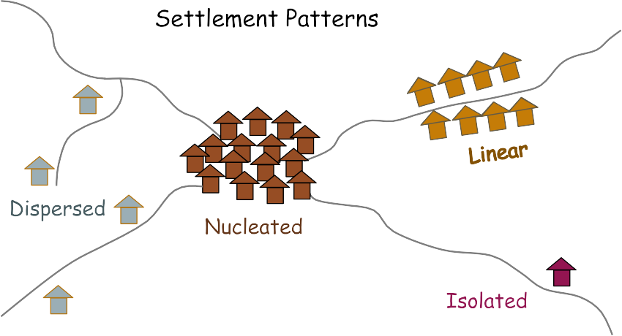

Settlement patterns created by the Author Hannah Westerduin

1. What might be the effects of climate change on Cairo? 1.
2. ​
3. ​
4. How might these effects be managed?

1.

2.

3.

# Mumbai case study

Find Mumbai, on the West coast of India on the map. Switch between the Atlas and World Boundaries map selector in the top left corner to see place names.

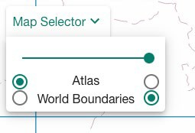

Try using the latitude and longitude lines to help you find Bangladesh, it sits at 19° N and 73° E.

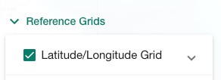

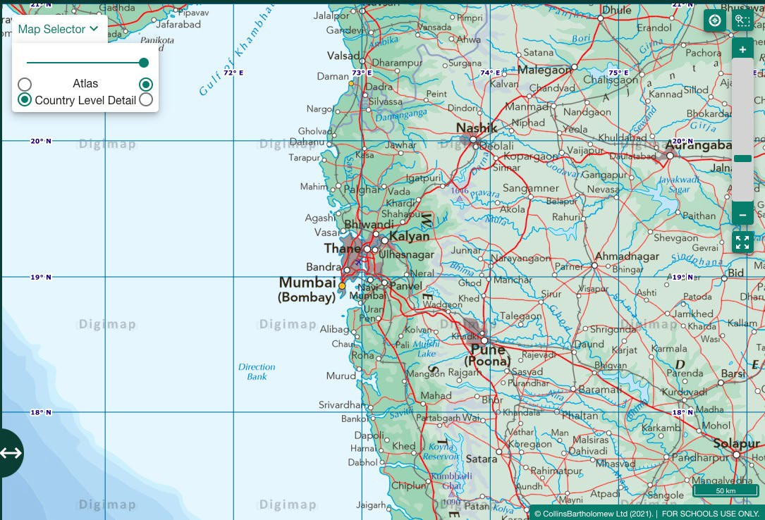

## Temperature

Select the world climate overlays 1970- 2000 and Avg. max 2021-2040.

* 1. How is the temperature predicted to change between 1970-2000 and 2021-2040?
     1. Rise from 15°C to 20°C to 25°C to 30°C
     2. Drop from 25°C to 30°C to 15°C to 20°C
     3. Rise from 25°C to 30°C to Over 30°C

## Population

Select the Population density overlay.

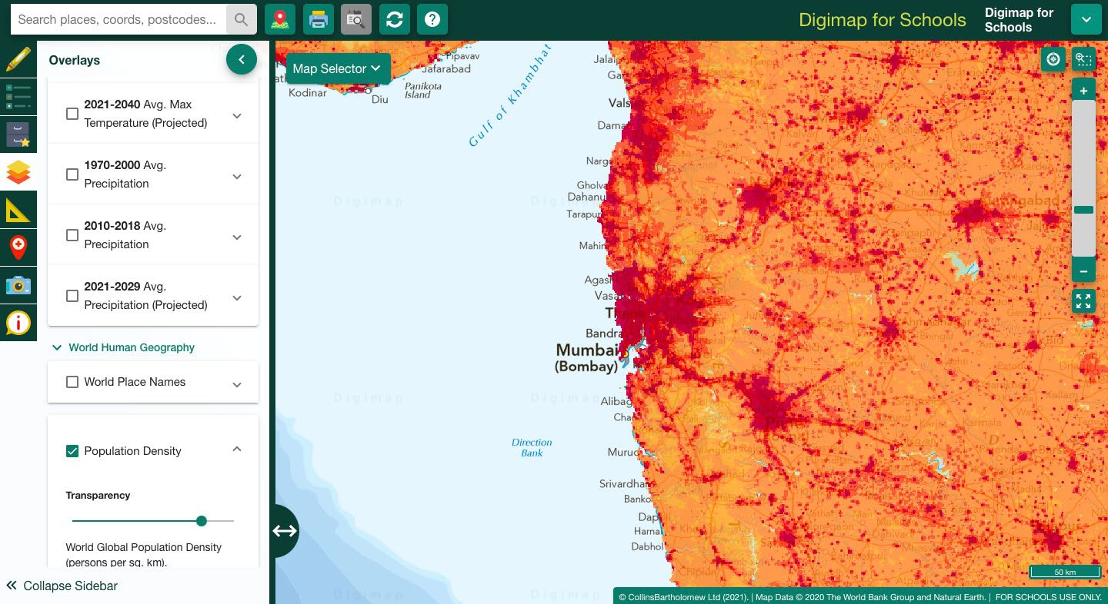

* 1. How many people will be affected by the change in temperature? Use the freehand shape tool to draw around Mumbai and the surrounding areas where population = 900.1 people per square km and then use the measure tool to calculate the area of your shape. (hint: Population x Area in km2)

1. ​
   1. Select the “generate file for printing” tool to create a map of what you have done. Save this map.

Print tool 

* 1. How might we slow or reverse the impact of climate change? Propose 3 strategies:

1.

2.

3.

## Precipitation

Mumbai has seasons of very heavy rain called monsoons.

* 1. What months of the year do these occur?
     1. December to March
     2. June to September
     3. October to January

Look at changes in precipitation- Select the Avg precipitation overlays.

* 1. Look at the precipitation overlays in 1970-2000 and 2010-2018. Does precipitation in the wider area:
     1. Stay the same
     2. Increase
     3. Decrease

ii. Describe the potential impacts of the change in precipitation. 1.

1. Compare rainfall in Mumbai to rainfall in the UK.
   1. What is the average rainfall where you live?

# Extra activity

Choose somewhere to build a new house (hint use the drawing tools to add a square and triangle to the map). Then have a look at the future precipitation and temperature overlays, can you see any changes? What might happen to your house in the future?

# BBC Bitesize Quizzes

If you finish have a go at these quizzes:

Weather and Climate <https://www.bbc.co.uk/bitesize/guides/zghrydm/test>

Climate change (scroll down to the quiz) <https://www.bbc.co.uk/bitesize/topics/zx38q6f/articles/z773ydm#zgck96f13>

Population and migration <https://www.bbc.co.uk/bitesize/guides/zkg82hv/test>