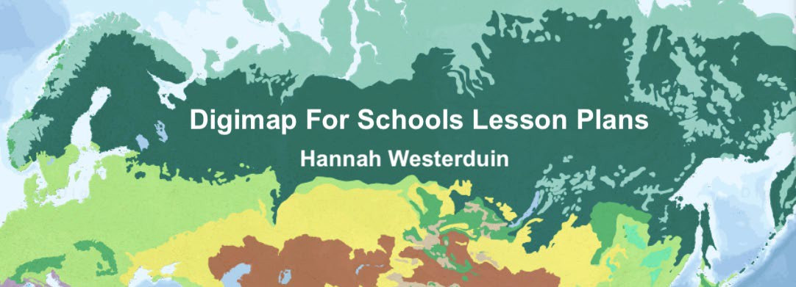



**LESSON PLAN 3**

# Climate Change: World temperature, precipitation, and population

**Teacher Guide**

**Geography Teaching Resource** **Secondary Ages 11-14 KS3 and Level 3/4**

**Climate Change- World Temperature, Precipitation, and Population**

**Teacher Guide**

The aim of this resource is to explore Climate Change through the World Climate Overlays of Temperature and Precipitation and the World Human Geography overlay of Population Density. There is a corresponding worksheet for distribution to students that supplements this lesson plan. Note: This resource is estimated to take 2+ lessons of 45 minutes to complete.

## Table of Contents

Climate Change- World Temperature, Precipitation, and Population 2

Table of Contents 2

Learning Objectives 3

Curriculum for Excellence Links 3

Introduction to Weather and Climate 4

Human Niche 4

Climate change 4

Climate refugees 4

ACTIVITY 5

1. Cairo case study 5

Temperature 5

Population 6

1. Mumbai case study 7

Temperature 8

Population 9

Precipitation 11

Extra activity 12

BBC Bitesize quizzes 12

Bibliography 13

Copyright 13

### Learning Objectives:

By the end of this worksheet students should be able to:

* Describe a natural environment different to their own, in terms of climate, physical features and living things.
* Identify the possible consequences of Climate change.
* Use climate overlays to explore changes in temperature and precipitation.
* Identifies strategies to slow or reverse the impact of climate change.
* Can make links between climatic changes and increases in migration.

|  |  |  |
| --- | --- | --- |
| **Level** | **Context** | **Location** |
| Secondary KS3  CfE Level 3  and Level 4 | Climate change and Hazards- World temperature, precipitation and population | Global with Case studies:   * Cairo * Mumbai |

### Curriculum for Excellence Links

|  |  |  |
| --- | --- | --- |
| **Es and Os** | **Experiences and Outcomes for planning learning, teaching and assessment** | **Benchmarks to support practitioners’ professional judgement of achievement of a level** |
| SOC 3-08a | I can identify the possible consequences of an environmental issue and make informed suggestions about ways to manage the impact. | * Provides a simple explanation of at least three consequences of an environmental issue, and for each suggest how they could be managed. |
| SOC 4-12a | I can identify threats facing the main climate zones,  including climate change, and analyse how these  threats impact on the way of life. | * Identifies at least three threats facing main climate zones and analyses how these threats impact on the way of life. |
| SOC 4-12b | I can carry out a geographical enquiry to assess  the impact and possible outcomes of climate change  on a selected region and can propose strategies  to slow or reverse the impact. | * Suggests the impact and possible outcomes of climate change on a chosen region and proposes reasoned strategies to slow or reverse the impact. |

## Introduction to Weather and Climate

**Weather** describes the daily condition of our atmosphere; it can be measured through temperature and precipitation. Long term trends in weather and weather conditions over large areas are known as **climate.** Climate is what is expected to happen rather than the actual weather conditions and sometimes the weather is completely different! To work out the climate you find the average weather conditions in a location over 30 years (BBC Bitesize 2022a).

Find out more about Weather and Climate here: <https://www.bbc.co.uk/bitesize/guides/zghrydm/revision/1>

### Human Niche

The climate varies a lot across the world, in some places the climate is too harsh for humans to live. Where humans do live is known as the **human niche.** For the last 6000 years, humans have been living in the same places, however climate change is now threatening to alter which areas will be habitable in the future.

### Climate change

Changes in the Earth’s average temperature is known as **climate change**. While changes in climate have happen naturally in the past, scientists now think that human actions creating greenhouse gases are causing the climate to change faster than before (BBC Bitesize, 2022b).

These rapid changes are disrupting weather systems, leading to warmer temperatures and heavier rainfall in some areas. This has the potential to create hazard events, such as heatwaves or flooding as sea levels rise. It may also change the distribution of the Earth’s climate belts, which would alter growing seasons and make it difficult for some countries to grow food (BBC Bitesize, 2022b). Developing countries in the Global South are predicted to experience the most severe changes to climate.

### Climate refugees

As the human niche changes, this will lead to migration from areas where temperatures rise beyond habitable conditions, these people are known as “climate refugees”. People moving from a permanent home in one place to another are known as **migrants (**BBC Bitesize, 2022c). <https://www.bbc.co.uk/bitesize/guides/zkg82hv/revision/5>

# ACTIVITY

## Cairo case study

### Temperature

Open Digimap for Schools

Find Cairo, select the world climate overlays 1970-2000 and 2010-2018

* 1. What was the average temperature here from 1970 to 2000?

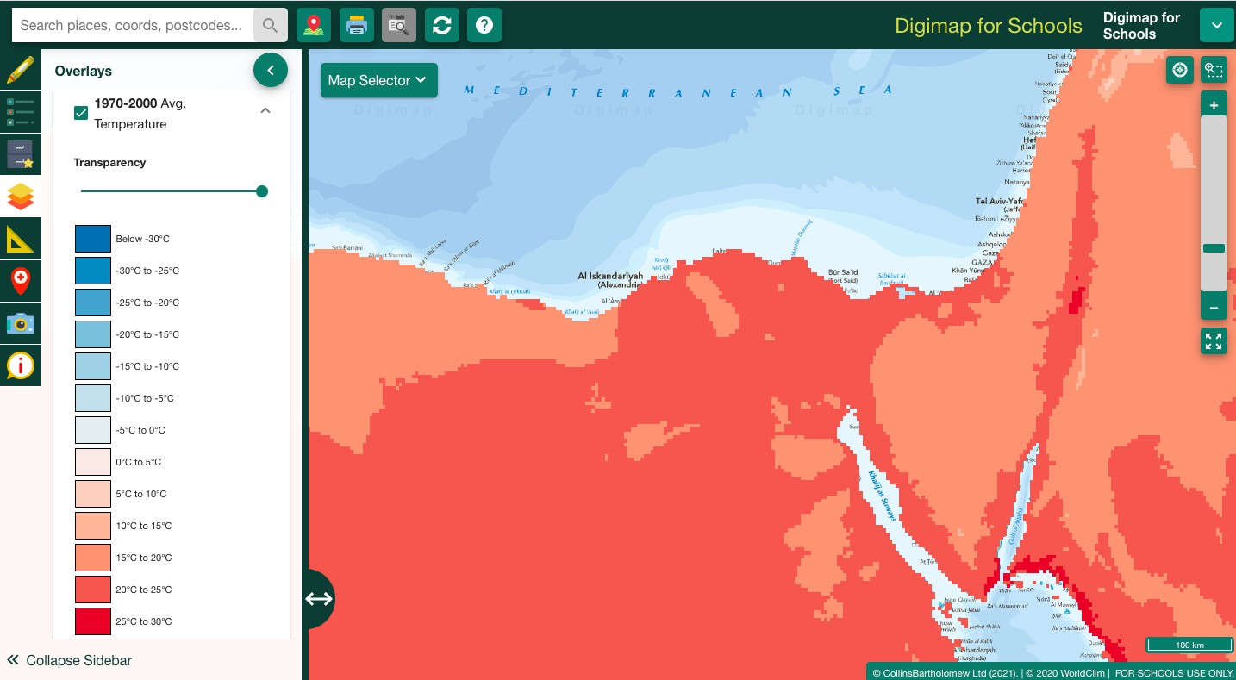A= 15°C to 25°C

* 1. What was the average temperature in Cairo from 2010 to 2018? A= 20°C to 30°C

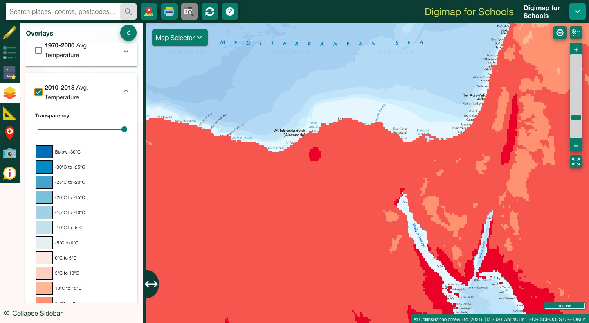

* 1. What is the change in temperature in the last 50 years? Between 5°C and 15°C

### Population

Select the world population overlay

* 1. How many people per square km live in Cairo? A= Over 900.1 people per square km

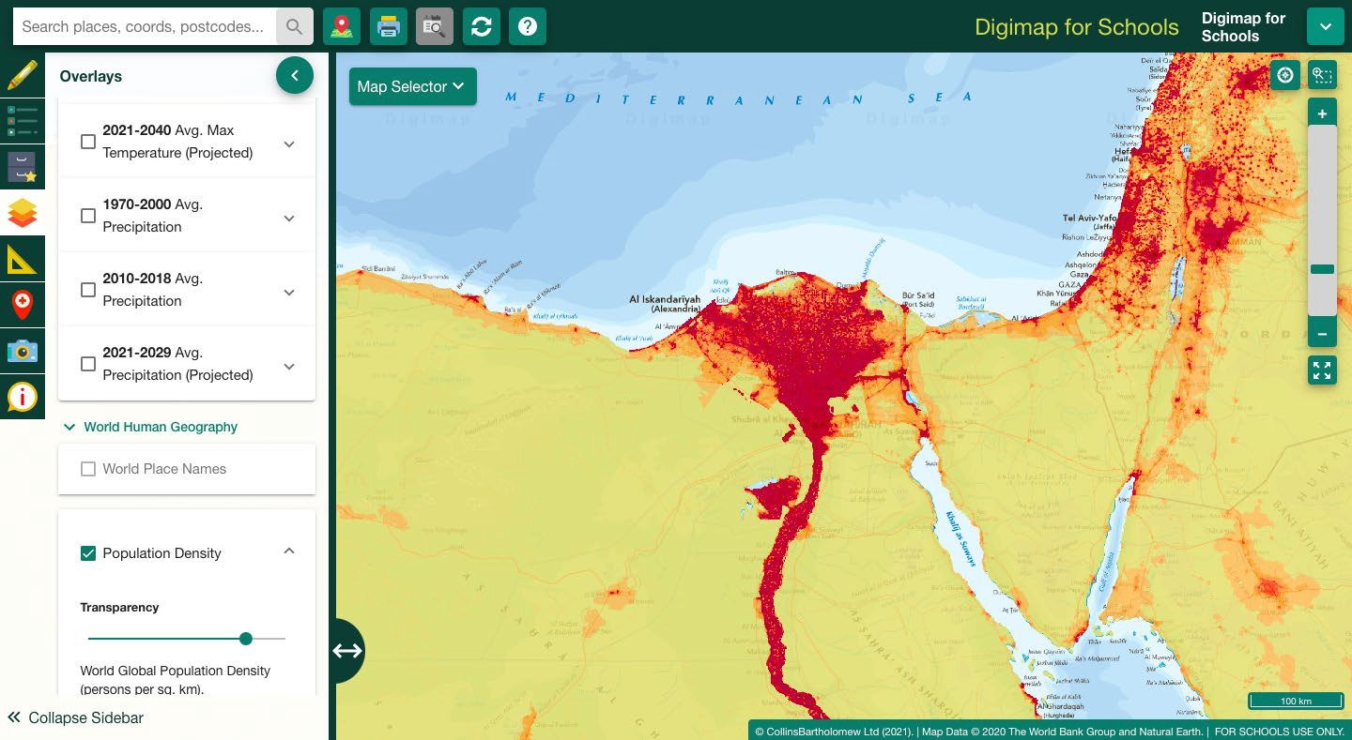

* 1. What kind of settlement pattern does the population in this area follow? Refer to <https://www.3dgeography.co.uk/settlement-patterns> from Lesson 1.

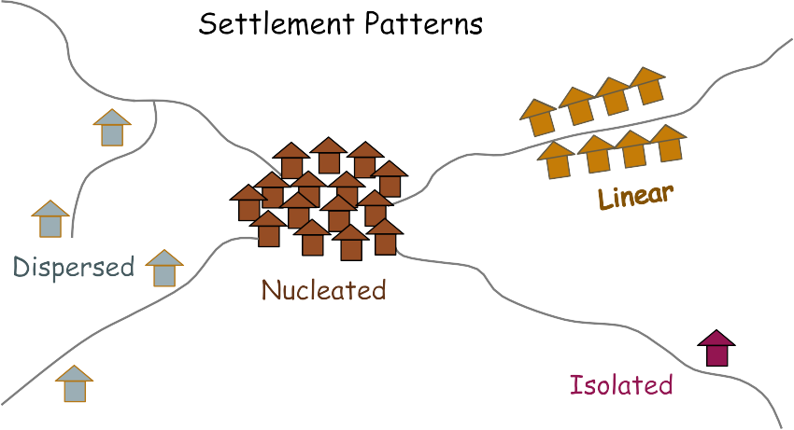

*Settlement patterns diagram created by the Author Hannah Westerduin*

A= Linear along the Nile, nucleated in Cairo?

* 1. What might be the effects of climate change on Cairo?

A= too warm for habitation, flooding from sea level rise, salinization of productive croplands, loss of homes and infrastructure, large numbers of climate refugees.

* 1. How might the effects of climate change be managed?

## Mumbai case study

Find Mumbai, on the West coast of India on the map. Switch between the Atlas and World Boundaries map selector in the top left corner to see place names.

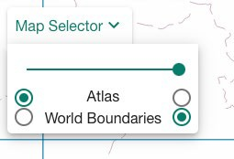

Try using the latitude and longitude lines to help you find Bangladesh, it sits at 19° N and 73° E.

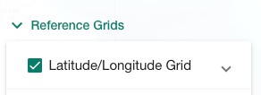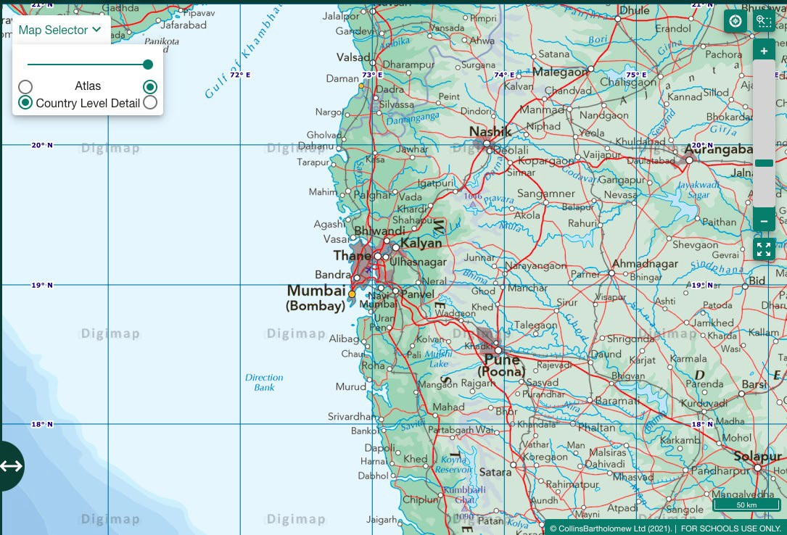

### Temperature

Select the world climate overlays 1970- 2000 and Avg. max 2021-2040

* 1. How is the temperature predicted to change between 1970-2000 and 2021- 2040?

A= rise from 25°C to 30°C to Over 30°C

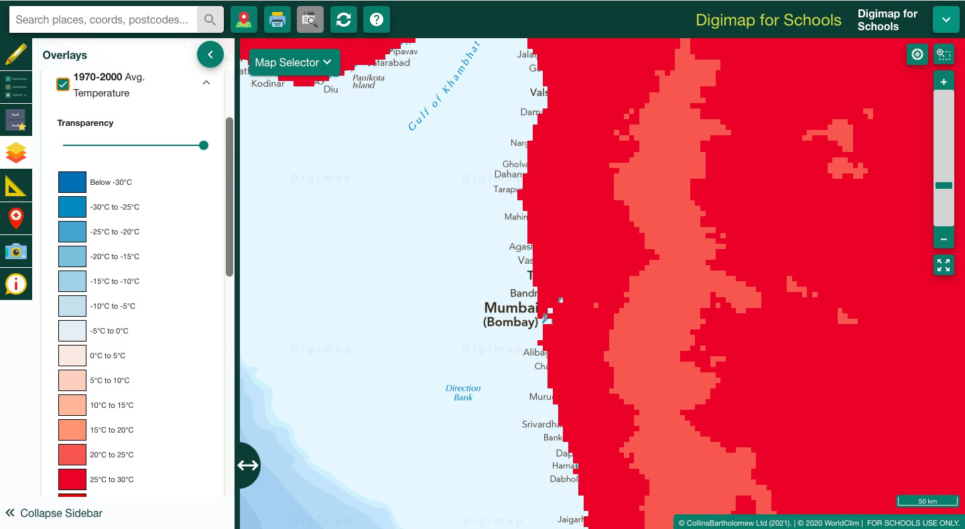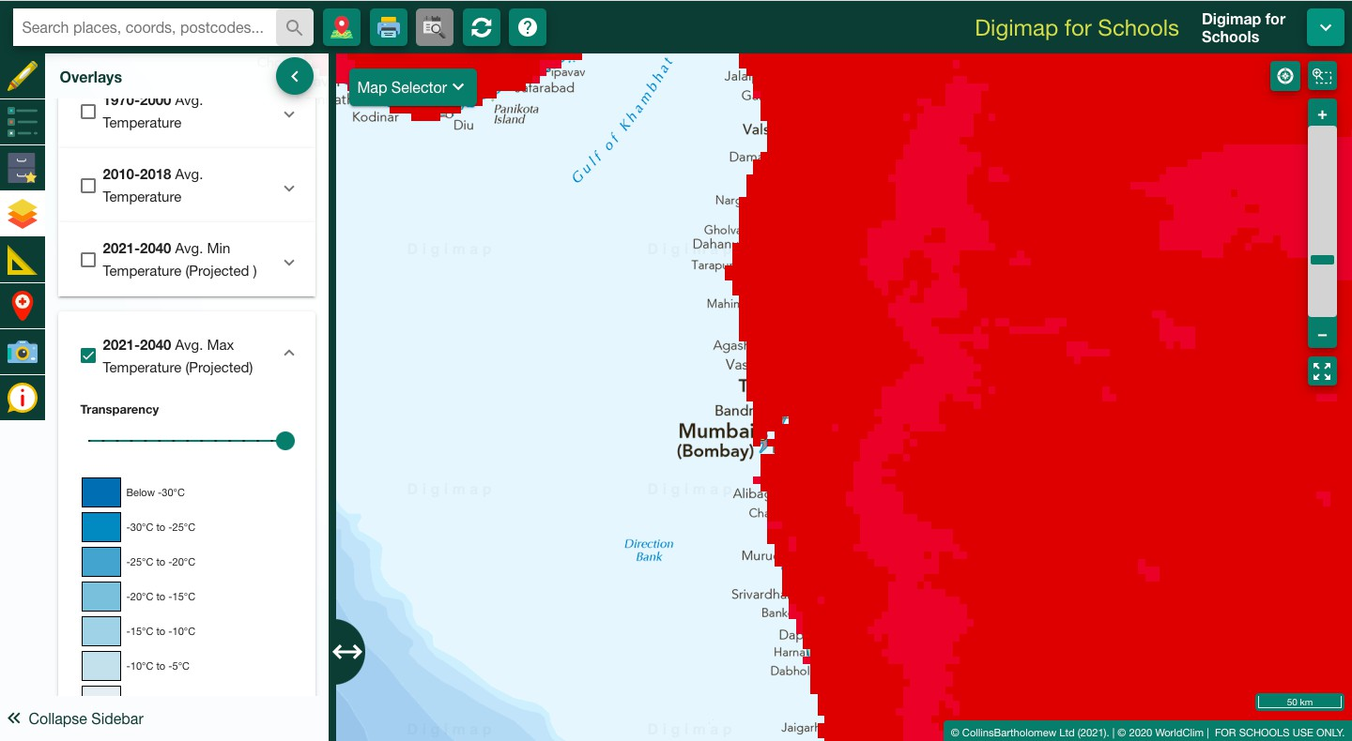

### Population

Select the Population density overlay.

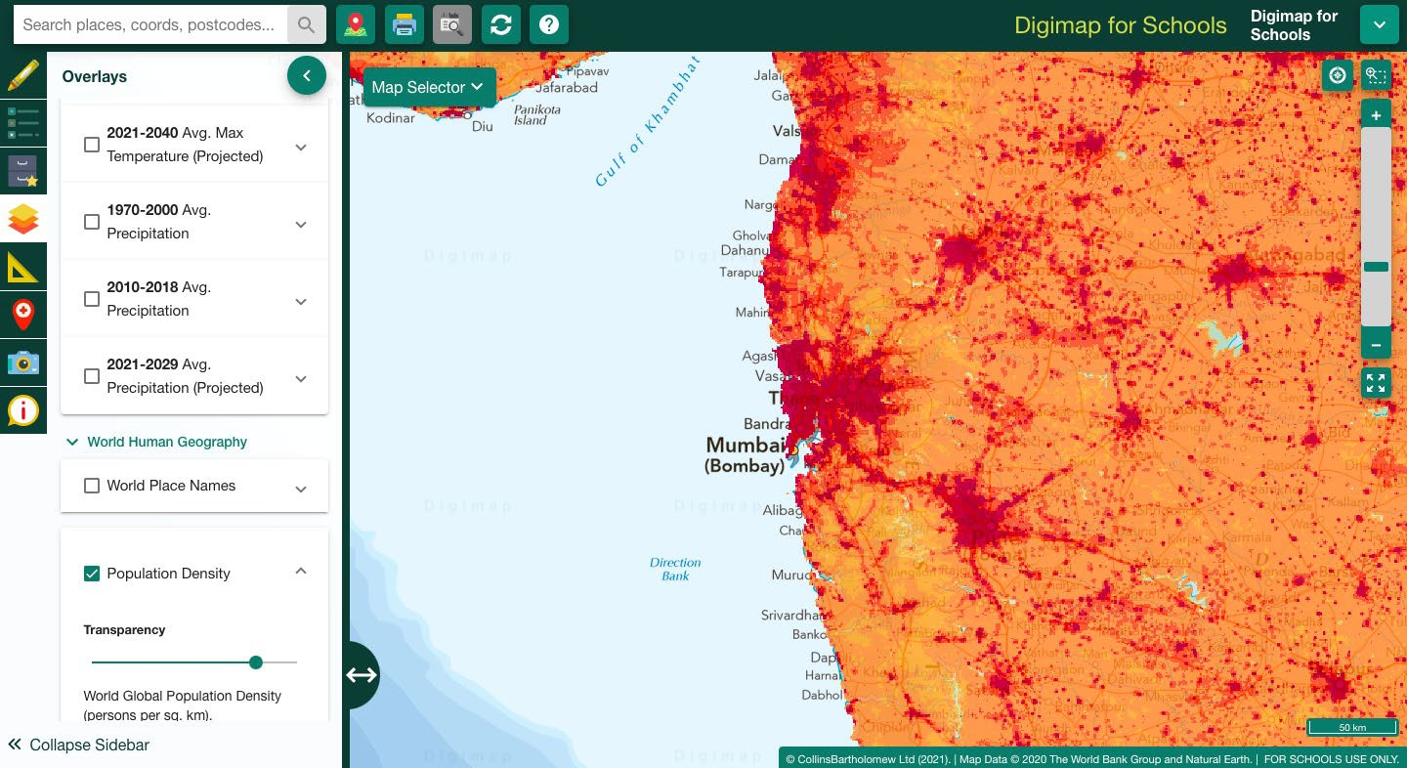

* 1. How many people will be affected by the change in temperature? Use the freehand shape tool to draw around Mumbai and the surrounding areas where population = 900.1 people per square km and then use the measure tool to calculate the area of your shape. (hint population x area in km2)

A= 900.1 people per square km x area A= 900.1 x 2941.5km2

A= 2647644.15 people?

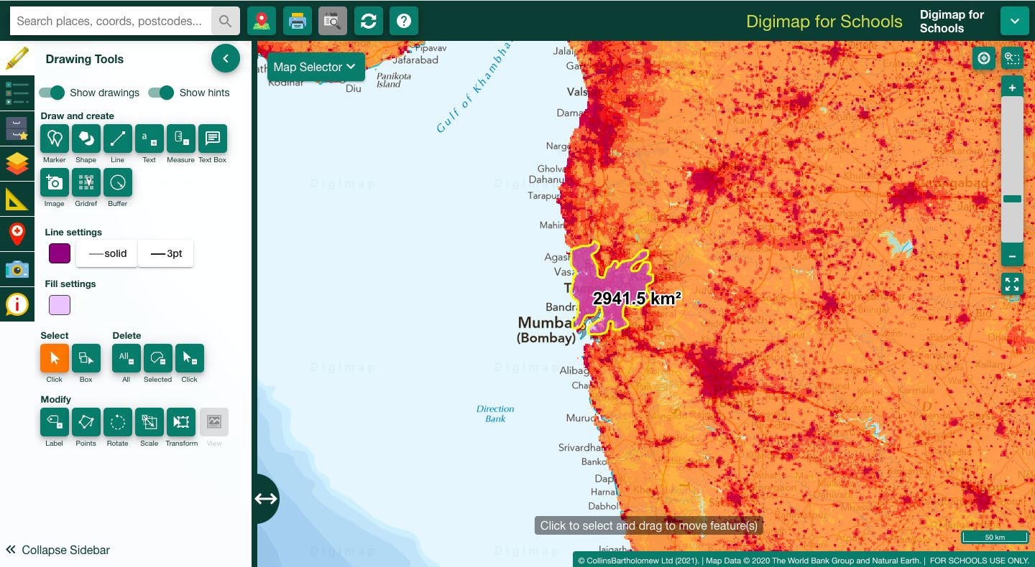

* 1. Print tool Select the “generate file for printing” tool to create a map of what you have done.
  2. How might we slow or reverse the impact of climate change? Propose 3 reasoned strategies.

### Precipitation

Mumbai has seasons of very heavy rain called monsoons.

* 1. What months of the year do these occur?
     1. June to September.

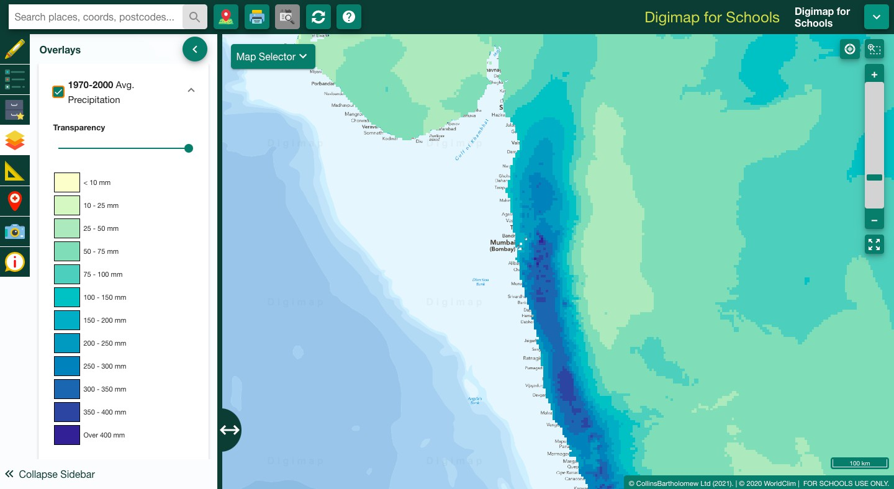Look at changes in precipitation- Select the Avg. precipitation overlays.

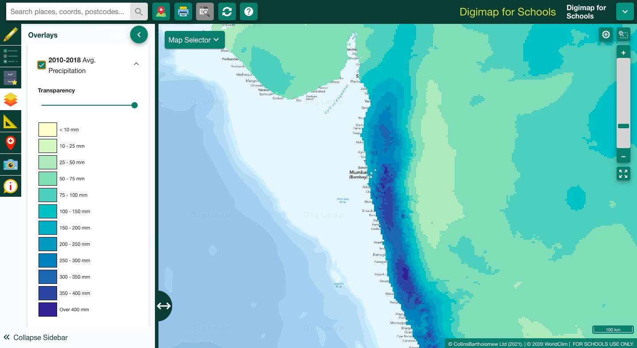

* 1. Look at the precipitation overlays in 1970-2000 and 2010-2018. Does precipitation in the wider area:

A= 2) Increase

* + 1. Describe the potential impacts of the change in precipitation.
       1. Increase in flooding
       2. migration
       3. Compare rainfall in Mumbai to rainfall in the UK.
          1. What is the average rainfall where you live?

## Extra activity

Choose somewhere to build a new house (hint use the drawing tools to add a square and triangle to the map). Then have a look at the future precipitation and temperature overlays, can you see any changes? What might happen to your house in the future?

## BBC Bitesize quizzes

Extra activity for students that finish ahead of time.

Weather and Climate <https://www.bbc.co.uk/bitesize/guides/zghrydm/test>

Climate change (scroll down to the quiz) <https://www.bbc.co.uk/bitesize/topics/zx38q6f/articles/z773ydm#zgck96f13>

Population and migration <https://www.bbc.co.uk/bitesize/guides/zkg82hv/test>

## Bibliography

BBC Bitesize (2022a). Weather and Climate. 3rd Level Geography Curriculum for Excellence. Available at:

<https://www.bbc.co.uk/bitesize/guides/zghrydm/revision/1>

BBC Bitesize (2022b). Climate Change. KS3 Geography. Available at: <https://www.bbc.co.uk/bitesize/topics/zx38q6f/articles/z773ydm>

BBC Bitesize (2022c) Causes and effects of Migration - Population and Migration. KS3 Geography. Available at: <https://www.bbc.co.uk/bitesize/guides/zkg82hv/revision/5>

BBC Bitesize (2022d). What is weather and climate? Test questions- 3rd Level Geography Curriculum for Excellence. Available at: <https://www.bbc.co.uk/bitesize/guides/zghrydm/test>

BBC Bitesize (2022d). Population and migration test questions- 3rd Level Geography Curriculum for Excellence. Available at: <https://www.bbc.co.uk/bitesize/guides/zkg82hv/test>

3D Geography (2021) Settlement Patterns. Available at: <https://www.3dgeography.co.uk/settlement-patterns>

## Copyright

© EDINA at the University of Edinburgh 2022

This work is licensed under a Creative Commons Attribution-NonCommercial-ShareAlike Licence.

