**How to?**

**One page cards for using Digimap for Schools with students**

Jo Skinner and Laura Woods

Geography Teaching Resource

7-11 years

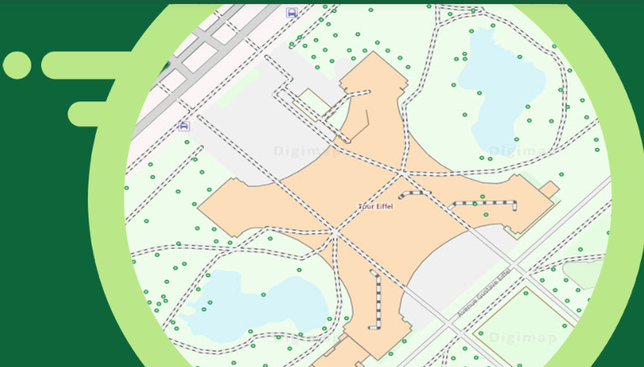

Figure 1: https://digimapforschools.edina.ac.uk/about/

Contents

How do I access Digimap? 3

How do I find my house? 4

How do I plan my route to school? 5

How do I add my own key? 6

How do I find the grid reference? 7

How do I create a polygon? 8

How do I measure a route? 9

How do I find the grid reference? 10

How do I import an image? 11

Copyright 12

Acknowledgements 12

# How do I access Digimap?

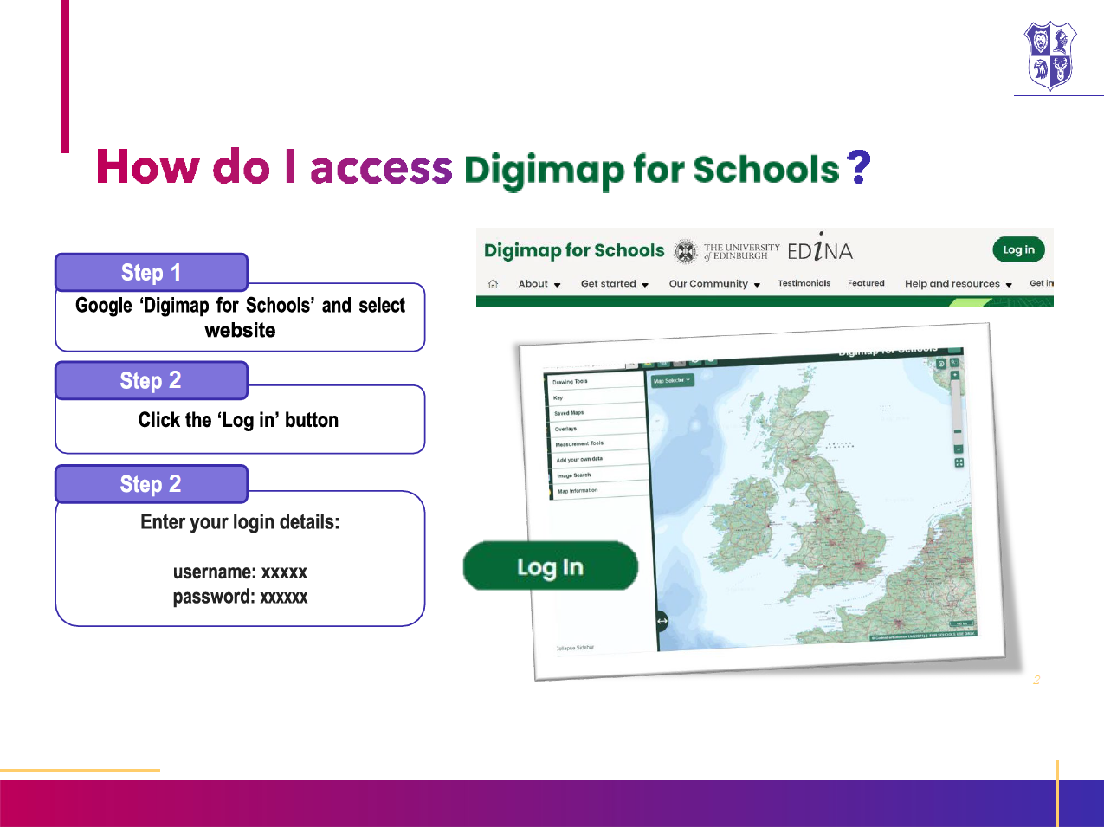

# How do I find my house?

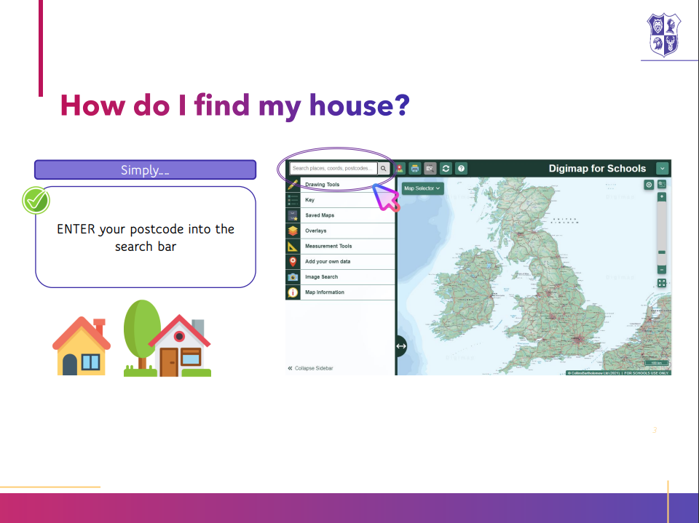

# How do I plan my route to school?

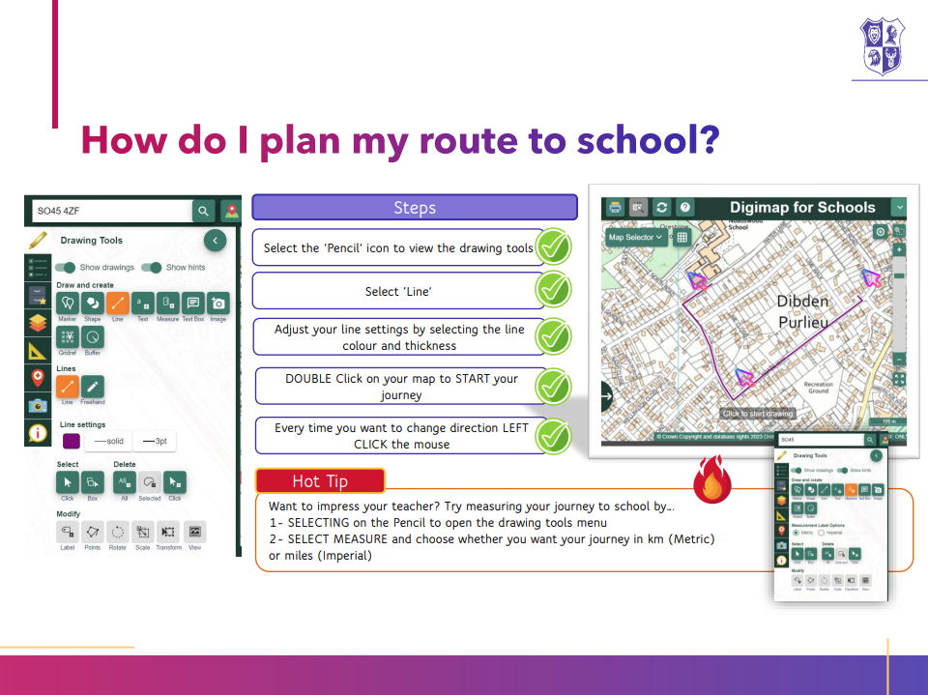

# How do I add my own key?

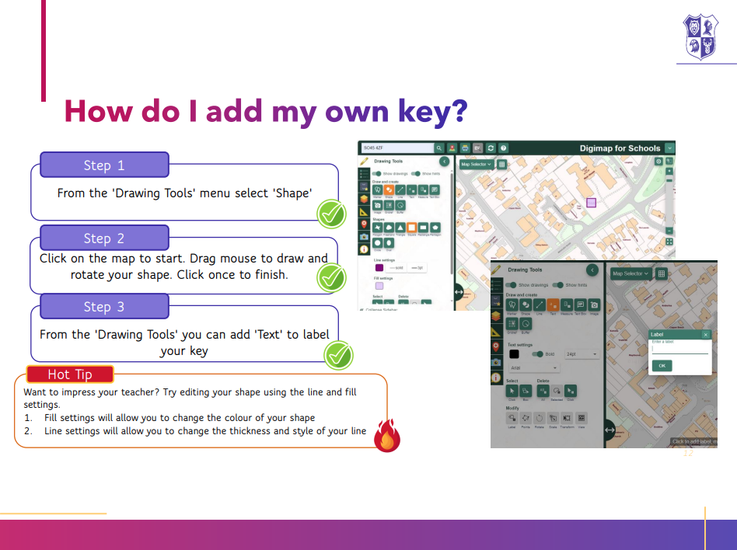

# How do I find the grid reference?

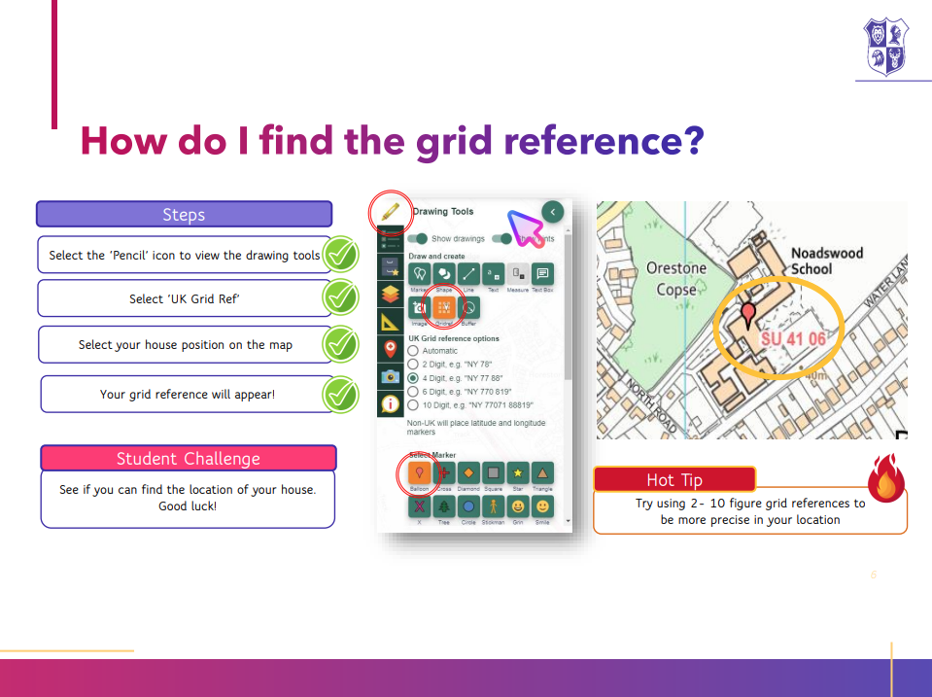

# 

# How do I create a polygon?

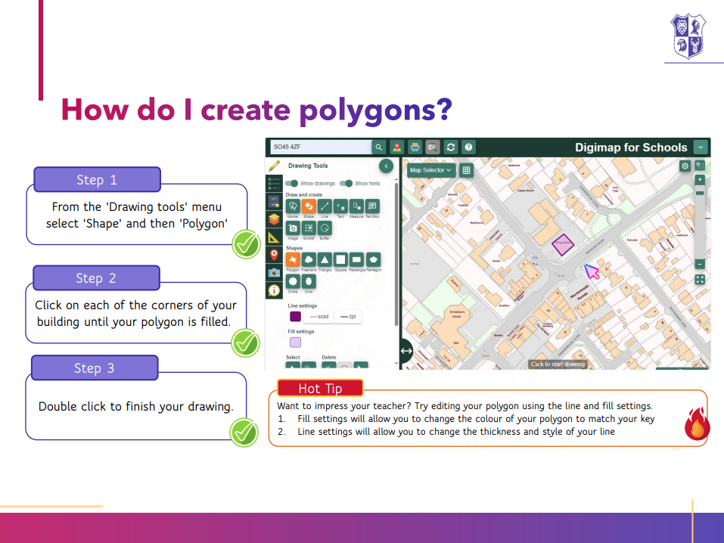

# How do I measure a route?

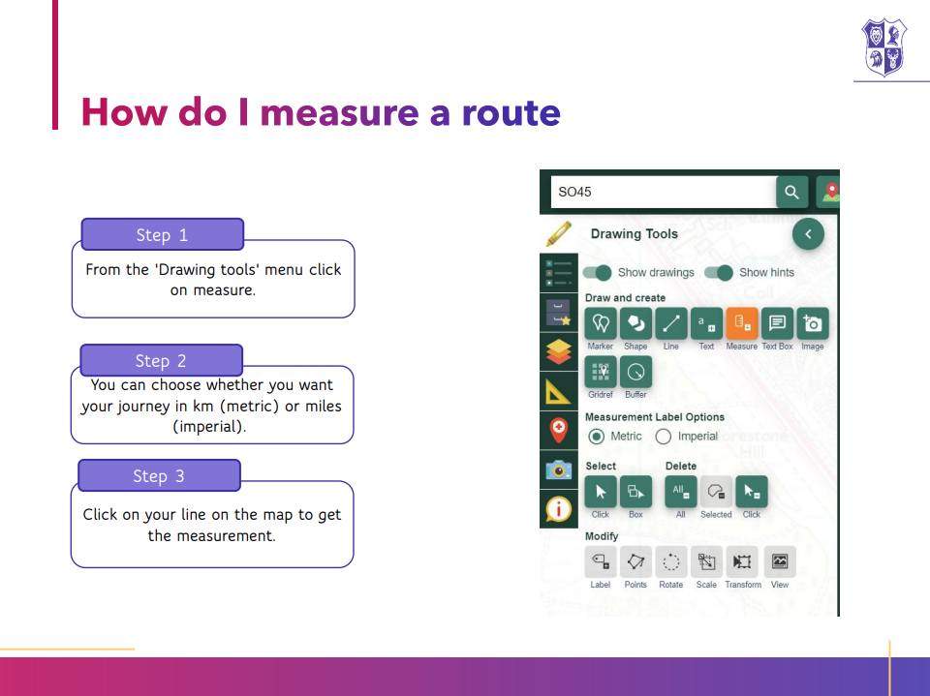

# How do I find the grid reference?



# 

# How do I import an image?

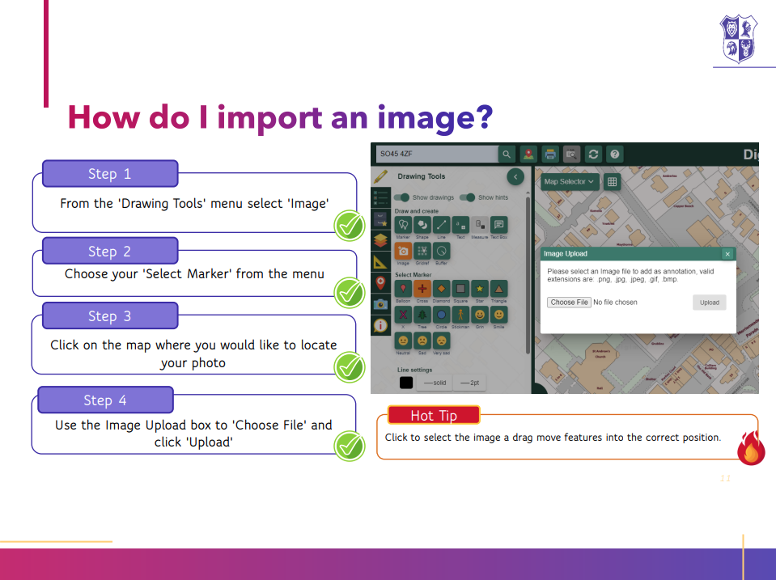

# Copyright

©EDINA at the University of Edinburgh 2016  
This work is licensed under a Creative Commons Attribution-Non Commercial Licence Creative commons licence, CC BY NC

# Acknowledgements

© CollinsBartholomew Ltd (2019) FOR SCHOOLS USE ONLY

© Crown copyright and database rights 2020 Ordnance Survey (100025252). FOR SCHOOLS USE ONLY.

Aerial photography © Getmapping plc. Contains OS data. FOR SCHOOLS USE ONLY.

Historic mapping courtesy of the National Library of Scotland. FOR SCHOOLS USE ONLY.