Shop for a House

Urban regeneration of local high street

Alan Parkinson

Geography Teaching Resource

Secondary
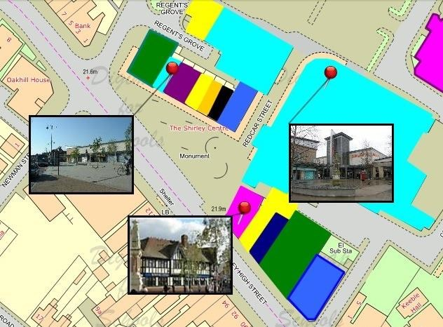

Contents
Digimap for Schools Geography Resources 3
Activity 3
Adding photographs 4
Using an iPad 4
Colour coding shops by type 4
Class introduction 5
Example map 6
Suggested colour coding 7
Taking it further 8
Web link 8
Copyright 9
Acknowledgements 9

Digimap for Schools Geography Resources
These resources are a guide for teachers to demonstrate to the whole class or direct individual students as appropriate. Each activity has several ideas within it that you can tailor to suit your class and pupils. Some resources contain worksheets for direct distribution to pupils.

Content and Curriculum Links

Level | Context | Location
Secondary | Fieldwork, retailing/urban land use | Any high street

Knowledge | Land use mapping/adding polygons/adding labels and photographs/measuring areas/creating and printing maps
Curriculum links (England) | Urban land use/retailing/regeneration – understanding the process of urbanization.
Curriculum links (Wales) | Locate places using maps and use maps to interpret and present locational information. Explain how and why places change.
Scottish Curriculum for Excellence | Social studies outcomes: people, place and environment: 0.07a, 2.10a, 4.10b, 2.14a.

Activity
Involve your class in an exploration of a local high street to identify what sort of shops there are. Discuss why some shops are empty and what might be done about it, including the option to turn some of them into affordable housing.

Most high streets are linear features and some of them are quite lengthy. This gives the option of giving individual pupils, or groups, responsibility for investigating clusters of shops. Create a visual record of the high street by adding photographs, annotations and colour-coding to the map. (This can be done over a period of time).

Adding photographs
(TIP: If you are creating a set of photographs yourself, use a Digimap for Schools print-out to note the frame number of each photograph onto the map as you proceed, so that you can find it easily later.)

Using an iPad
Photographs can be instantly attached to the map. Zoom into the largest scale of Digimap for Schools and locate the building you will photograph.
- Open the Drawing Tools.
- Select the photo icon from the Draw and Create area.
- Select the building on the map and follow the option for ‘take photo or video’.
- Take photo and select ‘use’ and then ‘upload’. The pin will be on the building and the photo attached by a line.
- To move photographs just select the photo and drag it to a new position.
- If the pin is in the wrong position, select the pin and both the pin and the photograph will move together.

Colour coding shops by type
The student hand-out sheet is pre-filled with some suggestions you can use or adapt. Alternatively, depending on the range of shops in the high street you could us the markers as reference to particular shops e.g. stick man could signify clothes shops.
- Open Digimap for Schools and zoom in to the largest scale at your chosen location and switch to aerial photography.
- Using your knowledge of the high street, pan and zoom to check out individual shops in the area and then annotate the same shops on a Digimap for Schools map with the right type of symbol colour taken from the pre-filled activity table.
- To annotate the property:
  - Open the Drawing Tools.
  - Select the Draw Polygon tool.
  - Choose the appropriate colour from the fill option and the outline option.
  - Starting at a corner of the building, click once and then click again at each turning point. Double click to complete and close the area of the building and it will be filled with your chosen colour.

- Repeat this for each building.
- Save your map.

Class introduction
High streets have been at the hearts of towns and communities for centuries. However, they need to be supported if they are to thrive and become ‘vital and viable’. They are facing an unprecedented threat from lifestyle changes and the availability of alternative shopping opportunities which are more ‘convenient’ for consumers. The main ‘threats’ to the town centre come from online retailing, out of town shopping malls (where shops are under cover) and retail parks (where parking may be free). Reduced disposable income may also play a part, as people have less ‘disposable income’.

One of the issues with the growing number of vacant (empty) shops is the visual impact that they have, contributing to a general sense of decline and neglect and making the street a less pleasant place to be.

Since the report was published, some town centres have made efforts to improve, and funding was made available to support a number of towns develop their ideas.

Planning regulations have traditionally protected high streets by preventing shops and office being changed into homes, it has been suggested that empty shops and offices could be converted to housing. With a shortage of housing and too many empty shops this looks sensible. Ideally the shops should all stay together and any converted to houses would be the ones that are furthest away from the centre. Would this work in your local high street?

Example map

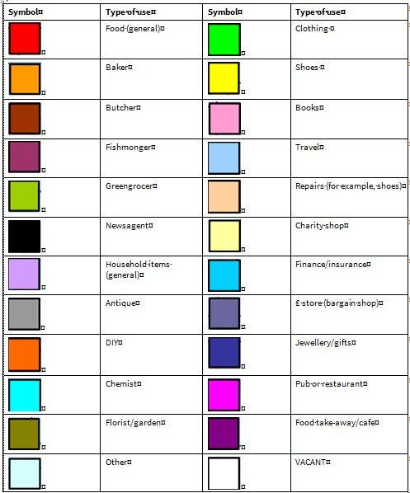
Suggested colour coding

Taking it further
If you have been unable to undertake class fieldwork, consider deliberately muddling up some or all of the photos so that they are attached to the wrong shops. Make pupils responsible for particular sections of shops and ask them to use the Modify tool to put them in the right place. Provide them with a separate sheet of photos with the grid reference of the correct place, or other clues.

You could extend the activity to explore shop-clustering by type. Some shops, such as shoe shops, are often found in particular clusters in areas of the high street. Does this happen in your local area?

Keep track of the changes that occur in your high street over a number of months, or even years. Students can then have access to a useful archive showing changes in your local area over a period of time.

Is your town a Clone Town? See the web links for a two-page survey sheet that includes a quick calculator to find out.

Look back in time at the high street by using the 1890s and 1950’s maps. How has the high street changed since?

Web link
The 2011 Portas Review and subsequent progress reports can be viewed here: www.gov.uk/search?q=portas&tab=government-results

Copyright
©EDINA at the University of Edinburgh 2016
This work is licensed under a Creative Commons Attribution-Non Commercial Licence

Acknowledgements
© CollinsBartholomew Ltd (2019) FOR SCHOOLS USE ONLY
© Crown copyright and database rights 2020 Ordnance Survey (100025252). FOR SCHOOLS USE ONLY.
Aerial photography © Getmapping plc. Contains OS data. FOR SCHOOLS USE ONLY.
Historic mapping courtesy of the National Library of Scotland. FOR SCHOOLS USE ONLY.

