Writing the Earth: Literacy Using Maps

Alan Parkinson

Geography Teaching Resource

Secondary
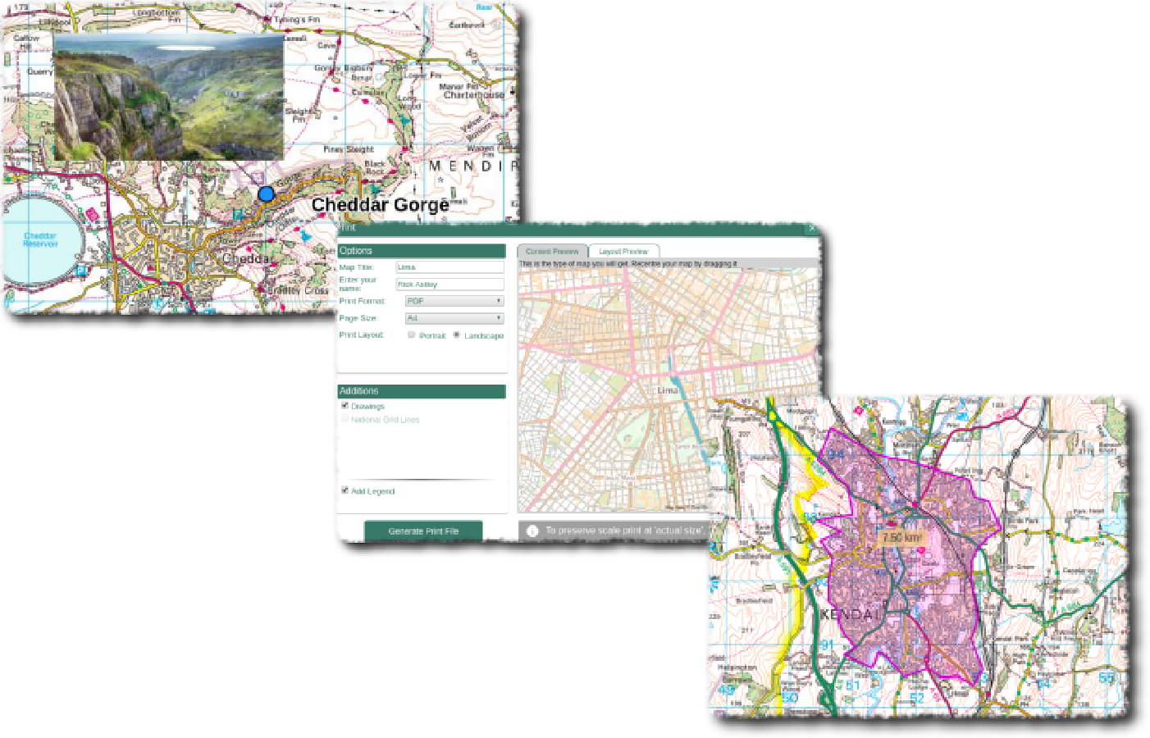

Contents
Digimap for Schools Geography Resources 3
Content and Curriculum Links 3
Activity 4
Introduction 4
Main activity 4
Story cubes 4
6 x 6 activity 4
Map cubes 5
Taking it further 5
Web links 5
Annex A 6
Example 6 x 6 grid suitable for use with Castleton area of the High Peak in Derbyshire 6
Annex B 8
Blank 6 x 6 activity grid: 8
Copyright 9
Acknowledgements 9

Digimap for Schools Geography Resources
These resources are a guide for teachers to demonstrate to the whole class or direct individual students as appropriate. Each activity has several ideas within it that you can tailor to suit your class and pupils. Some resources contain worksheets for direct distribution to pupils.

Content and Curriculum Links

Level | Context | Location
Secondary | Maps can be used to tell stories. Geography literally means ‘writing the earth’ and they can form the basis of some good literacy work. | Anywhere in GB

Knowledge/skills | Zooming levels, annotating a map, literacy.
Curriculum Links (England) | Map skills, literacy, landscapes.
Curriculum Links (Wales) | Use maps to interpret and present locational information, communicate ideas and information using maps and visual images.
Scottish Curriculum for Excellence | Social Science Outcomes: People, Place and Environment 1.07a, 1.14a.

Activity
Geography literally means ‘writing the earth’. This activity is about creating a story with an Ordnance Survey map sourced from Digimap for Schools as the setting, or as the inspiration. The map needs to be ‘brought to life’.

Introduction
Consider where your stories could be located. This could be with teacher guidance, or students could be asked to choose a place e.g. ‘somewhere with a castle’, ‘somewhere near the sea’ or ‘somewhere with a mysterious sounding name’ (the search function would come in handy for this).
It may also be useful to provide a theme for the story. Examples might be:
- Journeys
- Wish you were here
- What will I do for a living?
- Where will I live?
Some locations in Great Britain are associated with particular stories. Introduce your class to the fact that many famous writers have used geographical features as inspiration. (See the web links for some examples.)

Main activity
This activity works well when a physical prompt is provided to help focus thinking. Three options that could be used are:

Story cubes
Many teachers will already be familiar with these and it may be worth checking to see if your school already has a set. The most well-known are Rory’s Story Cubes, and the set called ‘Voyages’ includes lots of visual prompts that could be used in conjunction with a map from Digimap for Schools.

6 x 6 activity
This uses a similar idea but requires a key-word related to the area to be placed in each of 36 boxes. Roll 2 six-sided dice to generate the co-ordinates of a particular square. The word in that square is then used in the story. An example for the Castleton area of the High Peak in Derbyshire is shown at Annex A. A blank 6 x 6 grid is provided at Annex B.
(From an original idea by Steve Bowker.)

Map cubes
Create some MAP DICE to help get the story rolling. Search for ‘Dice net’ on the internet to find templates. Pupils should select an area of mapping and print it out at A4. They could then paste areas of mapping on each side of the dice. Each section of the story is prompted by the roll of a dice.
Depending on the area selected it may be more interesting to choose different areas of the map for each side of the dice, rather than to cut the dice out from one area of the map extract.

Taking it further
Alternatively, you could write some poetry. Simple verse forms like haikus work well with those who may struggle to write a lot. Poetry that is in the form of a calligram would also work well here.
A calligram is a diagram which contains words and is written in a way that conveys the meaning of that word. E.g. the word ‘Seashore’ written in words which are wavy and have blue at the top and yellow as an outline.

This could involve writing a poem or story about a river that takes the shape of the river’s course. Use your imagination with shapes and words.

Web links
- Example of classic authors inspired by the landscape: http://www.bl.uk/onlinegallery/onlineex/literland/
- List of books based on areas in London: http://www.independent.co.uk/arts-entertainment/books/features/tales-of-the-city-literary-map-of-london-810394.html
- Rory’s Story Cubes: https://www.storycubes.com/en/

Annex A

Example 6 x 6 grid suitable for use with Castleton area of the High Peak in Derbyshire

Lorries stuck | Pollution | Traffic Jams | Car parks full | Raining Heavily | Gore Tex jacket
Satellite navigation | Breakdowns | Noise | Children | Tourists | Shopping
Road cracking up | Steep Slopes | Mam Tor | Breakdown vehicle | Sunny | Cow
Sight seeing | Road signs | Very busy in the post office | Blue John | Tractor going slowly | Sheep on the road
Landslide | Detour Signs | Postcards | Litter | Ice cream van | Farmer
Graffiti | Fish and Chips | Caverns | Making lots of money | Picnic | Winnat’s Pass

Search for ‘Castleton in Digimap for Schools and enlarge to full screen by selecting Collapse Sidebar at the bottom left of the screen:
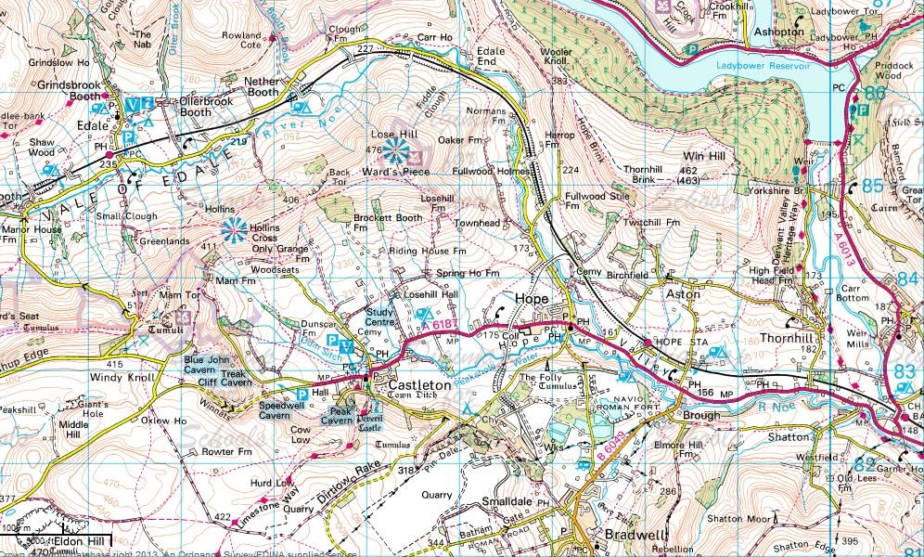

Annex B

Blank 6 x 6 activity grid:

Copyright
©EDINA at the University of Edinburgh 2016
This work is licensed under a Creative Commons Attribution-Non Commercial Licence

Acknowledgements
© CollinsBartholomew Ltd (2019) FOR SCHOOLS USE ONLY
© Crown copyright and database rights 2020 Ordnance Survey (100025252). FOR SCHOOLS USE ONLY.
Aerial photography © Getmapping plc. Contains OS data. FOR SCHOOLS USE ONLY.
Historic mapping courtesy of the National Library of Scotland. FOR SCHOOLS USE ONLY.

