Best of British

Plan a route to a tourist destination

Alan Parkinson

Geography Teaching Resource

Secondary
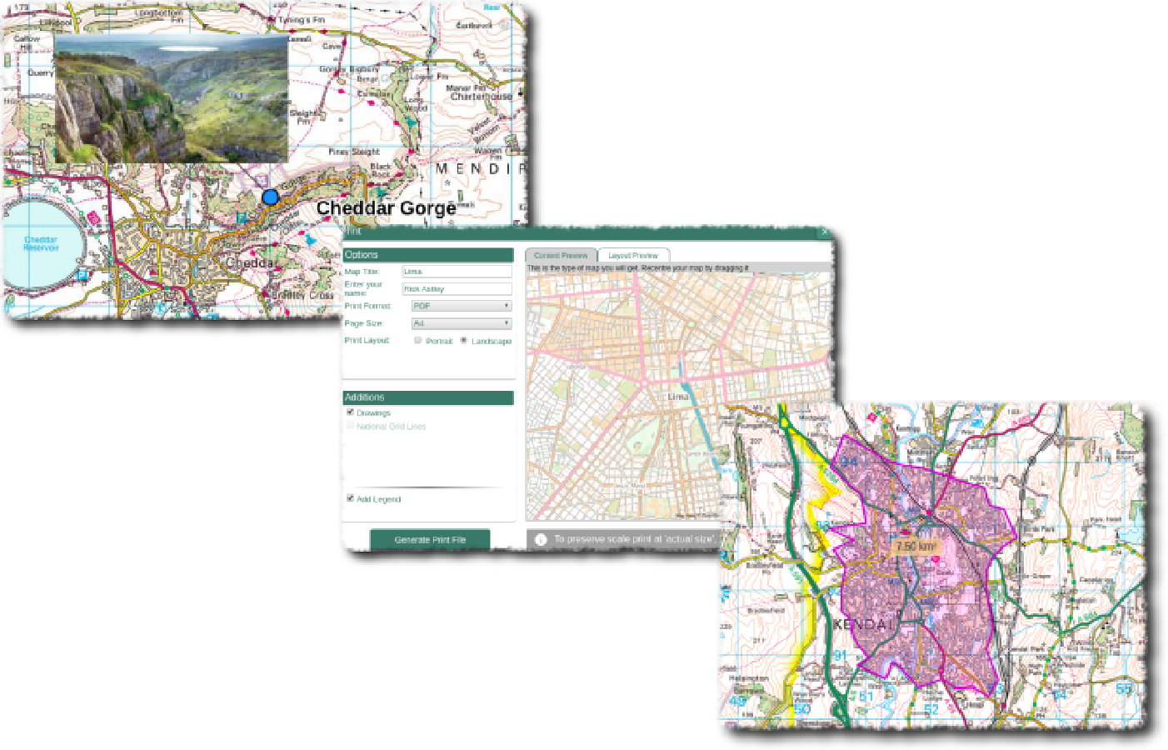

Contents

Contents 2
Digimap for Schools Geography Resources 3
Content and curriculum links 3
Introduction 4
Main activity 6
Event cards 7
Detour cards (optional) 9
Copyright 10
Acknowledgements 10

Digimap for Schools Geography Resources
These resources are a guide for teachers to demonstrate to the whole class or direct individual students as appropriate. Each activity has several ideas within it that you can tailor to suit your class and pupils. Some resources contain worksheets for direct distribution to pupils.
https://digimapforschools.edina.ac.uk/

Content and curriculum links
Level | Context | Location
Secondary | Plan an appropriate route to a tourist destination. | Location within Great Britain will vary depending on the students’ home area, as journeys will be made from the students’ home location to a range of alternative locations. There are also several disruptions that will be thrown into the mix during the planning phase to test the resilience of their planning.

Knowledge | Route planning/distance and direction/literacy/zoom levels/adding images
Curriculum links (England) | Tourism/Transport/Map Skills
Curriculum links (Wales) | - Locate places and environments using globes, atlases, maps and plans.  - Use six-figure grid references.  - Use maps, plans and imagery of different types and scales and ICT to interpret and present locational information.  - Explain the spatial patterns of features, places and environments at different scales.
Scottish Curriculum for Excellence | - Social Studies Outcomes: People, Place and Environment:  1.13a, b, 2.14a

Introduction
Explain to students that they are working for a coach company: DigiTours and it is their job to brief the coach driver on the travel arrangements for a booking that has just been made by a school group. A 52-seater coach will be taking the school students to a destination, which they will be given shortly.

Allocate the destinations
Distribute the event cards, found below. Each student could be allocated somewhere different, or they could be handed out to students in pairs or small groups, depending on the extent of access to Digimap for Schools. Groups could also be allocated a particular month as an alternative.

Find the place
They should start by seeing which place they are visiting and work out where they will need to travel to. Search is available (see image below).
Ask whether students have heard of the places they are visiting, to reinforce some general UK knowledge, or personal stories of those who have visited the places before.
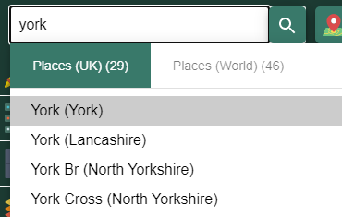

Plot the route
Students need to plot their route to the event.
This will be driven by a coach, so appropriate roads should be taken.
The route should be plotted to be as efficient as possible, to reduce fuel costs.
For some events, other forms of transport will also be needed, which might require further research. You may wish to allocate these locations to the most appropriate students.

Road atlas maps
Show students the different zoom levels that display ‘road atlas’ style mapping.
They can zoom in and out with the plus and minus signs on the scale bar.
Using zoom may using also aid the identification of the actual location, or specific features which may lie on the journey.
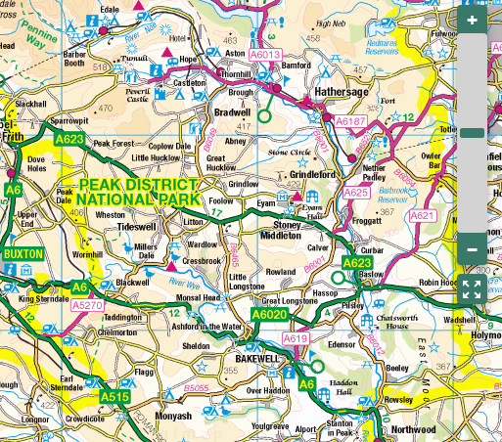

Main activity
Students should write out a route as a series of sections. These should reflect the instructions spoken by a ‘Sat Nav’.

Vocabulary prompt
You could use phrases like these when writing out your route:
- Please drive to highlighted route
- In ...... miles, enter roundabout
- Turn left
- Turn right
- Leave motorway at the next exit
- Enter tunnel
- Follow the A... , B...., M..... for .... miles
- North
- South
- East
- West

Taking it further
You might also want to throw in some ‘DETOUR’ cards at some point during the exercise to groups who are making good progress to see whether they can overcome some of the unforeseen problems that might occur when making a journey to such a busy and popular event.

Event cards
The event cards below can be printed and cut out and distributed to the students

Event cards – two events for each month through the year from January to December.

Up Helly Aa;  http://www.uphellyaa.org/  Last Tuesday in January  Lerwick, Shetland Islands | Hogmanay Celebrations:  https://www.edinburghshogmanay.com/  1st of January  Edinburgh, Scotland
Pancake Day Race: http://olneypancakerace.org/  Shrove Tuesday  Olney, Northamptonshire | Rugby Six Nations: https://www.sixnationsrugby.com/  First week of February  Twickenham, North London
Cheltenham Festival;  March,  Cheltenham Race Course, Gloucestershire | St. David’s Day Celebrations;  1 March,  Cardiff Waterfront
The University Boat Race:  https://www.theboatrace.org/  Putney, River Thames, South-West London | Trooping the Colour:  http://www.trooping-the-colour.co.uk/  Horse Guards Parade, Central London
The Maldon Mud Race;  http://www.maldonmudrace.com  23 May 2021  Maldon, Essex | Eurovision Song Contest Party;  May,  York City Centre, North Yorkshire
Wimbledon tennis tournament:  https://www.wimbledon.com/  End of June  Wimbledon, London | UK Darts Open  March,  Reebok Stadium, Bolton
The Proms:  https://www.royalalberthall.com/  July to September  Royal Albert Hall, London | Cheese Rolling Race: https://www.soglos.com/sport-outdoor/27837/Gloucestershire-Cheese-Rolling  May,  Cooper’s Hill, Gloucestershire
Notting Hill Carnival:  https://www.thelondonnottinghillcarnival.com/  August Bank Holiday  Notting Hill, London | Bristol International Balloon Fiesta:  http://www.bristolballoonfiesta.co.uk/  Second week in August  Bristol
London Fashion Week:  https://londonfashionweek.co.uk/  September  Venues across Central London | BUPA® Great North Run:  https://www.greatrun.org/great-north-run  September,  Newcastle
Goosey Fair:  https://www.tavistock.gov.uk/council-services/goose-fair  Second Wednesday of October  Tavistock, Devon | World Conker Championships  https://www.worldconkerchampionships.com/index.php  October  Ashton near Oundle, Northamptonshire
St. Andrew’s Day celebrations:  https://www.whatsonstirling.co.uk/events/st-andrews-day/  30 November  Stirling, Scotland | Bonfire Night celebrations:  https://www.lewesbonfirecelebrations.com/  5 November  Lewes, East Sussex

Detour cards (optional)

Road blocked by escaped sheep and closed for several hours. Find an alternative route suitable for a coach. | Bad weather means that any roads in hilly areas are likely to have delays with falling snow.
Work on a bridge means that your coach won’t fit under it – find a detour with no low bridges. | Fog slows down any vehicles that are not on motorways.
These can be thrown into the mix or handed to groups if appropriate to see how resilient the routes are. You may be able to think of some additional transport problems.

Copyright
©EDINA at the University of Edinburgh 2016
This work is licensed under a Creative Commons Attribution-Non Commercial Licence

Acknowledgements
© CollinsBartholomew Ltd (2019) FOR SCHOOLS USE ONLY
© Crown copyright and database rights 2020 Ordnance Survey (100025252). FOR SCHOOLS USE ONLY.
Aerial photography © Getmapping plc. Contains OS data. FOR SCHOOLS USE ONLY.
Historic mapping courtesy of the National Library of Scotland. FOR SCHOOLS USE ONLY.

