Introducing GIS – Keeping Safe at Night
Identifying quantity of streetlights in the locality
Alan Parkinson
Geography Teaching Resource
Secondary

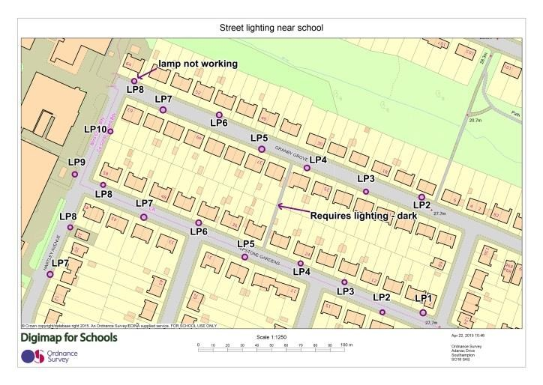

Contents
Real world example 3
‘Report it’ helps council work quicker and save money: 3
Main activity 3
Summary 3
Sources of information 4
Create your map 4
Extension: create a spreadsheet 6
Extension: identify cost savings 7
Copyright 8
Acknowledgements 8

Real world example

‘Report it’ helps council work quicker and save money:
Reporting streetlight or pavement issues and locating them accurately can be time consuming for both the general public and the Borough of Poole Council staff. By introducing a new online reporting tool, which contains mapping to locate a specific concern, the council has increased the number of website users and become more efficient, resulting in cost efficiency.
The challenge was to improve the accuracy of location reporting and simplify the process of reporting a problem. This required making it easier for the public to pinpoint the location of an issue so reducing the amount of repeat calls due to difficulties of identifying the location.
A ‘Report it’ web platform was developed, allowing residents to chart incidents on a map through the council’s website. Ordnance Survey MasterMap, a large-scale, highly-detailed map data was used to enable residents to easily and accurately locate issues regarding roads, pavements or streetlights. Reports based on the updated map were then distributed to engineers to resolve.

As a result of this initiative more residents are using the website and the tools to report defects. Also from a council perspective less time has been spent by front desk staff trying to understand issues and as a result call costs have been reduced saving the council around £5,000 a year.

Main activity
The activity for students to attempt is based on the real world example illustrated above.

Summary
Based upon the reporting of defects to the council this activity this would require the annotation of street lights in a chosen area where students travel on their way home or gather after school. To do this, a printout of Digimap for Schools could be used to annotate the location of each lamp post in the chosen area and record whether any lights are defective. Photographs of locations can be taken to record lights not working or areas where the lighting is poor or where it is required. The information would be transferred to Digimap for Schools online to record their findings.

Sources of information
- Further Ordnance Survey case studies can be found at: http://www.ordnancesurvey.co.uk/businessand-government/case-studies/index.html
- Image Search in Digimap for Schools gives access to a large bank of images of Great Britain and Ireland from Geograph.

Create your map
In this activity you will choose an area around the school, an area on the way home or where your group gathers after school to concentrate on. A sample activity is shown here and can be seen in more detail in the accompanying PowerPoint.

- After centring the map over your chosen location, create a printout for use to mark up the location of lamp posts at your chosen location. It would be ideal to use one of the zoom levels at the top of the zoom bar by the + mark.
- Visit the area of interest and record, using a pen to mark on the map extract, the location of each lamp post in the area and recording other helpful information such as the lamp post number/code and any telephone numbers displayed and take any photographs required.
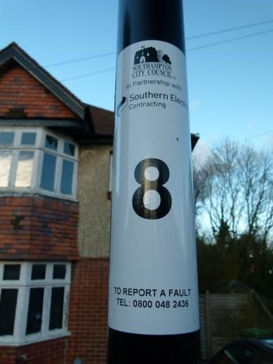
- Importantly, record whether the light is working properly or not and also areas which require improvements in lighting. Give reasons why further lighting might be needed.
- Open Digimap for Schools at your chosen location and record the location of each lamp post with a marker.
- Now add at each lamp post any number or the name found on the post. Use ‘Add Label’ and make sure the text is set to an appropriate size.
- Where you have made a special label such as “lamp not working” or “requires improved lighting – it is a dark place”, draw a line between the text and the location to which it refers on the map.
- Save the map and print.

Extension: create a spreadsheet
As an extension to this exercise create a spreadsheet of relevant information such as the example found here and in the accompanying PowerPoint.
Consider using this information to inform the local authority.
Phone the appropriate department (it might be displayed on the lamp post) or arrange to send the spreadsheet.
Information collected has included:
- the grid reference (using Digimap for School’s grid reference marker tool,
- the lamp number,
- the approximate location outside the correct house. The local authority department should have no problem recognising the location that you are concerned about.

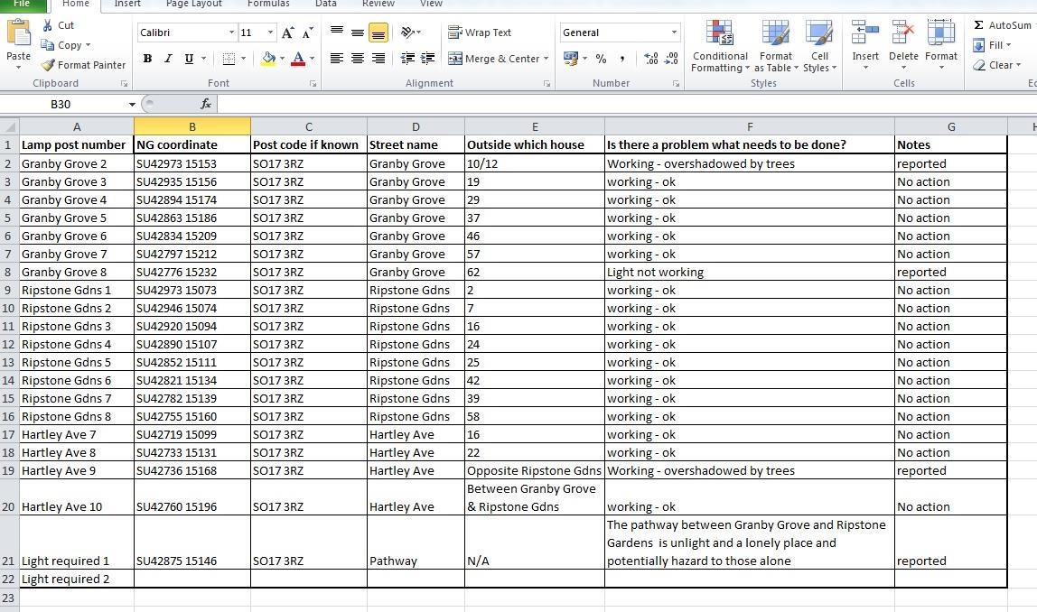

Extension: identify cost savings
One additional cost saving has been the identification of street-lights which can be switched off after midnight to save councils money. Keeping streets lit after dark costs over £300 million per year.
This has been a controversial move, with many people fearing an increase in crime.
A report in July 2015 reported on a survey of over 60 councils: http://www.bbc.co.uk/news/uk33692675 and suggested that there was no increase in crime.
With that as a background, students could also be tasked with identifying which lights might be switched off. A buffer could be placed around lights to show the area lit up by particular lights. A target of 10% of lights in an area could be set for students to identify.

Copyright
©EDINA at the University of Edinburgh 2016
This work is licensed under a Creative Commons Attribution-Non Commercial Licence

Acknowledgements
© CollinsBartholomew Ltd (2019) FOR SCHOOLS USE ONLY
© Crown copyright and database rights 2020 Ordnance Survey (100025252). FOR SCHOOLS USE ONLY.
Aerial photography © Getmapping plc. Contains OS data. FOR SCHOOLS USE ONLY.
Historic mapping courtesy of the National Library of Scotland. FOR SCHOOLS USE ONLY.

