Introducing GIS

Slimming down the cost of obesity

Alan Parkinson

Geography Teaching Resource

Secondary
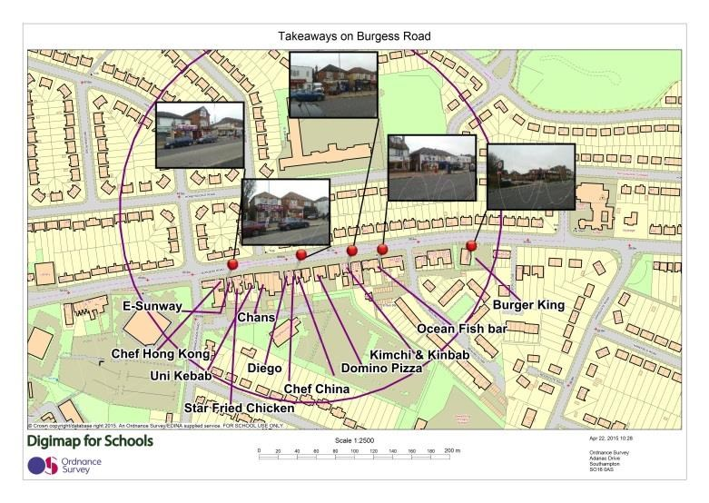
Contents
Digimap for Schools Geography Resources 3
Content and Curriculum Links 3
Introduction 3
Cutting obesity - Activity 4
Extension 7
Copyright 9
Acknowledgements 9

Digimap for Schools Geography Resources
These resources are a guide for teachers to demonstrate to the whole class or direct individual students as appropriate. Each activity has several ideas within it that you can tailor to suit your class and pupils. Some resources contain worksheets for direct distribution to pupils.

Content and Curriculum Links
Level | Context | Location
Secondary  GCSE | Identifying number of takeaway restaurants in the locality | Locality

Introduction
This activity is based on a real-world example of how using Ordnance Survey has helped tackle obesity in Birmingham schools.
Obesity is a huge problem in Birmingham, costing the city’s NHS £330 million a year. Almost a quarter of Year 6 children in the city were officially obese in 2014, with statistics directly linking the proximity of takeaways near school sites to the problem. Ordnance Survey data used within a GIS gave Birmingham’s Public Health team the data to tackle the problem head on.
Schools were plotted in close proximity to fast food takeaways e.g. fish and chip shops, pizza, kebab or Chinese restaurants and takeaways and burger shops. Those within 400 metres (5 minute walk) of a school were identified and collaborative action taken to disadvantage use of takeaways by children.
This challenge will require the collection of information about all takeaways in your chosen area. This can be done as a classroom-based research task, using internet sources but is also a good fieldwork activity.
Data collection can be carried out by providing students with paper map prints to mark up their findings.
Further Ordnance Survey case studies can be found at: https://www.ordnancesurvey.co.uk/business-government/products/case-studies

Cutting obesity - Activity
In this activity you will choose a school, youth club or leisure facility on which to focus on. A sample map is shown in the image below.
- Open Digimap for Schools.

- After centring the map over your chosen location, create a printout for the classroom or (ideally) field research to investigate takeaways in the vicinity of your chosen location. It would be ideal to use one of the zoom levels at the top of the zoom bar by the + mark for your map. Work out which zoom level produces the best coverage for your chosen location.

- In your research phase record the name of each takeaway that you identify. Mark the location of each on the map extract accurately and take a digital photograph of the business if one cannot be sourced from elsewhere.

- When your research is complete, open Digimap for Schools at your chosen location.
- Choose a suitable area of interest.
- Open the Drawing Tools.
- Select the buffer tool.
- Choose a suitable radius e.g. 200 metres or 0.2 kms or more.
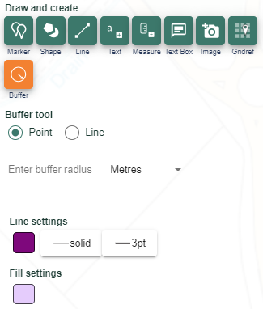
- Do the takeaways fall within your buffer circle? If not amend as required.
- Now add your photographs by using the add photo option.
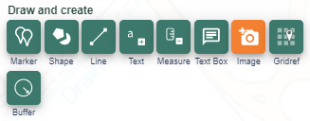
- Amend the location of the pin using the move feature button if required until it is located appropriately.

- Now add labels, to add the names of the takeaways at suitable locations, thinking about the final layout of the map.
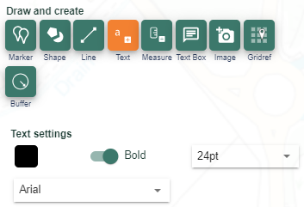
- Draw a line between the text and the location of the takeaway on the map, to link the label with the geographical location.
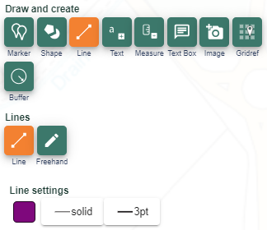
- Save the map and print if required.

Extension
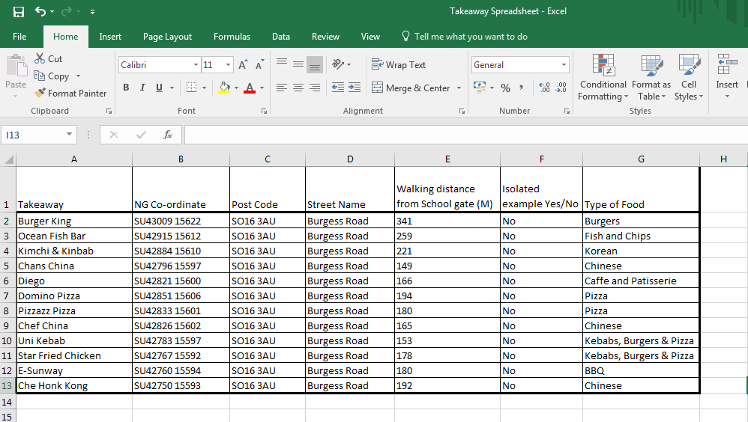
As an extension to this exercise create a spreadsheet of relevant information such as the example found here and in the accompanying PowerPoint.

- Grid reference information has been collected for each takeaway using the grid reference marker tool.
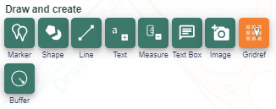

- The distance from the school gate to each takeaway has also been recorded. This is captured using the measure distance function within the measurement tool:

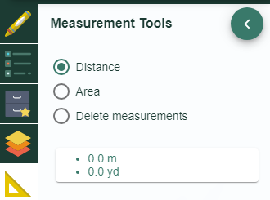
- Pedestrian crossing points on major roads could also be marked on the map and recorded on the spreadsheet with suitable comments.
- In the case study in Birmingham they were aiming for only 10% of outlets in the chosen area being takeaways. In the example shown, over 30% of outlets were takeaways, which was partly due to the close proximity of the local university.
- Identify appropriate demographic reasons why there might be a low or high proportion of takeaways depending on the results of your analysis.
- Demographic information can be obtained from the ONS website.

Copyright
©EDINA at the University of Edinburgh 2016
This work is licensed under a Creative Commons Attribution-Non Commercial Licence

Acknowledgements
© CollinsBartholomew Ltd (2019) FOR SCHOOLS USE ONLY
© Crown copyright and database rights 2020 Ordnance Survey (100025252). FOR SCHOOLS USE ONLY.
Aerial photography © Getmapping plc. Contains OS data. FOR SCHOOLS USE ONLY.
Historic mapping courtesy of the National Library of Scotland. FOR SCHOOLS USE ONLY.

