Mystery Maps

Interpreting and Locating Maps

Alan Parkinson

Geography Teaching Resource

Secondary
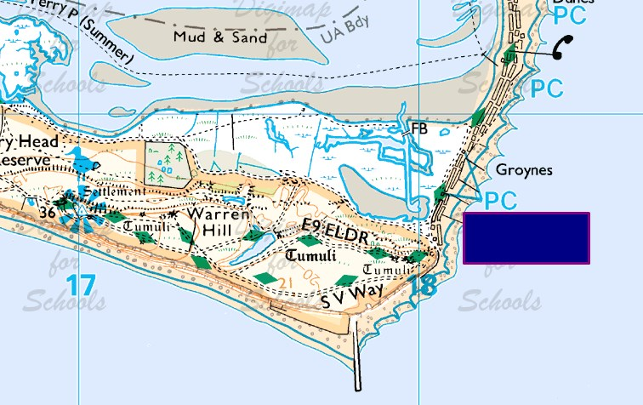

Contents
Digimap for Schools Geography Resources 3
Content and Curriculum Links 3
Activity 3
Introduction 4
Main activity 4
Create a mystery map 5
Taking it further 7
Web links 7
Copyright 8
Acknowledgements 8

Digimap for Schools Geography Resources
These resources are a guide for teachers to demonstrate to the whole class or direct individual students as appropriate. Each activity has several ideas within it that you can tailor to suit your class and pupils. Some resources contain worksheets for direct distribution to pupils.

Content and Curriculum Links
Level | Context | Location
Secondary | Interpreting and locating maps | 13 locations supplied (in the PowerPoint presentation) but can also be anywhere in GB. Can represent natural or man-made features, which may be relevant to school context.

Knowledge and skills | Exploring places, map recognition
Curriculum links (England) | Map Skills, exploring place
Curriculum links (Wales) | Locate places and environments using atlases and maps. Use maps, plans and ICT to interpret and present locational information.
Scottish Curriculum for Excellence | Social Studies Outcomes:1.14a – 4.14a

Activity
Displaying maps of a mystery location to encourage students to use the clues in the map itself to decide where the place is.

Introduction
When students use maps they are generally looking for, or at a map of, a location that they already know. Presenting students with a mystery map forces them to examine the map for clues in the landscape and to use their geographical knowledge to work out the location. This can also help them identify those elements of a map which are most useful in defining what gives a place its character.
As well as using these maps as the basis for a lesson or homework, they could also be used as an informal starter activity over a number of lessons by having one on display as students arrive in class. The activity below asks students to each create a mystery map that can be used to challenge the classes in future lessons. Teachers can use these as starters for future lessons or collate them all into a quiz activity.

Main activity
- Display mystery map(s) of your choice and ask students if they know where the places are. Challenge them to describe how they can find out by looking for clues on the map itself. Questions they might ask themselves are:
- Is it by the sea or inland?
- Do the place names give a clue, for instance do they look Scottish, Welsh, or give clues as to the function of the place?
- What natural shapes and patterns are there? Are there rocks, hills, water features?
- Does the type of vegetation give any clue?
- Are there tourist information symbols on the map?
- What man-made features are shown and do these shapes give any clues?
- Are there any buildings? Can they work out the purpose of the buildings?
- If required, also locate the mystery maps in Digimap for Schools using the grid reference supplied at the end of the PowerPoint and zoom out to show the locational context of the mystery place.
- Ask students to create their own mystery map. This will encourage them to look at a number of maps of places they have visited in order to find one that will fit the criteria.

Create a mystery map
You are going to create your own mystery map to challenge the rest of the class.
Think about places you have visited that other students will have heard of or choose a place local that most people will be familiar with.
Using Digimap for Schools navigate to that locality and test different zoom views of the place to try and find a map that will give some good clues but will not be so obvious that people will guess straight away. You will probably have to look at several locations before you find one that you are happy with.
- Ideally, your mystery map should be positioned so that place-names do not give away the location.
- If this is impossible you will need to cover place-names with a solid panel by choosing ‘Draw rectangle’ from Drawing Tools (see example in image below).
- After selecting Draw rectangle, change the fill settings so the fill is solid (see the red circle highlighting the setting on the image below).

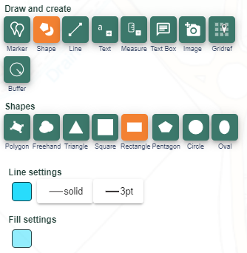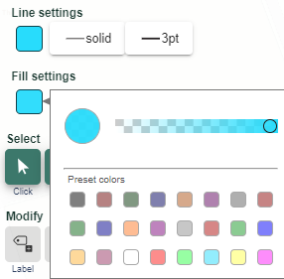

- Construct an extra clue that will be a real help to people to identify the location.

- Once you are happy with your map use Print screen or PrtSc on your keyboard to select the screen image and paste into Paint. Cut out the piece you want and paste into a power-point slide.
- Add the following text:
  - Your name and the extra clue.
  - The location of the map (give place-name and grid reference).
- Set up your slide so that the map is displayed instantly, but that an additional click is required to reveal your name and the clue and a further click to reveal the answer. Save/send as instructed by your teacher.

Taking it further
- Ask students to vote which are the 12 ‘best’ mystery maps. Give class groups/pairs responsibility for revising the slides so that they are suitable for Key Stage 2 pupils. Do they need to change the map? What extra clues should they give?
- Ask students to create ‘proper’ maps using the save/print functions within Digimap for Schools. Create a display in a public area of the school.
- Tweet a picture of your best example to the Digimap for Schools community: @Digimap4Schools

Web links
- There are occasional Mystery Map activities on the OS Blog: https://www.ordnancesurvey.co.uk/blog/
- Follow OS Leisure on Twitter: https://twitter.com/OSleisure

Copyright
©EDINA at the University of Edinburgh 2016
This work is licensed under a Creative Commons Attribution-Non Commercial Licence

Acknowledgements
© CollinsBartholomew Ltd (2019) FOR SCHOOLS USE ONLY
© Crown copyright and database rights 2020 Ordnance Survey (100025252). FOR SCHOOLS USE ONLY.
Aerial photography © Getmapping plc. Contains OS data. FOR SCHOOLS USE ONLY.
Historic mapping courtesy of the National Library of Scotland. FOR SCHOOLS USE ONLY.

