Quick Geography Ideas with a Historic Twist
Alan Parkinson
Geography Teaching Resource
Secondary
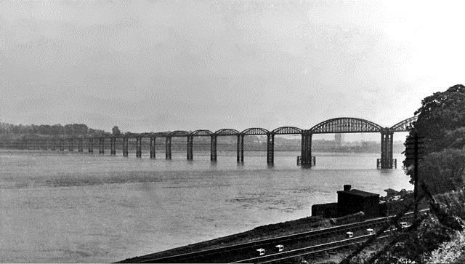

Contents
Digimap for Schools Geography Resources 3
Quick geography ideas with a historic twist 3
Introduction 3
Old school 4
Random Pin 4
Example: Kilbowie/Singer 4
Spot the difference 5
Printing 5
Town bypasses 6
Example: Stamford, Lincolnshire: 6
Coastal erosion 7
Bridges 9
Come and gone 11
Piers 13
Metroland: A case of ribbon development 15
Fields of shops 17
New Towns 18
Copyright 20
Acknowledgements 20

Digimap for Schools Geography Resources
These resources are a guide for teachers to demonstrate to the whole class or direct individual students as appropriate. Each activity has several ideas within it that you can tailor to suit your class and pupils. Some resources contain worksheets for direct distribution to pupils.

Quick geography ideas with a historic twist

Introduction
- Here are some quick and adaptable ideas for using the modern and historic 1890s maps to look at change over time. These can either be used on a whiteboard, or using printed maps as hand-outs, perhaps as a homework exercise.
- The historic maps included are old Ordnance Survey one-inch maps which were all published in the 1890s and 1950s which have been scanned by the National Library of Scotland. The exact map dates are not really relevant as in those days there could be several years between the survey of the area and the map publication!
- The closest modern map scale is the 1:50 000 scale, but Digimap for Schools allows you to zoom in and out of the historic map to enlarge the detail. Whenever you are at a scale suitable for viewing historic mapping the toggle bar will appear.
- Select Ordnance Survey and 1890s to fade between the historic and the modern map. When the historic maps were made the national grid reference framework did not exist, so detail on the old map may sometimes not fit exactly to the modern map and you may notice that the fit between the two maps worsens as you zoom in. If you see a difference in, for example, the course of a road, it does not mean the old maps were very inaccurate, or that a feature has since completely moved, but it is not possible to completely correlate the 1890s and modern mapping frameworks within a seamless GB dataset.
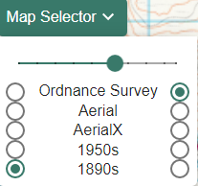
- There may also sometimes be a noticeable difference between details on the old map at what would have been the edges of the paper map sheets. This can be caused by sheets being of a different date, and sometimes due to a difference in the meridians used between the old maps.
- Uncovering and noticing these locations where the maps do not fit exactly could even become part of the activities that you plan.

Old school
How old is your school? Do you know what the present site was used for in 1890? Find out by using the Point Buffer tool (set buffer to 2km, choose 100% transparency and a bold colour for the outline). Now use the slider to see what was there before. What is still the same and what has changed? Do students think the changes are for the better? Are there any clues in the map relating to local professions for school leavers in 1890? Now ask them to do the same for their old school, or their next school. This could be particularly appropriate where a school has changed its site within the town since the time of the older map set.
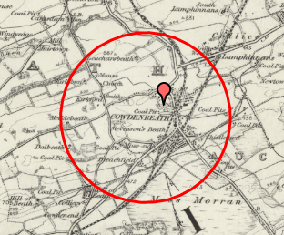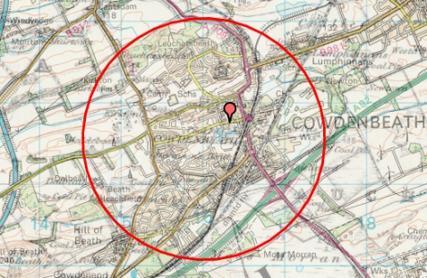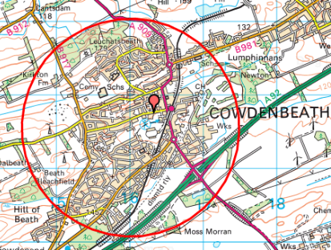

In Cowdenbeath there were numerous coal pits and a mill. These may have been the destination for many school-leavers back in the 1890s. There has been a decline in the number of coal pits as time has progressed.

Random Pin
We look at the modern OS maps and sometimes think what we see has been there forever. However, changes are happening all the time, sometimes very subtly. What can your students find if they pick a random location? Ask them to zoom out to the outline map of GB and put a pin at random in England, Scotland and Wales. Ask them to select the most ‘interesting’ of their three locations and to write about one or more difference they can see when they zoom in. You might also decide on what criteria you will base this assessment of how ‘interesting’ a place is.

Example: Kilbowie/Singer
In 1882 the ground was broken for the largest Singer Sewing machine factory in the world on 46 acres of farmland at Kilbowie. The factory closed in 1980 and was demolished in 1998 and has since been replaced by suburban housing. All that remains is the busy local railway station, which is still called Singer Station.

Spot the difference
If you have no computer access or want to set homework to introduce the concept of landscape change over time, simply give each student an A4 colour modern map and the 1890s version of the same area.

Printing
When making your prints make sure you tick ‘British National Grid’ and ensure that your printer is set to 100% scale (some printers default to ‘fit to paper’ which will distort the scale).
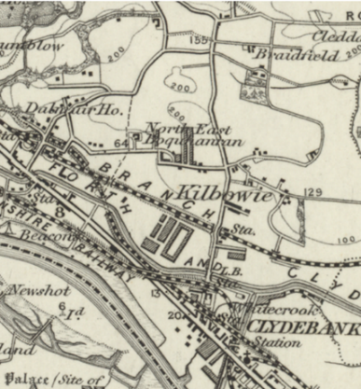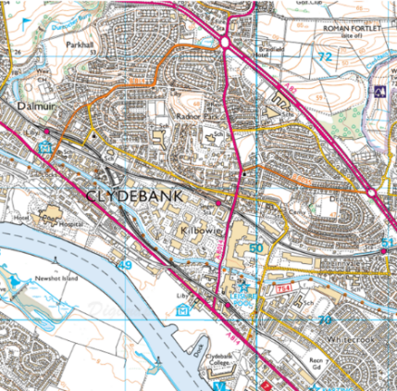

- First ask the students to identify a number of landmarks that appear on each map to ensure they can orientate themselves.
- Now ask them to comment on their impressions of the place they are looking at using appropriate geographical language and terms. How have things changed over the period?
- Next time they have access to a computer they could use Digimap for Schools to annotate some of the changes.

Town bypasses
The present-day classification of roads first started in 1913, so the 1890s maps don’t show the numbering system we are familiar with today. The A1 is the longest numbered road in Britain at 410 miles and over many years it has been diverted as more and more towns were given a bypass.

Example: Stamford, Lincolnshire:
Use Search to find this Lincolnshire town and zoom to a 1:50 000 map. (This scale of mapping shows primary road routes in green, so the bypass clearly shows up.) On the 1890s map Stamford’s original main road can be seen running across a narrow bridge through the town centre and the road can then clearly be shown re-joining the route of the old Roman Ermine Street. Stamford was bypassed in 1960.
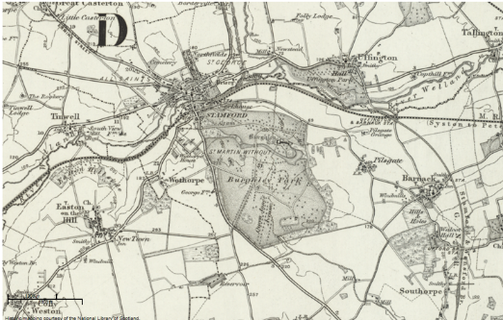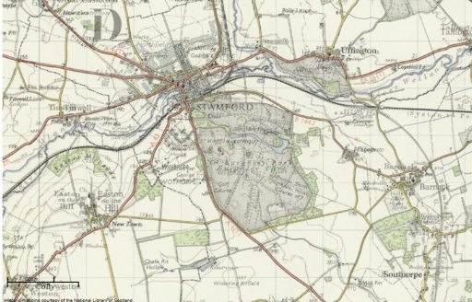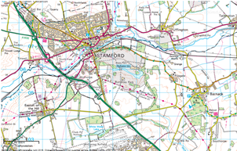

What changes can be observed on the modern map of Stamford that might be attributable to the bypass? What were the benefits and/or negative outcomes for the town?
Try also looking at the following towns: Grantham, Biggleswade, Newark or Morpeth. You will see that this is a controversial issue for many towns. Many exam specifications will offer scope for enquiring into local issues such as this. Recent changes to planning legislation have also placed the focus on housing which may be associated with such road schemes. See also: https://en.wikipedia.org/wiki/A1_road_(Great_Britain)

Coastal erosion
Changes can take place so slowly that we only realise what has happened by looking back over a long period. Examine the slow, but dramatic change that has taken place at Great Cowden on the Holderness coast of East Yorkshire.

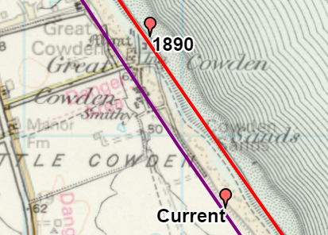
- First find Great Cowden on the map.
- Draw in the coast in a colour that will show up well e.g. purple and trace the mean high-water blue line on the modern map.
- Use another colour e.g. red to trace the line on the old map (the solid black line to the right of the slope symbol.
- Now when you fade from old to new you can see what has gone. (This includes the Inn and some houses).
- Ask your students what they think might happen next?
- Would they like to live in Eelmere Lane?
- Visit other locations along the Holderness coast, to explore how the cliffs along this stretch of coastline are being affected by erosion. Which places have been selected for hard engineering works to protect them?
- Can you find other examples around the GB coast?
What examples can you find of buildings being physically moved so that they don’t fall into the sea? Clavell Tower was moved in 2008.

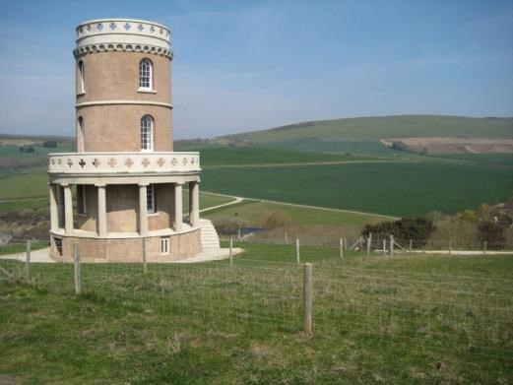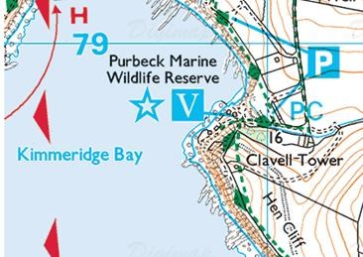

Bridges
A number of important bridges have been built since the 1890s.
- What has brought about the construction of these bridges in these locations, and what has been the effect on employment and social change in South Wales, Bristol, Edinburgh and Fife?
- Discuss whether crossings such as the Humber have been a ‘success’ and if so why?
- On a smaller scale, a bridge was opened to join the Isle of Skye to the mainland. Has this had the effect of slowing or stopping depopulation? For almost 10 years after opening, the bridge was a toll bridge, and users had to pay a significant sum to use it. The Scottish Government abolished the toll in 2004 following a vociferous campaign by islanders.
- Should other bridges be built to other offshore islands?
- Why has a bridge never been built to the Isle of Wight or to Orkney? How could these bridges be funded without using toll charges to raise money?
- Use the map to plot a possible route that the bridge could take, use the measuring tools to work out how long they would have to be, and compare their lengths with the bridges mentioned here.

Have a look at the following locations:
- Severn Road bridge
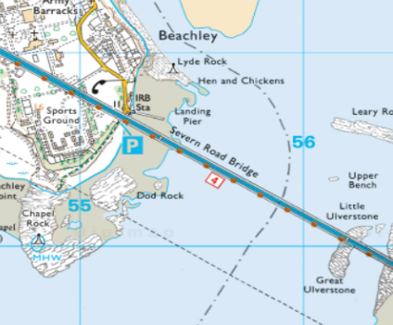
- Forth Road bridge
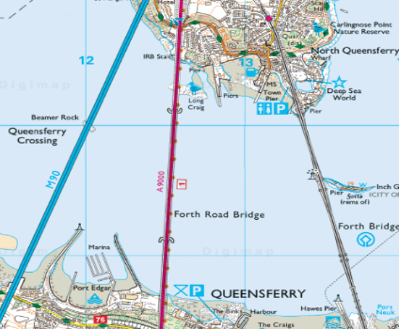
- Humber bridge
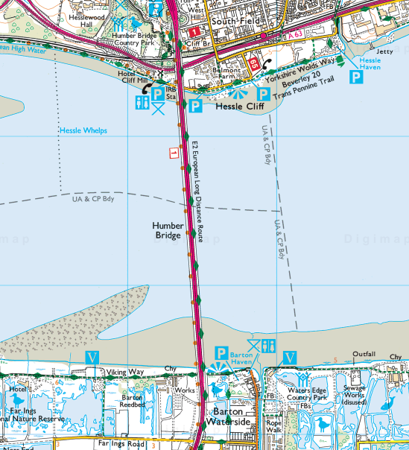
- Skye bridge
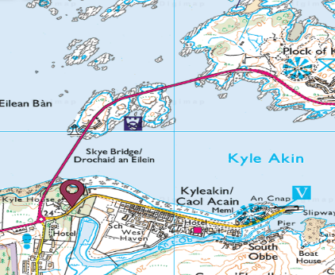

Come and gone
In the 1890s Great Britain was at its industrial peak. Heavy industries have since come and gone, creating social change in many parts of the country and also changing the face of the land. What large structures have come and gone between 1890 and today? Some of these have left scars on the modern landscape and influenced what happened to the land next.
Here are some examples:
- The Solway Firth viaduct between Annan in Scotland and Bowness-on-Solway in England.
- The Severn railway bridge between Sharpness in Gloucestershire and Lydney in the Forest of Dean.
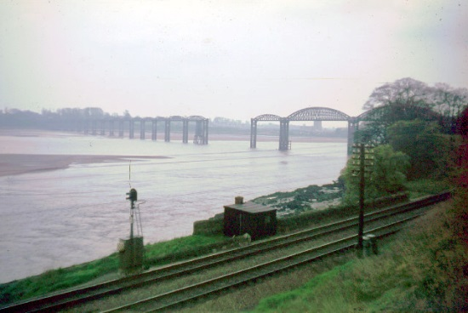
- Donibristle Naval Air Station in Fife was built close to the Forth Rail Bridge. Uses now include an industrial estate and a new settlement called Dalgety Bay, which was created in 1962 as Scotland’s first Enterprise town and which forms a dormitory suburb of Edinburgh. Many former aerodromes created in the First and Second World Wars have also found new uses.
  - Newark Airfield is now an agricultural ground.
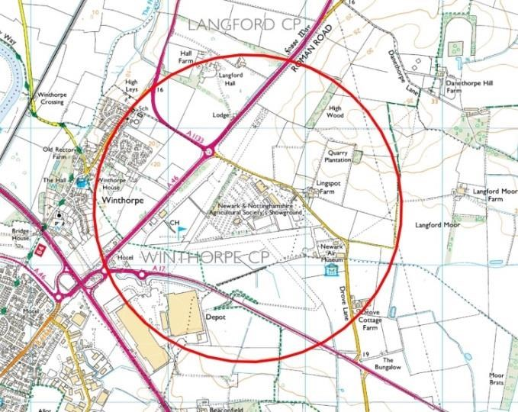

- Thirsk Airfield is now a turkey farm.
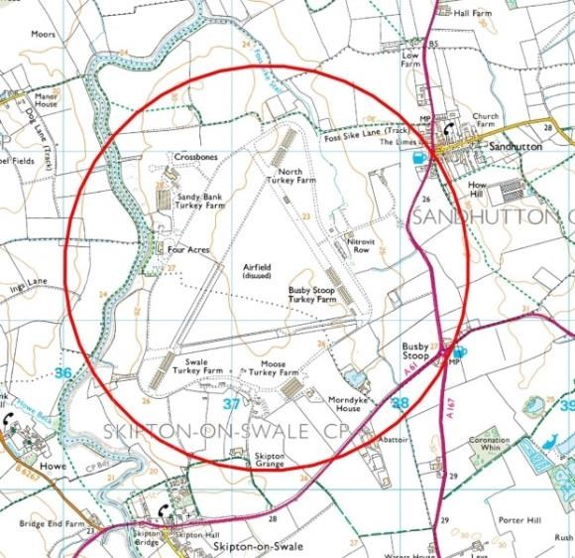
- Are there any in your area?

Piers
The seaside piers around the coast of Britain stand as a powerful reminder of the achievements of Victorian engineers and entrepreneurs. At the turn of the 20th century almost 100 existed. Today only around half that number remain, and several face an uncertain future. Some have succumbed to flames, most recently Eastbourne pier in August 2014. Pictured is Royal Pier in Southampton.
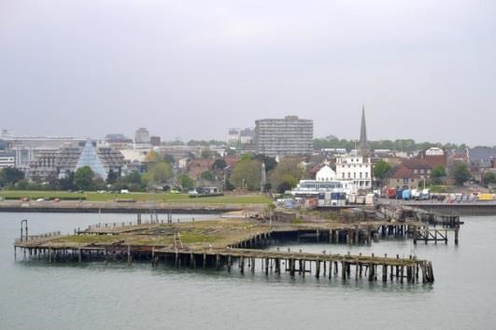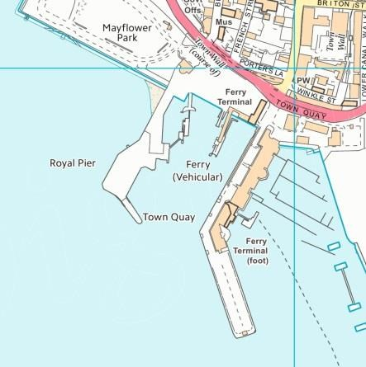

Many resorts had a pier as an extension of their promenade, and to host additional entertainment, such as theatres and amusement arcades.
Is there a pier in your area living a precarious existence? Some like Southampton’s Royal Pier are little more than a shell but plans exist to spend over £300 million on a project (https://piers.org.uk/pier/southampton-royal-pier/) to transform the Southampton waterfront which will include the Royal Pier.

A list of piers that still exist can be found at https://piers.org.uk/

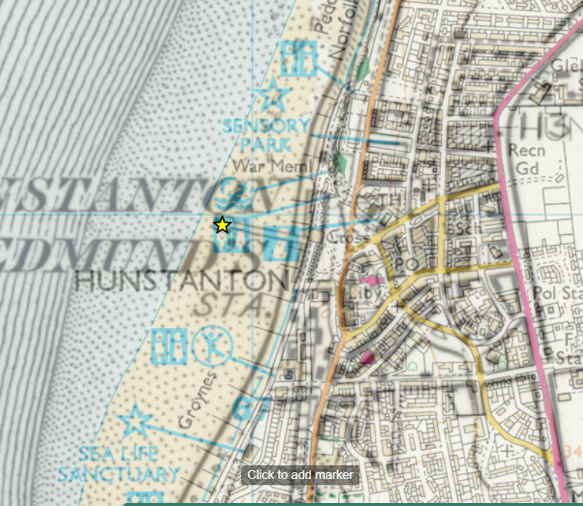
- Using the historic layer identify some piers some existed in the 1890s and have now disappeared. You may wish to ask students to play detective and identify these lost piers e.g. Hunstanton – can students uncover the lost stories of these structures and ‘pier’ into the past?
- Ask your students to consider why so many have been lost. Is it simply that people go abroad more now, or are there other factors? What makes a modern pier viable?
- Can you think of a location that does not have a pier but could do with one? Use the annotation toolbar to draw or annotate where you would locate it. Suggested locations could be where there was a lost pier, or where there never was one in the first place. The success of Southwold’s new pier could be used as an example. See http://www.southwoldpier.co.uk/
- If coastal piers are prone to sea damage, how about locating more piers in estuaries, on inland lakes, or in locations that are not necessarily covered by water, for example to give an elevated view above marshes?
- What do your students think about the new vertical pier in Brighton? Is this a pier? https://en.wikipedia.org/wiki/British_Airways_i360

Metroland: A case of ribbon development
In 1919 the Metropolitan Railway used a separate company called Metropolitan Railway Country Estates Limited to sell off surplus land for housing development. The result was a ribbon of housing development along the railway lines of the Metropolitan Railway spanning the counties of Buckinghamshire, Hertfordshire and Middlesex. The construction of tube railways and stations in this area followed the housing development.
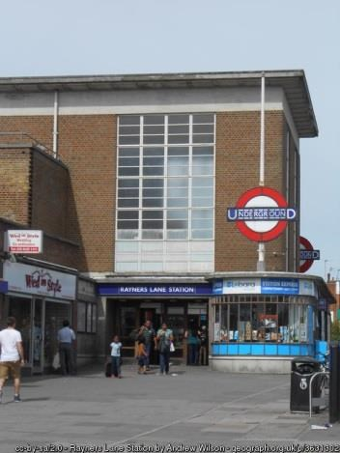
Rayners Lane Tube station – Harrow, West London
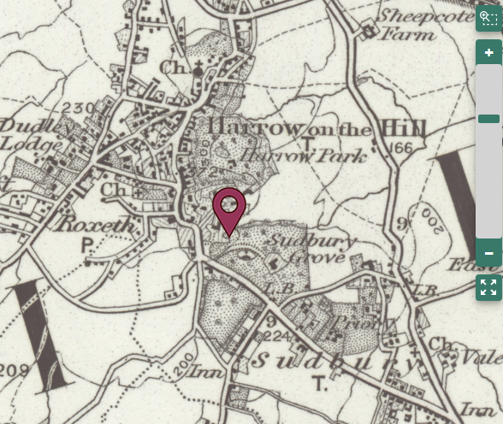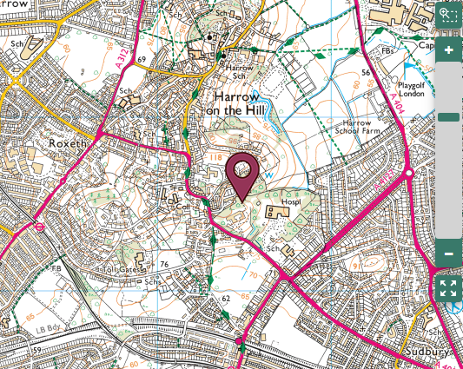

- Locate Harrow on the Hill and using the historic layer note that the area in the 1890s was largely rural, but with railway lines already in place. The modern map shows that the whole area is now largely filled in with housing.
- Ribbon development has occurred along many transport arteries, initially following the development of railways and latterly new roads. You can probably identify a similar example in an area near to you.
- Does modern housing follow transport routes in the same way, or would that be a disadvantage? The recent change to housing policy has meant that people are concerned that open space in those areas close to our large cities may be built upon. Students could also compare the layout of areas of housing in the present-day with those from the 1890s.
- Similarly, housing used to be sited close to industrial developments as many workers walked to their place of employment. Modern day commuting patterns mean that most people choose to live away from the place where they work.

Fields of shops
In order to preserve green space, recent planning regulation has encouraged re-use of brownfield sites. More controversially 16 of these sites were made into large, out-of-town indoor shopping centres (Under current planning policy no more will be permitted). Here is the list of 16 to look at on the modern map and the 1890s: http://en.wikipedia.org/wiki/List_of_out-oftown_shopping_centres_in_the_United_Kingdom
It includes the following:
- Brent Cross, opened in 1976, which was the first one.
- Bluewater in Kent, which is within an old chalk quarry (woodland in 1890s).
- Meadowfield in South Yorkshire, which is on the site of an old steel works.
- In London, Westfield Stratford City, which is sited close to the Queen Elizabeth Olympic Park on old railway land.
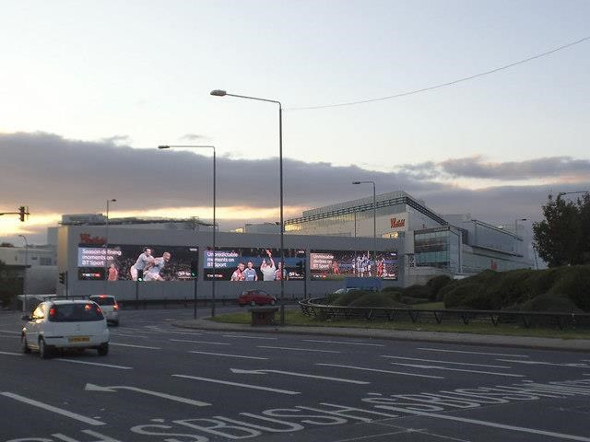
Westfield London – Shepherds Bush London
How big are these sites? Are their names an attempt to disguise the industrial scale of these sites or do they simply reflect a previous use of the land? If they are so successful, why are no more going to be built? Does their popularity reflect our busy modern lives, and the need for convenience?

New Towns
The original garden city movement, led by Luke Howard, saw the creation of places such as Letchworth and Welwyn Garden City. The New Towns Act of 1946 and later legislation enabled the creation of more new settlements. This enabled the dispersion of population to overspill areas beyond the green belt and helped to alleviate housing shortages resulting from bomb damage.
Example: Milton Keynes was in the third wave of new towns (1967 to 1970) and is sited approximately halfway between London and Birmingham. What were the names of the villages that were ‘lost’ in this development? Is there any sign of their previous identity in modern Milton Keynes?
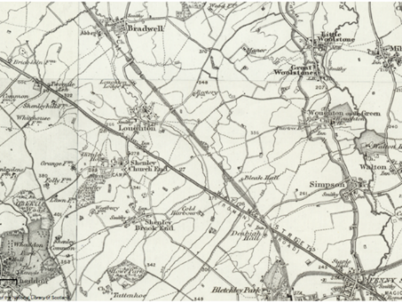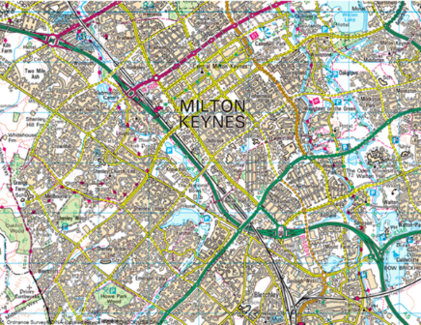
- Wherever large-scale housing development takes place, people who live there now are likely to object, as many of the reasons that attracted them to live there in the first place are threatened. One of the things people dislike is extra traffic.
- Towns often grew up along railway routes, but in the 1960s many routes were scrapped (see: http://en.wikipedia.org/wiki/Beeching_cuts ) Suggest to your students that in order to avoid more road congestion, the government will only support a new town proposal if the new residents can access the railway network. Students can either look at the options for reinstating a railway line that was on the 1890s map, but has since disappeared, or look at adding a new station to an existing line to find a suitable place for a new town taking up 25 square km?
- One example is the Leamside line which encompasses Durham, Washington and Pelaw in the NE of England. The line was closed in 1991 by British Rail and since then there have been various reviews for re-opening the line as a regional passenger railway. The line was lifted in 2013, but the track bed is to be protected for possible re-instatement in the future if required.
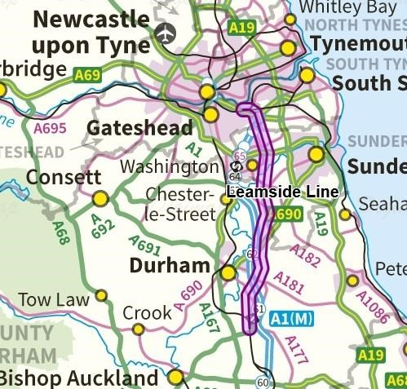

Copyright
©EDINA at the University of Edinburgh 2016
This work is licensed under a Creative Commons Attribution-Non-Commercial Licence

Acknowledgements
© CollinsBartholomew Ltd (2019) FOR SCHOOLS USE ONLY
© Crown copyright and database rights 2020 Ordnance Survey (100025252). FOR SCHOOLS USE ONLY.
Aerial photography © Getmapping plc. Contains OS data. FOR SCHOOLS USE ONLY.
Historic mapping courtesy of the National Library of Scotland. FOR SCHOOLS USE ONLY.

