Then and Now Quiz Maps
Alan Parkinson
Geography teaching resource

Secondary
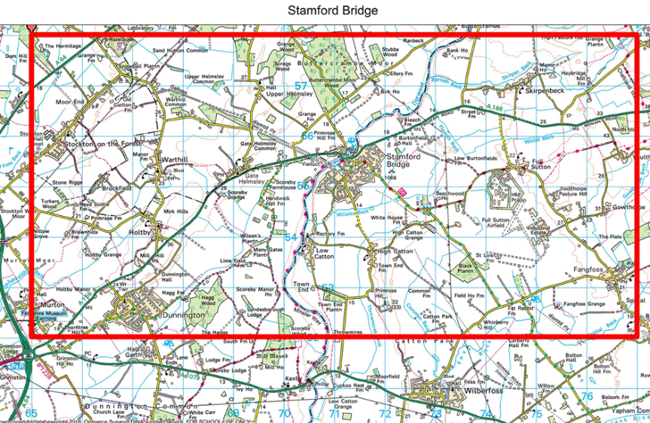

Contents
Content and Curriculum Links 3
Activity 3
Introduction 3
Main activity 3
Then and Now Quiz 4
Make your own ‘Then and Now’ Quiz 7
Tips 7
Taking it further: 7
Stamford Bridge Quiz 8
Saline Quiz 9
Caersws Quiz 10
Copyright 11
Acknowledgements 11

Content and Curriculum Links

Level | Context | Location
Secondary | Locating  Comparing | UK: separate quizzes for England, Scotland & Wales

Activity
Improve students understanding of changes in the landscape over the past 120 years by comparing 1890s historical mapping to a map of the present day. Using a quiz format this activity encourages them to look closely at the locations to find the answers to 10 questions for each of the three locations.
The accompanying power-point contains the maps and the quiz answers. The second part of the activity instructs students how to create their own quizzes in this format.

Introduction
Change happens constantly, and maps can be regarded as a snapshot in time. Comparing a map of the 1890s with a modern map of the same area can reveal a great deal about how people’s lives have changed in the last 120 years.
Examining the two maps can also help your students to better understand old maps, which may use some different map symbols and cartographic methods.

Main activity
This activity asks you to compare two maps, one from the 1890s and one from the present day to answer 10 quiz questions.
You can then create your own quiz map to challenge your friends or family.

Then and Now Quiz
Choose one of map areas you would like to study. Find the area in Digimap for Schools by entering the name in the search box.
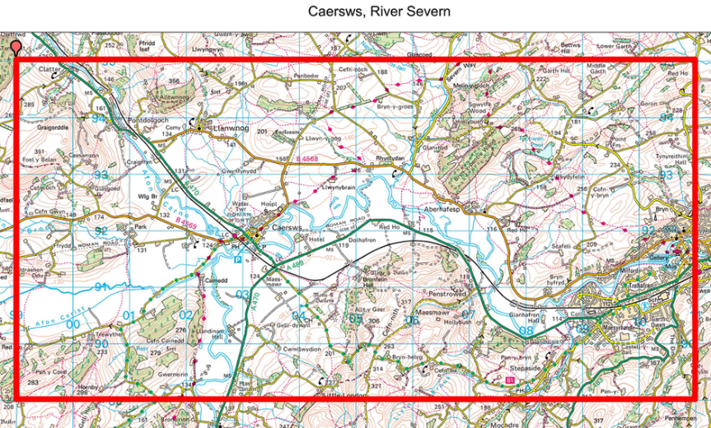
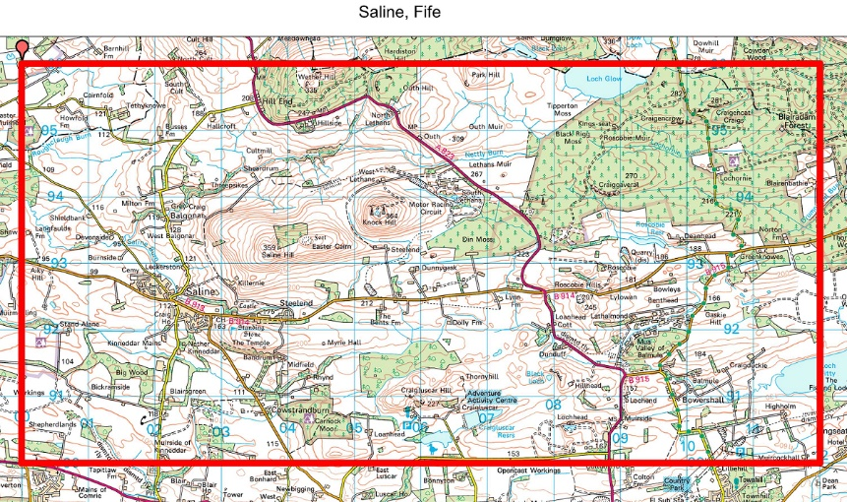

- Zoom in and out to understand where you chose is in relation to where you live.
- Create a red box around the quiz area you have chosen in Digimap for Schools using the following method. Learning how to do this will help you create your own quiz later. To do this:
- First open the Overlays menu. Check British National Grid to make the numbers clearer.
- Find the top left hand corner of the map you chose by entering the grid reference for one of these three points. Put a marker on it this point when you find it.
- SE 660 580 (Stamford Bridge)
- NT 000 960 (Saline, Fife)
- SN 980 950 (Caersws)
- Using the Drawing Tools choose ‘Draw and create’ and choose the rectangle.
- Choose red for the outline with a thick line style.
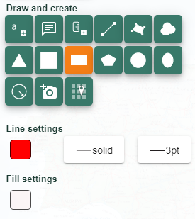
- Set the Fill to be totally transparent – the setting is circled in red in the image below.
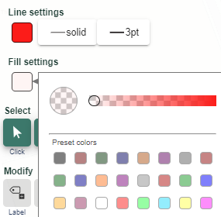
- Click on the map where you want to start drawing (at your marker) and draw a box 6 squares long and 12 squares wide. Click again to finish drawing. You can use your keyboard arrow keys to move the map while you do this.
- You can access the historical mapping by opening the Map Selector tool. Select the button to the right of any map to view on its own. Use the slider bar to fade one map into the other.
- You are now all set to answer the quiz questions.
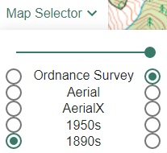

Make your own ‘Then and Now’ Quiz
Its easiest to choose an area you are familiar with, perhaps near where you live now or somewhere you have visited. Draw the boundary as recommended above. If you need to move the box you can select and drag it to a new location. Create a table in Word and fill it out with your own questions. Make another copy with the answers on for marking. Here are some ideas to help you make your questions, try to get a mixture of these sorts of questions in your quiz.
- Have any names been changed?
- Look for evidence of past industry that now no longer exists, or new industry since started.
- Does anything now have a different purpose? For example, an old quarry may now be a fishing lake.
- Has the vegetation changed significantly?
- What sort of new roads have been added?
- What things are the same as the 1890s, but are shown in a different way on the modern map?
- Has any form of transport been lost or added?
- Do rivers change course, have extra bridges or disappear?
- What modern infrastructure has been added, for example power lines, wind turbines etc
- Where did the local children go to school in the 1890s, has this changed?
- What tourist attractions now exist?

Tips
- Working across the map square by square using the tool which fades one map into the other will help you spot changes you can make a question about.
- Try to avoid questions that require someone to look things up somewhere else. As many questions as possible should be answered just using the information on the map.
- Aim to have a spread of questions across the map rather than all in one place.
- Test your quiz with just one person and amend your questions based on their feedback.

Taking it further
- Create a quiz map suitable for children younger than you, making the questions easier.
- Create a quiz map for which uses the 1950s maps instead of the 1890s map.
- Create a quiz that also makes participants look for clues in the aerial mapping

Stamford Bridge Quiz
 | Question | Answer
1 | Find Hatkill Field on the old map, what has been built there since?
2 | Today it is called Snowball Plantation. What was this farm called before?
3 | Do you think that there has been a significant loss of woodland since 1890?
4 | An important line is on the present-day map running North East across 3 km. It is not a road or river and is not on the old map. What does it carry?
5 | Full Sutton Airfield and the Industrial Estate are now on what was Common land. What ‘visible archaeological earthworks’ have disappeared?
6 | There was one in square 7455 and another in 7357. Yet another in 6752. In fact most villages had one of these places for shoeing horses and other work. None are noted on the modern map. What were they?
7 | In square 7055 a structure still exists that was built to carry one of the biggest transport features of the old map. What is it?
8 | The southernmost station is now a farm which implies heavyweight bunnies. What was the name of the station?
9 | The old Roman Road is shown on both maps but just to the south two names have disappeared. Can you name them both?
10 | Part of the old railway line is now used to train horses. Its name suggests they go very fast.
 | Bonus Point – what other battle took place in 1066!

Saline Quiz
 | Question | Answer
1 | Find the attraction at 093 918 which did not exist in the 1890s
2 | In square 0790 there was an industrial works creating what?
3 | Look in the lowest squares on the old map three of them reference an industry. What is it?
4 | Do you think people have more fun in this area than in the 1890s? What evidence on the map suggests they might?
5 | In the 1890s people lived at Bickram village in square 0091 but no longer. Perhaps some of them moved 4km away to a new place with a ‘metallic finish’? What is its name?
6 | Is there more or less forest here than in the 1890s?
7 | Something old is shown on Saline Hill, but it is not on the old map. What is it?
8 | Who lived in a cottage at 105940?
9 | What feature on the modern map in square 0290 might now be disused?
10 | What strangely southern name has now been given to North Burnside in square 0193?
 | Bonus Point – What type of trees have been planted in the new woods?

Caersws Quiz
 | Question | Answer
1 | Do you think the population of Caersws is now smaller than the 1890s, about the same, or much bigger?
2 | North of Caersws is a hospital, what was it in the 1890s?
3 | In square 0093 what provided the power for the Mill in the 1890s
4 | Both maps show contour lines and heights, but what extra map symbol is there on the modern map to warn motorists that a road is very steep? There are several examples in the top half of the map on the yellow roads.
5 | How did the people in the house called Wig at 013924 get their water in 1890?
6 | Look at the river between Caersws and Aberhafesp. Has this changed its course at all in the last 120 years?
7 | How did they cross the river without a bridge in 1890s? Look south of Caersws for an example, but it is no longer there today
8 | The line still exists, but what station has disappeared towards the East
9 | What has Maesmawr Hall near Caersws been turned into?
10 | What sport is now played at 041904?
 | Bonus Point – The additional settlement in the south east of the map is an extension of which town?

Copyright
©EDINA at the University of Edinburgh 2016
This work is licensed under a Creative Commons Attribution-Non Commercial Licence

Acknowledgements
© CollinsBartholomew Ltd (2019) FOR SCHOOLS USE ONLY
© Crown copyright and database rights 2020 Ordnance Survey (100025252). FOR SCHOOLS USE ONLY.
Aerial photography © Getmapping plc. Contains OS data. FOR SCHOOLS USE ONLY.
Historic mapping courtesy of the National Library of Scotland. FOR SCHOOLS USE ONLY.

