The maps of literature

Will Tuft

The impact of location on Scottish literature

P3-S3 English and literacy resource
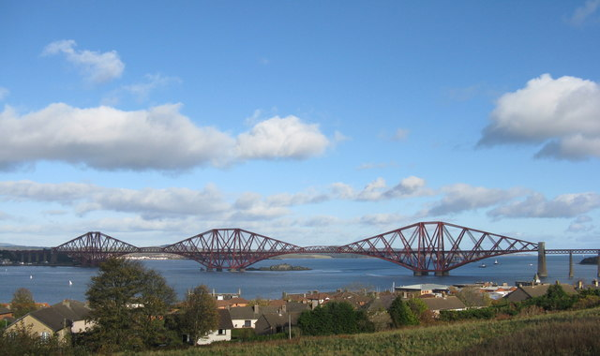
The Forth Bridge at Queensferry
cc-by-sa/2.0 - © M J Richardson - geograph.org.uk/p/5592738

Contents
Contents 2
Content and Curriculum Links 3
Introduction 4
Starter 4
Activity 4
Suggested tasks 6
Extension 7
Plenary 7
Copyright 8
Acknowledgements 8

Content and Curriculum Links
Scottish Curriculum for Excellence | LIT 3-25a  I can use notes and other types of writing to generate and develop ideas, retain and recall information, explore problems, make decisions, generate and develop ideas or create original text. I recognise when it is appropriate to quote from sources and when I should put points into my own words.  I can acknowledge my sources appropriately.  LIT 3-07a  I can show my understanding of what I listen to or watch by commenting, with evidence, on the content and form of short and extended texts.  LIT 3-13a  I can select and use the strategies and resources I find most useful before I read, and as I read, to monitor and check my understanding.

Learning Intention
How do geographical locations affect the story or characters in Scottish literature?

Success Criteria:
- All pupils will identify locations in written text.
- Most pupils will learn how to describe locations using text.
- Some pupils will learn how to use maps to understand emotion in literature.

Equipment
- Tablets
- DIgimap for Schools
- Original text

Time allocated
1-? Hour(s) dependent on how much of the text the class is looking at.

Introduction
These lessons are generic in focus, especially as the range of texts used in schools is so large. But the usage of maps to understand literary texts is a high-level skill. Studying a text such as Dracula requires a keen understanding of location, as do the novels of James Joyce or JM Coetzee, so using mapping tools to glean an understanding of how location underpins the happenings in a story is an important activity for progression. For the purposes of these lessons, I will be using Kidnapped by R L Stevenson but the tasks, activities and approaches can be used for any text with even the slightest geographical/locational bias.

Starter
Provide/project/ask pupils to read a passage of text. The passage will be selected by the teacher, for example: https://www.undiscoveredscotland.co.uk/usebooks/stevenson-kidnapped/chapter05.html

Pupils have to identify or highlight each time a location or place is mentioned in the passage. This idea of reading for content with a location focus should encourage the imagination of pupils to ‘see’ what is written rather than just reading it. It also provides a start to the locational theme of the lesson/task. This can be conducted on tablets and highlighter tools used. To develop this as a class activity, the passage could be placed into a Onenote document and annotated as a group to extrapolate locational details.

Activity
- Preselect the passage the class are going to work with and locate the places in Digimap for Schools, perhaps only the places that are included in the chapter you will be working with.
- Adding quotes from the text by dropping markers and adding labels gives pupils an even clearer idea of location and the journey that is being taken.
- Below: locations from chapter 5 of Kidnapped:

These quotes could then be placed in chronological order by pupils and the ‘journey’ between quotes identified on the map via directional arrows.

Alternatively, you could ensure all pupils had access to Digimap for Schools and could work with it in real time by adding their own label, quotes and placemarks where they saw fit.

Suggested tasks

The following suggestions are generic tasks that could be applied to the text you are working with both from maps made by a teacher and maps being made by pupils…
- Identify the spot where X makes their speech, what could they see around them?
- Below: Imagine you are with the protagonist at the placemark, what can you see all around you? What evidence do you have?

- If X travelled West, what do you predict may happen in the next chapter?
- Plan X’s route through the city to escape.
- Why could X see the whole city from there?
- In which direction is X facing? Why may that be important?
- What links the placenames in this chapter?
- X describes being in a small space. Measure the location you think it is, is it that small? Do X’s emotions play a part in perceiving it as small?
- In these locations, how do the pair know where they are going?
- Having read the text and seen the map, what do you want to know about the location?
- Map the route of the characters in this chapter and find quotes that support the route you have drawn (below).

These tasks could be extended to cover an entire text or be limited to one lesson on a small section of text, it is entirely up to the discretion of the teacher.

Extension
This entire activity could be set as a parallel topic as revision for an individual pupil. Younger pupils could build up their map of a text over a series of weeks and present a detailed, finalised map at the end of the text that encompasses a range of presentation and comprehension tasks. The tasks mentioned could be differentiated by identifying certain pupils to complete certain tasks, either suiting their interests of challenging their abilities. For example, a weaker pupil could be provided with a completed map of the text and then locates each chapter onto the map for the whole class, to provide responsibility for a pupil who may struggle to access the text at times.

Plenary
Any summaries for this would be dictated by the text, the analysis that was applied to it and the ability of the pupils. One option could be to select one sentence with a locational marker within in and discuss as a class what the pupils have found out from the maps about the area.

Copyright
©EDINA at the University of Edinburgh 2016.
This work is licensed under a Creative Commons Attribution-Non Commercial Licence.

Acknowledgements
© CollinsBartholomew Ltd (2019) FOR SCHOOLS USE ONLY.
© Crown copyright and database rights 2020 Ordnance Survey (100025252). FOR SCHOOLS USE ONLY.
Aerial photography © Getmapping plc. Contains OS data. FOR SCHOOLS USE ONLY.
Historic mapping courtesy of the National Library of Scotland. FOR SCHOOLS USE ONLY.

