Coastal Mysteries

Characteristics and change of three contrasting localities
Paula Owens
Geography Teaching Resource
Primary

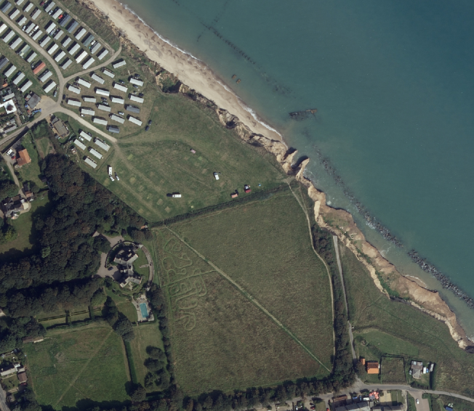

Contents
Contents 2
Digimap for Schools Geography Resources 3
Content and Curriculum links 3
Introduction 4
Main activity 4
Taking it further 5
Web links 5
Coastal Mysteries Worksheet 7
Copyright 8
Acknowledgements 8

Digimap for Schools Geography Resources
These resources are a guide for teachers to demonstrate to the whole class or direct individual students as appropriate. Each activity has several ideas within it that you can tailor to suit your class and pupils. Some resources contain worksheets for direct distribution to pupils.
https://digimapforschools.edina.ac.uk/

Content and Curriculum links

Activity
Matching images to maps by reading map features, discussing similarities and differences, identifying and explaining change in three different coastal areas.

Level | Context | Location
Primary | Characteristics and change of three contrasting localities | Happisburgh, Brighton, Tenby

Knowledge | Read and Interpret maps, understand some reasons why and how places change
Curriculum links (England) | Name and locate counties and cities of the United Kingdom, geographical regions and their identifying human and physical characteristics, and understand how some of these aspects have changed over time
Curriculum links (Wales) | Identify similarities and differences to describe, compare and contrast places and environments; describe the causes and consequences of how places and environments change
Scottish Curriculum for Excellence | Social Studies Outcomes: People, Place and Environment: SOC 2-07b, SOC 2-08a, SOC 2-08b

Introduction
Places are continually changing and this can be due to many influences. This activity compares three different places to enable pupils to discuss human and physical features, patterns of land use and change.
Happisburgh, a town on the Norfolk coast, is suffering coastal erosion at an alarming rate. The sea is eroding the ineffective sea defences; washing away the low cliffs and breaching large areas of unprotected, low lying land. This has led to people losing their homes and suffering financial loss.
Tenby used to be a fishing village but has developed into one of the major tourism resorts in South Wales. Instead of fishing, you are more likely to see fishing boats taking out day trippers, and the town has many hotels, cafes and other services catering for tourists.
Brighton has always been a popular tourism town and its development has been aimed to keep this industry thriving. Many people here rely on tourism for jobs.

Main activity
- Use the images provided on the accompanying PowerPoint to introduce three different coastal resorts. There are six images: each pair shows a different coastal town. Pupils have to match the images to the places shown on the map.
Have prepared three maps at the same scale and give pairs of groups of pupils a printed version to work from. An alternative would be to give pupils the photographs and let them find these maps themselves and view them on the computer screen.
See the accompanying PowerPoint for these maps:

- Map A Happisburgh Grid Reference: TG 379 310
- Map B Brighton Grid Reference: TQ 309 041
- Map C Tenby Grid Reference: SN 132 006
- Discuss the features shown on the maps and in the photographs. How easy is it to match them? Use the photos and maps to discuss what these places are like. Ask pupils to talk with a partner and make notes on their map about the characteristics of each place and compare.
- Ask pupils to think about the changes that have happened or are happening in each location. Discuss the reasons for change and what these places might look like in the future. All of the places have connections with tourism as many coastal places do. Discuss how tourism is either flourishing or dying out and why.
- Ask pupils to choose one of the locations and annotate a map with labels identifying the key characteristics and features. Write a report on this place and what it might feel like to live there now and/or in the future.
- Look back in time at these three locations using the 1890’s and 1850’s maps. Which location has changed the most and which one has changed least.

Taking it further
- You can use the image Search tool in Digimap for Schools to find images. (The images displayed are from Geograph, an online library of images of the UK that is open to anyone for contributions). Create your own coastal mystery and see if another group can match the images to the map.
- Select Image Search from the sidebar and enter your search terms to find matching images. NOTE: you can also enter an asterisk to see all available images at a location but only in the 5 most zoomed in maps.
- Use fieldwork to investigate changes taking place in your locality and take photographs to show what is happening.
- Use the ‘Add an image’ tool in the Drawing Tools to add these to an annotated map of your locality.

Web links
Geograph Images http://schools.geograph.org.uk/
Happisburgh erosion http://www.geograph.org.uk/photo/799574
Brighton Seafront http://www.geograph.org.uk/photo/24607

Coastal Mysteries Worksheet
Make notes to help you explain the changes that are happening in these locations. You could add another location of your own choosing to compare.
Location | Main human and physical characteristics | Evidence of change | Reasons for change
Tenby

Brighton

Happisburgh

Copyright
©EDINA at the University of Edinburgh 2016
This work is licensed under a Creative Commons Attribution-Non Commercial Licence

Acknowledgements
© CollinsBartholomew Ltd (2019) FOR SCHOOLS USE ONLY
© Crown copyright and database rights 2020 Ordnance Survey (100025252). FOR SCHOOLS USE ONLY.
Aerial photography © Getmapping plc. Contains OS data. FOR SCHOOLS USE ONLY.
Historic mapping courtesy of the National Library of Scotland. FOR SCHOOLS USE ONLY

