How many beats in a mile?

Will Tuft

Mapping and Graphing

Age 7-11

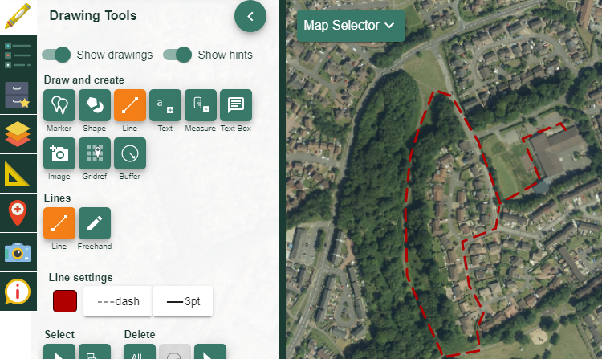

Contents
Contents 2
Digimap for Schools Geography Resources 3
Content and Curriculum Links 3
Introduction 4
Starter 5
Create a graph 7
Forming conclusions 8
Extension 8
Plenary 9
Copyright 10
Acknowledgements 10

Digimap for Schools Geography Resources
These resources are a guide for teachers to demonstrate to the whole class or direct individual students as appropriate. Each resource has several ideas within it that you can tailor to suit your class and pupils. Some resources contain worksheets for direct distribution to pupils.

Content and Curriculum Links
Scottish Curriculum for Excellence | HWB 2-22a / HWB 3-22a  I practise, consolidate and refine my skills to improve my performance. I am developing and sustaining my levels of fitness.  HWB 2-25a / HWB 3-25a  I am experiencing enjoyment and achievement on a daily basis by taking part in different kinds of energetic physical activities of my choosing, including sport and opportunities for outdoor learning, available at my place of learning and in the wider community.  MNU 1-03a  I can use addition, subtraction, multiplication and division when solving problems, making best use of the mental strategies and written skills I have developed.  MNU 2-20a  Having discussed the variety of ways and range of media used to present data, I can interpret and draw conclusions from the information displayed, recognising that the presentation may be misleading.  MNU 1-20b  I have used a range of ways to collect information and can sort it in a logical, organised and imaginative way using my own and others' criteria.  MTH 3-21a  I can display data in a clear way using a suitable scale, by choosing appropriately from an extended range of tables, charts, diagrams and graphs making effective use of technology.

Learning Intention
How does our Daily Mile affect our pulse?

Success Criteria:
- All pupils will learn how to measure their pulse rate.
- Most pupils will learn how to map a route using Digimap for Schools.
- Some pupils will learn how to use data to graph information.

Equipment
- Note pad.
- Digimap of local area with 0.5 mile buffer.
- Hi Vis vests for the walk.
- Tablet (if available).

Time required
Afternoon session (x2)

Introduction
A large number of Primary schools in Scotland take part in the Daily Mile initiative:
https://thedailymile.co.uk/

Building on Alan Parkinson’s previous work on mapping the route of these miles, this lesson looks to build a range of numeracy and health and well-being Experiences and Outcomes into this daily activity. Often, pupils do not identify how numeracy and mapping can be used in their everyday lives, particularly at Primary level.

The focus of the lesson is to engage pupils with their local area by combining the aspects
of mapping, health and numeracy. This is done through movement, mapping and graphical creation. The lesson is designed to either act as a standalone task to embed numeracy/mapping or could be used as part of a unit looking at data processing and presentation, which could then lead onto larger data presentation projects in numeracy or the Sciences.

Starter
- Project an image of somewhere within 0.5 miles of the school site alongside a map from Digimap for Schools of the area with a 0.5 mile buffer zone.
- Use the buffer tool in the Drawing Tools menu:

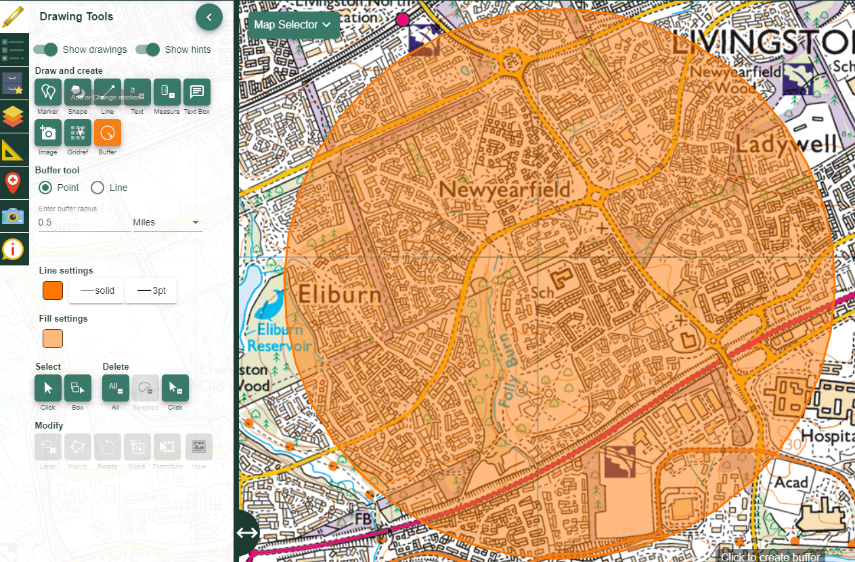

- Ask pupils where they would like to go in the area if they had the chance and why.
- Use directed questioning to establish where they find interesting and why.

Activity
- As a class, identify and map a route for the daily mile on the board. Use the line tool from the Drawing Tools to draw the route onto the board.
- It must include one lap of the playground but utilising the map symbols and information from the starter, link in where pupils would like to go.
- Open the Key on the left of the map. Encourage pupils to identify symbols of interest.

- Model how to measure your pulse rate:
  - https://www.bhf.org.uk/informationsupport/tests/checking-your-pulse
- Ensure that all pupils can do this by getting them to show a partner and count out the beats they feel on their own wrist.
- Use the counting for 6 seconds and multiplying by 10 method to work out a pulse rate.
- During the mile, get pupils to stop every 2-3 minutes and measure their pulse. Note down the pulse, location and time.
- For one side of the playground lap, get pupils to walk as fast as they can and take their pulse at the end.
- Return to the classroom and ask pupils to map the route, remembering the way they walked and the map from earlier (this can be a printed version or left on the board).
- They need to add text at the points where they took their pulse and note the heart rate at that location. The Drawing Tools text option can be used.

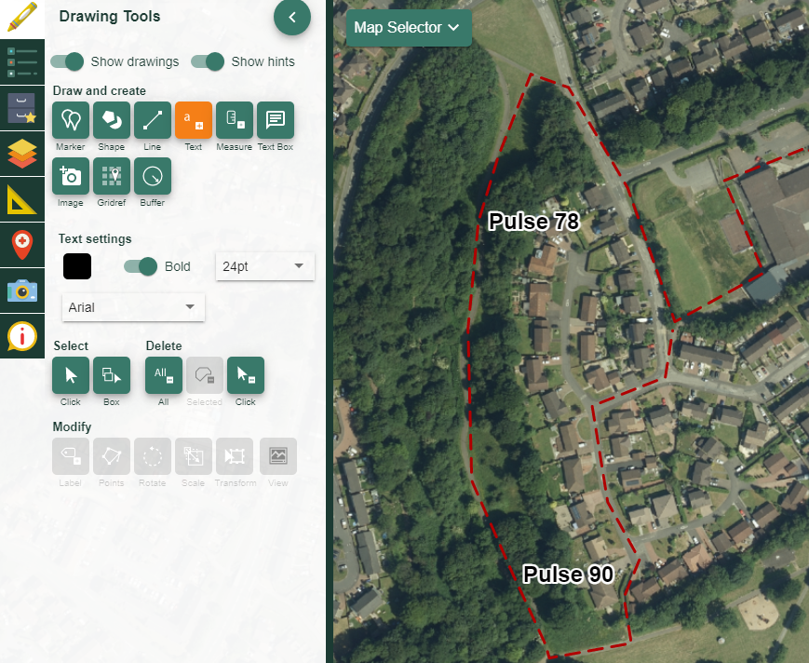

Create a graph
- Using the data they have collected, pupils are now to use excel or hand draw a graph to show their pulse rate over the mile. Use distance for the x axis and pulse for the y.
- Encourage pupil to go back to the map and measure the distances between data to make the x axis as detailed as possible (see below).
- Alternatively, something like the graph below could be created by each pupil to sit alongside their mapping.

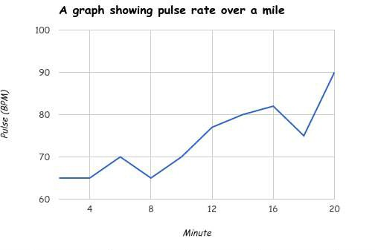

Forming conclusions
By now combining the map, graph and experience, pupils can now start to form conclusions about their pulse and how it has changed, by offering geographical features such as hills or temporal aspects such as being scared by a friend that may have led to a change of pulse rates.

The expectation is that pulse rate will quicken over the journey but this may not be the case. The task develops mapping, data presentation, conclusions and the ability to link seemingly unrelated information together.

Extension
Further the connections in the conclusion aspect to make links with scientific
explanation for the changes in pulse rate. To enhance the mapping difficulty, the route could be colour coded to show how pulse rate changed, displaying the ability to group information to create a pseudo-choropleth map.

Plenary
Ask pupils to write a 5-step plan to one of the following tasks:
- measuring your pulse (basic),
- making a route on Digimap for Schools (standard),
- or summarising their conclusion into 5 bullet points (most difficult).

Copyright
©EDINA at the University of Edinburgh 2016.
This work is licensed under a Creative Commons Attribution-Non Commercial Licence.

Acknowledgements
© CollinsBartholomew Ltd (2019) FOR SCHOOLS USE ONLY.
© Crown copyright and database rights 2020 Ordnance Survey (100025252). FOR SCHOOLS USE ONLY.
Aerial photography © Getmapping plc. Contains OS data. FOR SCHOOLS USE ONLY.
Historic mapping courtesy of the National Library of Scotland. FOR SCHOOLS USE ONLY.

