Square of the Year

Understanding features within a grid square

Alan Parkinson

Geography Teaching Resource

Secondary

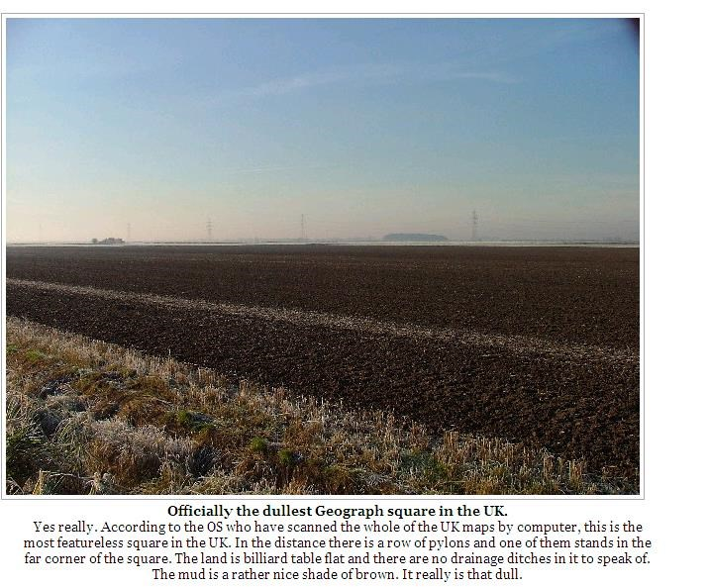
Contents
Digimap for Schools Geography Resources 3
Content and Curriculum Links 3
Activity 3
Introduction 4
Main activity 5
Square of the Year 8
Taking it further 12
Web links: 12
Copyright 13
Acknowledgements 13

Digimap for Schools Geography Resources
These resources are a guide for teachers to demonstrate to the whole class or direct individual students as appropriate. Each activity has several ideas within it that you can tailor to suit your class and pupils. Some resources contain worksheets for direct distribution to pupils.

Content and Curriculum Links
Level | Context | Location
Secondary | Understanding features within a grid square | Could be done with any GB map extract, including locally to the school.

Knowledge / Skills | Zoom levels, map symbols, printing maps
Curriculum links (England) | Map Symbols/Literacy
Curriculum links (Wales) | Locate places and environments using atlases and maps. Use six figure references and 1: 25 000/1: 50 000 maps. Use maps, plans and ICT to interpret and present locational information
Scottish Curriculum for Excellence | Social Studies Outcomes: People, Place and Environment:  0.07a, 1.07a, 1.14a

Activity
This activity involves creative writing, and a detailed examination of just one grid square of mapping. The writing can be done using the drawing tools of Digimap for Schools, or a printout can be produced, and the writing done separately.
This is an activity that will require students to think ‘inside the box’ for a change.

Introduction
Look at this image. What do you think it is?
This is SE8322 which has been nominated the least interesting map square at 1: 50 000 scale. All that is shown a small section of electricity transmission line and the edge of some text.

Main activity
- This activity begins by your students locating the ‘most boring grid square in the country’ using Digimap for Schools.
- It can be found easily by typing SE8322 into the search box.
- You may find it useful to add the national grid layers to the map:
  - Open Overlays.
  - Check British National Grid lines.
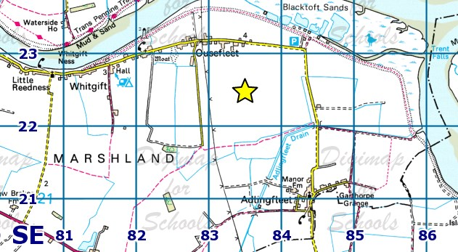
- To find out what it looks like in real life, try:
  - Open the Map Selector and select Aerial mapping.
  - Open the Image Search and enter an asterisk (*) to see all available images.
  - The image below is an image of our grid square from Geograph (an online library of images). Notice that the caption on the image says ‘UK’. Ordnance Survey maps are of Great Britain. (Northern Ireland produce their own maps). Many adults mix up UK and GB. Make sure your geography students are secure in understanding the difference between GB, UK and the British Isles!

- Now ask them to zoom in and they will see that the square is far less empty of features than first suggested. What additional detail is added or taken away as they change the zoom level? Discuss why this detail is not shown on the smaller scale map.

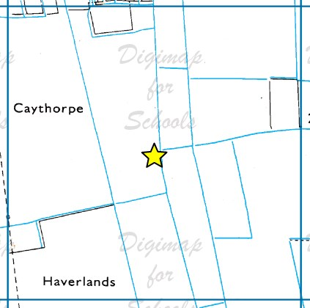

- As maps are zoomed in to larger scales there are many empty grid squares, but information that is shown is very detailed. For example, see the image below:

- Having considered what makes a grid square dull, students should now find one that they find most interesting and enter it for ‘Square of the Year’ using the hand-out(s) provided. It is suggested that students all use 1 km grid squares mapped at 1:25 000, and that they use the second level of zoom, so that results are comparable to each other.
Students need to choose their square promptly so you may wish to set a time limit for that and have some suggestions to hand. Here are a few ideas:

Edinburgh Castle | NT 252 735
London Eye, Thames and Parliament | TQ 307 799
GCHQ | SO 915 223
Alton Towers | SK 070 429
Media City | SJ 803 974
They should write a description of their square which makes it sound as if it is the best square of any on the whole map. Encourage students to use descriptive language to explain why the features are impressive, large, beautiful, stunning and so on. A template could be provided with some sentence starters for those students who may struggle to get going with a blank piece of paper.

Square of the Year
- You are going to be working with just one grid square of 1 square kilometre, using the 1:25000 mapping at its larger zoom level. You can check you are using the 1:25000 mapping in the Map Information menu, shown in the image below:
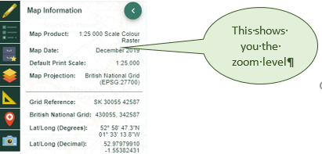

- Open the Overlays menu and check the British National Grid box, shown in treh image below.
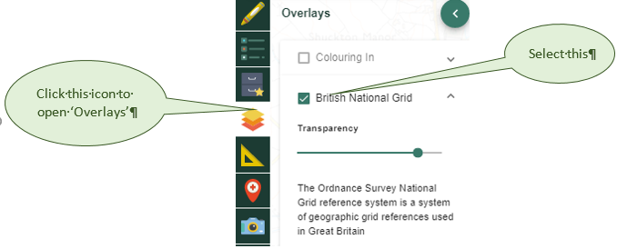

- Explore the map until you find a square that you think could be really interesting. Remember that you are looking for a place that has lots of interest actually within the square – things you can see from the square don’t count.

- Use the Drawing Tools and use the Grid Reference marker tool to find a Grid Reference for a location
- Switch the British National Grid on and off in the Overlays menu.
- To find the grid reference of the square you need to locate the grid reference tool at the bottom left corner of the square. Omit the last two numbers of each set of four (which will be zeros if you have positioned the tool very exactly). Write the two letters and four numbers of your chosen square here.

- You may want to highlight the edge of your square using the Draw polygon tool.
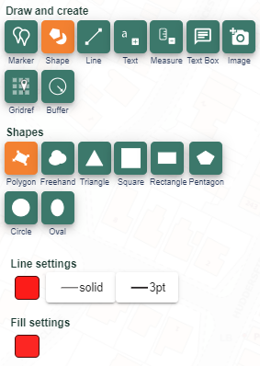

- Select your outline colour under Line – we suggest red.

- Under Fill, make sure you select 100% transparency – the transparency option is circled in red on the image below.

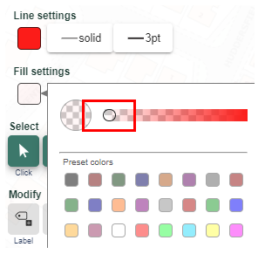

- You are going to enter your grid square for the Square of the Year competition. Look at the features that are actually found in your square. Use the box below to jot down a description to explain why the features are impressive, large, beautiful, stunning and so on. Now write a description which makes it sound as if it is the best square of all. Be creative!

- Why not design an Ordnance Survey map inspired trophy for the winning square?

Taking it further
- This activity could also be undertaken using grid squares covering other scales of mapping, including large scale OS MasterMap.
- The activity could be located in the school area. Print out a map, cut up the squares and allocate randomly to students, or groups of students. Challenge them to find the best features of their square and to take photographs of the views. They should use the tools within Digimap for Schools to create an A3 map highlighting their square and pinpointing the photograph locations. Other labels should describe the features. Display and encourage voting to decide the best local square.
- Students should be encouraged to explore the Geograph images available in Image Search in Digimap for Schools.
- Here photos are linked to grid squares. If they have photographs of their square, they should add it to the site, completing a full description.
- Has this square always looked like this? Use the historical layers to identify what changes have occurred since 1890 or/and 1950.
- Consider whether certain squares have a natural advantage when it comes to the competition: are squares near the sea, or in mountainous areas better than those in urban areas – does the ‘amount’ of features in a square make a difference?

Web links:
- This is a downloadable two page leaflet explaining the national grid system.
https://www.ordnancesurvey.co.uk/documents/resources/guide-to-nationalgrid.pdf

Copyright
©EDINA at the University of Edinburgh 2016
This work is licensed under a Creative Commons Attribution-Non Commercial Licence

Acknowledgements
© CollinsBartholomew Ltd (2019) FOR SCHOOLS USE ONLY
© Crown copyright and database rights 2020 Ordnance Survey (100025252). FOR SCHOOLS USE ONLY.
Aerial photography © Getmapping plc. Contains OS data. FOR SCHOOLS USE ONLY.
Historic mapping courtesy of the National Library of Scotland. FOR SCHOOLS USE ONLY.

